1. Link to GitHub repository <https://github.com/JaeBrow3/csd-340>

2. Screenshot of the validator results with errors

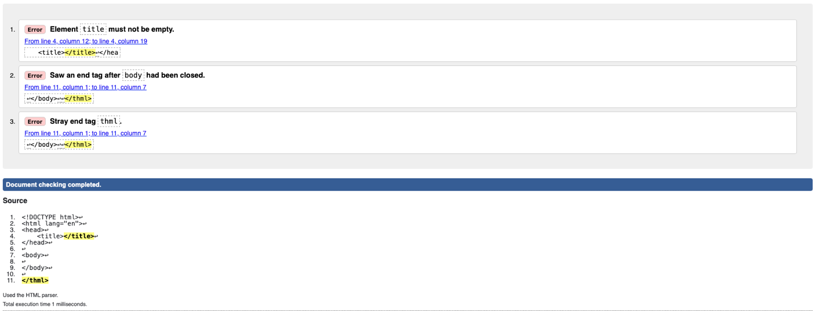

3. Screenshot of the validator results with no errors

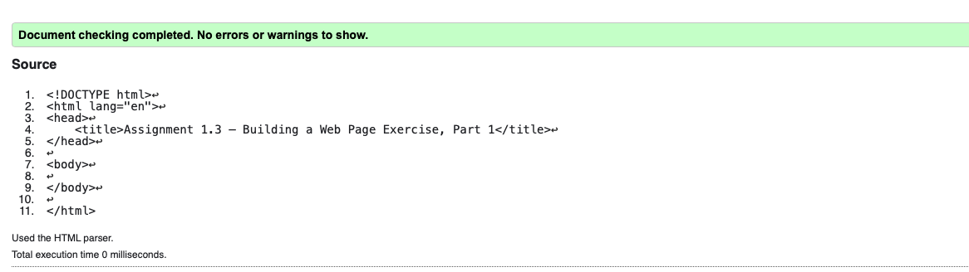

3. Screenshot of the validator results for updated results with no errors

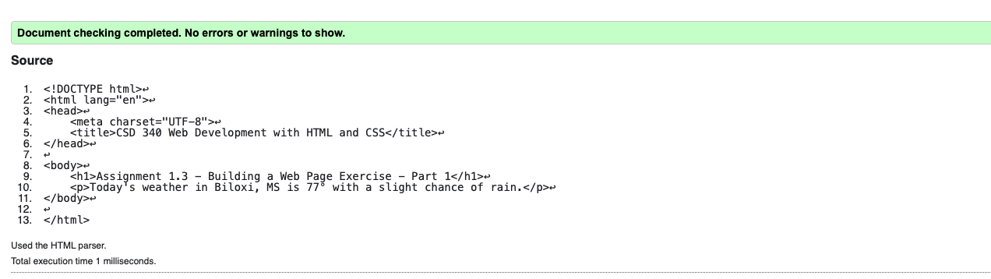

4. Screenshot of the web page

