1. Link to GitHub repository https://github.com/JaeBrow3/csd-402

2. Screenshot of local directory (properly formatted)

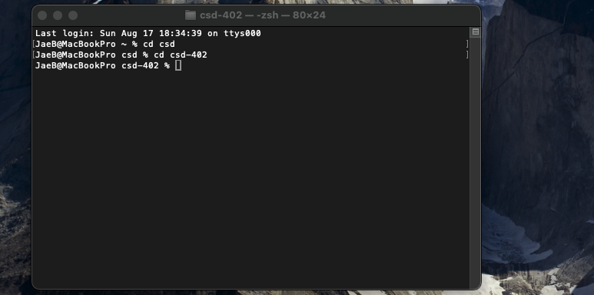

3. Screenshot of GitHub repository

