

Paper Break Down

The clinical adoption meta-model: a temporal meta-model describing the clinical adoption of health information systems

Jae Duk Seo

# Abstract, Background

* Abstract: Health Information System promises a positive transformation of the healthcare industry, however adoption to such models are a task to overcome and CAMM is a model that can address these challenges.
* Background: There are already preexisting models when adopting a new system/tool that can benefit the health care industry, however, these systems face challenges in deployment. From being successful to not even being deployed.   
  Clinical Adoption Meta Model – Is a temporal model that describe a tool adoption to Health Information System.  
  + Adoption Model: describes how a tool or new application gets to be integrated to the formal organization. And there are already different kinds and type of adoption model but they have few things in common.  
    a) Describe number of dimension – Example) Usage of the application  
    b) Designed for specific audience – Example) Developer, Researcher etc.…  
    c) Variability in assessment   
      
    CAMM – Focus on clinical adoption of an application
  + Adoption Models in Healthcare system: As mentioned above there are already existing adoption model for clinical applications. An example of such is FITT frame work – which focuses on the fit between Individual, Tasks and Technology.   
    A lot of adoption model have been developed for specific tasks such as HIMSS Analytic provide three EMR model, 1-US, 2-Canada, 3- Ambulatory EMRs.  
      
    However, many of these models seem to miss out on three points, such as a contextualized adoption that is   
    a) Generic to Health   
    b) But also sufficiently contextualized as to be accessible to key stakeholder audiences such as clinicians and administrators  
    c) ties together HIS adoption and clinical benefit over time to guide expectations of adoption over time

# Clinical Adoption Meta Model

* CAMM was developed at eHealth Observatory to fulfill the needs to evaluate a tool that is being deployed in provincial Health Information System in Canada.  
    
  Via research it was clear that common understanding of HIS adoption overtime was needed between multiple key stakeholders. However,  
  a) Some models did not fulfill the need of stakeholders  
  b) Too Complex  
  c) Too General  
    
  Hence, CAMM was born to address these limitations of pre-existing adoption models. CAMM is reliable since, it was used as a discussion and planning tool for IT leadership, implementers and clinicians.  
    
  CAMM have 4 dimensions which are   
  a) availability  
  b) system use   
  c) clinical/health behavior   
  d) clinical/health outcome  
  and each dimension have one or more attribute describing their purpose.   
    
  D1 – Availability – [User Access – login], [System availability – Server running], [Content availability – Is the content available to the user]   
  Is the application available 24/7?   
  Example) Web site not available because the server is down hence not available.   
    
  D2-System Use – [Use of the system – is the system being used by the clinicians], [User experience – Is the system too complicated for a user to use the system]  
  Example) No one goes on the website to use its service.  
    
  D3- clinical/health behavior-[Adoption to the system – is the system becoming a ritual to the clinical ]  
  Example) Doctors begin to use a certain website again and again since they are useful to them even if they do not have to.   
    
  D4- clinical/health outcome-[Impacted attribute of the HIS thanks to the adoption of the system – thanks to the system becoming integrated with the organization an expected/intended outcome have been reached]  
  Example) Thanks to the website now healthcare became cheaper to the patients

# CAMM adoption Archetypes

* When tracking the progress using the CAM Model, there are multiple possible outcomes, here we discuss seven types of possible outcomes which are
* 1. No Deployment.
* 2. Low Adoption.
* 3. Adoption without Benefit (behaviour and outcome).
* 4. Behaviour Change without Outcome Benefit.
* 5. Adoption with Outcome Benefits.
* 6. Adoption with Harm.
* 7. Benefit without Use.  
    
  And it is important to note that not every outcome leads to successful adoption. Hence careful monitoring of the system adoption is needed.   
    
  1. No Deployment – The application does not even get deployed to Healthcare system, maybe due to limited funding.   
    
  2. Low Adoption – The application does get deployed but no one uses it.   
  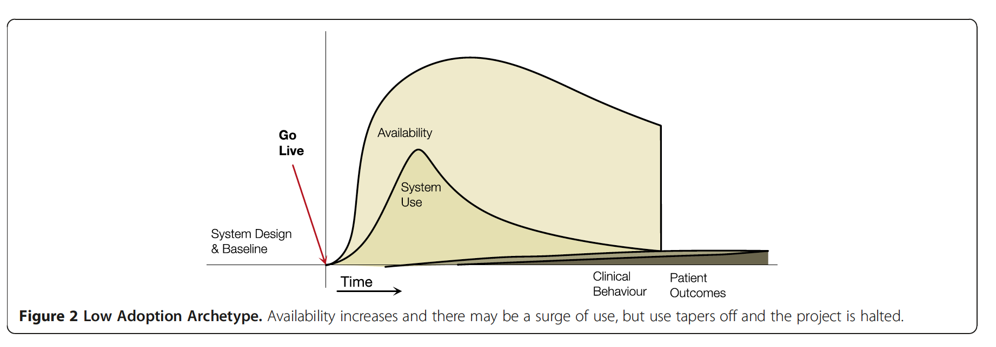

3. Adoption without Benefit (behaviour and outcome) – A application/tool is adopted and clinicians are using it but there is no clinical behavior or outcome  
  
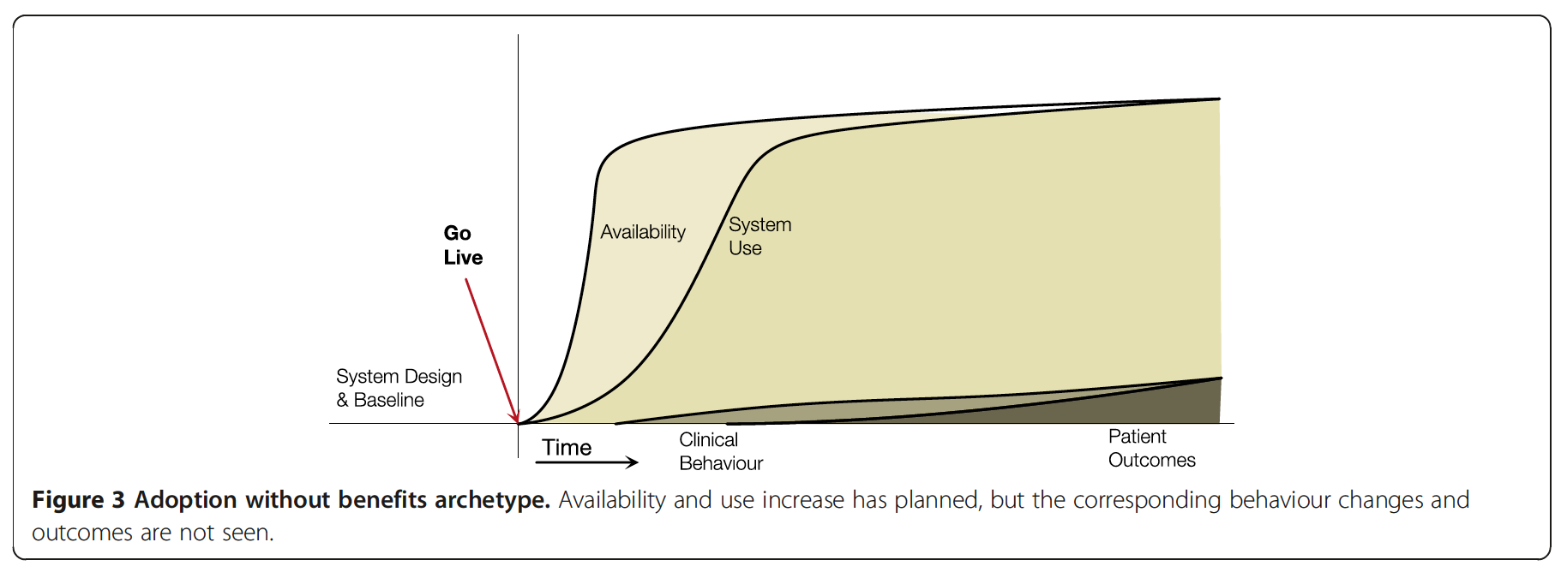  
  
4. Behavior Change without Outcome Benefit – A system gets deployed and it is used as well as clinicians like to use it, but there are no clinical outcome benefits  
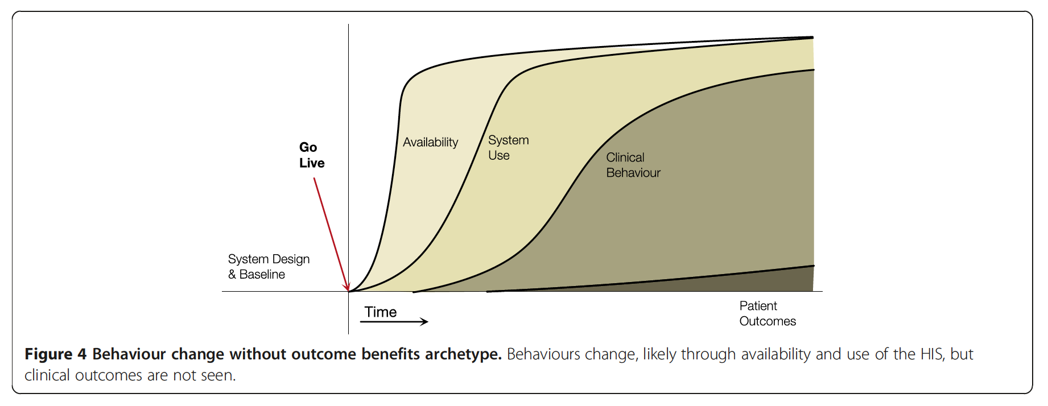

5. Adoption with Outcome Benefits – Most beneficial Archetype – Thanks to the system/tool/application an expected outcome is observed.  
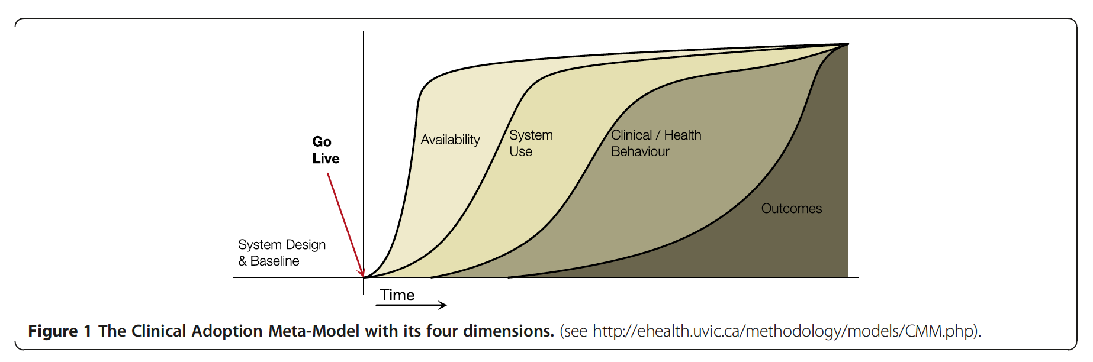  
  
6. Adoption with Harm – the system is in use but it harms the organization rather than benefitting them – AVOID!  
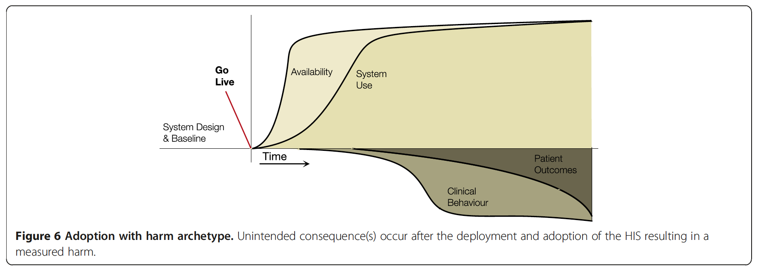  
7. Benefit without Use – A rare care, when the system is used once or twice, and does not get used afterwards but still benefits the organization.   
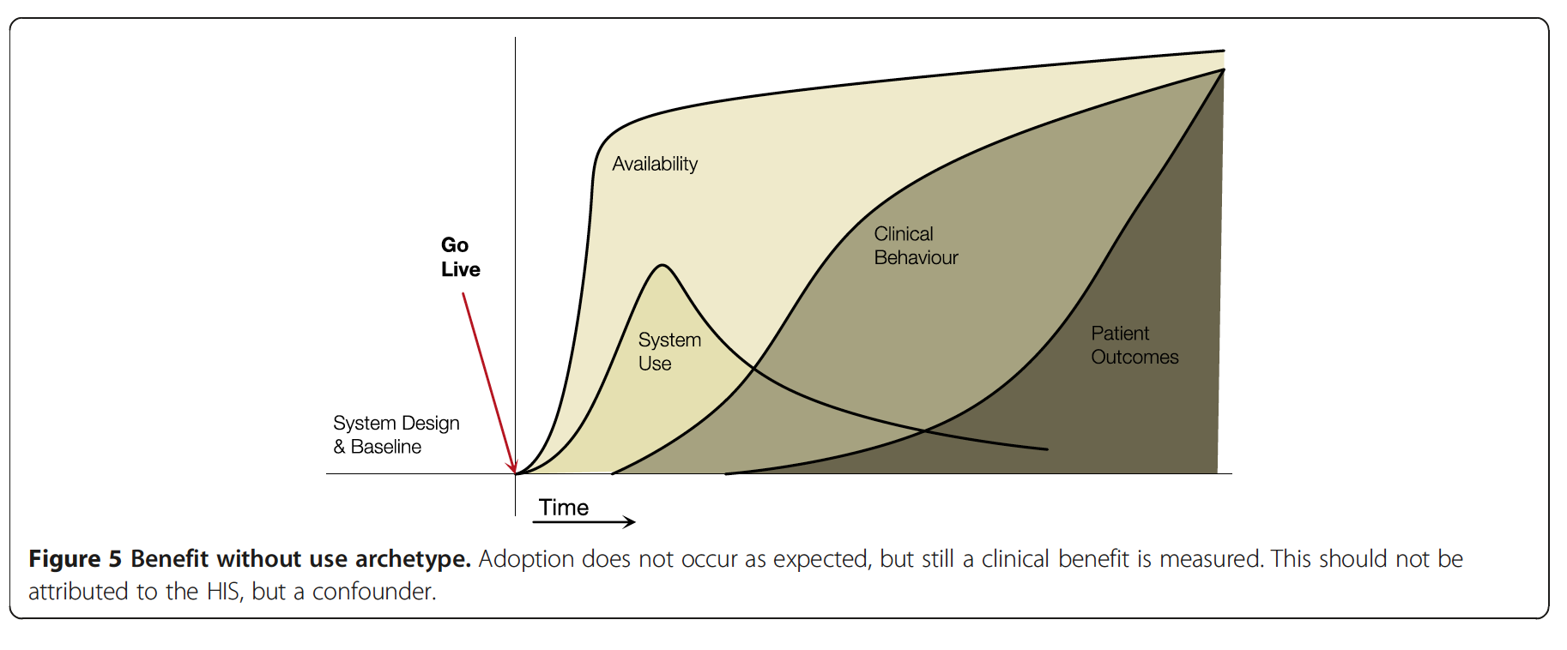

# Discussion and Conclusion

* CAMM is suitable to meet the criteria for Lahrmann criteria for an adoption model  
  a) Have multiple dimensions – Availability, Use, etc.…  
  b) Allow variability in assessment – Not described in paper  
  c) developed for specific audiences – Such as developer, researcher, learner etc.  
    
  Developer – Benefits them, since they can know where they went wrong, in each step. Can trace back to the point where the CAMM is not showing a desired outcome.   
    
  Evaluators – Use the model to measure performance of the application as well as the impact that it has on the organization.   
    
  Learner/Researcher – Via CAMM they can research or learn the design studies on adoption.   
    
  Some limitations are that CAMM is not time specific, it would be good to have a indication of expected time for each dimension.   
    
  In conclusion – "It highlights the importance of measuring multiple aspects of adoption over time to ensure that attribution of benefit can be realistically attributed to the use of HISs.”