

Discrete Structures

Lecture 1 ~ 3

# Sequences and Recursions

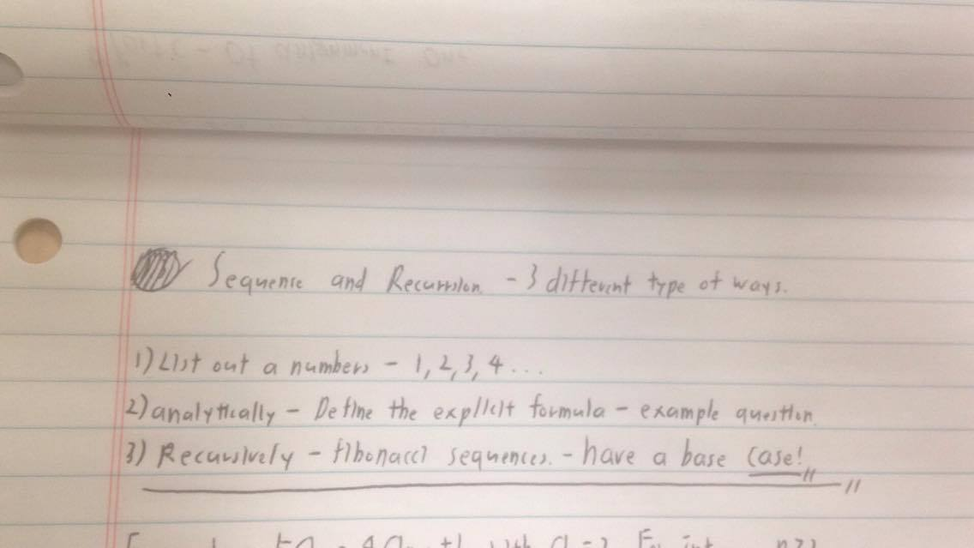

# Example of Analytic Sequence and explicit Formula

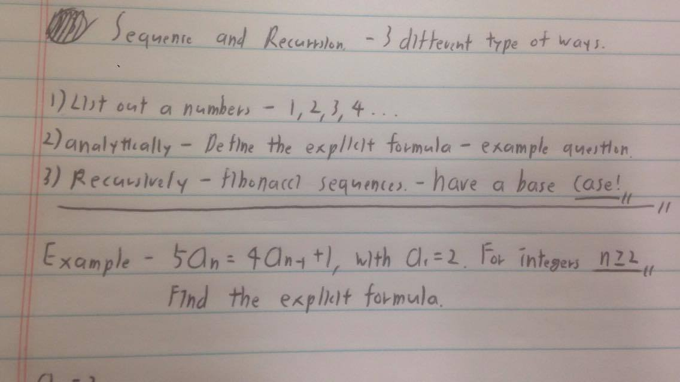

Base case of a1 = 2. Express this sequence with formula

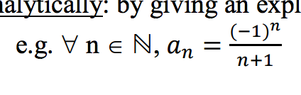

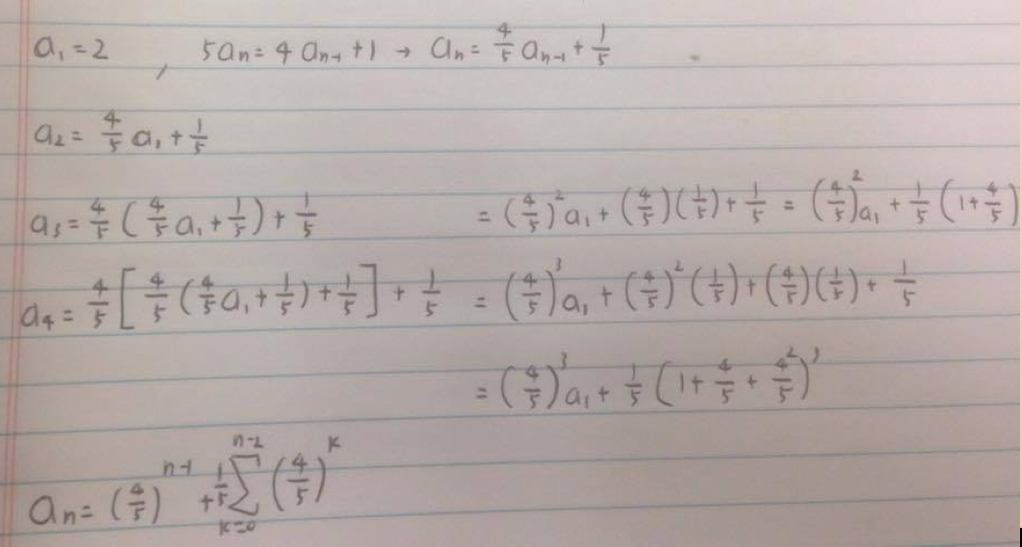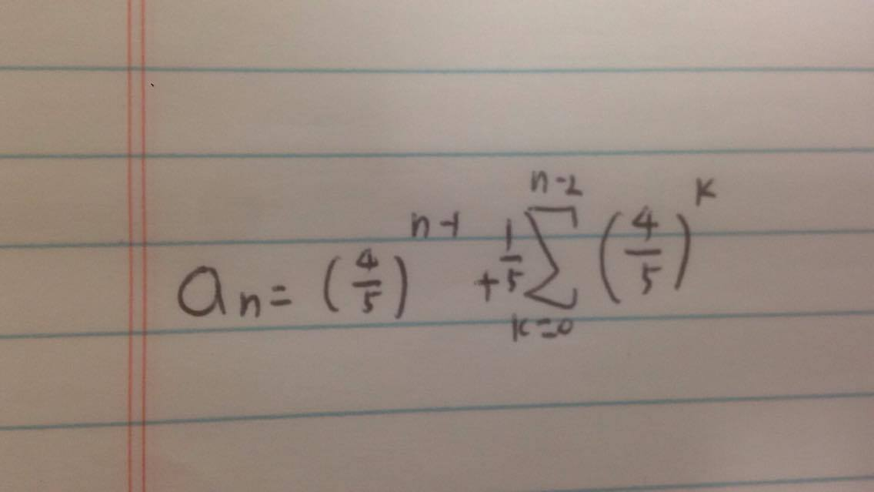

Not the final answer but still close – on the right track

# Example of Recursion – Fibonacci sequence

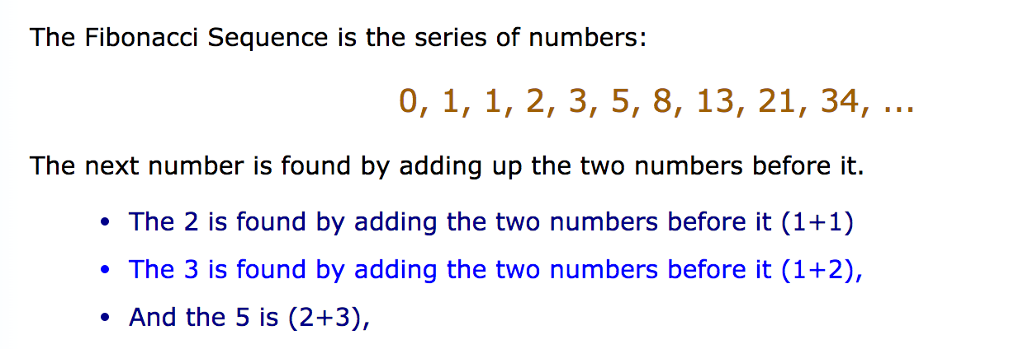

* Lets define a base case !
* 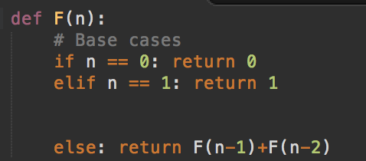
* If n = 0 then return 0   
  If n = 1 then return 1  
  Else multiplication of past term and past past term
* 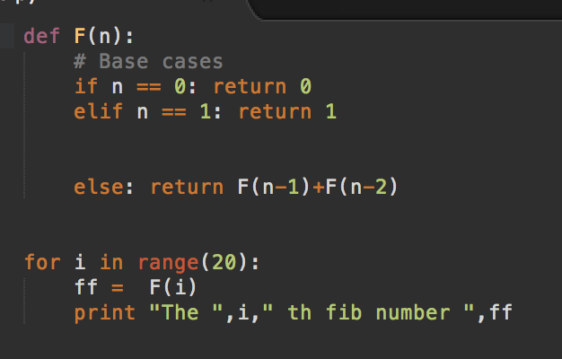

# SUMMATION AND PRODUCT NOTATIONS

Not going to cover if you don't know, don't worry.

<http://www.mathsisfun.com/algebra/sigma-notation.html>

<http://math.illinoisstate.edu/day/courses/old/305/contentsummationnotation.html>

# BASIC SEQUENCES AND THEIR SOLUTIONS

Arithmetic sequences

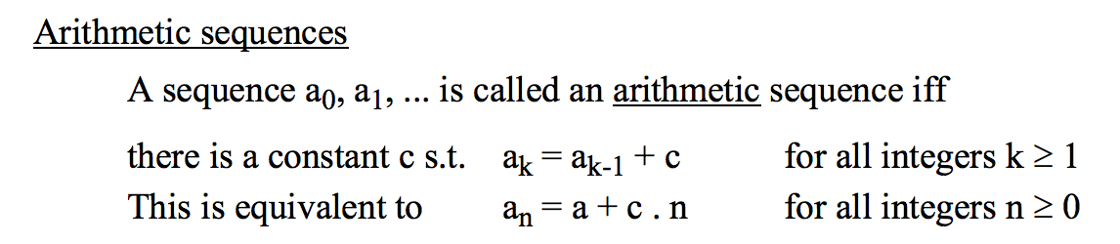

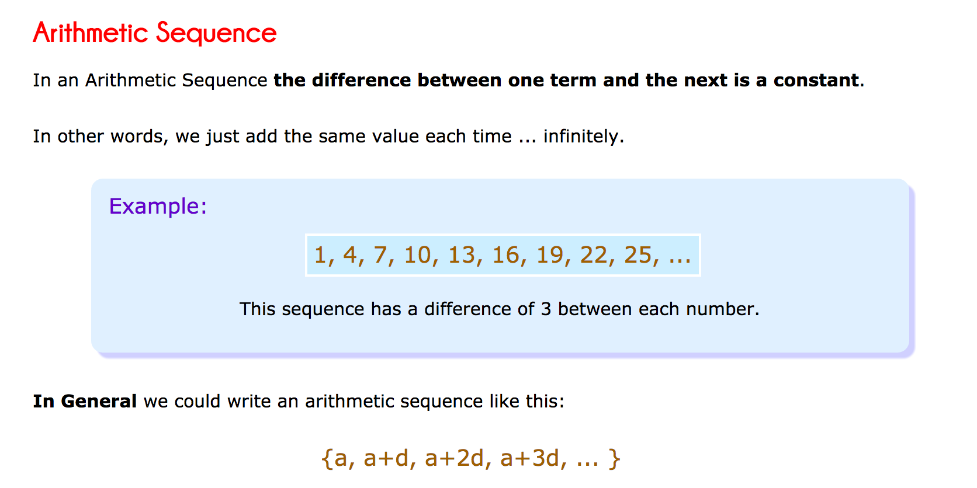

Geometric Sequences

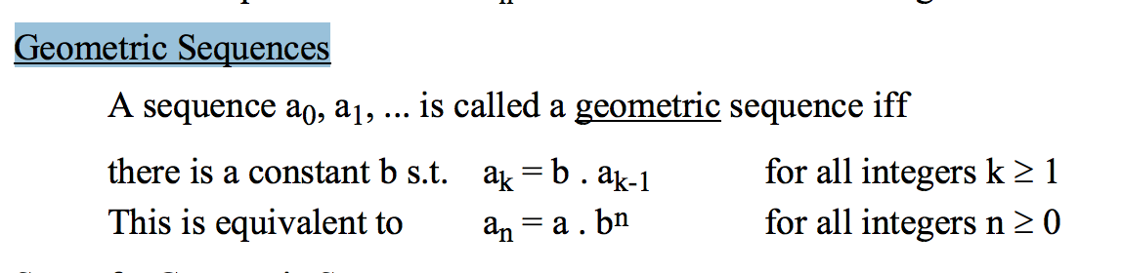

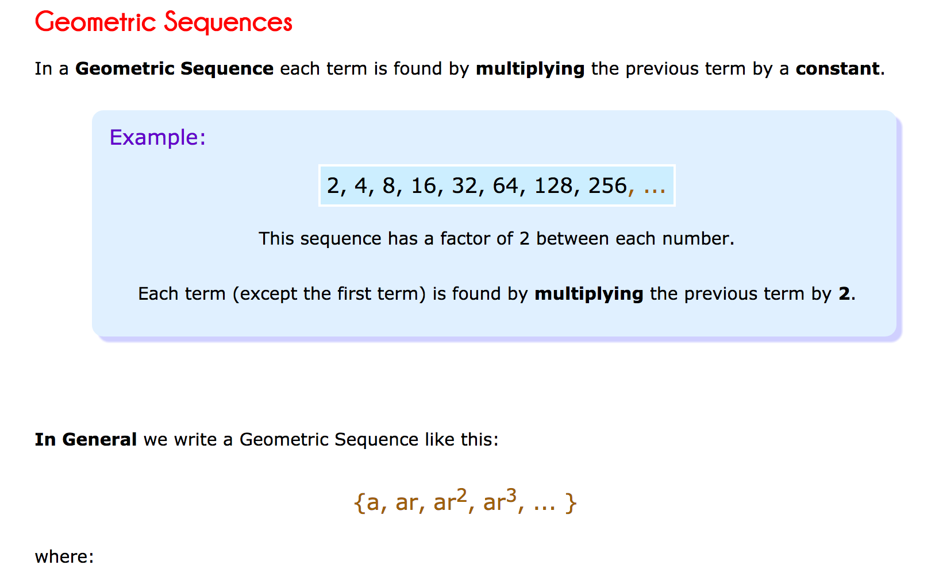

Sum of a Geometric Sequence

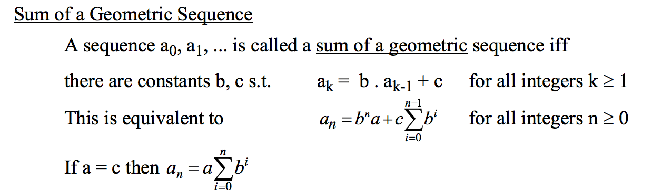

# Combination of both Geometric and Arithmetic