

Link for the exam: <http://quigley.scs.ryerson.ca/~mth210/OldExams/Finals/W05%20Final%20Exam.pdf>

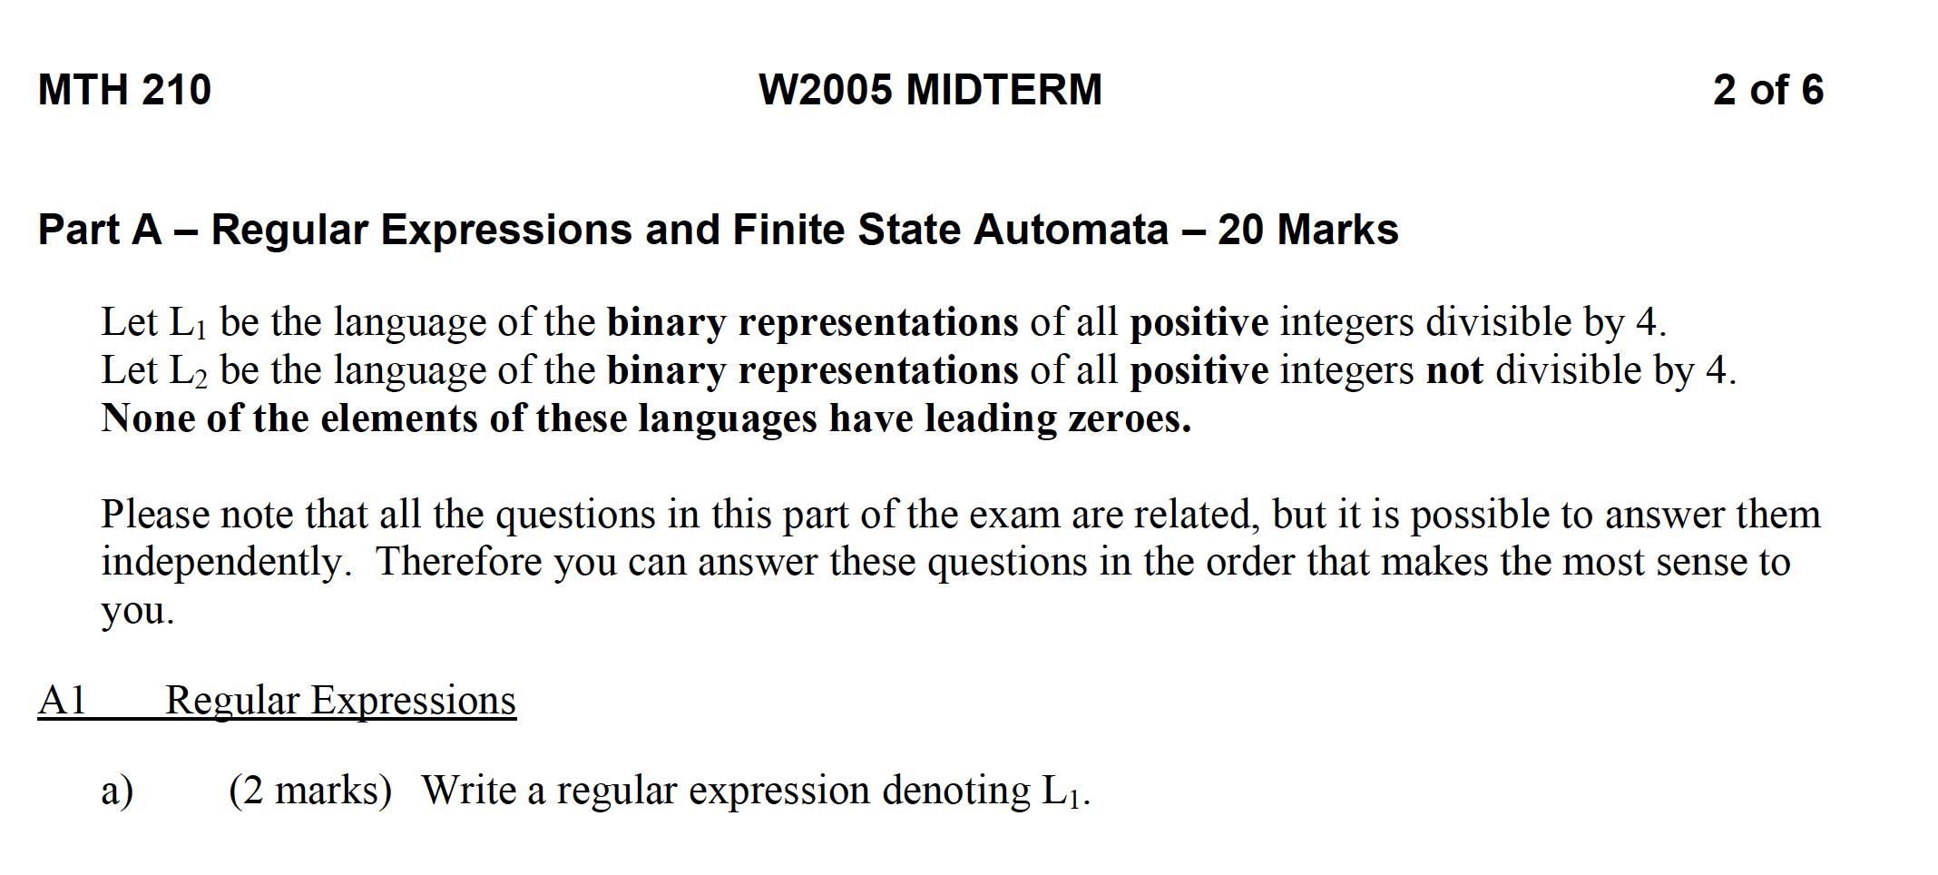  
  
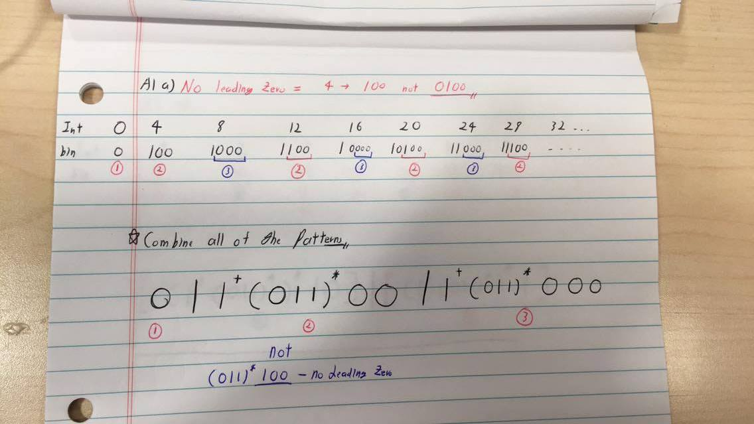

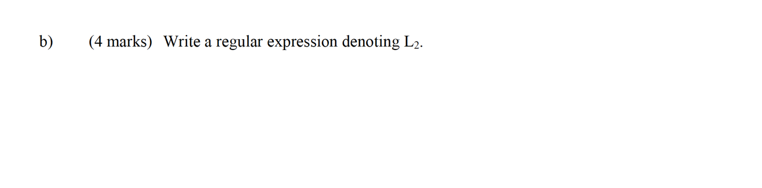  
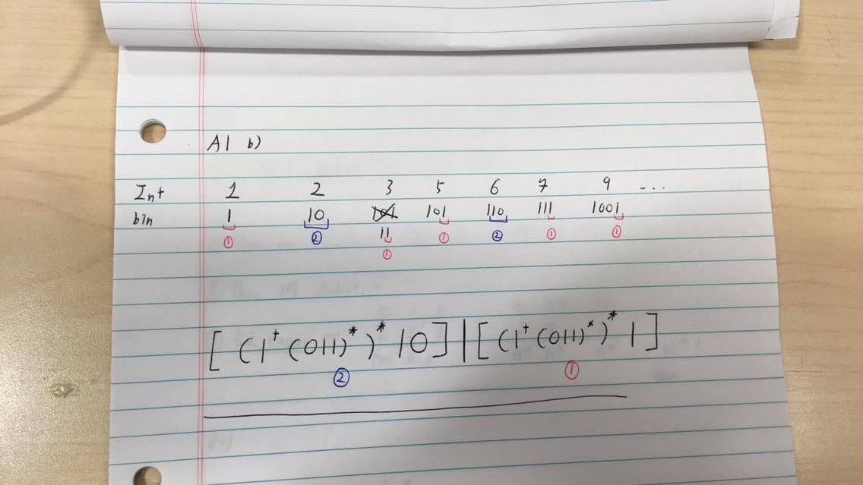

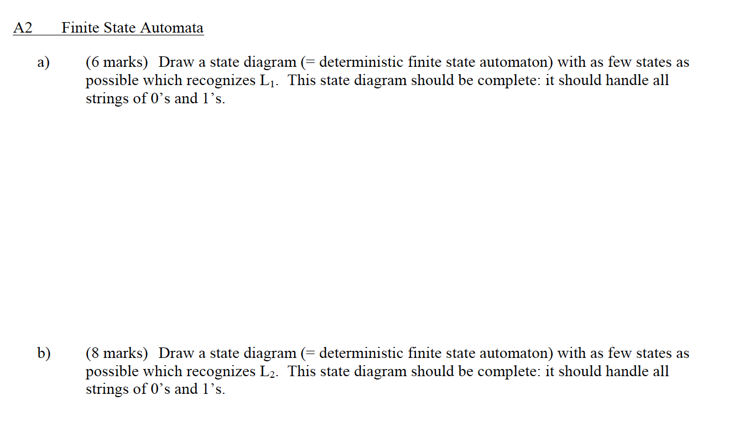  
  
Please visit the website: <http://hackingoff.com/compilers/regular-expression-to-nfa-dfa>

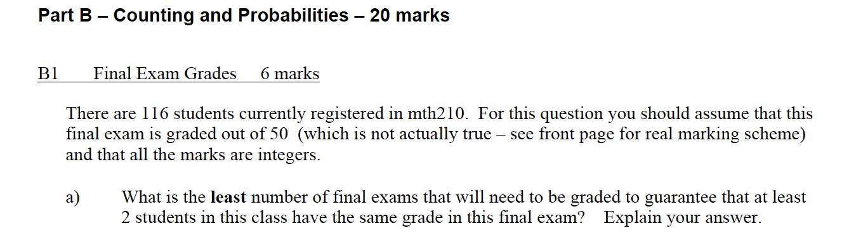  
  
  
Credits:

1. The Pigeonhole Principle: <http://www.eecs.yorku.ca/course_archive/2008-09/S/1019/Website_files/19-the-pigeonhole-principle.pdf>
2. [Discrete Math 1] Pigeonhole Principle : <https://www.youtube.com/watch?v=2-mxYrCNX60&t=197s>

