

Classroom Robot DOCUMENTATION



Contents

Toe Chart 1

UML Diagram 2

Debugging Evidence 3

# 

|  |  |  |
| --- | --- | --- |
|  |  |  |

# Toe Chart

Toe Chart listing the applications functions(tasks), the object used to finish the tasks, and the event involved.

|  |  |  |
| --- | --- | --- |
| **Task** | **Object** | **Event** |
| **Get/Set Students and Desks** |  |  |
| Classroom layout selection | **DialogResult** | **Form1.Load** |
| classroom layout  Get and Set student variables | **gridViewClass**  **Students ArrayList** | **DialogResult.Any**  **DialogResult.Any** |
| Get and set Desk colour variables  **Save Students** | **Colours ArrayList** | **DialogResult.Any** |
| Saves students on btnClick | **btnSave** | **btnSaveClick** |
| Take students from gridView | **gridViewClass** | **btnSaveClick** |
| Store taken students in new csv file  **Sort Students**  Sort students  Display sortedStudentForm  Students ArrayList to DataTable  DataSource of grid = DataTable | **ArrayList**  **Students ArrayList**  **SortedPopup.Form**  **DataTable sortedList**  **gridViewStudentList** | **btnSaveClick**  **btnSort**  **btnSort**  **btnSort**  **btnSort** |
| **Search Student: Sort Students**  Take text value from textbox | **txtFind** | **btnSearch** |
| Highlight the student that is == to txtFind  **Clear Grid of students**  Remove all student name values | **gridViewStudentList**  **DataTable.Clear()** | **btnSearch**  **btnClear** |
|  |  |  |
| **Random Access File** |  |  |
| Selected student on grid is written to txt file  Search RAF for a student | **gridViewClass & Students**  **Students** | **btnRAF**  **btnRAF** |
|  |  |  |
|  |  |  |
|  |  |  |
|  |  |  |
|  |  |  |
|  |  |  |
|  |  |  |

# UML Diagram

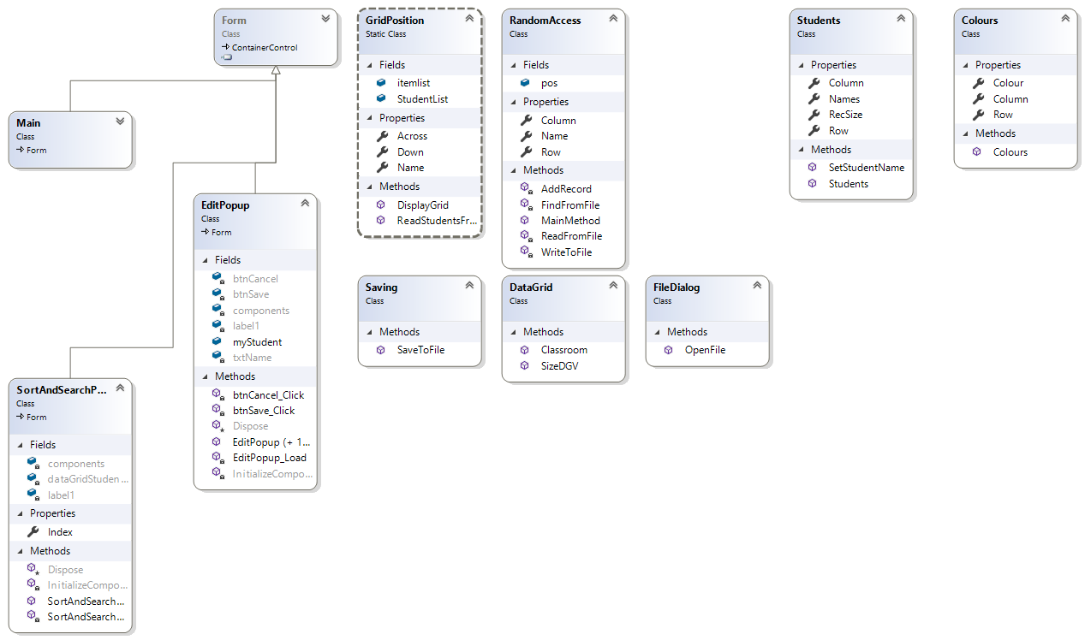Provided UML Class Diagram showing all classes, fields and methods.

# Debugging Evidence

Evidence of debugging

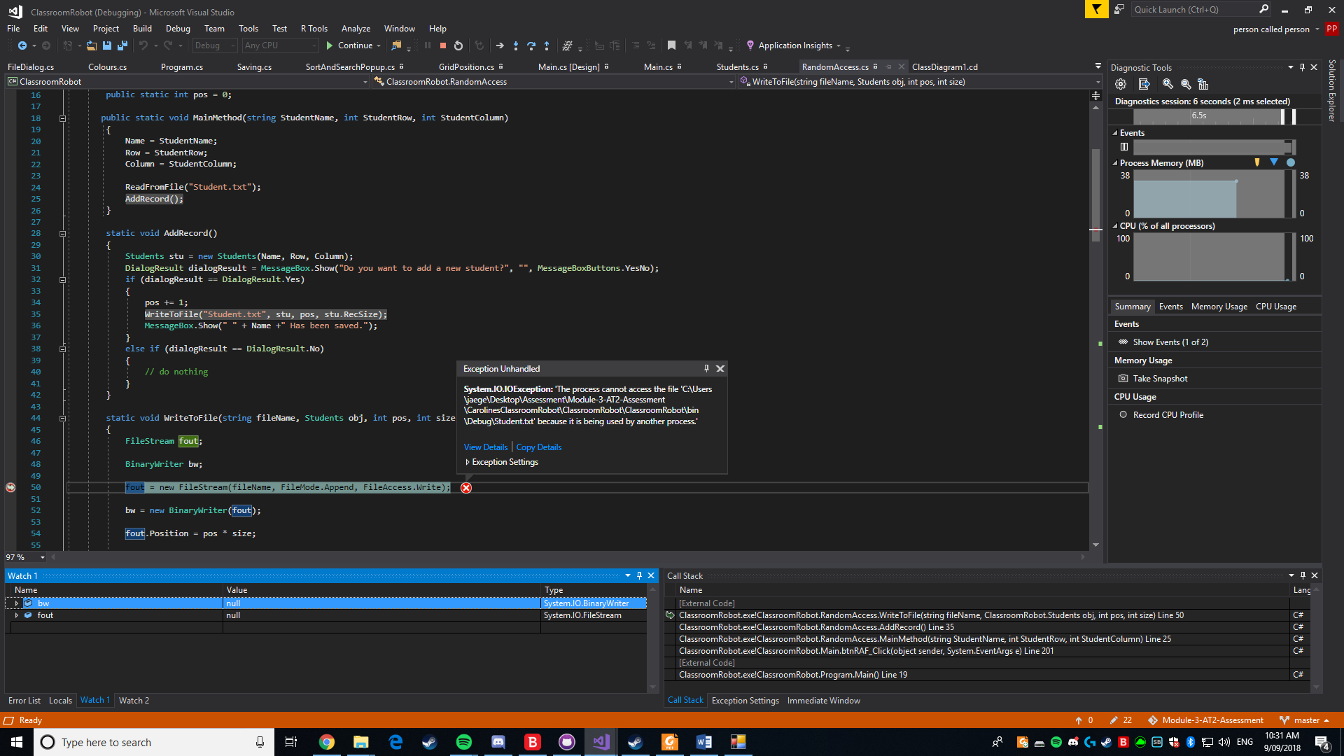

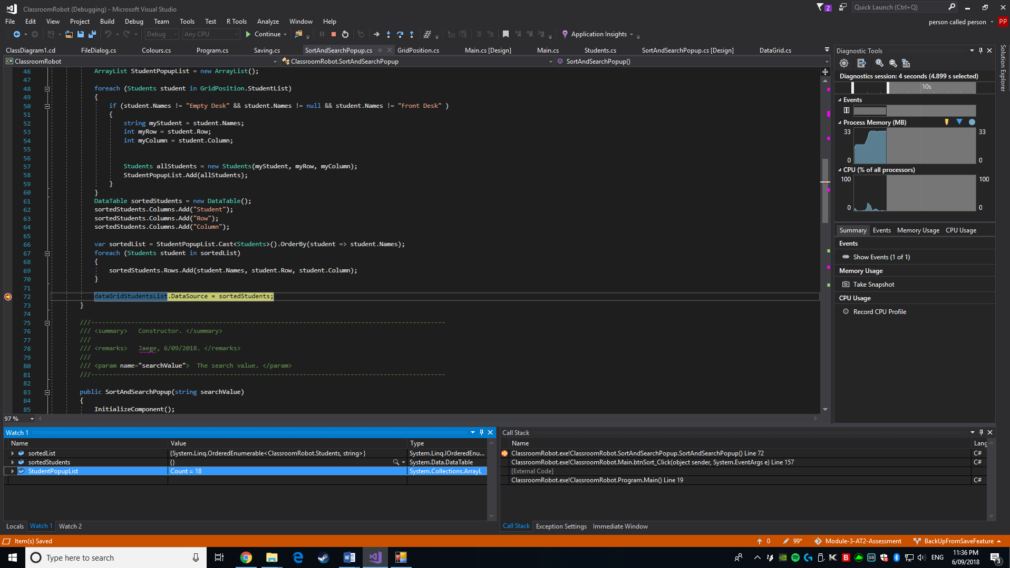Handling exception, by placing watches and running through the code to determine where the fault lay.

Checking that the variable is receiving a value.

Checking that the variable is receiving a value.