|  |
| --- |
| 2017년 10월 31일 Java 실습보고서 |
| Int를 입력받고 sc.nextLine()하고 String으로 nextLine()을 입력받음 |
|  |

|  |
| --- |
| 실습 1) 단어장 작성하기(방법1) |

**■ 소스코드**

**[ex01.java]**

**/\***

**\* [실습1]**

**\*/**

**import java.io.File;**

**import java.io.FileNotFoundException;**

**import java.util.Scanner;**

**public class ex01 {**

**public static void main(String[] args) {**

**File file=new File("test.txt");**

**Scanner scan;**

**Scanner sc=new Scanner(System.in);**

**String str="";**

**final int SIZE=100;**

**String[] str2=new String[SIZE]; // 단어**

**String[] str3=new String[SIZE]; // 뜻**

**int sum=0, index=0;**

**boolean boo=true;**

**try {**

**scan = new Scanner(file);**

**while(scan.hasNextLine()){ // 다음 줄의 입력 여부 판단**

**str=scan.nextLine();**

**String[] tmp=str.split(":"); // 단어와 뜻을 ":"로 구분**

**for(int i=0; i<tmp.length; i++){**

**if(boo){**

**str2[index]=tmp[i];**

**boo=false;**

**}else{**

**str3[index++]=tmp[i];**

**boo=true;**

**}**

**}**

**}**

**for(int i=0; i<index; i++){ // 공백제거**

**str2[i]=str2[i].trim();**

**str3[i]=str3[i].trim();**

**}**

**while(true){**

**System.out.print("1.객관식 2.주관식 3.단어장 4.점수조회 5.종료 >> ");**

**int menu=sc.nextInt();**

**if(menu==1){**

**Gak g=new Gak(str2, str3, index);**

**g.run();**

**sum+=g.getTotal();**

**}else if(menu==2){**

**Ju j=new Ju(str2, str3, index);**

**j.run();**

**sum+=j.getTotal();**

**}else if(menu==3){**

**System.out.println("[단어목록]");**

**for(int i=0; i<index; i++)**

**System.out.println(str2[i]+" : "+str3[i]);**

**}else if(menu==4){**

**System.out.println("[총점 : "+sum+"점]");**

**}else if(menu==5){**

**System.out.println("총 점수 : "+sum);**

**System.out.println("프로그램을 종료합니다.");**

**break;**

**}else{**

**System.out.println("Error");**

**}**

**}**

**scan.close();**

**sc.close();**

**} catch (FileNotFoundException e) {**

**// TODO Auto-generated catch block**

**e.printStackTrace();**

**}**

**}**

**}**

**[Gak.java]**

**// 객관식 문제(5문제만 출제함) <완료>**

**import java.util.Random;**

**import java.util.Scanner;**

**public class Gak {**

**private final int SCORE=10;**

**private String str1[];**

**private String str2[];**

**private int index;**

**private int total;**

**private final int PRO=5;**

**private boolean boo[];**

**Scanner sc=new Scanner(System.in);**

**Random r=new Random();**

**public Gak(){**

**total=0;**

**}**

**public Gak(String[] str1, String[] str2, int index){**

**this.str1=str1;**

**this.str2=str2;**

**this.index=index;**

**boo=new boolean[index];**

**total=0;**

**}**

**public void run(){**

**System.out.println("[객관식 문제]");**

**for(int i=0;i<PRO;i++) {**

**int myAnswer; // 자신이 고른 답**

**String select[]=new String[4]; // 객관식 선택문항**

**int rIndex=r.nextInt(index); // 단어 랜덤**

**int sIndex=r.nextInt(4); // 선택문항 인덱스 랜덤**

**boolean rBoo[]=new boolean[index];**

**if(boo[rIndex]){ // 중복된 문제 제거**

**i--;**

**continue;**

**}**

**boo[rIndex]=true;**

**select[sIndex]=str2[rIndex];**

**rBoo[sIndex]=true;**

**for(int j=0; j<select.length; j++){**

**int rand2=r.nextInt(index);**

**if(j==sIndex)**

**continue;**

**else{**

**if(rIndex!=rand2 && rBoo[rand2]==false){**

**select[j]=str2[rand2];**

**rBoo[rand2]=true;**

**}else{**

**j--;**

**continue;**

**}**

**}**

**}**

**System.out.println("Q"+(i+1)+". "+str1[rIndex]);**

**for(int j=0; j<4; j++)**

**System.out.println((j+1)+". "+select[j]);**

**System.out.print("답 입력 >> ");**

**myAnswer=sc.nextInt();**

**if(myAnswer-1==sIndex){**

**System.out.println("정답입니다. 10점 획득");**

**total+=SCORE;**

**}else**

**System.out.println("틀렸습니다.");**

**}**

**System.out.println("점수 : "+total+"점 획득");**

**}**

**public int getTotal(){**

**return total;**

**}**

**}**

**[Ju.java]**

**// 주관식 문제<완료>**

**import java.util.Random;**

**import java.util.Scanner;**

**public class Ju {**

**private final int SCORE=10;**

**private String str1[];**

**private String str2[];**

**private int index;**

**private int total;**

**private boolean boo[];**

**Scanner sc=new Scanner(System.in);**

**Random r=new Random();**

**public Ju(){**

**total=0;**

**}**

**public Ju(String[] str1, String[] str2, int index){**

**this.str1=str1;**

**this.str2=str2;**

**this.index=index;**

**boo=new boolean[index];**

**total=0;**

**}**

**public void run(){**

**System.out.println("[주관식 문제]");**

**for(int i=0;i<index;i++) {**

**String myAnswer;**

**int rIndex=r.nextInt(index);**

**if(boo[rIndex]){**

**i--;**

**continue;**

**}**

**System.out.print("Q"+(i+1)+".\t"+str1[rIndex]+" => ");**

**myAnswer=sc.nextLine();**

**boo[rIndex]=true;**

**String[] tmp=str2[rIndex].split("/"); // 단어 뜻의 각 경우를 "/"으로 구분**

**for(int j=0; j<tmp.length; j++){**

**if( myAnswer.equals(tmp[j]) ) {**

**total+=SCORE;**

**System.out.println("정답입니다. 10점 획득");**

**break;**

**}**

**if(j==tmp.length-1)**

**System.out.println("틀렸습니다.");**

**}**

**}**

**System.out.println("점수 : "+total+"점 획득");**

**}**

**public int getTotal(){**

**return total;**

**}**

**}**

**[test.txt]**

considering that : ~을 고려하건대

frankly speaking : 솔직히 말하여

consider : 고려하다/간주하다

consideration : 고려/생각

considerable : 상당한

last : 마지막/지난/계속하다

society : 사회

social : 사회적인

sociable : 사교적인

socialize : 사회화하다

**■ 결과화면**

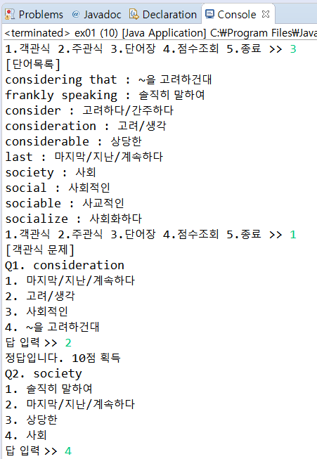

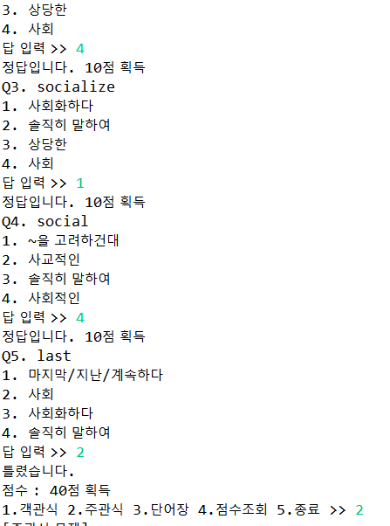

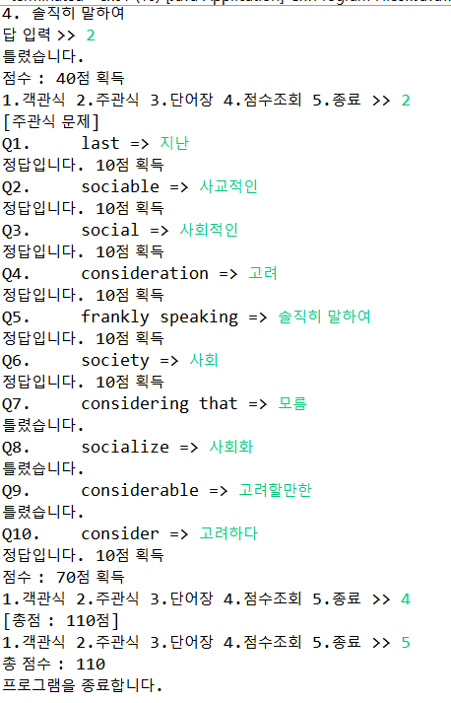

|  |
| --- |
| 실습 2) 단어장 작성하기(방법2) |

**■ 소스코드**

**[quetionManager.java]**

**package Dictionary;**

**import java.util.Random;**

**import java.util.Scanner;**

**public class questionManager {//게임실행**

**private Scanner scan=new Scanner(System.in);**

**private Random r=new Random();**

**private int point=0;**

**public void start(Words []w) {//주관식**

**System.out.println("단어 퀴즈(주관식)");**

**for(int i=0;i<10;i++) {**

**int r1=r.nextInt(10);**

**if(!w[r1].isUsed()) {**

**w[r1].using();**

**System.out.print(w[r1].getWord()+": ");**

**String temp=scan.nextLine();**

**if(w[r1].getMeaning().contains("/")) {**

**String s[]=w[r1].getMeaning().split("/");**

**for(int j=0;j<s.length;j++) {**

**if(s[j].equals(temp)) {**

**point++;**

**System.out.println("정답입니다.");**

**break;**

**}else if(j==(s.length-1))**

**System.out.println("오답입니다.");**

**}**

**}**

**else if(temp.equals(w[r1].getMeaning())) {**

**point++;**

**System.out.println("정답입니다.");**

**}**

**else**

**System.out.println("오답입니다.");**

**}else**

**i--;**

**}**

**System.out.println(point+"개의 정답");**

**for(int i=0;i<10;i++)**

**w[i].reset();**

**point=0;**

**}**

**public void start2(Words[] w) {//객관식**

**System.out.println("단어 퀴즈(객관식)");**

**for(int i=0;i<10;i++) {**

**int r1=r.nextInt(10);**

**if(!w[r1].isUsed()) {**

**w[r1].using();**

**System.out.println((i+1)+". "+w[r1].getWord()+"의 뜻은?" );**

**String temp[]=new String[4];**

**int num=r.nextInt(4);**

**temp[num]=w[r1].getMeaning();**

**for(int k=0;k<4;k++) {**

**if(k!=num) {**

**temp[k]=w[r.nextInt(10)].getMeaning();**

**if(temp[k].equals(temp[num]))**

**k--;**

**else {**

**for(int j=0;j<k;j++) {**

**if(temp[j].equals(temp[k]) && j!=num) {**

**temp[j]=w[r.nextInt(10)].getMeaning();**

**j--;**

**}**

**}**

**}**

**}else**

**continue;**

**}//객관식 보기만 랜덤으로**

**for(int j=0;j<4;j++) {**

**System.out.print((j+1)+") "+temp[j]+" ");**

**}**

**System.out.println();**

**System.out.print("정답 :");**

**int ch=scan.nextInt();**

**if(ch==(num+1)) {**

**System.out.println("정답입니다.");**

**point++;**

**}**

**else**

**System.out.println("오답입니다.");**

**}else**

**i--;**

**}**

**System.out.println(point+"개의 정답");**

**for(int i=0;i<10;i++)**

**w[i].reset();**

**point=0;**

**}**

**public void show(Words[] w) {**

**System.out.println("단어장");**

**for(int i=0;i<10;i++)**

**System.out.println(w[i].getWord()+" : "+w[i].getMeaning());**

**}**

**}**

**[quiz.java]**

**package Dictionary;**

**import java.io.File;**

**import java.io.FileNotFoundException;**

**import java.util.Scanner;**

**public class quiz {**

**public static void main(String args[]) throws FileNotFoundException {**

**File file =new File("test.txt");**

**Scanner scan;**

**int count=0;**

**Words[] words=new Words[10];**

**questionManager q=new questionManager();**

**scan=new Scanner(file);**

**while(scan.hasNextLine()) {**

**String str=scan.nextLine();**

**words[count]=new Words(str);**

**count++;**

**}**

**scan.close();**

**while(true) {**

**Scanner sc=new Scanner(System.in);**

**System.out.println("1)주관식 2)객관식 3)단어장 4)종료하기");**

**System.out.print("메뉴 선택: ");**

**int menu=sc.nextInt();**

**switch(menu) {**

**case 1:{**

**q.start(words);**

**break;**

**}**

**case 2:{**

**q.start2(words);**

**break;**

**}**

**case 3:{**

**q.show(words);**

**break;**

**}**

**case 4:{**

**return;**

**}**

**default:{**

**System.out.println("메뉴를 잘못입력");**

**break;**

**}**

**}**

**}**

**}**

**}**

**[Words.java]**

**package** Dictionary;

**public** **class** Words {

String word,meaning;

**boolean** used=**false**;

**public** Words(String str) {

String[]temp=str.split(":");

**this**.word=temp[0].trim();

**this**.meaning=temp[1].trim();

}

**public** String getWord() {

**return** word;

}

**public** String getMeaning() {

**return** meaning;

}

**public** **void** using() {

used=!used;

}

**public** **boolean** isUsed() {

**return** used;

}

**public** **void** reset() {

used=**false**;

}

}

**■ 결과화면**

