Omikuji  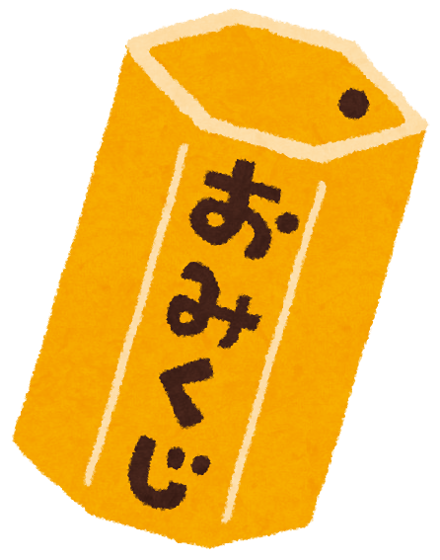  It is used to know your future.  You can buy it at a shrine. | Sensu  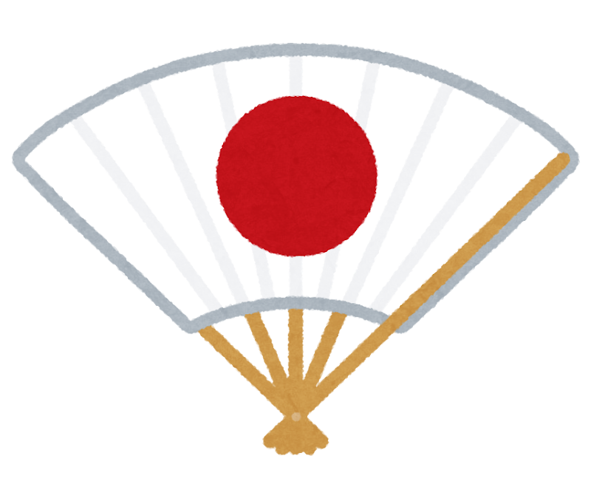  It is used when you want to cool down.  You can buy it at a 100-yen shop. | Kendama    It is used when you want to play a game.  You can buy it at a toy store.
Oshibori  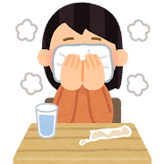  It is used when you want to clean your hands and face.  You can get it at a restaurant. | Chopsticks  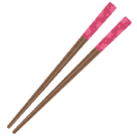  It is used when you eat Japanese food.  You can buy it at a supermarket. | Kotatsu  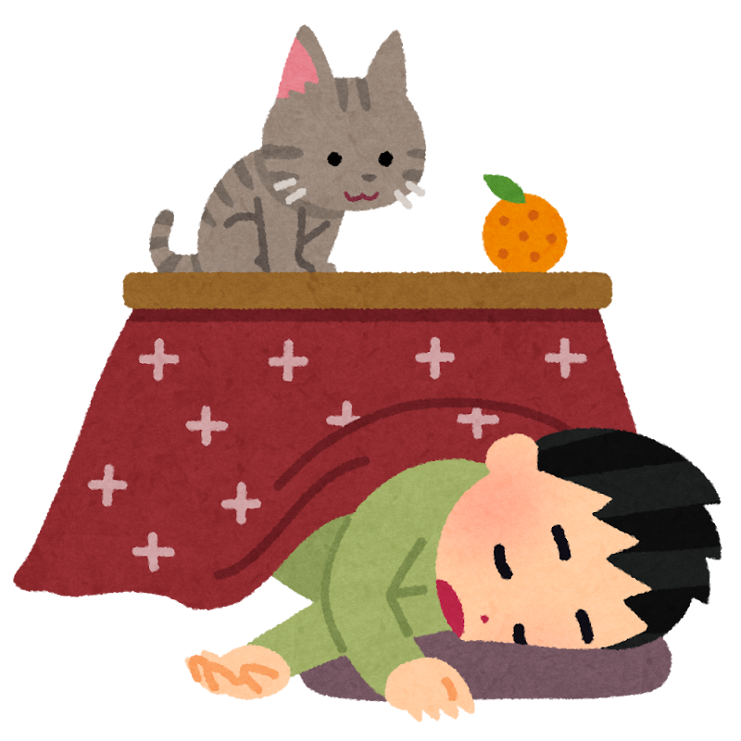  It is used when you want to warm up in winter.  You can buy it at a home store.
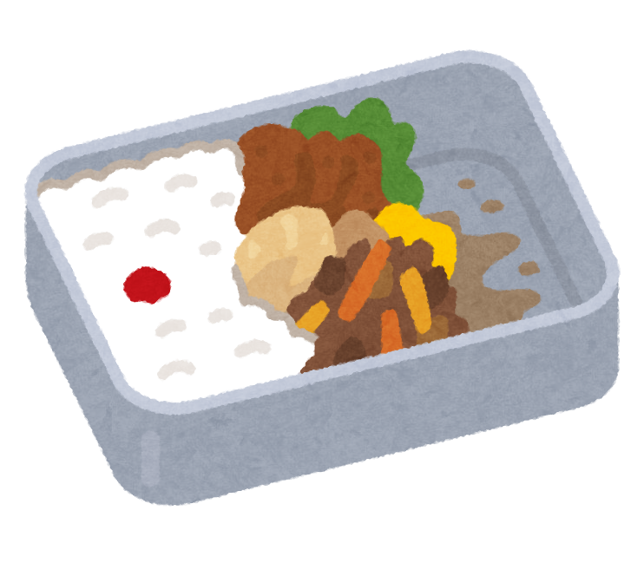  Bento  It is used when you want to eat lunch.  You can buy it at a convenience store | Green Tea  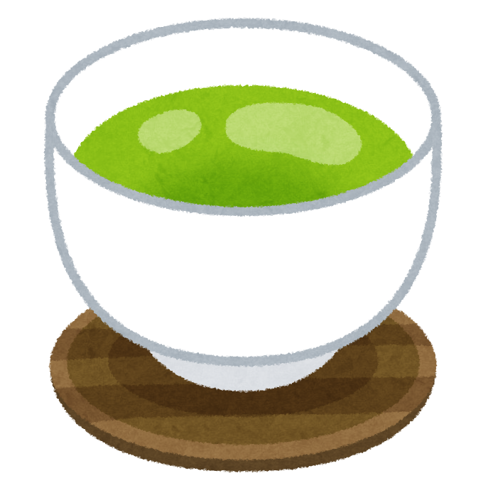  It is used when you are thirsty.  You can buy it at a vending machine | Jinbei  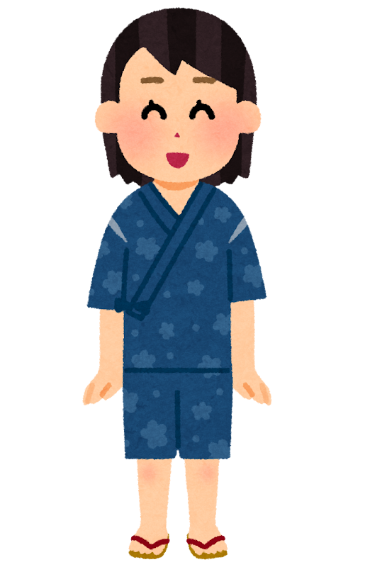  It is used when you are at a summer festival.  You can buy it at a clothing store.

