**Jaeline Granda (001257108)**

Program Structures & Algorithms

Spring 2021

Assignment No. 2

**Task:** To implement three methods in class Timer. To implement InsertionSort method in InsertionSort class. To implement a main program to run the benchmarks using four different arrays and at least 5 values of n.

**Conclusion:** From the runs, I was able to create a table with the time it took to sort each different array using 5 different n values to double the array size every run. I was able to create a graph that showed the time it took to sort the arrays was linear for the most part. This means there is a linear relationship between the number of elements in the array and the time it takes to sort the array.

Additionally, from the table based on the runs, we can see that the Random array and Ordered array take the longest. They also have steeper slopes than the Partially ordered array and Reversed Ordered array.

**Tests:**

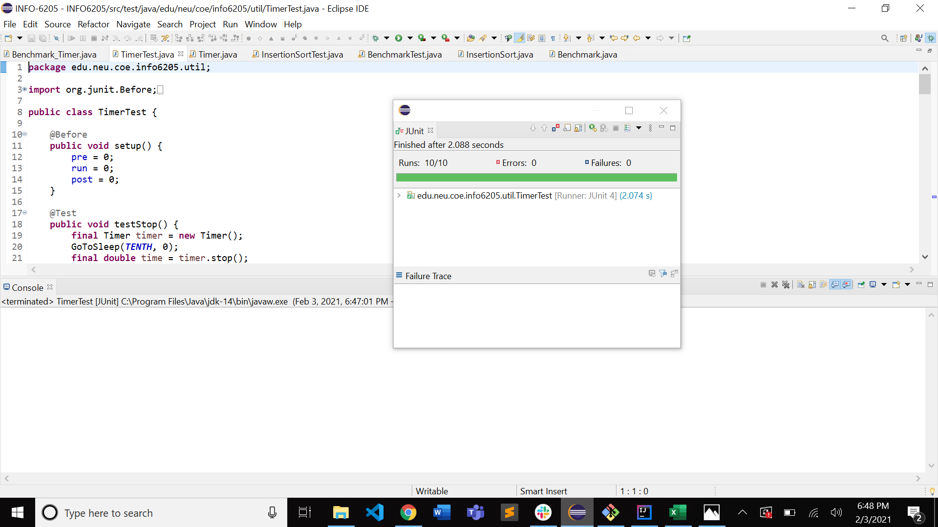

**Runs:**

