Supplement - Biserial correlation transformations

11 juli, 2019

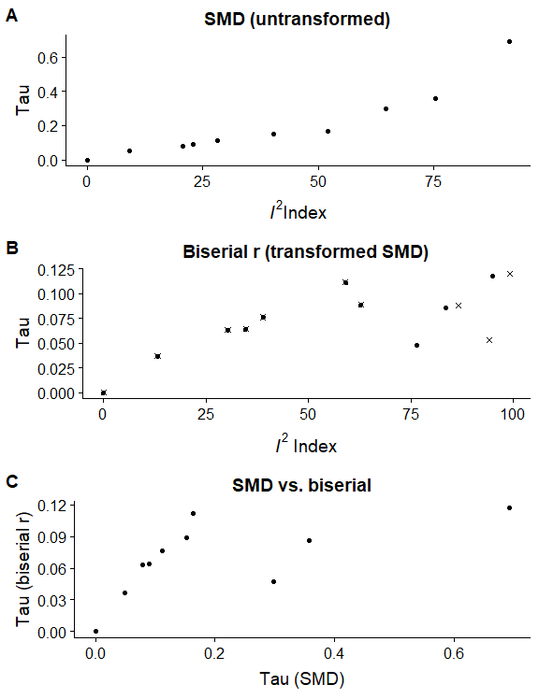

*Figure S.1* Association between $τ$ and $I^{2}$ after and before standardized mean difference (SMD) effects were transformed into biserial correlations for all effects reported as SMDs in ManyLabs 1. Panel A shows the association between $τ$ and $I^{2}$ without transformation when using the meta-analytic specification of the original authors (see main text). Panel B shows the same associations for the same effects after transformation to biserial correlations, either with truncation of correlations over 1 (circles) or without (crosses). Panel C shows the association between $τ$ for the same effects before and after transformation.