CIS 1250 Python Program5 – Play a game

# Turn in Requirements:

5 pts. Name your project LastnameP5, such as GarnerP5.

# Program Requirements:

1. 5 pts. Write the file name, your name, email address and purpose of the program at the top of your source code in a comment.

# GarnerP3

# Programmer: Chantal muhumure

# EMail: cmuhumure @cnm.edu

# Purpose: provides user capability to find fruit in a string

1. 5 pts. Add comments as appropriate. Be sure that your program output is neatly presented to the user.
2. Write a program that does the following:
   1. Initialize an empty list which you will use to store the results of each game.
   2. Start a game of rock paper scissors with to user.
      1. The user will play against the computer. A scissor can cut paper, a rock can knock a scissor, and paper can wrap a rock.
      2. Structure the play loop so the player plays the game until the user or the computer has won twice and then the player is asked if they want to play another round.
      3. Ask the user to select his/her choice (rock, paper, scissors)
      4. After the user has entered his/her choice, the program use a random number generator for its selection.
      5. Your program will evaluate who won or if there was a tie.
      6. The program reports what the computer chose, the user’s choice, who won that round, and game tally. The game tally shows number of rounds, wins/losses for the player and number of ties.
      7. Ask the player if the user wants to play again.
   3. When done display a goodbye message.
3. The game should look something like this:

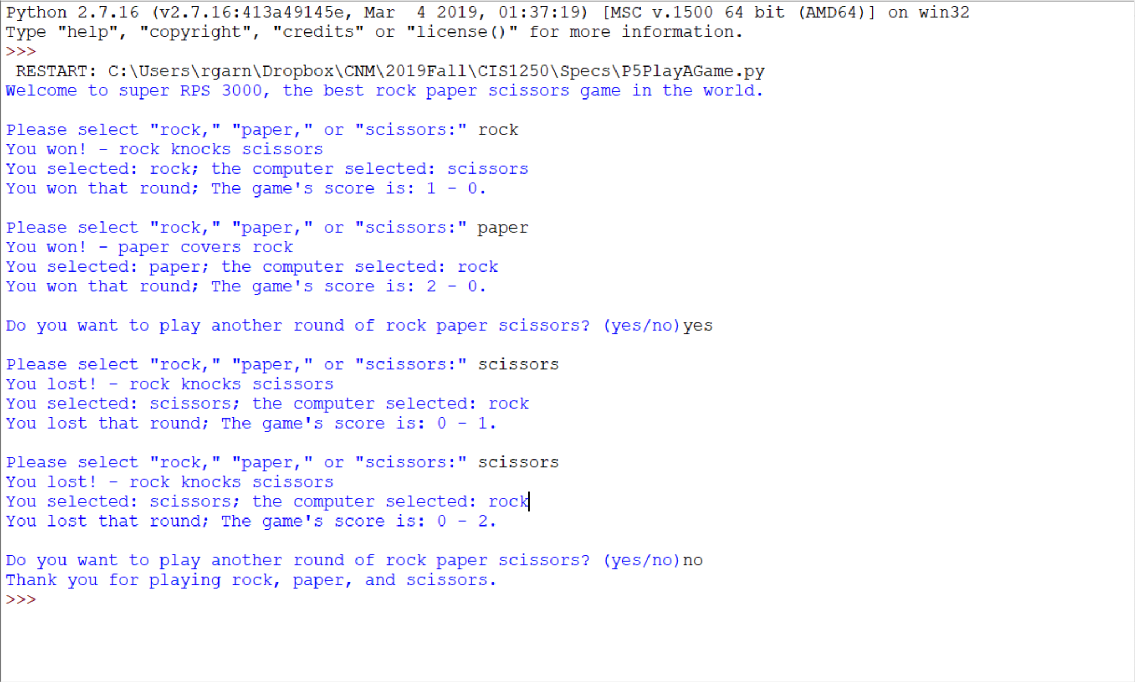

# Hints:

You may need to use an if/elif/else block that will look something like:

If

elif

elif

elif

else

Remember to indent the blocks of code that come after and are associated with your while, if, elif and else statements.

To generate random numbers use the random library.

Example:

import random

doanother = 'y'

while doanother == 'y':

someValue = random.randrange(3)

print someValue

doanother = raw_input ('Again y/n: ').strip().lower()[0]

Example of using Random:

>>> import random

>>> random.randrange(3)

0

>>> random.randrange(3)

1

>>> random.randrange(3)

2

>>> choices=['rock','paper','scisors']

>>> compchoice = choices[random.randrange(3)]

>>> compchoice

'scisors'

>>>