HW-Lect10-5

cleaned <- read.csv("C:/Users/jaesu/OneDrive/Desktop/School_code/STAT390/hw-1/cleaned.csv")

cleaned$Drink.week

hist(cleaned$Drink.week)

hist(cleaned$Money.week)

windows.options(width=10, height=10)

plot(sqrt(cleaned$Drink.week), cleaned$Money.week, main="Drinks per week vs Money per week", pch=19)

library(lattice)

qqmath(cleaned$Drink.week, dist=qexp, cex=0.5)

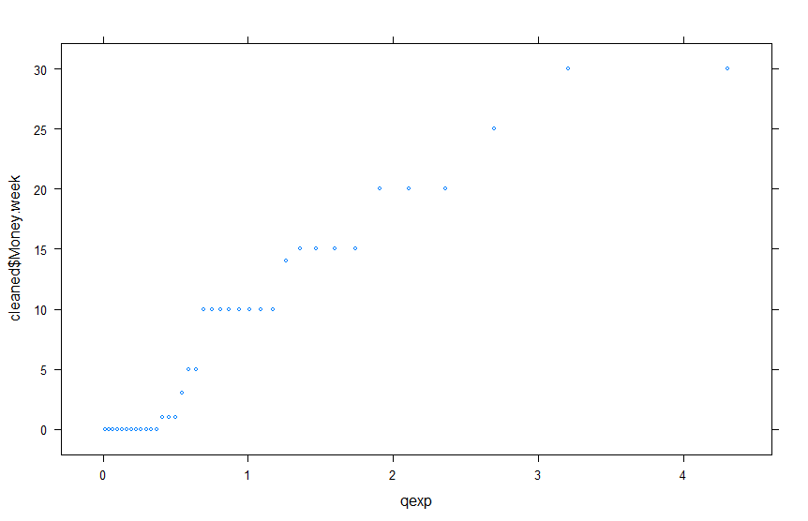

qqmath(cleaned$Money.week, dist=qexp, cex=0.5)

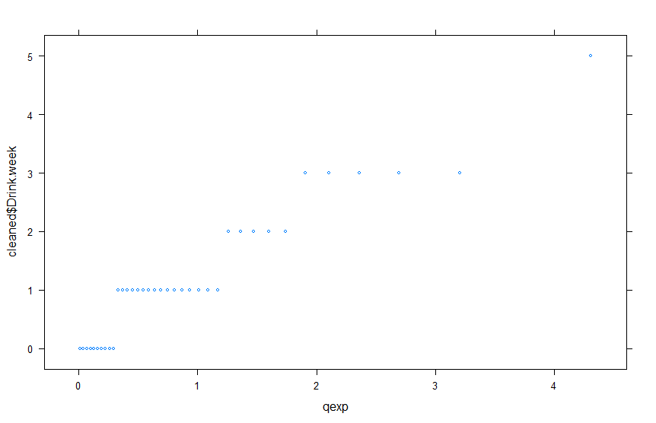

Lect-11-1

cleaned <- read.csv("C:/Users/jaesu/OneDrive/Desktop/School_code/STAT390/hw-1/cleaned.csv")

windows.options(width=10, height=10)

plot(sqrt(cleaned$Drink.week), cleaned$Money.week, main="Drinks per week vs Money per week", pch=19)

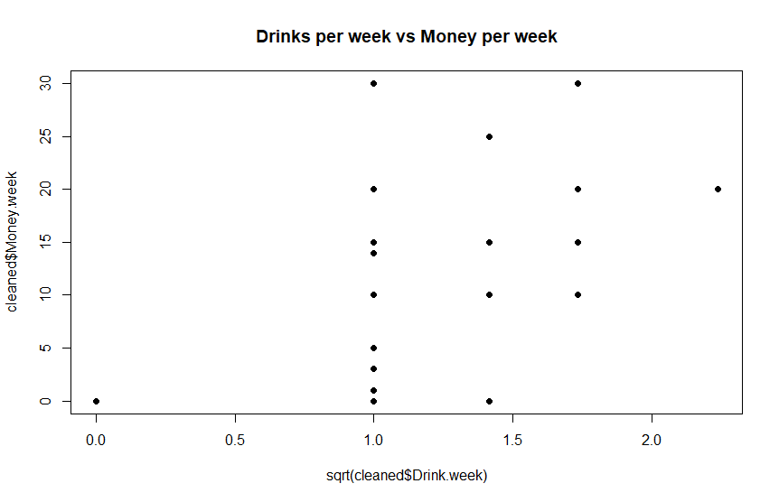

Lect 12-5

MOE <- c(29.8,33.2,33.7,35.3,35.5,36.1,36.2,36.3,37.5,37.7,38.7,38.8,39.6,41.0,42.8,42.8,43.5,45.6,46.0,46.9,48.0,49.3,51.7,62.6,69.8,79.5,80.0)

Str <- c(5.9,7.2,7.3,6.3,8.1,6.8,7.0,7.6,6.8,6.5,7.0,6.3,7.9,9.0,8.2,8.7,7.8,9.7,7.4,7.7,9.7,7.8,7.7,11.6,11.3,11.8,10.7)

plot(MOE,Str)

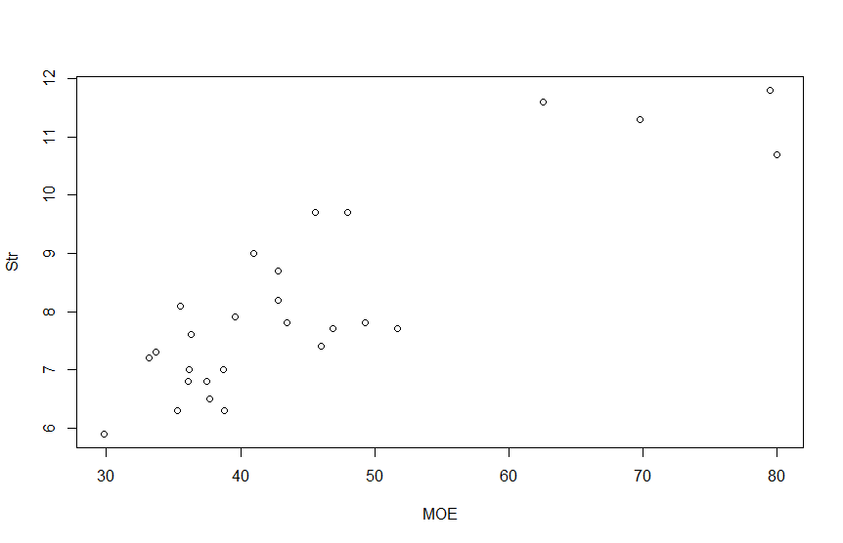

boxplot(MOE)

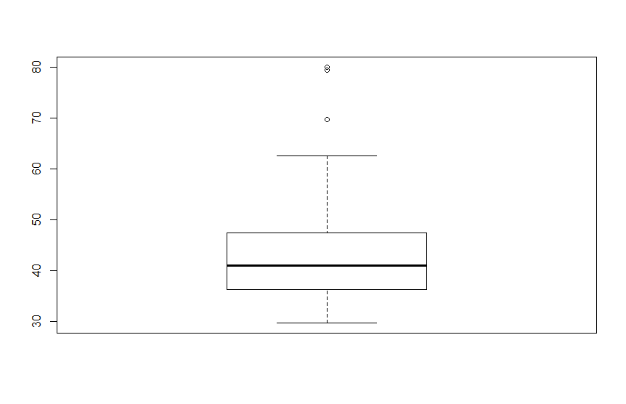

boxplot(Str)



qqnorm(MOE, cex=0.5)

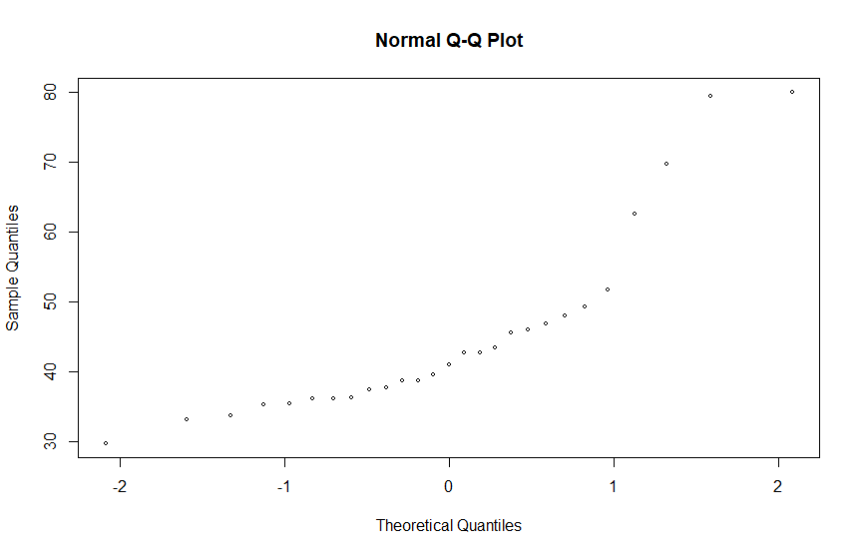

qqnorm(Str, cex=0.5)

