CAD MODEL INVENTORY ManageMENT System

Organizing Large Collections of 3D Geometry Models

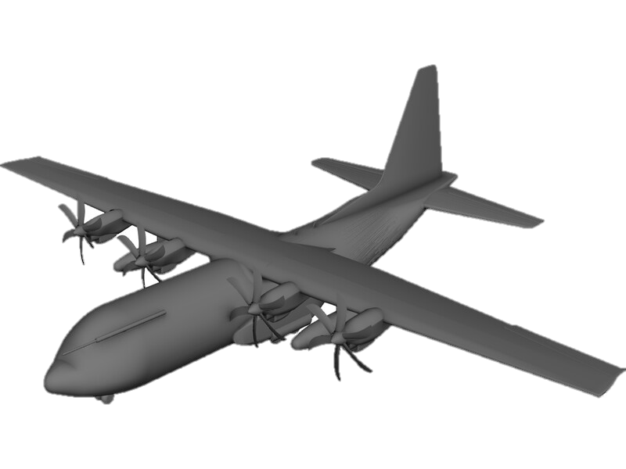

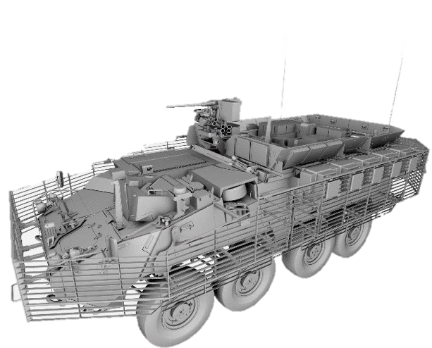





Christopher Sean Morrison

Senior Computer Scientist

TAble of  
Contents

Software Summary 1

CAD Model Inventory Management System 1

Purpose 2

CADventory is a 3D CAD file, categorical tagging, and associated metadata inventory management system. 2

Audience 2

Introduction 3

Software Description 5

CADventory is a 3D CAD file, categorical tagging, and associated metadata inventory management system. 5

Core functionalities and features 5

Stakeholder Analysis 8

Primary Target Audience 8

Secondary Target Audience 9

Tertiary Stakeholders 9

Market Analysis 11

Resiliency to Market Changes 11

Positioning STrategy 12

Technical Specifications 13

Hardware Requirements 13

Software Requirements 13

Development Infrastructure 14

Development Roadmap 15

Minimum Viable Product (MVP) 15

Conclusion 17

References 18

Appendix A: Software Architecture 19

Appendix B: GUI WIREFRAME Concept DESIGNS 20

Appendix C: Architecture assessment 23

Cost-Benefit Matrix 23

Explanation of scoring 24

Development Complexity 24

Performance 24

Cross-Platform Compatibility 24

UI Sophistication 24

Policy Compliance 25

Enterprise Integration 25

Appendix D: House of Quality assessment 26

# Software Summary

## CAD Model Inventory Management System

This software overview details an inventory management system (IMS) for computer-aided design (CAD) 3D geometry models and their associated data files in a U.S. federal government analytic modeling and simulation (M&S) context. In particular, the proposed software development considers the niche challenges and restrictions involved creating and deploying a solution compliant with federal regulations, in adherence with government information technology (IT) policies, easily integrated with available IT infrastructure, and compatible with existing production workflows. The software is also envisioned to address unique data requirements of an existing enterprise 3D model repository with thousands of models, hundreds of principal variants, and tailored to existing analysis environment requirements. The proposed IMS product hereafter will be referred to by the project name “**CADventory**”.

Unlike existing product data management (PDM) systems available commercially for CAD, this proposed IMS is a domain customization intended to require significantly less administrative, financial, and technical overhead. Of paramount importance is usability, user interface (UI) efficiency, and user experience (UX). In order to accelerate acquisition, open source technologies will be leveraged to the greatest extent possible while maintaining high standards for compliance, testing, and software assurance.

## Purpose

### CADventory is a 3D CAD file, categorical tagging, and associated metadata inventory management system.

The primary purpose of CADventory is to directly facilitate the data organization, productivity, collaboration, and file management needs for individuals and teams of 3D modelers. It aims to help manage potentially millions of data files from a variety of sources, in use by multiple users, and at potentially atypical and varied fidelities. It aims to manage myriad file types including various CAD file formats, images, hand measurements, scanned documents, miscellaneous data files, imported/exported/converted geometries, and more.

## Audience

CADventory targets individuals and teams managing existing collections of models, often spanning years or decades of acquisitions. The primary government users of CADventory are 3D modelers supporting vehicle studies and other modeling, simulation, and analysis contexts. Secondary users include respective project managers, team leaders, engineers, and analysts that interface with 3D modeling teams.

As the principal target domain is 3D CAD solid modeling for scientific analyses and government use, the tool will need to incorporate appropriate business logic behaviors specific to government, scientific research, and analysis needs. This means identifying unique application development restrictions and requirements, as well as policy and regulatory mandates.

# Introduction

The U.S. Government has developed 3D geometry models for various analyses purposes for decades (Klopcic and Reed, 1999). Such analysis can include survivability, lethality, vulnerability, signature studies, and more. These models are typically custom-tailored with unique fidelity requirements that are not typically encountered in the CAD industry. This includes stringent elements of solid modeling (Rossignac and Turner, 1994) and a need to analyze entire vehicles in-memory, performantly, and at extreme levels of fidelity. While solid modeling is not unique to government M&S, some source domains (e.g., manufacturing) and most analytic domains (e.g., finite element analyses (FEA)), do not typically involve the same type of preparation work due to specific analysis domain requirements (Deitz, 1984), and an analysis approach centered around the ray tracing technique.

With development beginning in 1979, the varied and complex requirements resulted in the development of BRL-CAD, 3D modeling and rendering software custom-developed to address the niche analysis domain. The enduring implication of such specialization means that existing 3D modelers often must convert geometry models to and from other CAD systems. This adds an additional data management and integration considerations which are discussed below in more detail.

The end result is the existence of several data repositories of 3D CAD models in BRL-CAD and other CAD formats of entire vehicles, vehicle variants, non-vehicle geometries, and associated data files spanning decades. These files are currently and predominantly managed by multiple agencies and companies, entirely ad hoc.

As such, this document details a proposed solution for the ad hoc management of CAD model inventory through the development of a software suite. This software suite aims to be compatible with existing workflows and expectations of users while both organizing and streamlining data management. It's designed to empower existing modeling teams, streamline workflows, and safeguard sensitive information, all while improving production pipeline and data management efficiency. It will be tailored to meet the unique challenges faced by government researchers and CAD modelers.

The proposed government deployment environment for CADventory includes both unclassified and classified use. The technical implications of running in a non-networked, air-gapped, and/or classified environment are taken into consideration in the proposed architecture, application design, and choice of technologies. All proposed business logic and inventory management features are, however, agnostic to said restrictions and will remain applicable to and usable within other (non-government) environments. As such, all aspects of CADventory software design and development are unclassified and embrace a collaborative open source architecture approach for continued development and maintenance.

While comprehensive data management is not believed to be achievable in less than a year development timeframe, the goal is a functioning application that demonstrates efficacy and enables future continued development. It’s envisioned that future support, updates, and customization will follow in concert with the ever-changing landscape of 3D data management needs.

# Software Description

### CADventory is a 3D CAD file, categorical tagging, and associated metadata inventory management system.

CADventory is a 3D geometry inventory management system designed to address the distinct needs of high-level CAD model management, particularly as it pertains to high-performance computing, the organizational needs of an existing library of CAD models, and production analysis environments. CADventory aims to provide an interface for managing those models, tagging them categorically, organizing their associated files, and bringing efficiency to existing workflows.

Due to compliance, infrastructure, and security limitations, the primary system architecture is envisioned as a desktop application that either accesses a locally mounted network file share or other locally accessible filesystem containing existing CAD models and associated files. CADventory aims to facilitate indexing of an existing library of model data files.

## Core functionalities and features

1. Geometry data management:   
     
   CADventory shall provide facilities for organizing CAD data with associated files pertaining to specific (typically vehicle) assets.
2. Existing data integration:   
     
   CADventory shall work with existing hierarchical file repositories where models are groups into folders, with files for related models grouped into subfolders.
3. Metadata management:   
     
   CADventory shall keep track of pertinent CAD model metadata through categorization, tagging, and indexing capabilities.
4. Multiuser access:   
     
   CADventory shall allow multiple users to work simultaneously on the same model repository, accessed over a network file share. As a desktop application, CADventory may rely on existing operating system infrastructure for user authentication, filesystem access control, and logging.
5. Version control:   
     
   CADventory shall maintain a history of data and metadata revisions, ensuring data integrity and facilitating rollback to previous data and/or reconstruction of indices.
6. Visualization:   
     
   CADventory shall provide a visual index of 3D models for ease of navigation, discovery, viewing, and user experience.
7. Scalability:   
     
   CADventory shall be compatible with existing model repositories consisting of millions of files, thousands of folders, and handling large data files efficiently and at scale.
8. Compatibility:   
     
   CADventory shall be compatible with existing infrastructure, tools, and CAD file formats to the extent possible at the filesystem level.
9. Source code:   
     
   CADventory shall be developed in a manner that results in maintainable, performant, and portable source code. CADventory shall be developed using version control.

# Stakeholder Analysis

The primary stakeholders for CADventory are 3D CAD geometry modelers in R&D analysis environments creating, updating, and managing multiple CAD models. The secondary audience are individuals that said CAD modelers interface with regularly including project managers, team leaders, engineers, and analysts. Tertiary stakeholders are those indirectly affected by CADventory development or deployment, individuals that are not consumers or providers of 3D model data.

## Primary Target Audience

Primary users will require a tool that can manage large files including large CAD geometry files but also significant associated data files (e.g., terrain data, point cloud scan data, collections of photography). The tool will need to address the specific workflow needs of those users which typically entails working with models at a vehicle level or scene level (consisting of multiple vehicles or vehicles in situ environments), ***not*** at the assembly or part level as is typical in other CAD modeling domains.

Given the government domain, maintaining accuracy and fidelity are of paramount importance. Also significant are data security requirements, which are to be satisfied by existing IT infrastructure restrictions and policies which place intrinsic technical limitations on application architecture and behavior. For example, it is extremely complicated from a policy perspective to set up web server infrastructure, so the proposed application architecture for users involves working with existing network file system infrastructure.

## Secondary Target Audience

Secondary user interests and requirements center more around oversight and workflow integration. Engineers and analysts in particular will be concerned with the integration of CAD models with other (non-CAD / analysis) tools from primarily a consumer perspective, receiving access to both preliminary and finished 3D models from primary users.

Secondary users have an even greater need for introspective and indexing capabilities, facilitating their ability to find and aggregate indices of available 3D models. This greatly affects their ability to coordinate among different teams and analysis product consumers.

Other secondary stakeholders include project managers and team leaders whose principle responsibility is being apprised of current/recent modeler activity, resource allocations, and overall status of ongoing modeling efforts.

## Tertiary Stakeholders

Given the professional and government development environment, other noteworthy stakeholders including IT support staff that will be concerned with IT infrastructure implications, to include but not limited to filesystem utilization, taxing of server CPU resources, and any added maintenance implications.

Similarly, adherence to federal regulations are intrinsically requisite given the U.S. federal application domain. This includes adherence to the following standards, regulations, and policies:

1. NIST SP 800-37 Rev 2, Risk Management Framework for Information Systems and Organizations: A System Life Cycle Approach for Security and Privacy.
2. NIST SP 800-53, Security and Privacy Controls for Information Systems and Organizations.
3. DoDI 8310.01, Information Technology Standards in the DoD.
4. DoDI 8500.01, Cybersecurity.
5. DoDI 8510.01, Risk Management Framework (RMF) for DoD Systems.
6. Army Regulation AR 25-2, Army Cybersecurity (formerly Army Information Assurance).
7. DISA Application Security and Development Security Technical Implementation Guide (STIG), v5.

# Market Analysis

Across the U.S. federal government are a wide variety of CAD systems and PDM systems in use for myriad purpose. The defense industry and analysis R&D domain in particular is characterized by a demand for typically very high fidelity, security, and distribution of modeling tasks across a team of expert modelers. The features and capabilities of existing PDM systems are highly part-centric and assembly-centric, often focused around massive industry domains such as manufacturing or product design. They cater predominantly to general CAD functionalities.

Moreover, PDM systems are typically highly specialized and integrated with particular commercial CAD products and/or vendors with detrimental compatibility or feature implications. PDM systems also typically entail significant licensing costs, license management, IT infrastructure implications, and significant technical expertise requirements to set up and maintain them. As PDM systems are typically major enterprise investments, this also implies an inherent risk to the organization, beholden to the longevity and licensing of the PDM supplier.

## Resiliency to Market Changes

The government M&S analysis domain has been around for more than 50 years, surviving many dominant CAD and PDM systems that ultimately failed or were overcome by a competitor. Over decades, there have been numerous CAD industry leaders bought out or killed by competition or other market forces. As such, it’s in the U.S. Government’s long-term interest from a risk-management perspective to remain agnostic and resilient to changes in market dominance. Development of CADventory satisfies a need for independence by providing a solution that can be continuously developed, maintained, and customized as needed. This of course comes with costs, but this cost has been demonstrably proved beneficial by the 40+ year old development of BRL-CAD, an open source solid modeling system customized for government needs in order to remain resilient to industry changes. CADventory, with its specialized focus on 3D geometry management and integration in adherence with government standards, will continue to fill a unique niche in a similar manner.

## Positioning STrategy

CADventory’s unique selling proposition (USP) lies in its ability manage large collections of 3D models at a high filesystem level, with a user-friendly interface that integrates well for managing existing CAD model repository data, and all while adhering to stringent IT infrastructure restrictions. With the primary target audience being current professionals working in a M&S context, the needs of an audience with niche requirements will be met better than existing commercial solutions that target broader industry needs.

# Technical Specifications

## Hardware Requirements

The software shall work on modern (as of 2024) personal computing hardware such as a typical desktop or laptop computer released within the past 2 years.

The software shall not require specific compute hardware such as specific GPUs or CPU types (e.g., RISC/CISC, ARM/M1/M2, etc).

The software shall work on systems with at least 8GB of memory available. The software will work optimally on systems with 64GB or more of available memory.

The software may assume adequately available system memory and filesystem storage for any intermediate processing needs.

The software shall work across a local network. Network file locking is not necessarily available or reliable. Software performance may be subject to network performance implications accordingly.

## Software Requirements

See Stakeholder Analysis above for a list of regulatory requirements and technical specifications.

The software shall work cross-platform, minimally running on **Mac OS 13.6+**, **Linux**, or **Windows 11+** for prototyping, testing, and demonstration purposes.

The software must be implemented using a technology stack compatible with existing in use and/or compatible with current IT policy without involving special permission or exemption requests. As such, the software may utilize **Java w/ Swing, Java w/ NetBeans Platform, or C++ w/ Qt**.

The software may utilize hidden (dot) folders, text files, and/or SQLite database files for per-model metadata storage.

The software shall recognize and support indexing of a variety of CAD file formats, minimally including **BRL-CAD**, Creo, NX, CATIA, Rhino3D, and SpaceClaim.

The software shall recognize the availability of related CAD data including images (photography), documents (minimally txt, pdf, and docx), and other data files identified as critical types.

The software shall utilize checksums and/or digital signatures to ensure data integrity and detect change.

The software may be reviewed for STIG category I compliance, but will only need to document any outstanding issues identified.

## Development Infrastructure

The project may use **GitHub/GitLab** for revision control, development logging, and continuous integration (CI) testing.

The project shall demonstrate CI testing for at least one platform.

The project shall incorporate some code coverage testing.

The project shall incorporate some code quality testing.

The project shall set up backups of all project data.

# Development Roadmap

CADventory development is described by three principle phases. The first phase, conceptualization, covers project setup, design, and initial architecture scaffolding. The second phase, coding, entails spiral sprints working towards MVP. The remaining third phase, testing, centers around refinement and compliance auditing.

## Minimum Viable Product (MVP)

The user-accessible features of the software are described in more detail in the Software Description section prior. MVP installation deployment demonstration may be limited to a single operating system platform, either Windows, Mac OS, or Linux.

The minimum features necessary for MVP include the ability to:

1. manage CAD inventory (create/add, read, update, and delete),
2. populate the inventory using GUI or automation,
3. generate an inventory report for models matching user-specified criteria (e.g., land vehicles tagged as “wheeled”).

Primary trackable inventory items relevant for this M&S analysis market domain and MVP development include the following configuration items:

1. Model short name (e.g., ICV)
2. Model long name (e.g., M1126 Infantry Carrier Vehicle)
3. Model alias(es) (e.g., Stryker)
4. Model “type” (e.g., wheeled)
5. Organizational owner (e.g., U.S. Army)
6. Model Source (e.g., National Ground Intelligence Center)
7. Filesystem location (e.g., /h/tlib/Strkyer/ICV)
8. Model creation date
9. Last modification date
10. Modeler(s)
11. File owner(s)
12. Model suitability (e.g., VL-analysis ready)
13. Classification (e.g., Unclassified)
14. Conversions (e.g., STL, 3DM, STEP)
15. Exists Photography (e.g., yes/no)
16. Exists Drawings (e.g., yes/no)
17. Exists Measurements (e.g., yes/no)
18. Listing of unaccounted files
19. Listing of accounted files
20. 1-page summary sheet generation per model

Without the ability to revert changes, CADventory is not to modify any existing CAD library file(s), only index and track files in-situ with model-associated metadata stored accordingly alongside CAD models (e.g., in hidden folders or SQLite).

**Auditing & Backups**

All accesses by CADventory users must be tracked in a way that allows auditing of system usage and any indexing or metadata changes. Information will minimally include username, timestamp, and type of access.

CADventory should provide administrative functions for backing up cached inventory information and checking the integrity of existing inventory data.

# Conclusion

In summary, this software overview proposes the development of a novel CAD model inventory management system that will allow for the indexing and summary reporting of existing collections of 3D geometry models. It provides a desktop interface that will be usable by a team of 3D modelers to help index, organize, and manage models previously and actively being developed. The proposed CADventory desktop application allows for tagging and recording of CAD models and CAD model metadata via a technical approach consistent with government computing environment requirements and regulatory restrictions. This interface will provide near-term immediate benefit to existing stakeholders in a niche production analysis environment.

A detailed accounting of core features and functions are provided with consideration of stakeholder impact, market impact, strategic investment, and technical restrictions. A multi-phased development roadmap details primary features along the critical path and a plan for addressing software development.

# References

* *Klopcic, J. and Reed, H. (1999).* Historical Perspectives on Vulnerability/Lethality Analysis*. AD-a361 816. Army Research Laboratory. Aberdeen Proving Ground, MD.*
* *Rossignac, L., and Turner, J., "*Solid modeling*," in IEEE Computer Graphics and Applications, vol. 14, no. 2, pp. 13-, March 1994, doi: 10.1109/38.267466.*
* *Deitz, P.H. (1984).* Solid Modeling at the US Army Ballistic Research Laboratory*. ADA147491. U.S. Army Ballistic Research Laboratory, Aberdeen Proving Ground, MD.*

# Appendix A: Software Architecture

Here is a general simplified depiction of the application software architecture, focusing on key components and their primary associations. The UI presents information from the filesystem for a selected model library, stores and tracks per-library information via a storage manager, and generates library summary reports. Report generation and file handling are built on top of existing libraries provided for accessing geometry data and metadata as well as related images, documents, conversions, and other files directly associated with a given model.

**┌──────────────────────────────────────────────────────────────────────┐**

**│ CADventory │**

**│ │**

**│ ┌──────────────────────────────────────────────────────────────┐ │**

**│ │ User Interface (Qt) │ │**

**│ └─────────────┬───────────────────────┬─────────────────┬──────┘ │**

**│ │ │ │ │**

**│ ┌─────────────▼───────────┐ ┌────────▼─────────┐ ┌────▼──────┐ │**

**│ │ Filesystem Processor │ │ SQLite or JSON │◄─│ Report │ │**

**│ └─────────────┬───────────┘ │ Storage Manager │ │ Generator │ │**

**│ │ └──────────────────┘ └────┬──────┘ │**

**│ │ │ │**

**│ ┌─────────────▼───────────┐ │ │**

**│ │ Geometry/Image/Document │ │ │**

**│ │ Handler │ │ │**

**│ └─────────────┬───────────┘ │ │**

**│ │ │ │**

**│ ┌─────────────▼────────┐ │ │**

**│ │ CAD Libraries │◄───────────────────────────────┘ │**

**│ └──────────────────────┘ │**

**└──────────────────────────────────────────────────────────────────────┘**

# Appendix B: GUI WIREFRAME Concept DESIGNS

**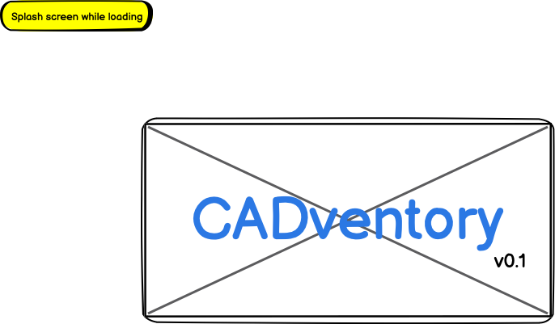  
  
  
  
  
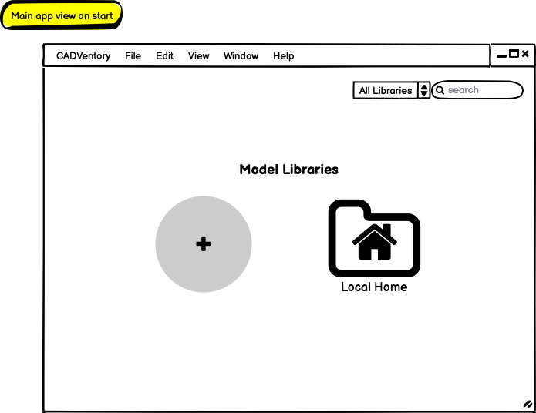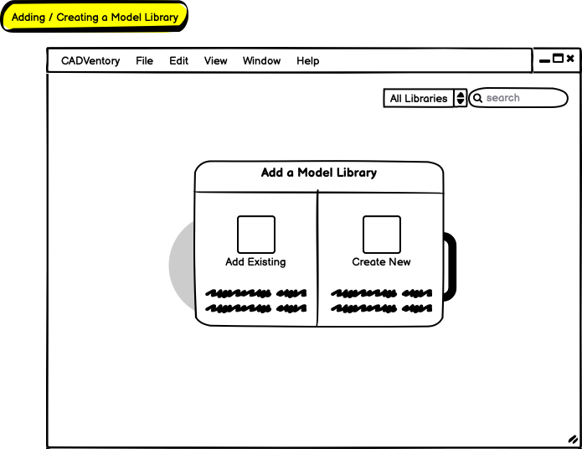  
  
  
  
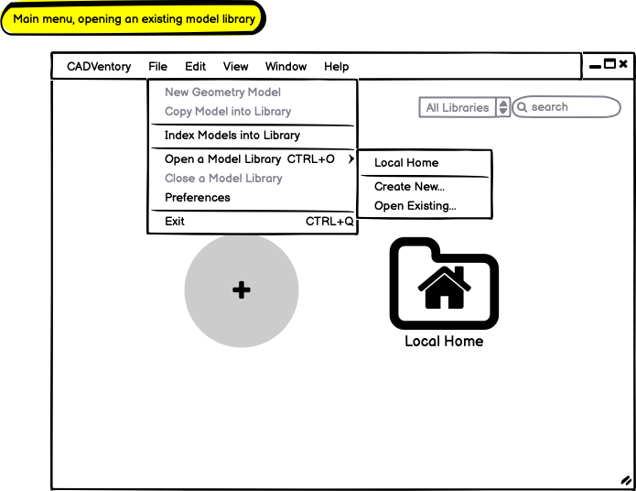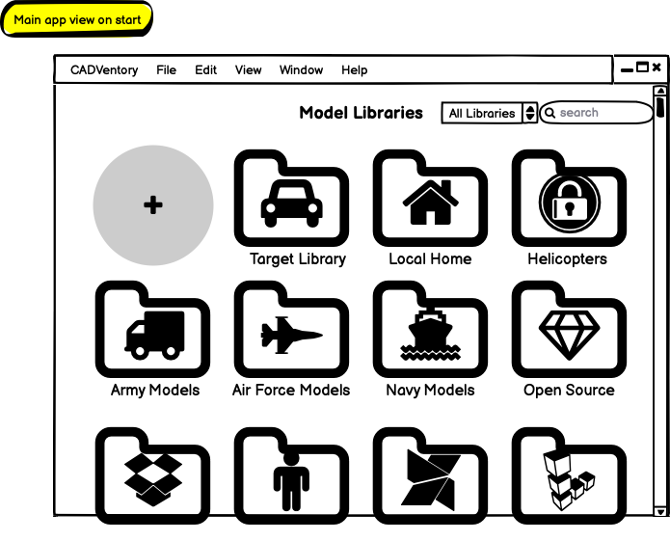  
  
  
  
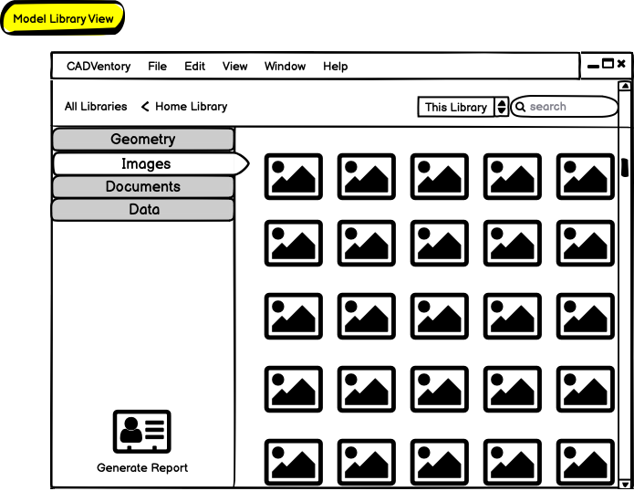**

# Appendix C: Architecture assessment

Here we evaluate primary tradeoff considerations between selecting Java with Swing, Java with NetBeans Platform, and C++ with Qt as the technical architecture for CADventory. To compare the technology stacks, we evaluate considerations such as development complexity, performance, cross-platform compatibility, UI sophistication, policy compliance, and enterprise integration. We use a 1 to 5 scale where 1 indicates lowest cost-benefit and 5 indicates highest.

## Cost-Benefit Matrix

|  |  |  |  |
| --- | --- | --- | --- |
| Consideration | Java w/ Swing | Java w/ NP | C++ w/ Qt |
| Development Complexity | 3 | 2 | 3 |
| Performance | 4 | 4 | 5 |
| Cross-Platform Compatibility | 5 | 5 | 4 |
| UI Sophistication | 3 | 4 | 5 |
| Policy Compliance | 4 | 4 | 5 |
| Enterprise Integration | 3 | 4 | 5 |
| **Total Scoring** | **22** | **23** | **27** |
| **Favorability** | **73.3%** | **76.7%** | **90%** |

## Explanation of scoring

### Development Complexity

The overall ease of development and learning curve is very similar for all three options with Netbeans Platform being (relatively) the most complex due to a far greater lack of supporting resources (e.g., tutorials, guides, articles, example code, etc).

### Performance

All three options are capable of highly-performance architecture design and are scalable to requirements, but the lower-level large file management and efficient filesystem traversal capabilities of C++ give it a particular advantage for working with a large existing library of CAD files and associated data files. Java applications can be less performant (at least without necessitating additional infrastructure) compared to native applications, particularly during high-memory utilization and application startup.

### Cross-Platform Compatibility

While Qt is a cross-platform API, Java-based solutions are intrinsically cross-platform giving them a clear advantage for portability.

### UI Sophistication

Netbeans Platform, while not as modern in presentation, provides many modern and advanced features such as automatic file browsing, logging, filetype associations, document handling, runtime management, extension development, customizability, and more that would otherwise require additional effort as compared with Qt or Swing. Qt is an API framework specifically for creating sophisticated modern GUIs.

### Policy Compliance

All three options can be made compliant with aforementioned IT policy and infrastructure restrictions. Java-based solutions, however, do have additional Security Technical Implementation Guideline (STIG) requirements specific to operation in a government environment as compared with a C++ Qt-based application. This gives C++ with Qt a lesser compliance and ongoing maintenance cost.

### Enterprise Integration

The stakeholders’ R&D enterprise environment, particularly as tailored to existing M&S application development and analysis capabilities results in a favoring towards C++ with Qt, followed closely by Java with Netbeans Platform, as both are in production use by flagship products and targeted stakeholders.

# Appendix D: House of Quality assessment

