데이터베이스기초 과제 1

32193430 산업공학과 이재원

문제 해결 여부

|  |  |
| --- | --- |
| Mysql을 이용한 학사 DB 생성(auto_increment 사용) | O |
| Python 3를 이용한 학사 DB 생성 | O |
| 보충문제 | O |

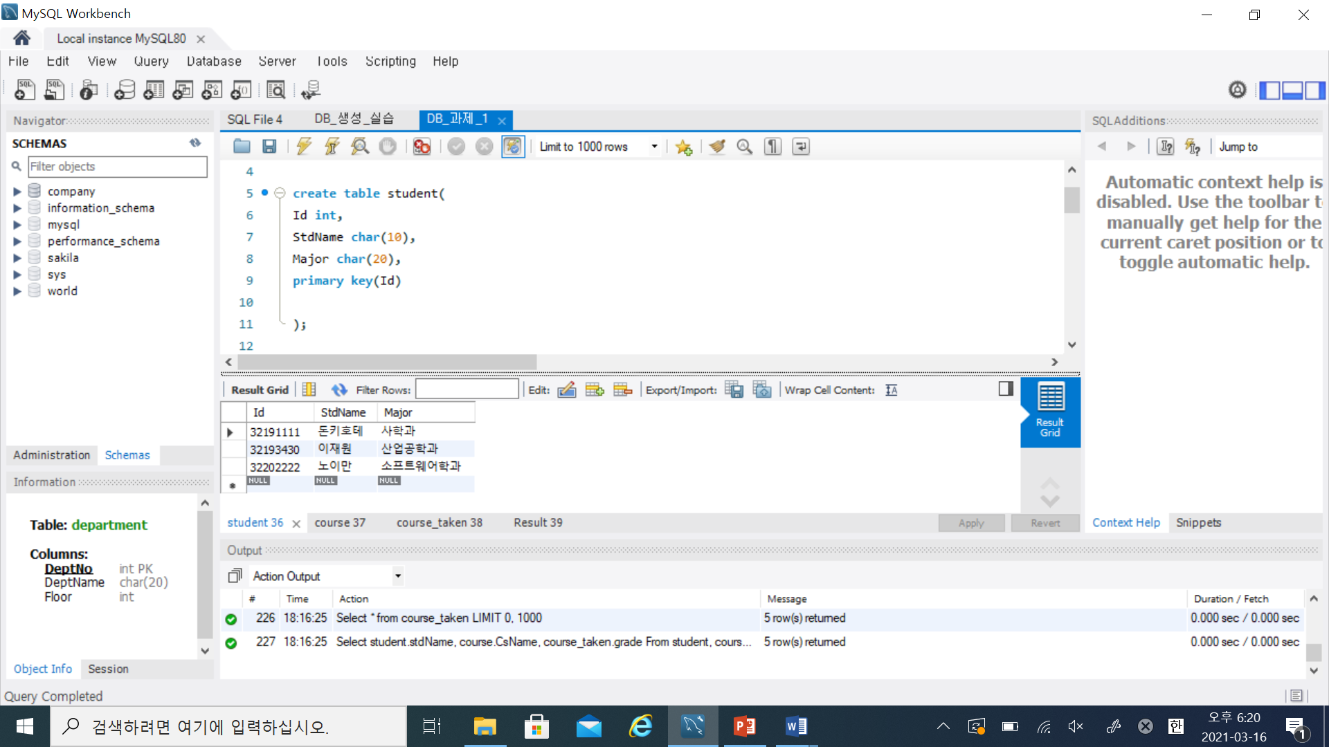문제 1. Mysql을 이용한 학사 DB 생성

Student Table

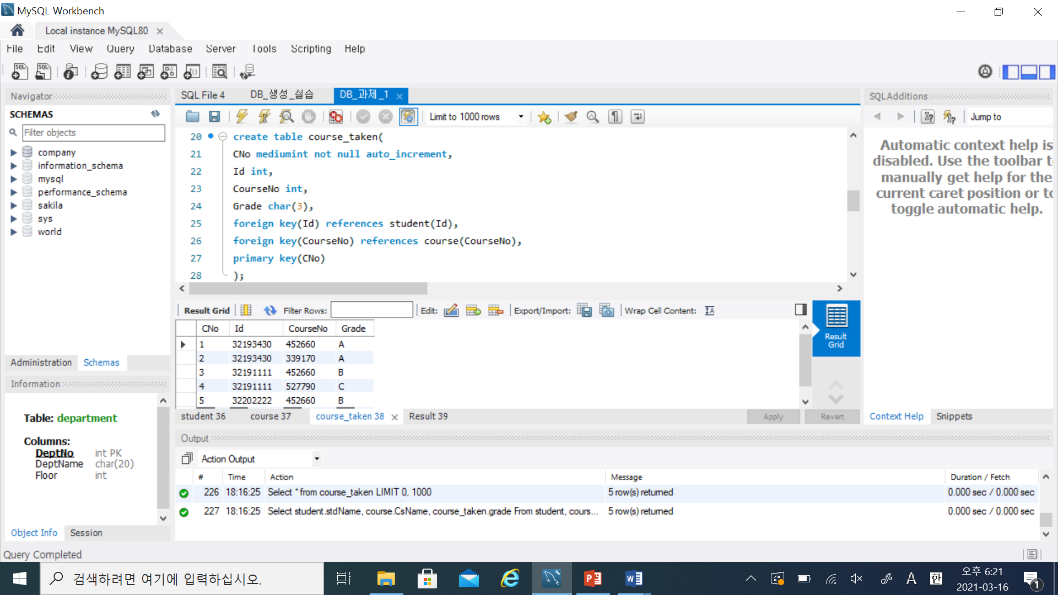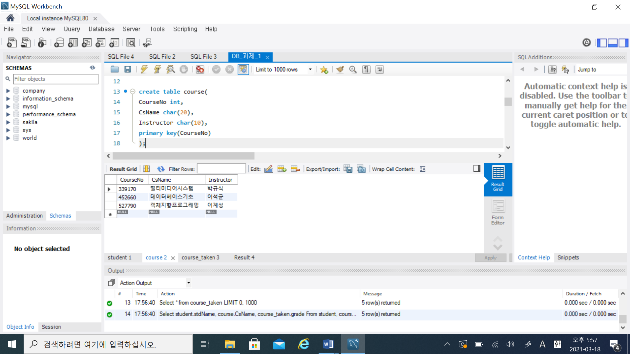Course Table

Course_taken Table

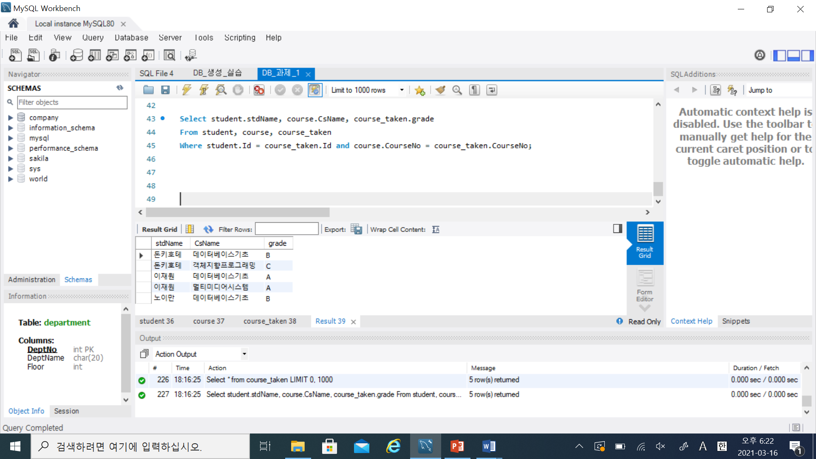

## Mysql Code

drop database if exists BachelorDB;

create database BachelorDB;

use BachelorDB;

create table student(

Id int,

StdName char(10),

Major char(20),

primary key(Id)

);

create table course(

CourseNo int,

CsName char(20),

Instructor char(10),

primary key(CourseNo)

);

create table course_taken(

**CNo mediumint not null auto_increment,** ##일련번호 자동 생성

Id int,

CourseNo int,

Grade char(3),

foreign key(Id) references student(Id),

foreign key(CourseNo) references course(CourseNo),

primary key(CNo)

);

insert into Student

values (32193430, '이재원', '산업공학과'), (32191111, '돈키호테', '사학과'), (32202222, '노이만', '소프트웨어학과');

insert into Course

values (452660, '데이터베이스기초', '이석균'), (339170, '멀티미디어시스템', '박규식'), (527790, '객체지향프로그래밍', '이계성');

insert into Course_taken (Id, CourseNo, Grade)

values (32193430, 452660, 'A'), (32193430, 339170, 'A'), (32191111, 452660,'B'), (32191111, 527790, 'C'), (32202222, 452660, 'B');

Select * from student;

Select * from course;

Select * from course_taken;

Select student.stdName, course.CsName, course_taken.grade

From student, course, course_taken

Where student.Id = course_taken.Id and course.CourseNo = course_taken.CourseNo;

문제 2. Python 3를 이용한 학사 DB 생성

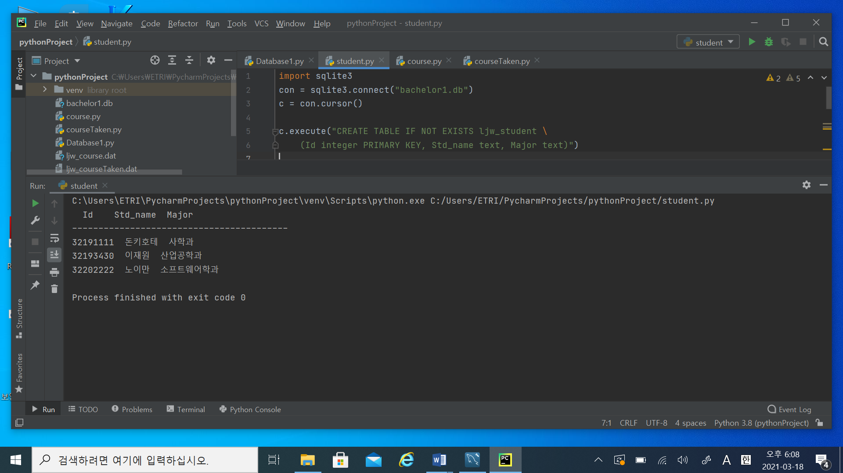

Student Table

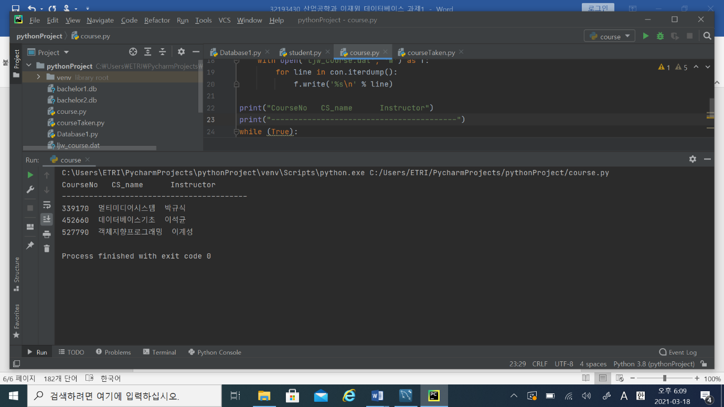Course Table

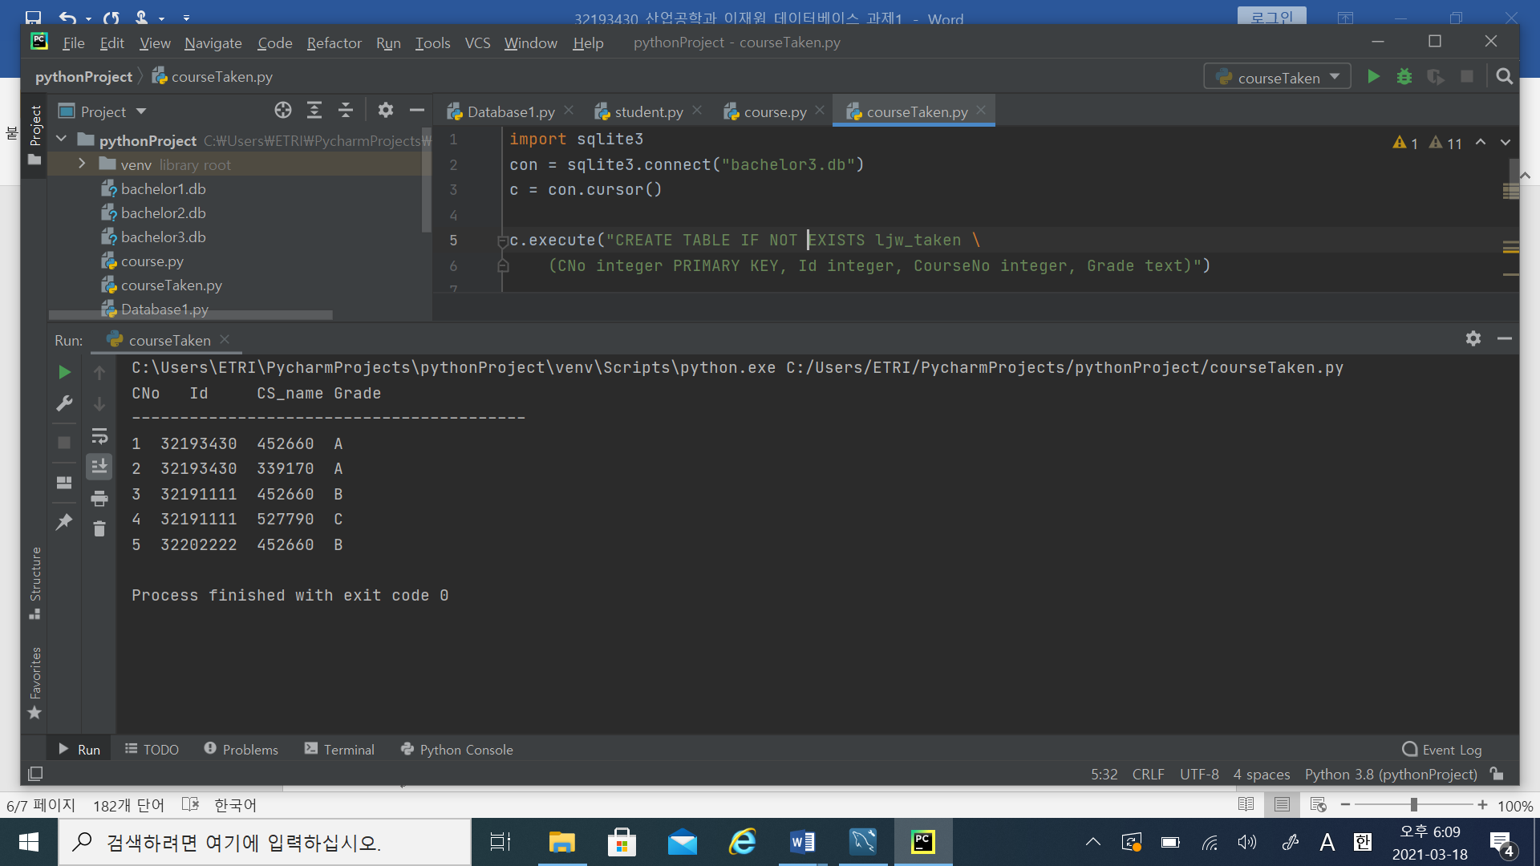

CourseTaken Table

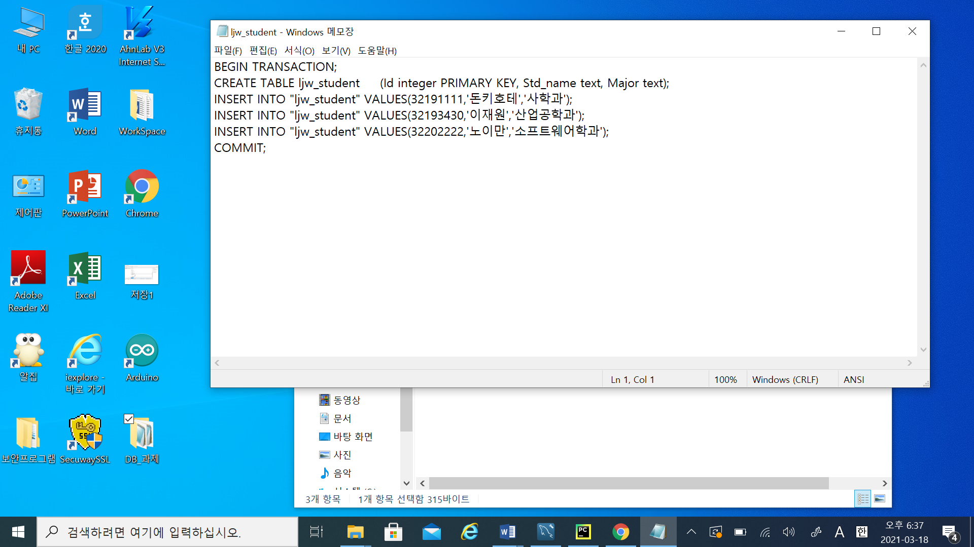

ljw_student.dat

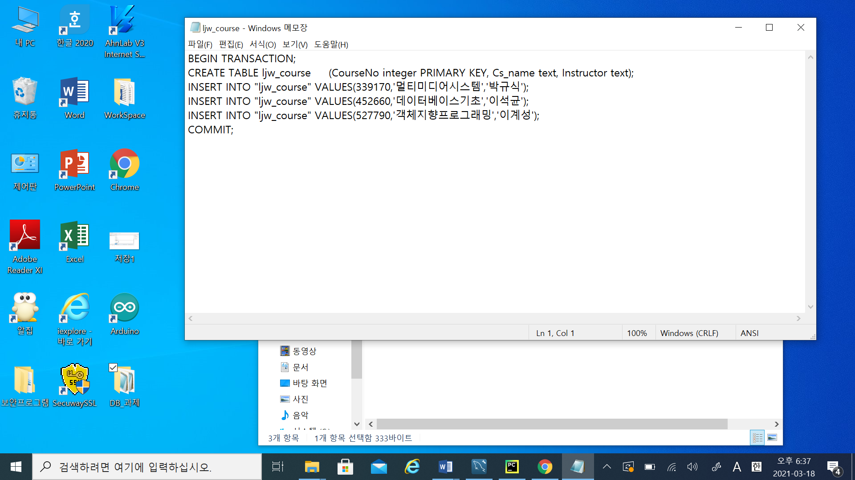

ljw_course.dat

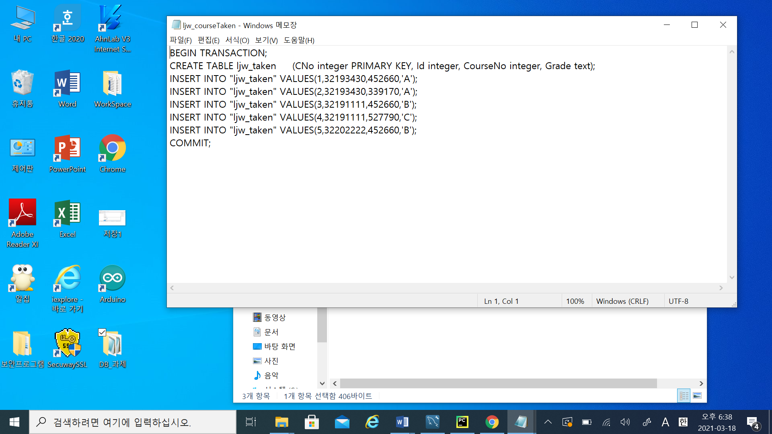

ljw_courseTaken.dat

## Python 3 Code

Student Table

import sqlite3  
con = sqlite3.connect("bachelor1.db") ## 학사DB 생성  
c = con.cursor()  
  
c.execute("CREATE TABLE IF NOT EXISTS ljw_student \  
 (Id integer PRIMARY KEY, Std_name text, Major text)") ## table 생성  
  
  
tuple1 = (  
 (32193430, '이재원', '산업공학과'), ## 데이터 삽입  
 (32191111, '돈키호테', '사학과'),  
 (32202222, '노이만', '소프트웨어학과')  
)  
  
c.executemany("INSERT INTO ljw_student(Id, Std_name, Major) VALUES(?,?,?)", tuple1)  
  
c.execute("SELECT * FROM ljw_student")  
  
print(" Id Std_name Major")  
print("-----------------------------------------")  
while (True): ##반복문과 print를 이용한 table 출력  
 row = c.fetchone()  
 if row == None:  
 break;  
 data1 = row[0]  
 data2 = row[1]  
 data3 = row[2]  
 print("%8d %3s %3s" % (data1, data2, data3))

import pandas as pd ##pandas를 이용할 수도 있다.  
rows = c.fetchall()  
cols = [column[0] for column in c.description]  
data_df = pd.DataFrame.from_records(data=rows, columns=cols)  
print(data_df)

with con: ## Binary File로 table 저장  
 with open('ljw_student.dat', 'w') as f:  
 for line in con.iterdump():  
 f.write('%s\n' % line)  
  
c.close

Course Table

import sqlite3  
con = sqlite3.connect("bachelor2.db")  
c = con.cursor()  
  
c.execute("CREATE TABLE IF NOT EXISTS ljw_course \  
 (CourseNo integer PRIMARY KEY, Cs_name text, Instructor text)")  
  
tuple2 = (  
 (452660, '데이터베이스기초', '이석균'),  
 (339170, '멀티미디어시스템', '박규식'),  
 (527790, '객체지향프로그래밍', '이계성')  
)  
  
c.executemany("INSERT INTO ljw_course(CourseNo, CS_name, Instructor) VALUES(?,?,?)", tuple2)  
  
c.execute("SELECT * FROM ljw_course")  
with con:  
 with open('ljw_course.dat', 'w') as f:  
 for line in con.iterdump():  
 f.write('%s\n' % line)  
  
print("CourseNo CS_name Instructor")  
print("-----------------------------------------")  
while (True):  
 row = c.fetchone()  
 if row == None:  
 break;  
 data1 = row[0]  
 data2 = row[1]  
 data3 = row[2]  
 print("%5d %3s %3s" % (data1, data2, data3))  
  
c.close()

Course_Taken Table

import sqlite3  
con = sqlite3.connect("bachelor3.db")  
c = con.cursor()  
  
c.execute("CREATE TABLE IF NOT EXISTS ljw_taken \  
 (CNo integer PRIMARY KEY, Id integer, CourseNo integer, Grade text)")  
  
tuple3 = (  
(1, 32193430, 452660, 'A'),  
(2, 32193430, 339170, 'A'),  
(3, 32191111, 452660,'B'),  
(4, 32191111, 527790, 'C'),  
(5, 32202222, 452660, 'B')  
)  
  
c.executemany("INSERT INTO ljw_taken(CNo, Id, CourseNo, Grade) VALUES(?,?,?,?)", tuple3)  
  
c.execute("SELECT * FROM ljw_taken")  
  
with con:  
 with open('ljw_courseTaken.dat', 'w') as f:  
 for line in con.iterdump():  
 f.write('%s\n' % line)  
  
print("CNo Id CS_name Grade")  
print("-----------------------------------------")  
while (True):  
 row = c.fetchone()  
 if row == None:  
 break;  
 data1 = row[0]  
 data2 = row[1]  
 data3 = row[2]  
 data4 = row[3]  
 print("%1d %8d %6d %1s" % (data1, data2, data3, data4))  
  
c.close()

문제 3. 보충문제

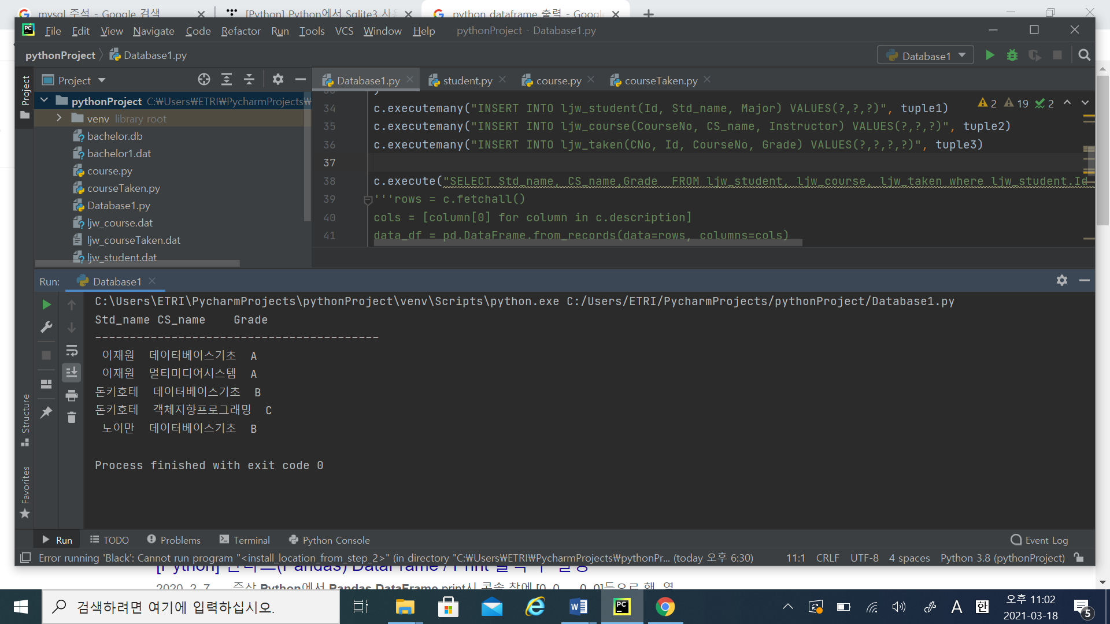

아래와 같은 코드를 추가하여 위의 출력결과가 나왔다.

## Python 3 Code

c.execute("SELECT Std_name, CS_name,Grade FROM ljw_student, ljw_course, ljw_taken where ljw_student.Id = ljw_taken.Id and ljw_taken.CourseNo = ljw_course.CourseNo ")