My Clusters

Contributors: Samuel Hibbard and John Decker

1. Hierarchical Clustering

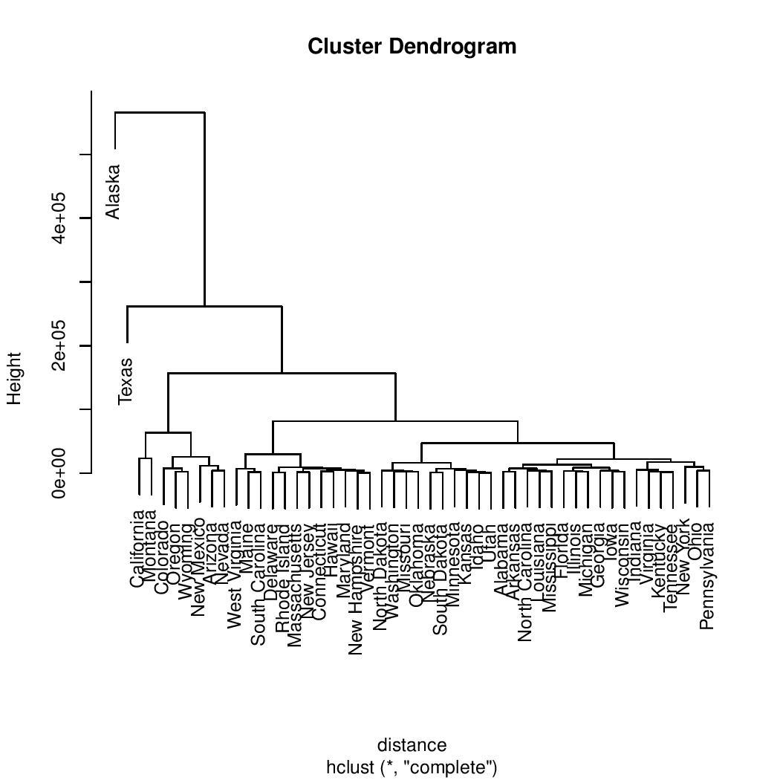

1. Normalized Data

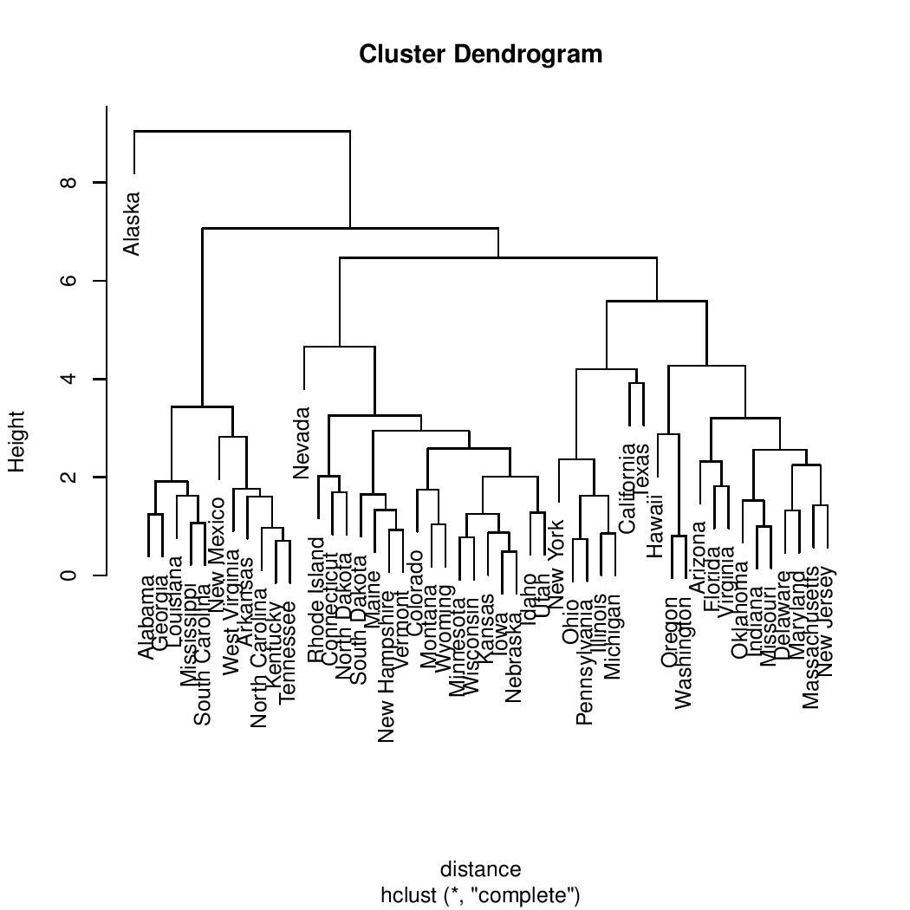

1. Removed Area

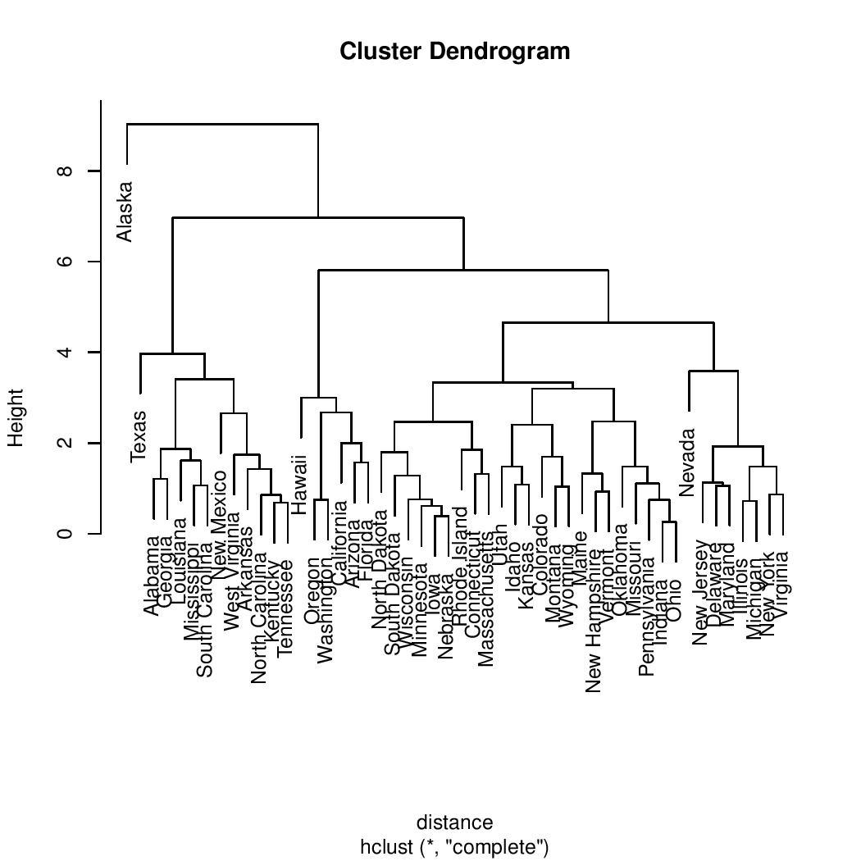

1. Only Frost

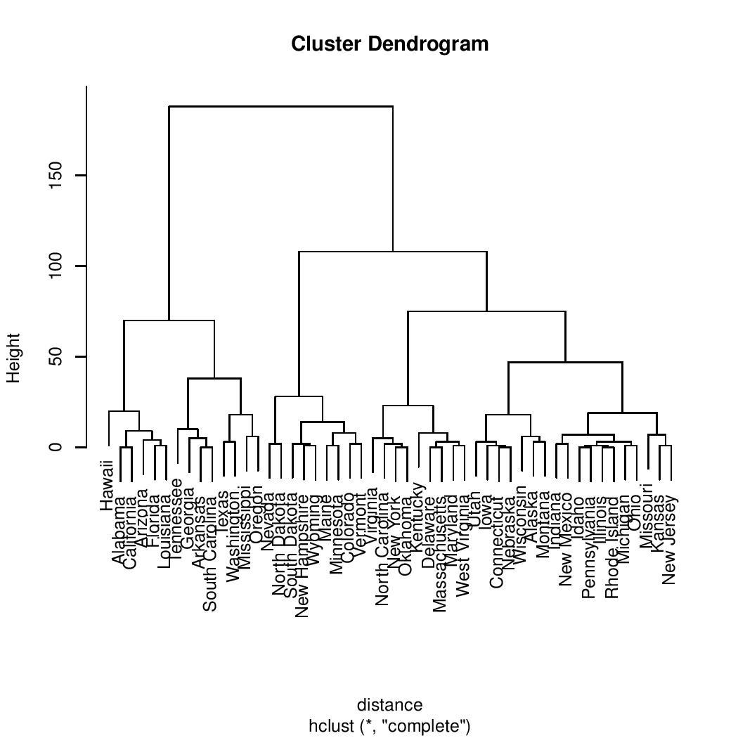

1. Clustered Only into 3

---------MEAN------------

Population Income Illiteracy Life Exp Murder HS Grad

1 -0.4873370 0.1329601 -0.641201154 0.7422562 -0.8552439 0.5515044

2 0.9462026 0.7416690 0.005468667 -0.3242467 0.5676042 0.1558335

3 -0.2269956 -1.3014617 1.391527063 -1.1773136 1.0919809 -1.4157826

Frost Area

1 0.4528591 -0.1729366

2 -0.1960979 0.4483198

3 -0.7206500 -0.2340290

---------ASSIGNEMNTS--------

Alabama Alaska Arizona Arkansas California

3 2 2 3 2

Colorado Connecticut Delaware Florida Georgia

1 1 1 2 3

Hawaii Idaho Illinois Indiana Iowa

1 1 2 1 1

Kansas Kentucky Louisiana Maine Maryland

1 3 3 1 2

Massachusetts Michigan Minnesota Mississippi Missouri

1 2 1 3 2

Montana Nebraska Nevada New Hampshire New Jersey

1 1 2 1 2

New Mexico New York North Carolina North Dakota Ohio

3 2 3 1 2

Oklahoma Oregon Pennsylvania Rhode Island South Carolina

1 1 2 1 3

South Dakota Tennessee Texas Utah Vermont

1 3 2 1 1

Virginia Washington West Virginia Wisconsin Wyoming

2 1 3 1 1

---------SUM OF SQUARES--------

67.72742 111.66951 23.62227 203.0192

1. Plotted 1 through 25 And Elbow method

Around 5 is where I thought where it started to change with the clusters.

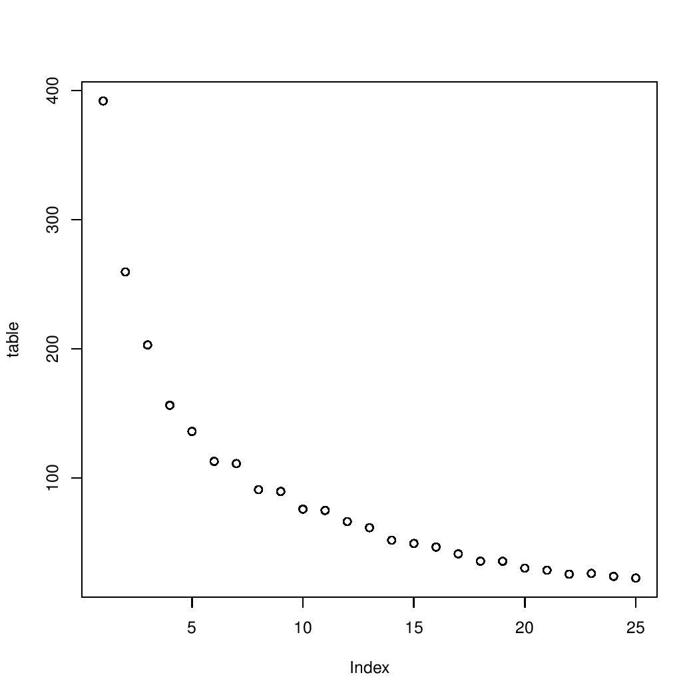

1. 2D representation for a cluster of 5

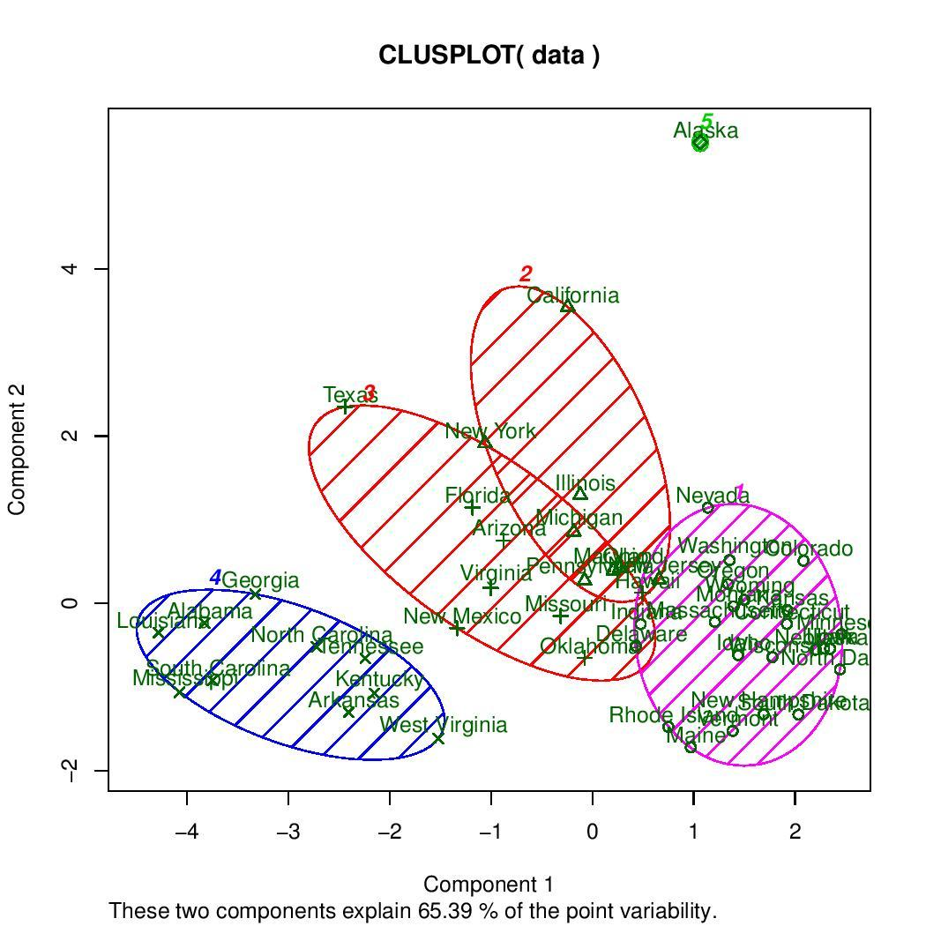

Both Sam and I worked through the problems together and evaluated every step of the assignment. Due this I feel that I deserve a D due to the amount of effort placed into this assignment.