The results presented in this study, together with a growing body of literature, support the conclusion that dynamic sparse training (DST) can simultaneously achieve scientific competitiveness and operational efficiency at scale.
1. Scientific Competitiveness
Traditionally, dense neural networks have been considered the standard for maximizing accuracy. However, recent research increasingly challenges this assumption. Dynamic sparse training methods maintain a train–remove–regrowth mechanism, enabling models to continuously adapt their connectivity and explore a larger effective parameter space during optimization. This dynamic exploration (referred to as in-time overparameterization) allows sparse models to generalize as well as or even better than dense counterparts, despite using far fewer active parameters.
Model | Method | Energy (Wh) | Train Acc. (%) | Eval Acc. (%)
ResNet | Dense | 54.19 | 91.92 | 87.22
 | DST | 48.29 | 93.96 | 90.16
ViT | Dense | 129.50 | 49.16 | 49.08
 | DST | 116.85 | 65.04 | 63.32
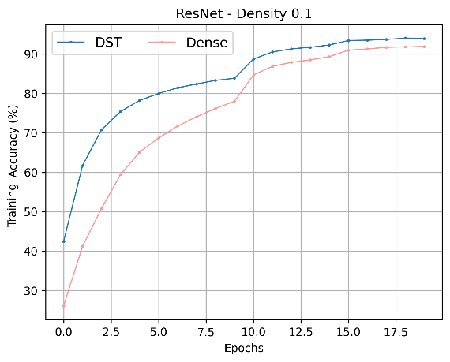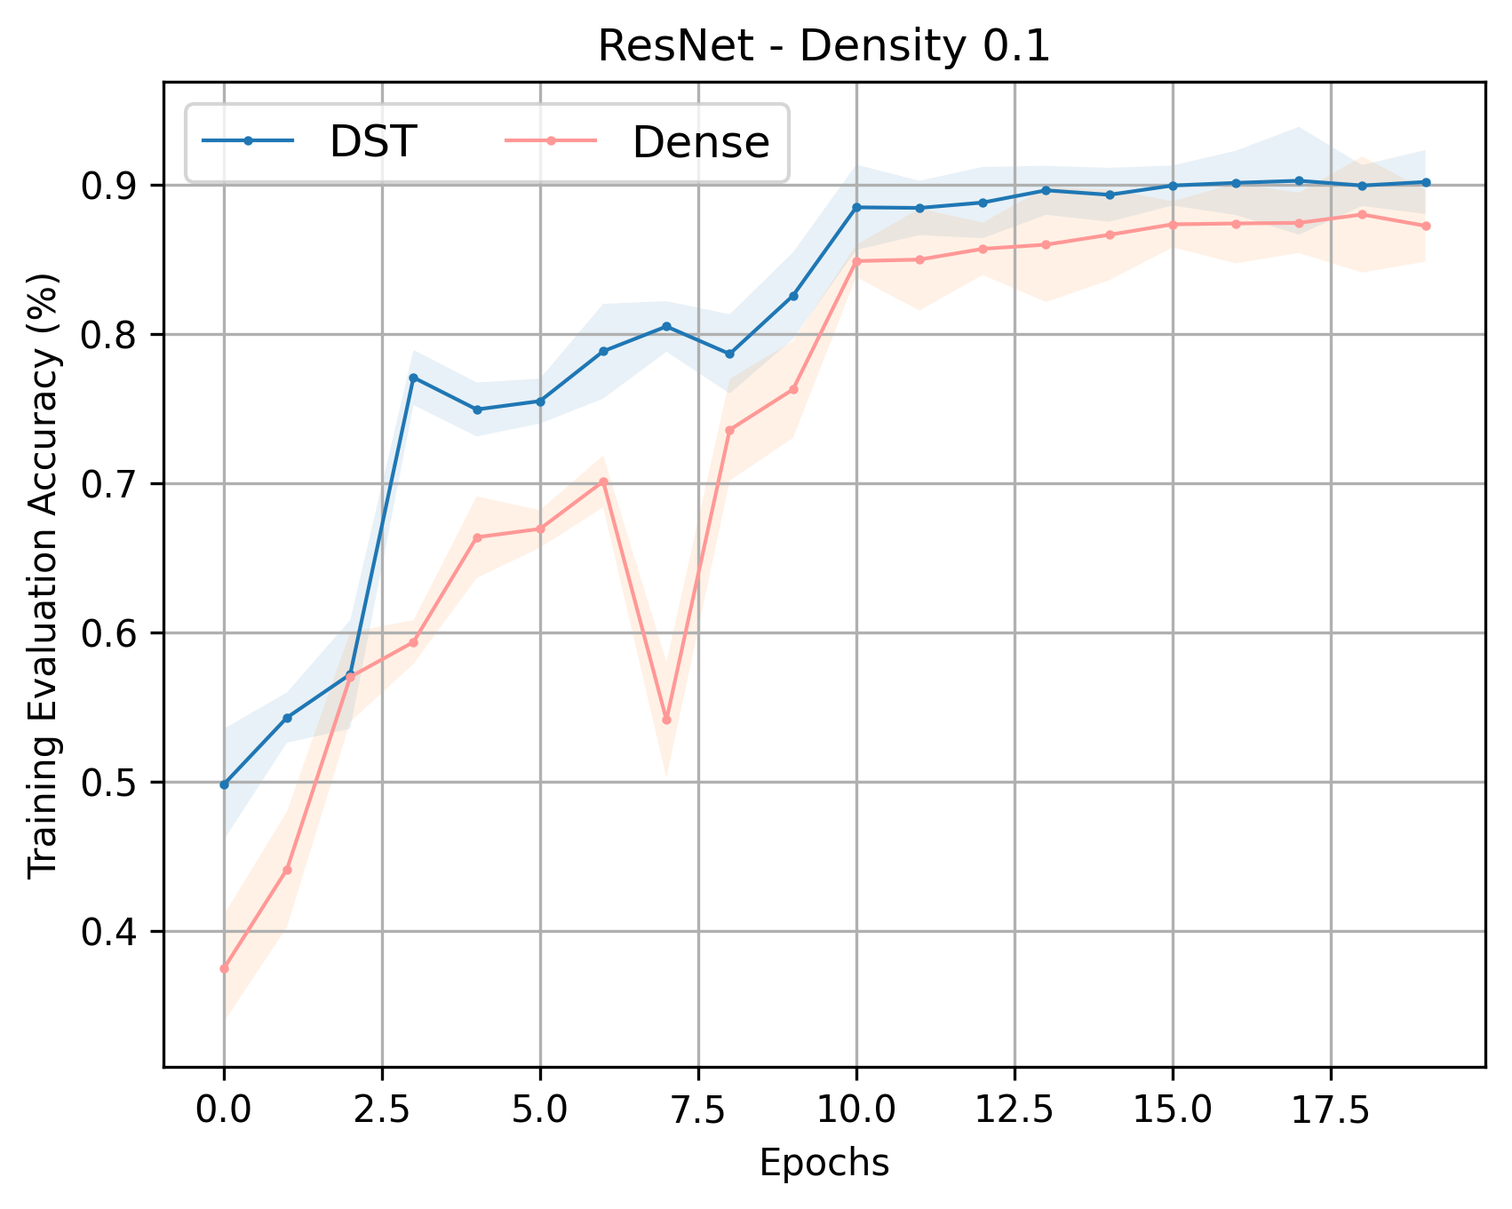
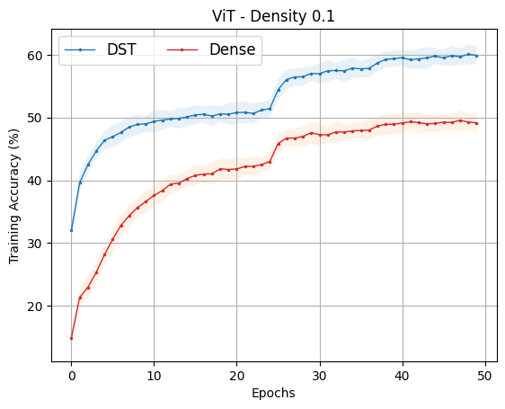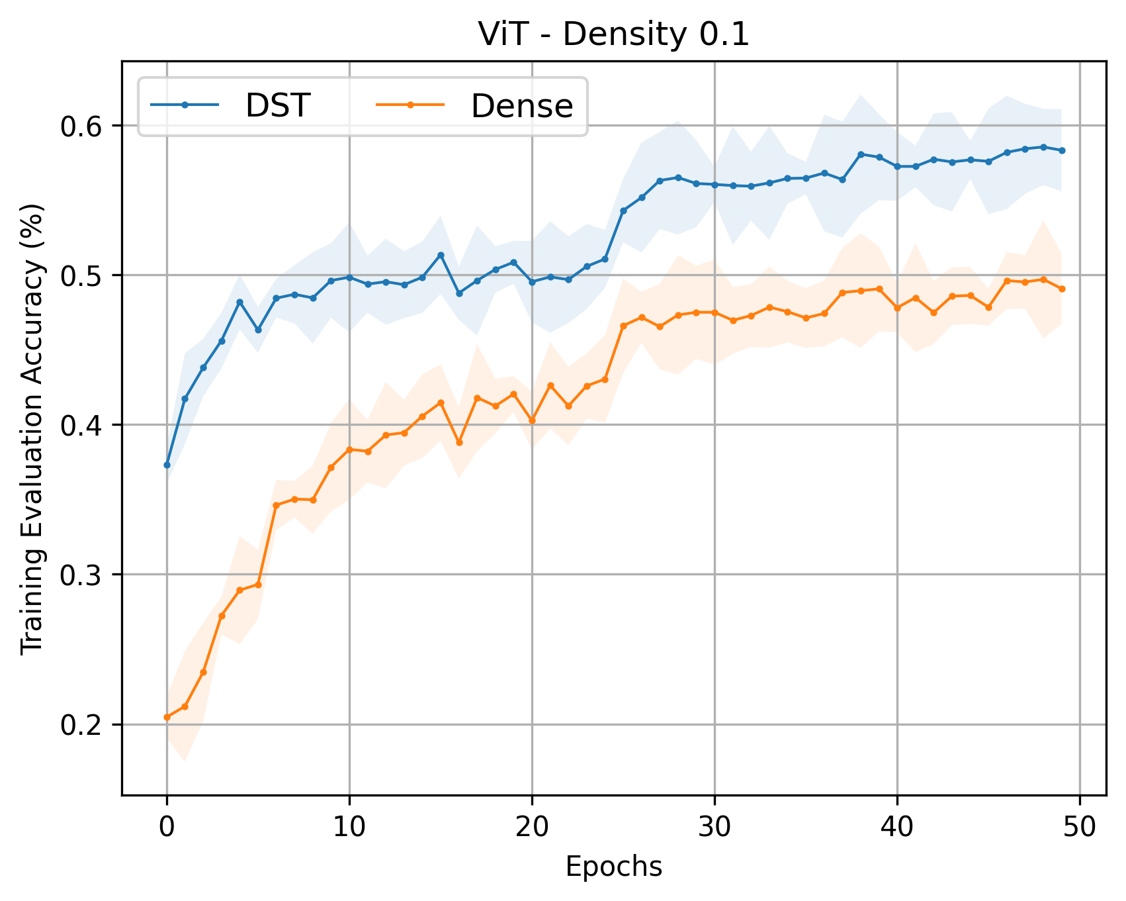
Our empirical experiments align with these findings:
- ResNet: DST improves evaluation accuracy from 87.22% → 90.16%
- ViT: DST yields a substantial improvement from 49.08% → 63.32%
These gains are consistent with prior work showing that DST can match or exceed dense performance, and even improve robustness under challenging conditions. In some studies, sparse networks outperform dense ones across tasks while maintaining the same parameter budget.
2. Operational Efficiency
A major motivation for sparsity is reducing the computational and energy cost of deep learning. Sparse networks activate only a subset of parameters at each step, significantly reducing memory accesses and compute requirements. This directly translates into lower energy consumption and improved scalability.
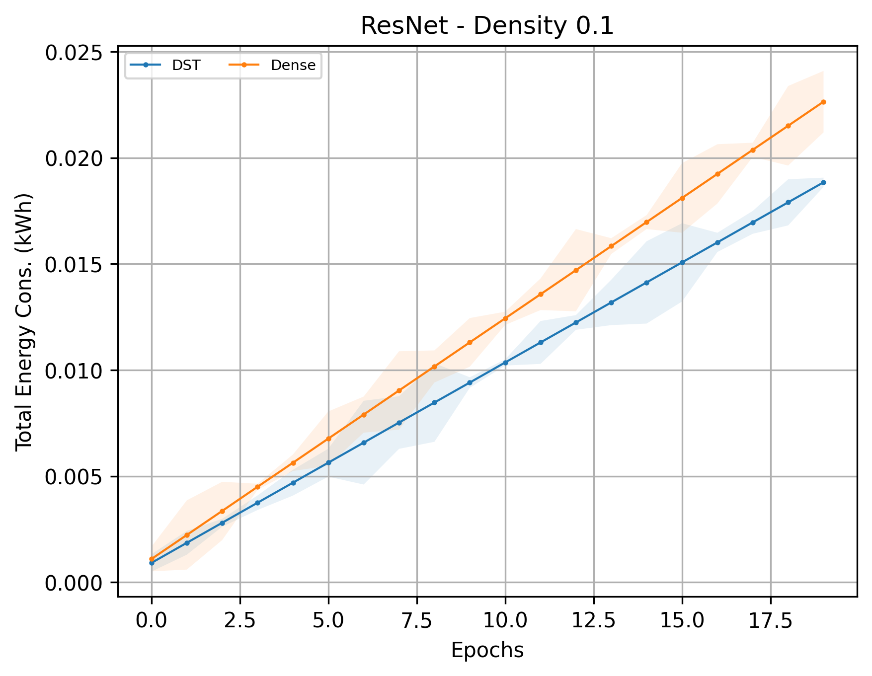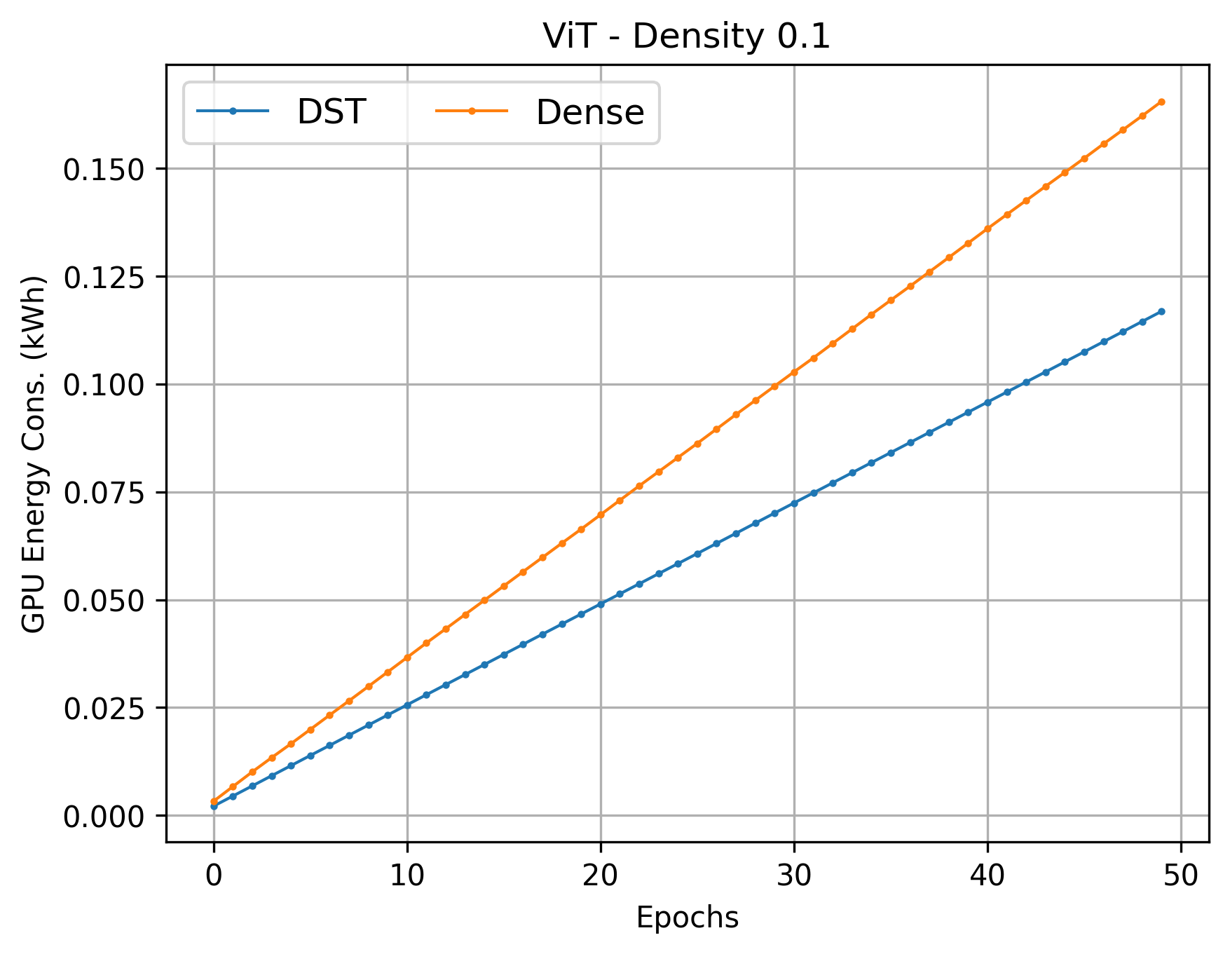
Our results clearly demonstrate this:
- ResNet: ~11% reduction in energy (54.19 → 48.29 Wh)
- ViT: ~10% reduction in energy (129.50 → 116.85 Wh)
These improvements are consistent with broader findings that DST can reduce FLOPs, training time, and memory usage, sometimes by large margins, without sacrificing accuracy. Furthermore, recent advances in structured sparsity show that DST can deliver real hardware speedups (e.g., up to 3× inference acceleration), addressing practical deployment concerns.
3. Bridging the Gap to Real-World Deployment
Earlier concerns about sparsity focused on its limited hardware efficiency, particularly for unstructured sparse patterns. However, modern research directions—such as energy-aware sparsity—are closing this gap by making sparse computations more compatible with real systems.
Additionally, DST enables training under fixed resource budgets and supports scaling to larger models by reallocating saved resources—making it especially relevant for large-scale and energy-constrained environments.
Conclusion
Combining insights from both empirical results and prior research, we conclude that:
Dynamic sparse training is not only competitive with dense training but can surpass it, while simultaneously reducing energy and computational cost.
Rather than introducing a trade-off, DST offers a synergistic advantage, where:
- Accuracy maintain due to better exploration of parameter space and implicit regularization,
- Efficiency improves due to reduced computation and memory usage.
Therefore, DST represents a scalable paradigm for real-world deployment, particularly in the context of sustainable AI and large-scale deep learning systems.

