**Dr. AMBEDKAR INSTITUTE OF TECHNOLOGY**

(An Autonomous Institute Affiliated to Visvesvaraya Technological University, Belagavi,

Accredited by NAAC, with ‘A’ Grade)

Near Jnana Bharathi Campus, Bangalore 560056



**A PROJECT REPORT ON**

**“Car price prediction using Linear Regression”**

Department of Master of Computer Application

Submitted by

JAFAR SADIQ A M (1DA21MC023)

in association with Aqmenz Automation Pvt. Ltd.

**Chapter 1**

**Company profile**

**1.1 Formation of company**

Aqmenz Automation Private Limited is a private incorporated on 15th October 2018. It is classified as Non-Govt Company and is registered at Registrar of companies, Bangalore.

**1.2 Brief history of company**

Aqmenz Automation Pvt Ltd (AAPL) was started on October 2018. It is situated in northern part of Bangalore, RT Nagar Karnataka. AAPL provides Mechanical Design & Automation solutions to their client companies. AAPL also involved in Open source Robotics and devel oped different varieties of Robots. Aqmenz also started INDOSKILL, a separate platform for the students to get training and work on various Real Time Industrial Projects. Indoskill offers skill-oriented hands-ontraining through an online platform. Field of Expertise: Open-source Robotics, Industrial Automation, Product Design, Python and Deep Learning and Embedded Systems.

**1.3 Major Milestones:**

We have under gone many industrial projects. Our major clients are BIAL (Bangalore International Airport Limited), GE (General Electric) and Amics technologies.

**1.4 Vision and mission**

Our Motto and Vision are to create awareness & training young generation to current and future jobs demands and also help to current and future jobs demands; meanwhile help the students and employees to meet the mandatory necessities of future human resources and skill demands. We are in the 4th industrial revolution. The technological revolution is catastrophic like never before, hence continues awareness for the up-gradation environment is much essential. Aqmenz Automation Pvt. Ltd. is working to help and enhance the potential of studentsand employees. So that future human resources will be very beneficial, purposeful and profitable to the nation.

**1.5 Objectives**

• AAPL had a trust in Skill India mission & vision, hence our utmost priority is to add skill to the young Generation and make them Profitable and productive for the nation.

• We aim in Providing Industrial Automation Training Skill module kits to Institution University’s & Collage Lab Facilities with Lowest Possible Price for Benefits of Technical Students.

• Identifying young entrepreneurs and motivate, training them to establish Start-up to create Employment as well as prosperity for the nation.

• Consultation, Sourcing and supplying highly skilled Manpower to Industry for better efficiency and productivity.

• Providing low cast & precise industrial automation solutions.

• Very eager to fetch solution for most complex industrial problems in a mode

**1.6 About the company**

Organization structure The organization structure is having three different departments such as design department, software department and sales and marketing.

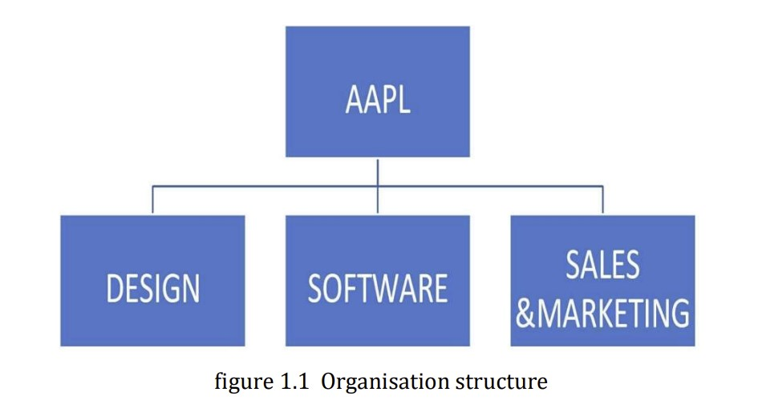

**1.7 Services offered**

• Provides Design & Automation solutions.

• All type of automation projects to companies using PLC’s, SCADA embedded systems.

• We provide robots and robotic solutions to small and medium scale companies.

• Embedded solutions to companies like GE

• We conduct technical skill-oriented training programs to engineering colleges.

• We also provide robotics and automation lab equipment’s for colleges. Number of people working in company and their responsibilities There are 20 persons in this company, out of which:

• Shamanna Mohan, Chief Executive Officer (CEO)

• Mohammed Azhar Hussain, Chief Technology Officer (CTO)

**1.8 Ongoing projects**

• Automation related projects

• CNC Machines

• Open-source Custom Robots

• Garment Industry slider project

**Chapter 2**

**Introduction**

Data analysis is a process of inspecting, cleansing, transforming and modelling data with the goal of discovering useful information, informing conclusions, and supporting decision making. Every product that is manufactured is supposed to have distinguishing physical characteristics, which makes it attractive and provides usefulness and value to customers; these characteristics are known as Design, and the process employed in this regard is known as product design. Product designs clearly defines a problem , develops a proper solution for that problem and validates the solution with the real users Product design is the process of creating a new product to be sold by a business to its customers. It is essentially the efficient and effective generation and development of ideas through a process that leads to new products Data mining is a particular data analysis technique that focuses on statistical modelling and knowledge discovery for predictive rather than purely descriptive purposes, while business intelligence covers data analysis that relies heavily on aggregation, focusing mainly on business information. In statistical applications, data analysis can be divided into descriptive statistics, explorative data analysis (EDA), and confirmation data analysis (CDA). EDA focuses on discovering new features in the data while CDA focuses on confirming or falsifying existing hypothesis. Predictive analysis focuses on the application of statistical models for predictive forecasting or classification, while text analytics applies statistical, linguistic, and structural techniques to extract and classify information from textual sources, a species of unstructured data. All of the above are varieties of data analysis.

• In this internship program we have done a project.

• Project: Data Analysis Of Software Salaries

• The software used in designing is Jupyter Notebook.

**Chapter 3**

**Tools exposed**

**3.1 Jupyter notebook**

The juypter notebook app is a server-client application that allows editing and running notebook documents via a web browser. The jupyter notebook app can be executed on a local desktop requiring no internet access or can be installed on a remote server and accessed through the internet. In addition to displaying/editing/running notebook documents, the jupyter notebook app has a dashboard, a control panel showing local files and allowing to open notebook documents or shutting down their kernels. A notebook kernel is a computational engine that executes the code contained in a notebook document. The jupyter kernel referenced in this guide executes python code. Kernels for many other language exist. When you open a notebook document the associated kernel is automatically launched. When the notebook is executed the kernel performs the computation and produces the results. Depending on the type of computations the kernel may consume significant CPU and RAM. Note that the RAM is not released until the kernel is shut down. The notebook dashboard is the component which is shown first when you launch jupyter notebook app. The notebook dashboard is mainly used to open notebook documents and manage the running kernels. The jupyter notebook extends the console based approach to interactive computing in a qualitatively new direction, providing a web based application suitable for capturing the whole computation process: developing, computing and executing code as well as communicating the results. The jupyter notebook combines two components a web application and notebook documents. A web application: A web browser based tool for interactive authoring of documents which combine explanatory text, mathematics, computations and their rich media output. Notebook documents: A representation of all content visible in the web application, including inputs and outputs of the computations, explanatory text, mathematics, images and rich media representation of objects.

**3.2 Google colab**

Colaboratory or colab for short, is a product from Google research. Colab allows anybody to write and execute arbitrary python code through the browser and is especially well suited to machine learning, data analysis and education. More technically colab is a hosted jupyter notebook service that requires no setup to use, while providing access free of charge to computing resources including GPUs. Colab resources are not guaranteed and not unlimited, and the usage limits sometimes fluctuate. This is necessary for colab to be able to provide resources free charge. Resources in colab are prioritized for interactive use cases. We prohibit actions associated with bulk compute, actions that negatively impact others as well as actions associated with bypassing the policies. Jupyter is the open source project on which the colab is based. Colab allows you to use and share jupyter notebooks with others without having to download, install or run anything. You can search colab notes using google drive. Clicking on the colab logo at the top left of the notebook view will show all notebooks in drive. You can also search for notebooks that you have opened recently by clicking on file and then open notebook. Google drive operations can time out when the number of folders or subfolders in a folder grows too large. If thousands of items are directly contained in the top level “My drive” folder then mounting the drive will likely time out. Repeated attempts may eventually succeed as failed attempts cache partial state locally before timing out. Colab is able to provide resources free of cost in part by having dynamic usage limits that sometimes fluctuate this means that overall usage limits as well as idle timeout periods, maximum VM lifetime, GPU types available and other factors vary over time. Colab does not publish these limits in parts because they can vary quickly. This is necessary for colab to be able to provide access these resources free of charge. Colab works with most of the major browsers and is most thoroughly tested with the latest versions of Chrome, Firefox and Safari.

**Chapter 4**

**Task performed:**

Data analysis of car price prediction

4.1 General steps

• Extracting the data form data set.

• Analysis of the data.

• Performing the basic operations.

• Developing the predictive model.

**4.2 Importance of data analysis**

While analysing data sets, it is important to define the objectives so that further steps become clearer. Analysis lets us pose questions about data. For questioning data, it is important to have data collection on which further operations will be carried out. After the above steps, “Data Analysis” comes into picture. Data analysis o is the process of raw data cleaning and conversion so that further operations become easier to carry on and then the conclusions can be drawn from the results. For Today, data has become the backbone of all research in almost every field. Research and analysis is no more limited to just the area of sciences, but has grown to be a part of businesses – startups and established organisations, government works and more.

**Data set :**

A data set is a collection of similar and related data or information. It is organised for better accessibility of an entity. Data sets are used for data analytics as they provide related information in a united form. It can be structured or unstructured.

Data set link: <https://www.kaggle.com/code/sagarvarandekar/software-salaries-eda>

**Chapter 5**

**Results and discussions**

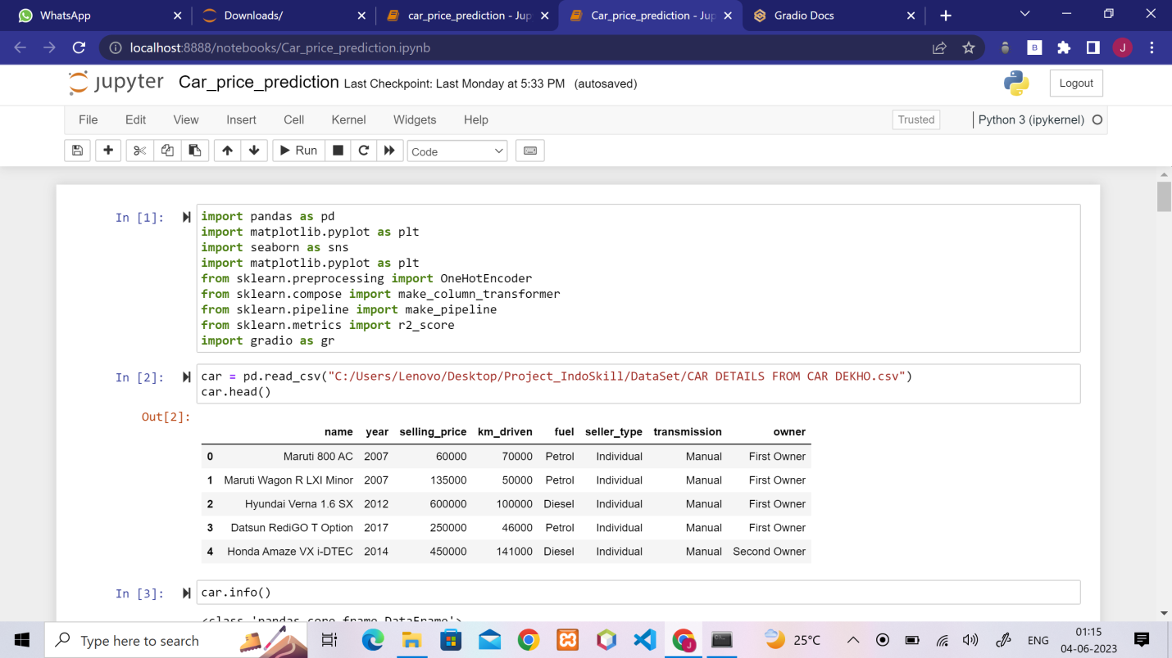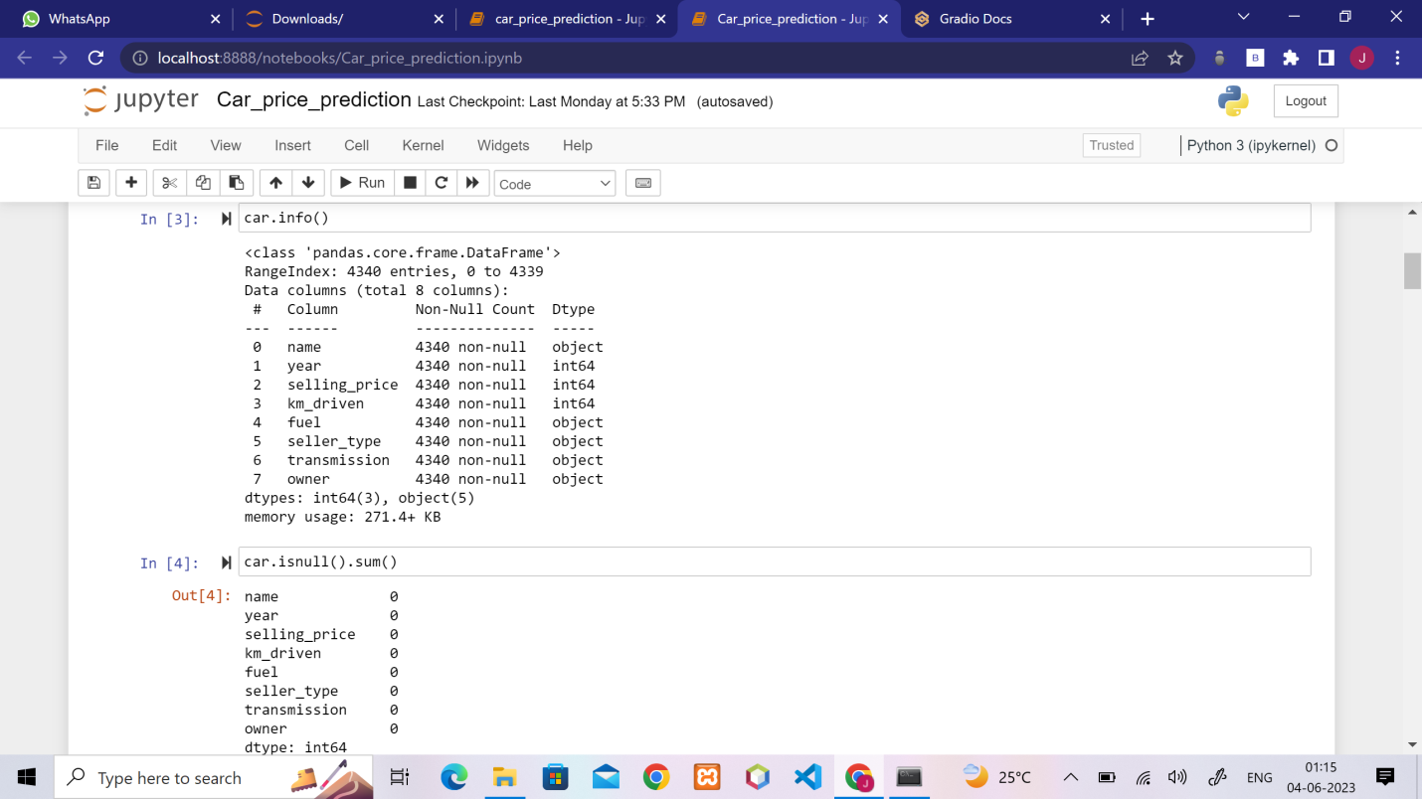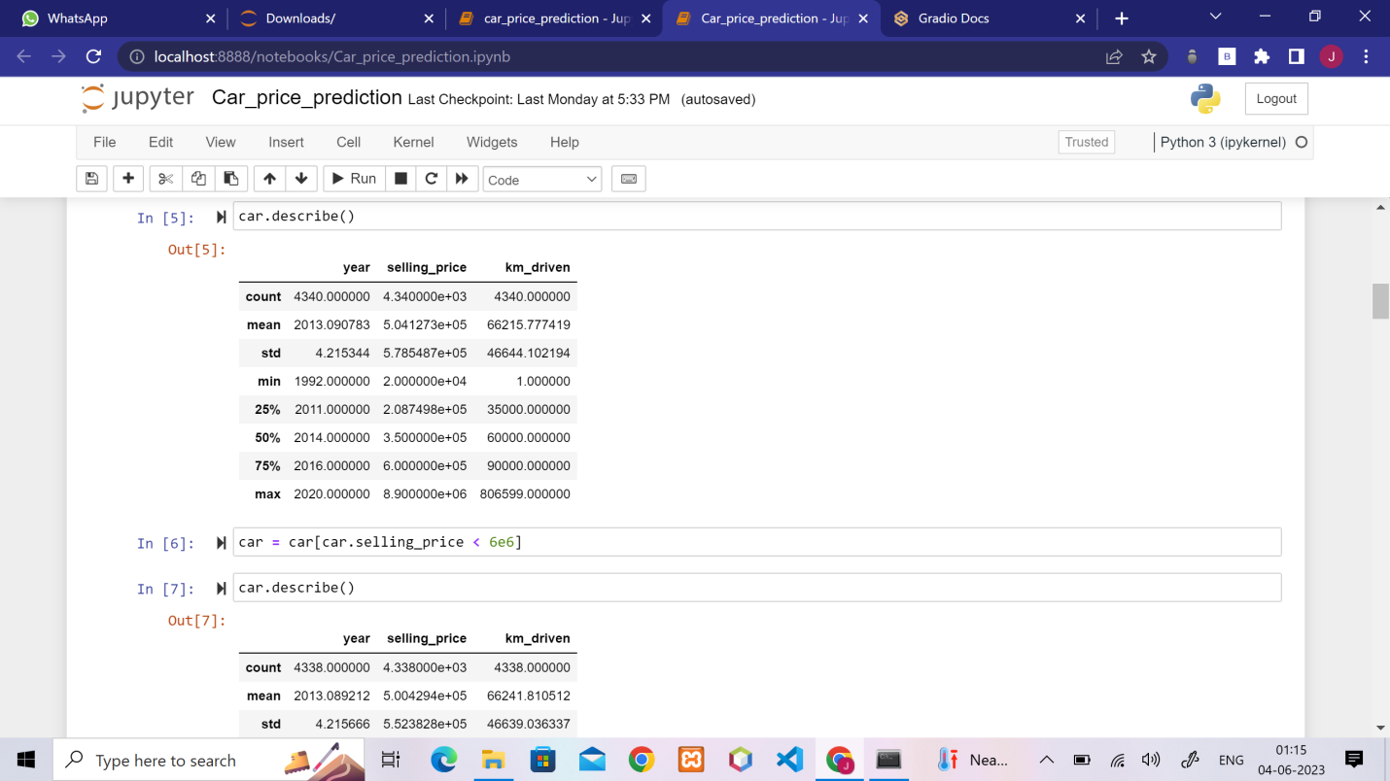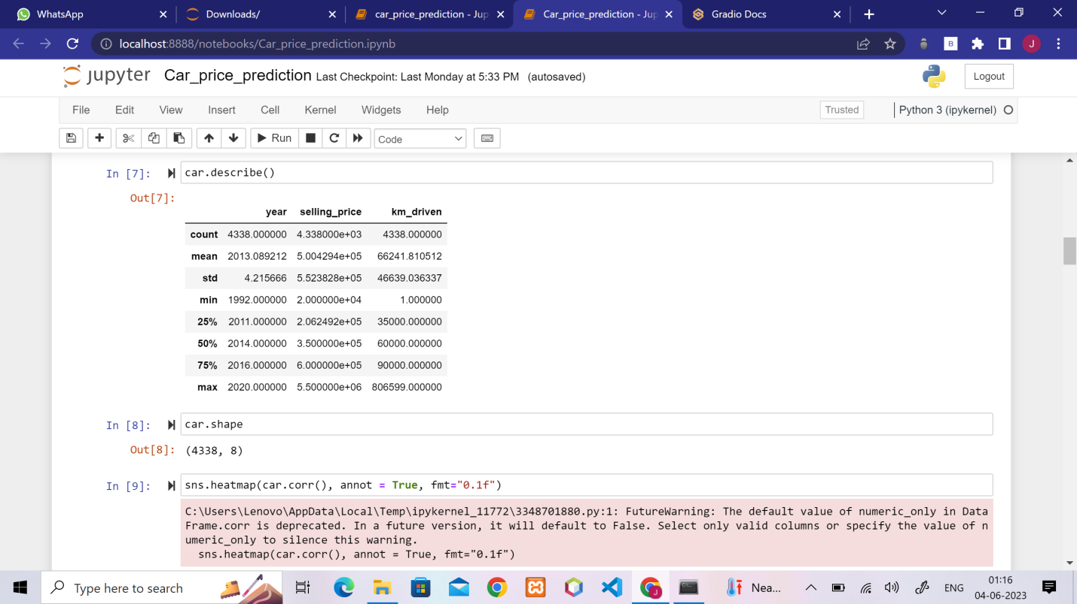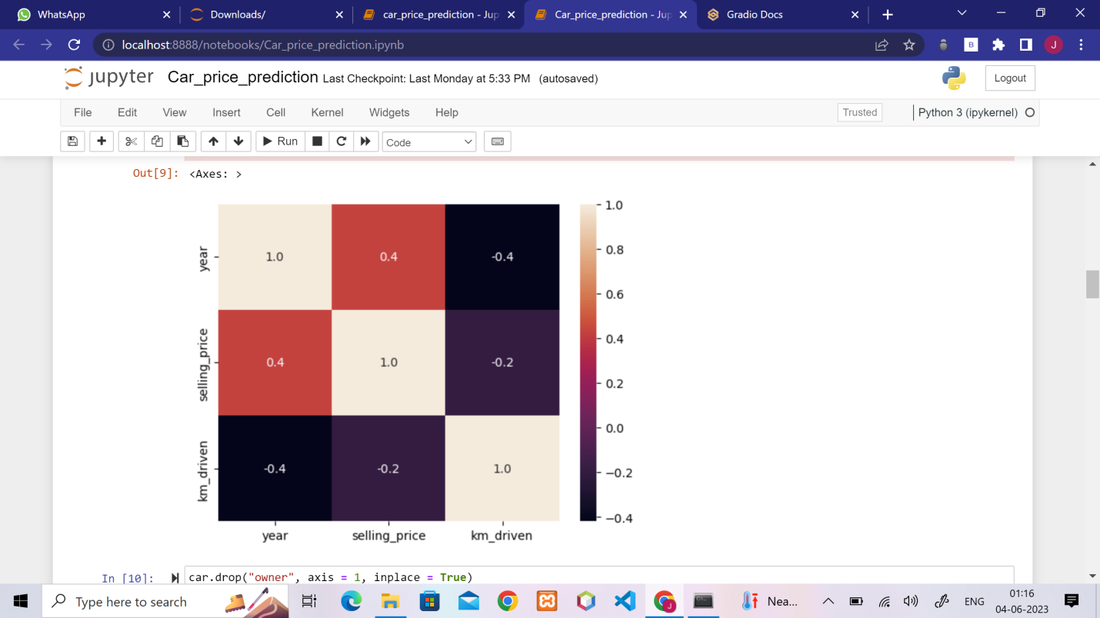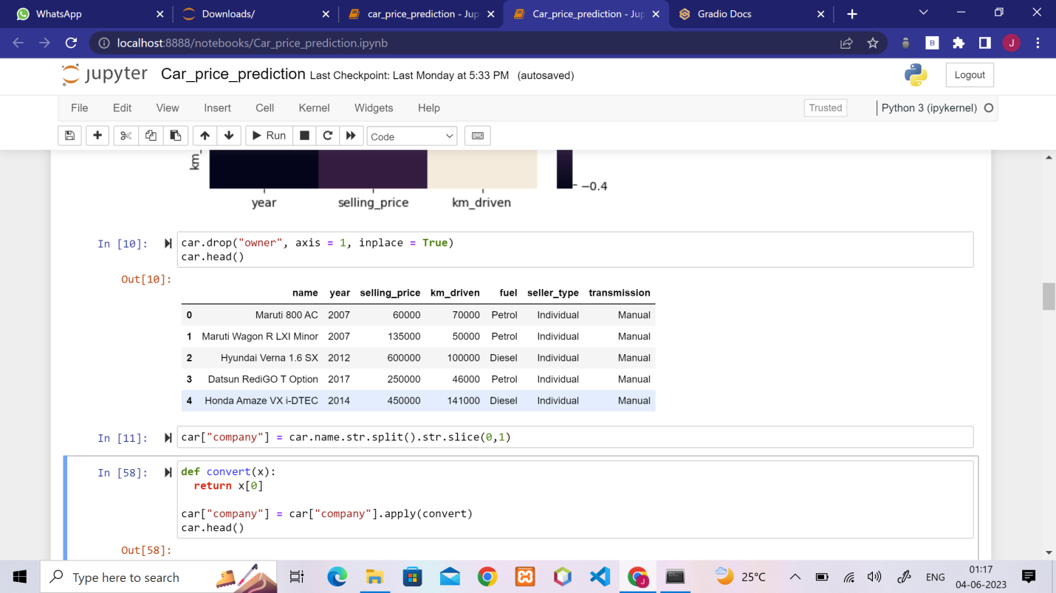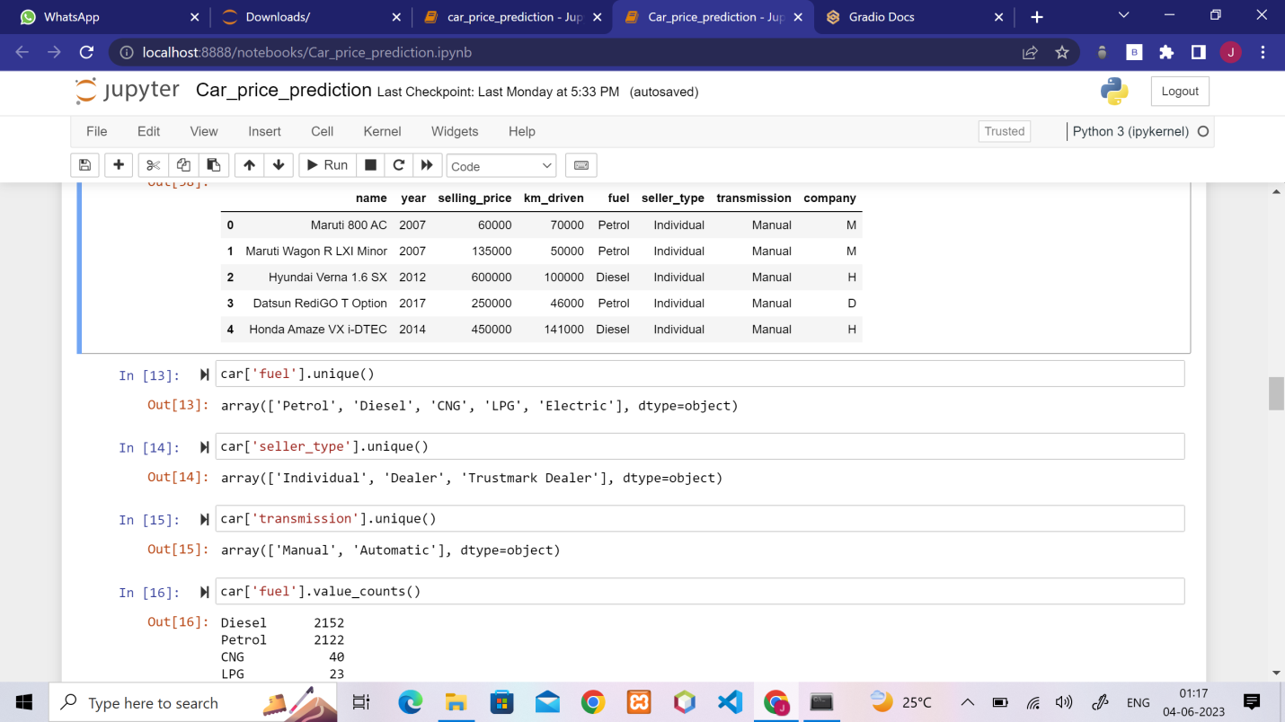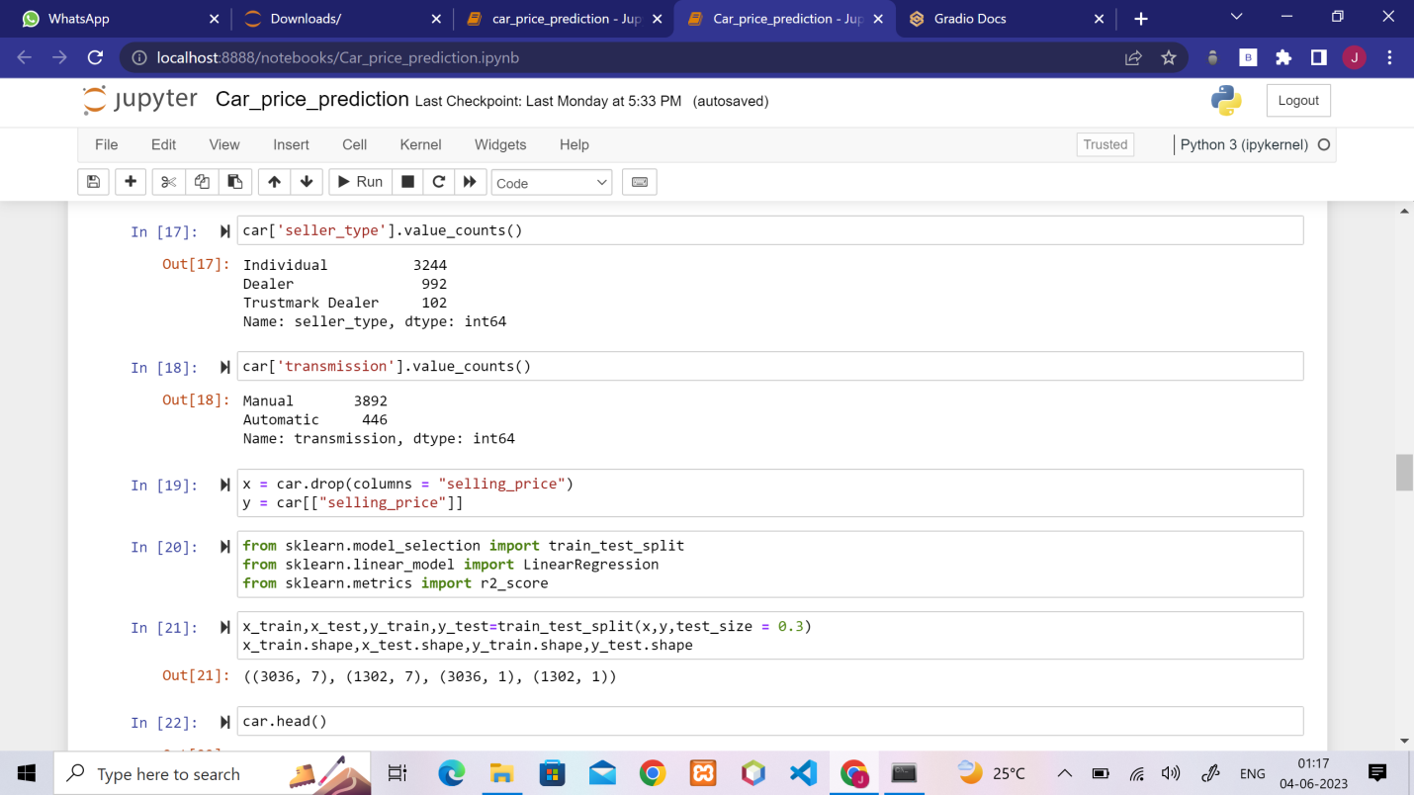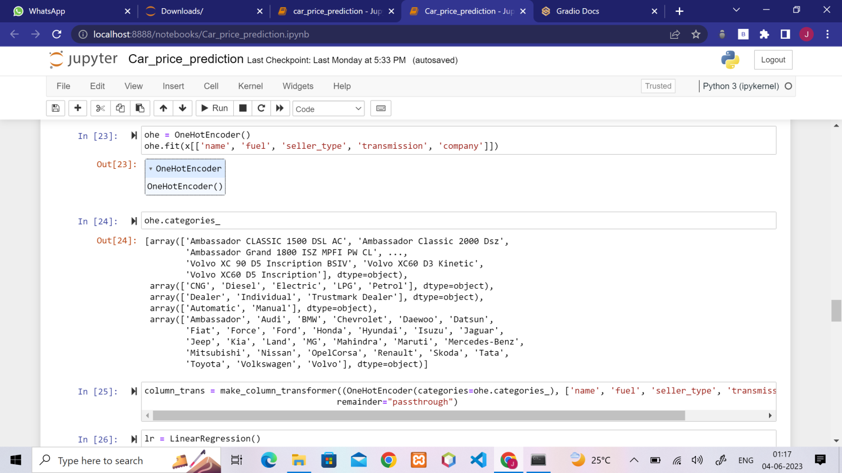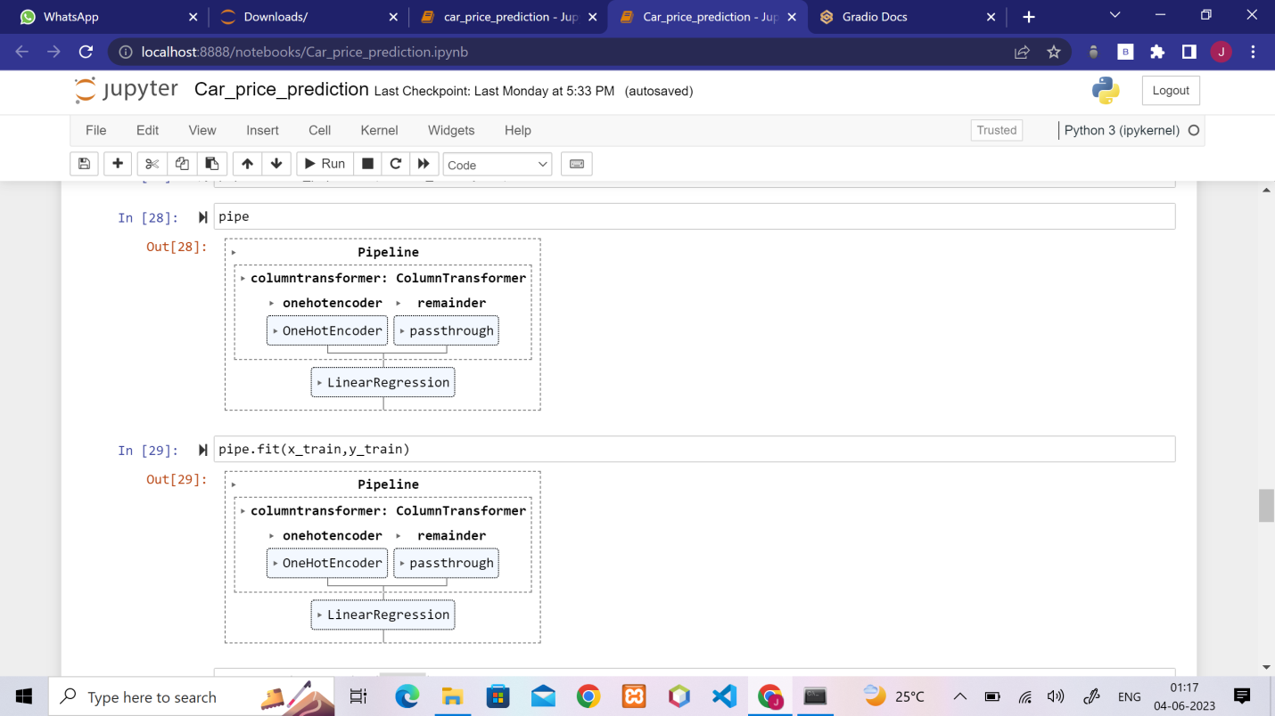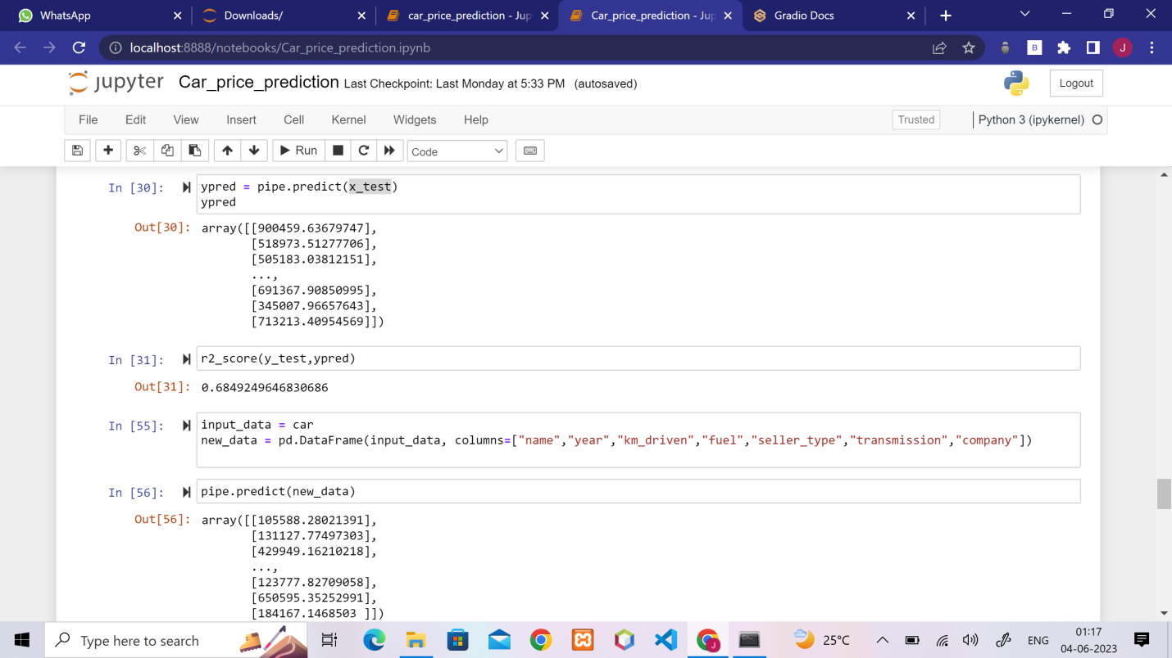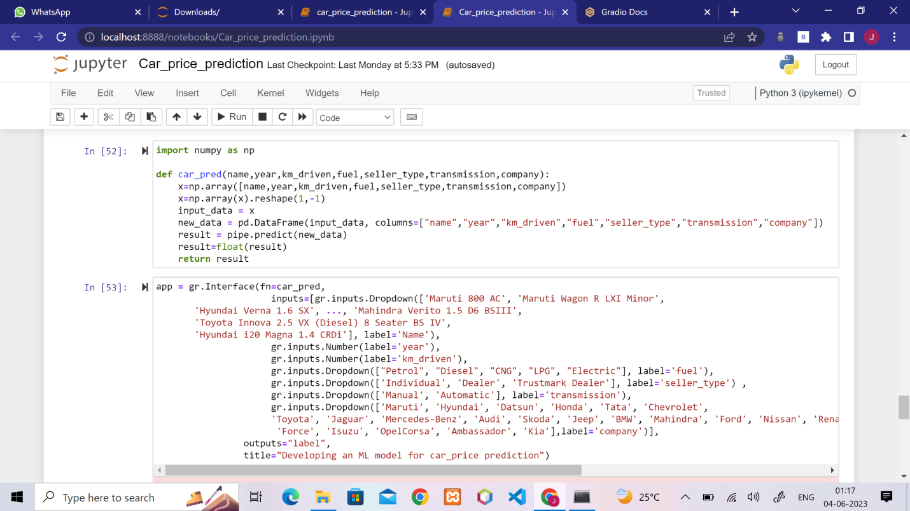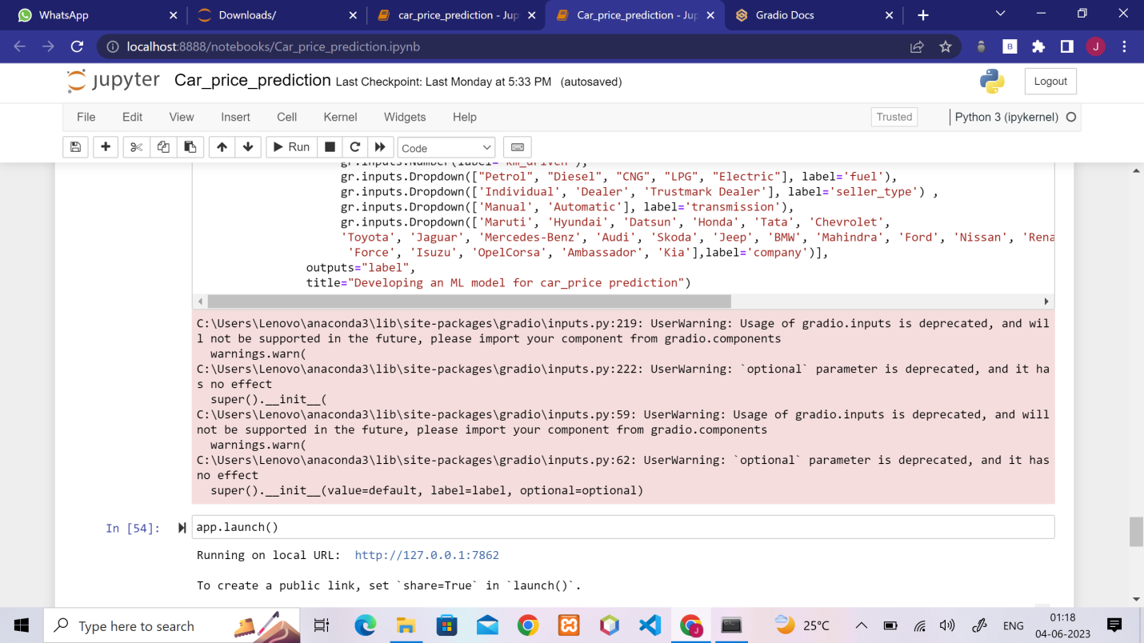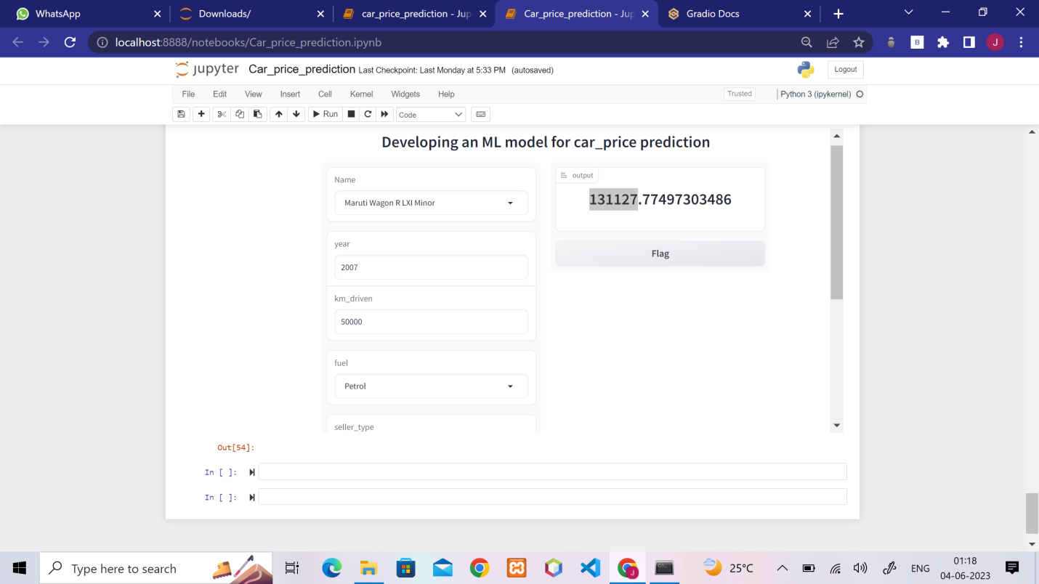

**Chapter 6**

**Reflection notes**

**6.1 Skills acquired**

1. Understand, evaluate, design and implement artificial intelligence models. 2. Implement contemporary artificial intelligence techniques, from knowledge representation, to deep learning, developing in demand skills and leadership qualities for an exciting career in AI. 3. Apply the legal, ethical, social and philosophical context for practical AI projects. 4. Extend knowledge in artificial intelligence through research, experimentation and analysis. 5. Practical or hands on experience in training an ML model. 6. Gain expertise in technical drawing to visualize concepts.

**6.2 Technical outcomes**

• Machine learning involves computations on large data sets, hence we learnt strong basic fundamental knowledge such as computer architecture, algorithms and data structure complexity. Getting in depth into the python language and exploring new commands.

• Synthesize visual perception skills along with drawing skills to visually communicate ideas. Deconstruction of designs for its motives and inspirations. To learn to synthesize data and make connections within the data points using the available frameworks.

• To frame an appropriate actionable problem statement with reference to user needs and contextual alignments.

• Data analysis of different data sets and to understand the concepts on a real world basis to implement and make use of AI/ML in our upcoming career.

• To train different models and to make sure the requirement of the respective clients and make to implement a model according to their requirements.

**6.3 Time management**

Time management helps you allocate time for the most important tasks. When we follow a schedule we don’t have to spend time and energy on what to do. Instead we can focus on what matters and do well. The quality of the work will suffer if we are constantly worrying about meeting the deadlines. Time management helps to prioritize the tasks, so we can have enough time to focus on each project to put in the effort and produce high quality outcomes. Many software companies have to work against tight timelines. Proper time management will allow us to allocate enough time to meet each deadline. Planning ahead also keeps us calm and think freely to work more in an efficient way.

**6.4 Personality development**

Personality development is referred to as a process of developing and enhancing one’s personality. It helps one to gain confidence and high self esteem. It is essential to think positive and don’t get upset over minor things, to be a little flexible and always look at the broader perspectives of life. Do not think of harming others and share whatever you know. Always help others. Be a patient listener and never interrupt when others are speaking. Try to imbibe good qualities of others. Confidence is the key to a positive personality. Exude confidence and positive aura wherever you go. Personality development teaches you to be calm and composed even at stressful situations. Never over react. Avoid finding faults in others. Learn to be a little broad minded and flexible.

**Chapter 7**

**Conclusion**

In conclusion, this internship has been a very useful experience for me. I can safely say that my understanding of the job environment has increased greatly. However, I do think that there are some aspects of the job that I could have done better and that I need to wort on. I have built more confidence in usage of software tools. The two main things I learnt after my experience in this firm are time management and being self-motivated. I have gained new knowledge and skills and met new people. Usage of big data tools can improve operational efficiency. Data analysis helps companies make informed decisions, create a more efficient marketing strategies, improve customer experience, streamline operations , among many other things. Usage of charts, maps, other visual representations of data to help present your findings in an easy-to-understand way. Improving the data visualisation skills often means learning visualisation software.

**References**

1. Mittal P, Sharma M, Jain P. A detailed study of security and privacy concerns in big data. Int J Appl Eng Res. 2018; 13:7406–11

2. Paul Z, Eaton C. Understanding big data: analytics for enterprise class Hadoop and streaming data. McGraw-Hill Osborne Media;2011. P. 1–166.

3. Philip R. Big data analytics. TDWI best practices report, fourth quarter. 2011;19(4):1– 34.

4. Karthik K. Trends in big data analytics. J Parallel Distr Com. 2014;74(7):2561–73.

5. Chong Ho Y. Exploratory data analysis. Methods. 1977; 2:131–60.

6. G data: various R programming tools for data manipulation. [cited 2005 May]. https://www.researchgate.net/publication/275646231_gdata_Various_R_programming _ tools for_ data_ manipulation.

7. The art of R programming: a tour of statistical software design. [cited 2012 Apr]. https://www.researchgate.net/publication/254296013_The_Art_of_R_Programming_A _ Tour _of _Statistical _Software _Design _by _Norman _ Matloff.