AI Job Market Analytics: Analyzing AI-Related and Traditional Job Market Trends
Data Analytics Project Report
Submitted by
Jafar Sareef A
B.Tech — Information Technology
Mookambigai College of Engineering
Academic Year: 2022–2026

Table of Contents
Abstract
Introduction
Problem Statement
Objectives
Research Question
Dataset Description
Technologies Used
Data Preprocessing
Exploratory Data Analysis
Salary Analysis
Geographic and Category Analysis
Time Trend Analysis
Interactive Dashboard
Key Findings
Limitations
Conclusion
Future Scope
References
Appendix

1. Abstract
This project investigates patterns in AI-related and traditional job postings across three countries — the United Kingdom, the United States, and India — using a dataset of 1,696 job listings collected between May 2023 and July 2026. The dataset was assembled using five targeted search keywords: artificial intelligence, machine learning, automation, data entry, and customer service. The first three keywords represent AI-associated roles, while the latter two serve as reference categories for traditional work patterns.
The project follows a structured data analytics pipeline comprising data loading, quality inspection, preprocessing, exploratory data analysis (EDA), and interactive visualisation via a Plotly Dash dashboard. The analysis reveals that 60.2% of all postings in the dataset were classified as AI-related, with particularly high concentrations in IT, Engineering, and Scientific & QA categories. Within the search keywords, machine learning achieved 100% AI classification, while customer service reached only 0.3%. Salary data — kept strictly separate by currency — shows a descriptive difference between AI-related and non-AI postings within each country. All findings are presented as descriptive observations; no causal claims are made about the effect of AI on employment.
2. Introduction
2.1 Background
Artificial intelligence has rapidly transitioned from a research discipline into a mainstream technology embedded across industries including finance, healthcare, manufacturing, defence, and technology. As organisations adopt AI-driven tools and workflows, the composition of the workforce is evolving. Job categories that once required minimal technical expertise are increasingly intersecting with AI, while entirely new role categories — such as machine learning engineering, applied AI research, and generative AI development — are emerging.
Understanding these shifts requires data. Job posting data represents one observable signal of how demand for different skills and roles is changing over time. By examining what employers advertise, analysts can characterise the composition and distribution of the contemporary job market — even if the data cannot by itself explain why demand is changing or what employment outcomes result.
2.2 Motivation
This project is motivated by the practical value of understanding where AI-related job demand is concentrated, how it compares to traditional roles, and whether observable differences exist across countries and industries. For students, job seekers, educators, and policy analysts, such information can support informed decision-making about skills development, curriculum design, and workforce planning — provided the data limitations are clearly understood.
2.3 Importance
Analysing job-posting patterns provides a timely and accessible window into labour market trends. This project does not aim to prove causal relationships between AI adoption and employment outcomes. Instead, it focuses on describing observable patterns in a defined dataset — identifying where AI-related roles appear, how they are distributed across countries and categories, and how associated salary figures compare within the same currency.
3. Problem Statement
The primary question this project seeks to address is: How is AI changing the job market, and what roles are emerging across different countries and industries?
Available public datasets on job postings provide an opportunity to examine this question descriptively. However, several challenges must be addressed:
- (a) Job posting datasets are typically collected via search keywords, which means they do not constitute a random or representative sample of all open positions.
- (b) Salary data may be absent, predicted algorithmically, or expressed in different currencies, all of which limit direct comparisons.
- (c) Reposted listings can inflate posting counts, and contract/employment-type fields may be largely missing.
- (d) Observed patterns in job postings cannot, on their own, establish whether AI has caused job losses, job creation, or any specific employment outcome.
This project addresses these challenges through careful preprocessing, transparent flagging of data quality issues, and presentation of findings as descriptive observations.
4. Objectives
The specific objectives of this project are:
- 1. To load, inspect, clean, and preprocess a real-world job-market dataset while preserving all original records.
- 2. To classify job postings as AI-related or Non-AI and analyse their distribution across countries, categories, and search keywords.
- 3. To perform per-currency salary analysis distinguishing AI-related from Non-AI roles and predicted from stated salary values.
- 4. To identify job categories with the highest concentrations of AI-related postings.
- 5. To analyse temporal trends in posting volume across the dataset period.
- 6. To build an interactive Plotly Dash dashboard enabling exploratory filtering and visualisation of the results.
- 7. To present all findings honestly, within the limitations of the dataset, without unsupported causal claims.
5. Research Question
"How is AI changing the job market, and what skills and roles are emerging across different countries and industries?"
This question is approached empirically using job-posting data as a proxy for employer demand. The dataset allows this question to be addressed in terms of posting volumes, category distributions, salary patterns (within currencies), and geographic differences — but not in terms of actual employment outcomes, workforce displacement, or skills verification.
6. Dataset Description
6.1 Dataset Overview
The dataset used in this project is the AI Job Market 2026: Automation vs Traditional Role dataset, publicly available on Kaggle. It was sourced from a job aggregation platform and covers job postings from three countries: the United Kingdom (GB), the United States (US), and India (IN).
Dataset source: https://www.kaggle.com/datasets/mariaaqdas/ai-job-market-2026-automation-vs-traditional-role

Property | Details
File name | ai_job_market_dataset.csv
Total rows | 1,696
Total columns (raw) | 19
Countries | United Kingdom, United States, India
Search keywords | artificial intelligence, automation, machine learning, data entry, customer service
Date range | May 2023 to July 2026
Currency | GBP (UK), USD (US), INR (India)
Exact duplicate rows | 0
Table 1: Dataset Summary
6.2 Search Keywords
The dataset was assembled using five search keywords. These keywords are important to understand when interpreting the results: the first three are associated with AI-related roles, and the latter two represent traditional or task-based roles included as comparison categories.
6.3 What the Dataset Can and Cannot Represent
The dataset provides a snapshot of employer demand signals within the scope of these five search keywords across three countries. It can support descriptive analysis of posting volumes, keyword distributions, category breakdowns, and salary patterns. However, it cannot represent the complete global job market, establish causality between AI adoption and employment trends, verify actual hiring outcomes, or confirm the real skills required in listed roles (since descriptions are truncated to approximately 500 characters). It also cannot prove that AI caused job losses or displacement.
7. Technologies Used
The project was implemented entirely in Python. The following libraries and tools were used:
Table 2: Technologies and Libraries
Technology / Library | Version | Purpose
Python | 3.12 | Programming language
Pandas | >=2.0 | Data loading, cleaning, analysis
NumPy | >=1.24 | Numerical operations
Matplotlib | >=3.9 | Static EDA chart generation
Seaborn | >=0.12 | Statistical visualisation support
Plotly | >=6.0 | Interactive chart rendering
Dash | >=4.0 | Interactive web dashboard framework
Dash Bootstrap Components | >=2.0 | Dashboard layout and UI components
python-docx | >=1.1 | Word report generation

The project was developed in a standard Python 3.12 environment on Windows. All dependencies are listed in requirements.txt and can be installed with pip install -r requirements.txt.
8. Data Preprocessing
All preprocessing was implemented in Jafar_AI_Job_Market_Analytics.py. The original CSV file was never modified. The preprocessed data existed only in-memory during execution.
8.1 Missing Values
Three columns contained missing values of significance: contract_type (74.5% missing), contract_time (51.3% missing), and the salary columns (salary_min, salary_max, salary_avg — each with 183 null values, representing 10.8% of rows). The two contract columns were filled with the value 'Unknown' rather than being imputed or deleted. Salary nulls were preserved. A single company field contained one null entry (0.1%), which was also preserved.
8.2 Duplicate Checking
A full row-level exact duplicate check was performed. No exact duplicates were found across all 1,696 rows. All job IDs were unique. A Boolean flag column exact_duplicate was added to the dataset (all False).
8.3 Repost Identification
Same-role reposts were identified as rows sharing an identical title and company name but having different job IDs or dates. This pattern indicates that a role was re-advertised over time rather than that a duplicate data entry occurred. A total of 778 rows (45.9%) were flagged as reposts using a Boolean column is_repost. These rows were preserved because they represent genuine posting activity. Analysis was performed on both the full 1,696-row dataset and a 918-row unique-role subset (is_repost = False).
8.4 Suspicious Salary Flagging
Four salary records contained values far below plausible annual salary thresholds for their respective currencies (e.g., £13, £20.50, £500, $32). These records were not deleted but were flagged using a Boolean column salary_suspicious = True. They were excluded from all salary distribution charts to avoid distorting results. The thresholds applied were: GBP < £1,000, USD < $1,000, INR < ₹10,000.
8.5 Date Conversion
The created column was parsed from a timezone-aware string into a UTC datetime object. The created_date column was parsed from DD-MM-YYYY string format into a Python date object. Both columns produced zero parsing failures.
8.6 Boolean Standardisation
The is_ai_related column, which contained 'TRUE'/'FALSE' strings, was converted to Python Boolean (True/False). The salary_is_predicted column, which contained 0/1 integers, was converted to Boolean. Both preserved their original meaning.
8.7 Feature Engineering
The following derived columns were created to support analysis and dashboard filtering:
- job_type: Human-readable label derived from is_ai_related. Values: 'AI-Related' or 'Non-AI'.
- salary_status: Derived from salary_is_predicted. Values: 'Predicted' or 'Stated'.
- year: Integer year extracted from created_date.
- month: Integer month extracted from created_date.
- year_month: Period string in 'YYYY-MM' format, used for time-series grouping.
- exact_duplicate: Boolean flag — whether a row is an exact duplicate of another (all False in this dataset).
- is_repost: Boolean flag — whether a row shares title + company with at least one other row.
- salary_suspicious: Boolean flag — whether a salary_avg value falls below the per-currency threshold.
9. Exploratory Data Analysis
9.1 Overall AI vs Non-AI Distribution
Across all 1,696 job postings, 1,021 (60.2%) were classified as AI-related and 675 (39.8%) as Non-AI. When the dataset is filtered to unique roles only (is_repost = False, removing 778 reposted listings), 918 distinct postings remain: 633 AI-related (69.0%) and 285 Non-AI (31.0%). The higher AI proportion in the unique-role subset suggests that non-AI roles were more frequently reposted than AI-related roles in this dataset.
These figures reflect the composition of postings collected via the five search keywords and do not imply that 60% of all jobs in these countries are AI-related.
Figure 1: [ AI vs Non-AI Overall Donut Chart]
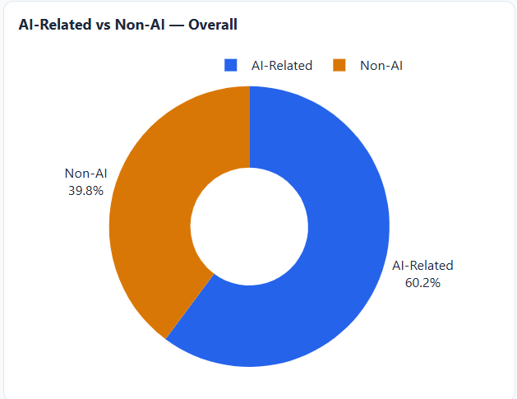
9.2 Search Keyword Analysis
The five search keywords show markedly different AI-related proportions, which validates the dataset design — AI-focused keywords yield predominantly AI-related results, while traditional-task keywords yield predominantly Non-AI results:

Table 3: AI-Related Proportion by Search Keyword
Keyword | AI-Related | Total | AI %
machine learning | 298 | 298 | 100.0%
automation | 329 | 348 | 94.5%
artificial intelligence | 384 | 450 | 85.3%
data entry | 9 | 300 | 3.0%
customer service | 1 | 300 | 0.3%

The near-zero AI classification for customer service (0.3%) and data entry (3.0%) confirms that these keywords predominantly surface traditional role postings, providing a useful descriptive baseline against which AI-focused keywords can be compared.

Figure 2: [ AI Proportion by Keyword Horizontal Bar Chart]
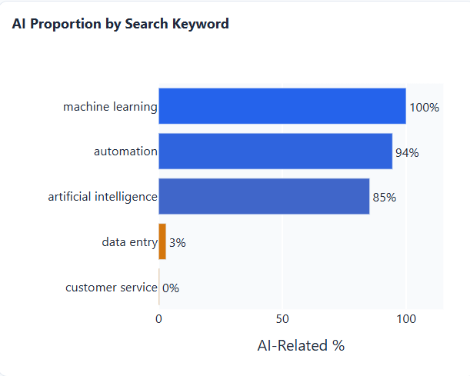
9.3 Repost Analysis
Of the 1,696 postings, 778 (45.9%) were identified as temporal re-posts — the same job title from the same company appearing on multiple dates. These are not data errors; they reflect roles that remained open or were re-advertised. Both the full-posting count and the unique-role count are presented throughout the analysis to give an accurate picture.
10. Salary Analysis
IMPORTANT: Salary values exist in three separate currencies — GBP (UK), USD (US), and INR (India). All salary analysis in this section is performed separately within each currency. No direct comparison of raw GBP, USD, and INR figures is made.
10.1 Data Preparation for Salary Analysis
Before computing any salary statistics, the following filters were applied: rows where salary_avg was null (183 rows) were excluded; rows where salary_suspicious was True (4 rows) were excluded. This yielded 1,509 rows for salary analysis.
10.2 Per-Currency Salary Statistics
Table 4: Salary Summary by Currency and Job Type (suspicious records excluded)
Currency | Job Type | n | Median Salary | Mean Salary
GBP | AI-Related | 405 | £57,500 | £63,318
GBP | Non-AI | 338 | £27,146 | £31,983
USD | AI-Related | 448 | $125,010 | $129,653
USD | Non-AI | 301 | $40,625 | $43,466
INR | AI-Related | 17 | Rs. 750,000 | Rs. 992,941
INR | Non-AI | 0 | N/A | N/A

Within each currency, AI-related postings show a descriptively higher median salary than Non-AI postings. In GBP, the AI-related median is approximately 2.1 times the Non-AI median. In USD, the multiple is approximately 3.1. The INR group has only 17 AI-related records with salary data (and 0 Non-AI salary records after exclusions), so INR figures are indicative only. No causal relationship between AI classification and salary level is implied; this is a descriptive observation.
Figure 3: [Salary Boxplot by Currency and Job Type]
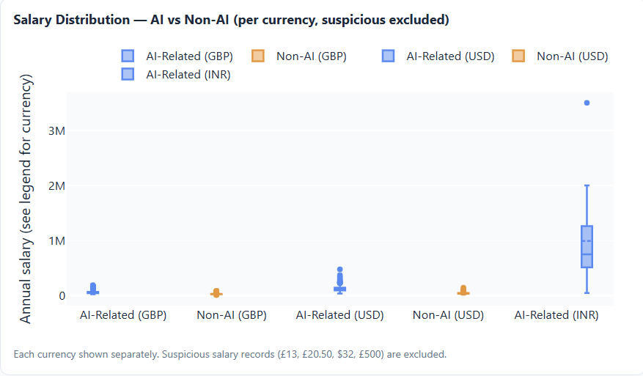

10.3 Predicted vs Stated Salary
Of the 1,509 salary-valid rows used in analysis, 1,161 have salary_is_predicted = True, meaning the salary figure was an algorithmic estimate rather than an employer-stated value. This represents 76.9% of salary-valid rows. Only 348 rows (23.1%) contain employer-stated salary values. This high predicted proportion must be considered when interpreting salary findings.
Note: The 68.5% figure sometimes cited in project notes refers to the predicted proportion across all 1,696 rows (including null-salary rows). The analytically correct denominator for salary-specific findings is the 1,509 salary-valid rows, giving 76.9%. This report uses 76.9% consistently.
10.4 Approximate USD Normalisation (Analytical Estimate Only)
To enable a cross-country visualisation, salary values were approximately normalised to USD using fixed mid-2024 exchange rate estimates: GBP x 1.27, INR x 0.012. This normalisation is an analytical convenience only. It does not represent official exchange rates and should not be treated as a precise conversion. The dashboard labels this chart as 'Approx. USD equivalent — analytical estimate only' with the conversion assumption stated explicitly.
Figure 4: [Approx. USD Normalised Salary by Country]
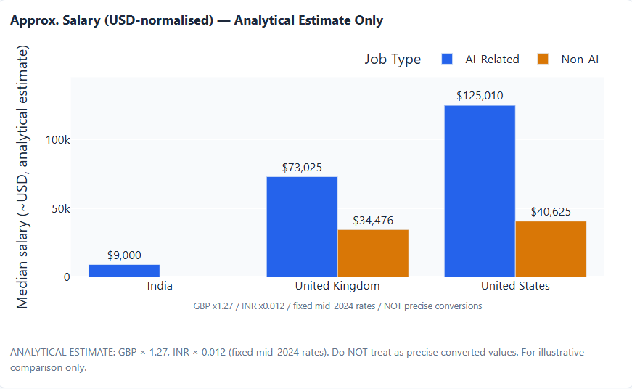
11. Geographic and Category Analysis
11.1 AI Proportion by Country
India shows the highest AI-related proportion at 83.5% (167 of 200 postings), followed by the United States at 59.9% (449 of 750) and the United Kingdom at 54.3% (405 of 746). The high proportion for India is partly a reflection of the search terms used — data entry and customer service yielded fewer postings from the Indian portion of the dataset. These figures describe the composition of collected postings, not the overall AI-related employment level in each country.
Table 5: AI Proportion by Country (All Postings)
Country | AI-Related | Non-AI | Total | AI %
India | 167 | 33 | 200 | 83.5%
United States | 449 | 301 | 750 | 59.9%
United Kingdom | 405 | 341 | 746 | 54.3%

Figure 5: [ AI vs Non-AI by Country Grouped Bar Chart]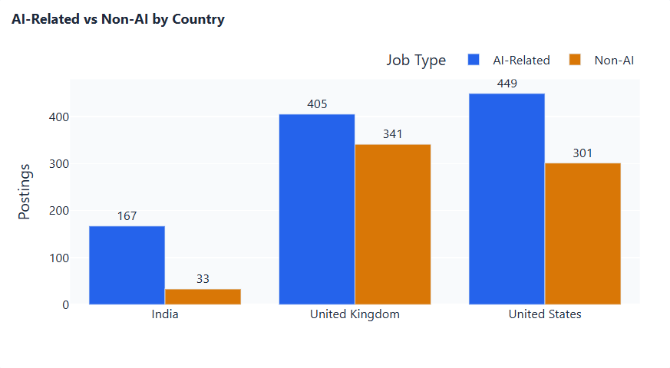
11.2 Top Job Categories by Country
IT Jobs is the largest category in all three countries. In the UK, Engineering Jobs ranks third. In India, Sales Jobs and Teaching Jobs appear prominently, reflecting the broader range of postings collected via the automation and artificial intelligence keywords in that market segment.
11.3 AI Proportion by Job Category
Among job categories with at least 10 postings, Engineering Jobs (95.4%), IT Jobs (93.8%), and Scientific & QA Jobs (93.5%) show the highest AI-related proportions. By raw AI-related count, IT Jobs leads with 652 postings, followed by Engineering Jobs (226) and Scientific & QA Jobs (29).
Table 6: Top Categories by AI-Related Count and Proportion (n >= 10)
Category | AI-Related Count | Total | AI %
IT Jobs | 652 | 695 | 93.8%
Engineering Jobs | 226 | 237 | 95.4%
Scientific & QA Jobs | 29 | 31 | 93.5%
Teaching Jobs | 20 | 31 | 64.5%
Sales Jobs | 24 | 133 | 18.0%
Admin Jobs | 6 | 202 | 3.0%
Customer Services Jobs | 1 | 153 | 0.7%

Figure 6: [AI-Related Jobs by Category Horizontal Bar Chart]
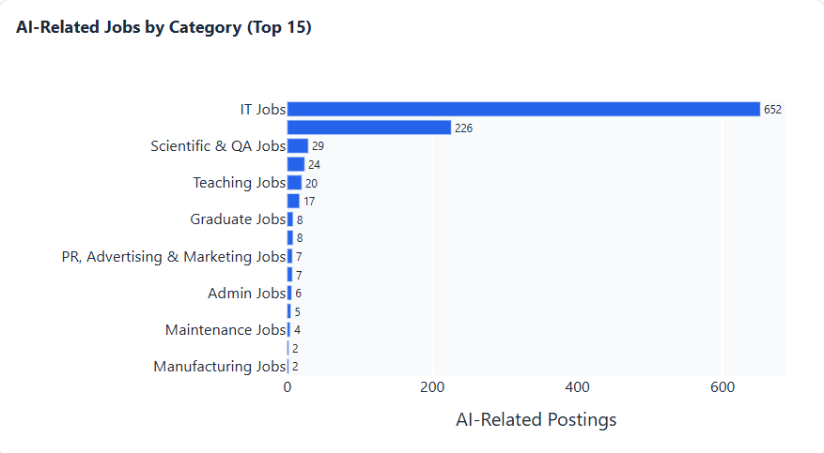
12. Time Trend Analysis
The dataset spans May 2023 to July 2026. However, the coverage is highly uneven: approximately 96.5% of all postings are dated in 2026, with 2026-08 alone containing 1,015 postings (59.8% of the total). Earlier years — 2019 through 2025 — collectively account for only a small fraction of the data.

Table 7: Job Postings by Year
Year | AI-Related | Non-AI | Total | AI %
2019 | 8 | 0 | 8 | 100.0%
2020 | 1 | 0 | 1 | 100.0%
2021 | 1 | 0 | 1 | 100.0%
2022 | 3 | 0 | 3 | 100.0%
2023 | 1 | 1 | 2 | 50.0%
2024 | 3 | 0 | 3 | 100.0%
2025 | 20 | 21 | 41 | 48.8%
2026 | 984 | 653 | 1,637 | 60.1%

Given that fewer than 60 postings are available from 2019–2025, time-series trend analysis is effectively limited to 2026. Trends within 2026 can be explored at the monthly level in the dashboard. The uneven temporal coverage is a significant limitation for drawing conclusions about how AI-related posting volumes have evolved over the years.
Figure 7: [Monthly Posting Volume Trend Line Chart]
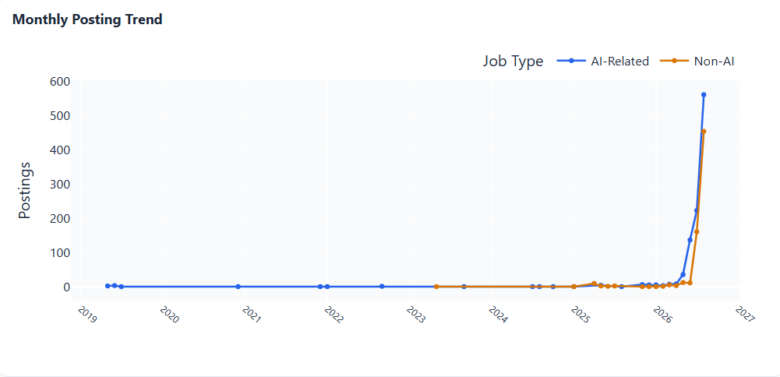
13. Interactive Dashboard
13.1 Architecture
The interactive dashboard was built using Plotly Dash (v4.4.1) with Dash Bootstrap Components (v2.0.4) for layout. It is implemented as a self-contained Python script: Jafar_AI_Job_Market_Dashboard.py. The dashboard loads and preprocesses the dataset at startup, then serves an interactive web application locally at http://127.0.0.1:8050. It uses a two-panel layout: a fixed sidebar with filters on the left and a responsive content area with KPI cards and charts on the right. All chart rendering is done client-side using Plotly.js via callback-driven server responses.
13.2 Filters
The dashboard provides five multi-select dropdown filters: Country (United Kingdom, United States, India), Search Keyword (five options), Job Type (AI-Related, Non-AI), Year (all years in the dataset), and Currency (GBP, USD, INR). A Reset Filters button restores all filters to their default empty state (showing all data). All KPI cards and charts respond dynamically to filter changes.
13.3 KPI Cards
Six KPI cards display top-line statistics for the currently filtered data: Total Postings, AI-Related count, Non-AI count, AI percentage, Unique (non-repost) roles, and Re-post count.
13.4 Charts
The dashboard includes ten interactive charts:
- 1. AI vs Non-AI Overall — Donut chart showing proportion of AI-related and Non-AI postings in the filtered dataset.
- 2. AI vs Non-AI by Country — Grouped bar chart comparing posting volumes by country and job type.
- 3. AI Proportion by Keyword — Horizontal colour-gradient bar chart showing the AI-related percentage for each search keyword.
- 4. AI-Related Jobs by Category — Horizontal bar chart showing the top 15 job categories by AI-related posting count.
- 5. Monthly Posting Trend — Line chart showing AI-related and Non-AI posting volumes by year-month.
- 6. Salary Distribution by Currency and Job Type — Box-plot chart with separate traces per currency and job type. Suspicious salary records are automatically excluded. No cross-currency comparison is displayed.
- 7. Predicted vs Stated Salary — Box-plot chart comparing salary distributions for predicted and employer-stated values, shown per currency.
- 8. Total vs Unique Postings — Grouped bar chart comparing all postings versus unique (non-repost) roles by job type.
- 9. Contract Type and Time — Faceted bar chart showing contract_type and contract_time distributions, labelled as descriptive only.
- 10. Approx. USD-Normalised Salary — Grouped bar chart showing median approximate-USD salary by country and job type. The chart includes a visible annotation: 'GBP x1.27 / INR x0.012 / fixed mid-2024 rates / NOT precise conversions'.
13.5 Data Limitations Panel
A fixed limitations panel is visible at the bottom of the sidebar. It lists seven key limitations including the multi-currency constraint, predicted salary proportion, sparse contract fields, keyword-based sampling, and the absence of causal inference.
13.6 Dashboard Screenshots
[Full Dashboard View showing KPI cards, apply with filters, and charts]
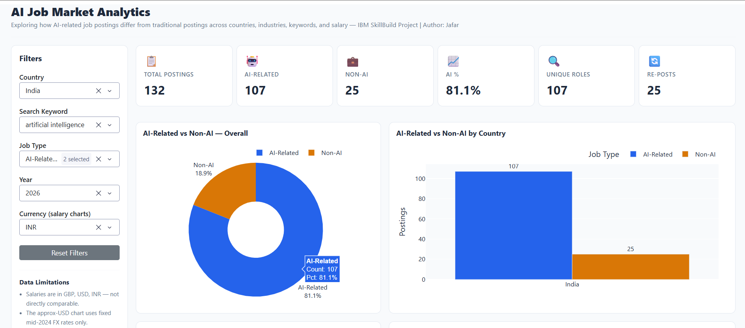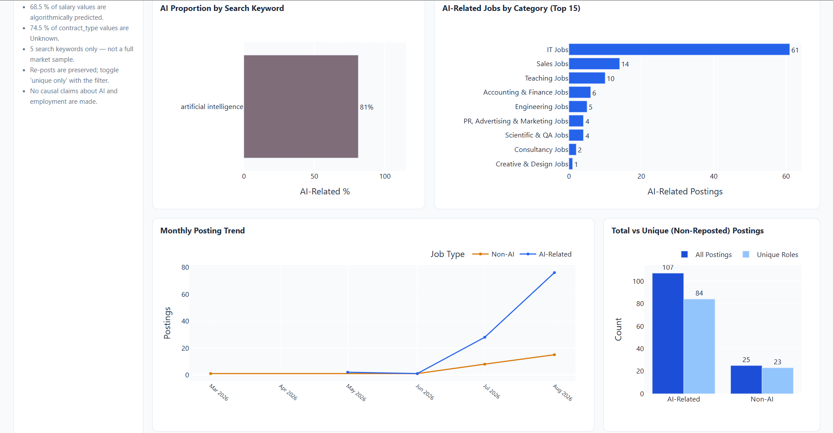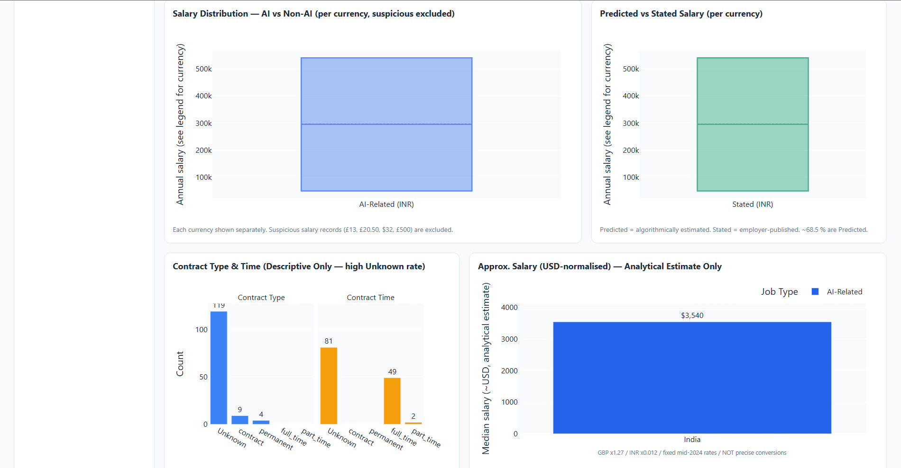
14. Key Findings
The following findings are descriptive observations based on the analysed dataset. They do not constitute proof of causal relationships between AI and employment outcomes.
- F1. AI-related postings represent the majority of collected listings: 60.2% across all 1,696 postings, and 69.0% among the 918 unique (non-repost) roles.
- F2. The machine learning keyword produced 100% AI-related postings (298/298), confirming that this keyword is effectively specific to AI-related roles. The automation keyword produced 94.5% AI-related results (329/348).
- F3. Traditional-task keywords show near-zero AI classification: data entry (3.0%, 9/300) and customer service (0.3%, 1/300).
- F4. IT Jobs and Engineering Jobs are the two largest AI-related categories by count, with AI proportions of 93.8% and 95.4% respectively.
- F5. Within GBP postings, AI-related roles show a median salary of £57,500 compared to £27,146 for Non-AI roles. Within USD postings, AI-related roles show a median of $125,010 compared to $40,625. These are descriptive comparisons within each currency only.
- F6. India shows the highest AI proportion among the three countries (83.5%), though this is partly attributable to the lower number of traditional-keyword postings in the Indian dataset segment.
- F7. 45.9% of postings are temporal re-posts. The high re-post rate indicates that many AI-related roles remained persistently advertised over time.
- F8. Of the 1,509 salary-valid rows, 76.9% contain predicted (algorithmic) salary estimates rather than employer-stated figures. Salary findings should be interpreted with this in mind.
- F9. The dataset coverage is heavily concentrated in 2026 (96.5% of postings), which limits year-over-year trend analysis.
15. Limitations
- L1. Keyword-based sampling: The dataset was collected using only five search keywords. It does not represent the complete job market in any country.
- L2. Coverage concentration: Approximately 96.5% of postings are from 2026, making meaningful multi-year trend analysis impossible with this dataset.
- L3. Multi-currency salaries: Salary values in GBP, USD, and INR cannot be directly compared. The approximate USD normalisation used in the dashboard is an analytical estimate using fixed mid-2024 exchange rates only.
- L4. Predicted salaries: 76.9% of salary-valid rows contain algorithmically estimated salary figures (salary_is_predicted = True), not employer-stated values.
- L5. Sparse contract data: 74.5% of contract_type and 51.3% of contract_time values are Unknown. Contract analysis is descriptive only and should not be used for conclusions about employment patterns.
- L6. Truncated descriptions: Job descriptions are cut off at approximately 500 characters in the dataset. Skills analysis or role characterisation from descriptions is not feasible.
- L7. No causal inference: The dataset cannot establish that AI caused job losses, job creation, salary changes, or any other employment outcome. All findings are descriptive patterns within this specific collection of job postings.
- L8. Re-posts inflate counts: 45.9% of postings are temporal re-listings. Analysts should use the is_repost filter when counting distinct roles.
- L9. Only three countries: The dataset covers only the UK, US, and India. Findings cannot be generalised to the global job market.
- L10. Suspicious salary records: Four records with implausibly low salary values (£13, £20.50, £500, $32) have been flagged and excluded from salary analysis but retained in the dataset.
16. Conclusion
This project set out to explore how AI-related job postings differ from traditional postings across countries, industries, and salary levels using a publicly available job-market dataset. The analysis, conducted entirely in Python with Pandas, Matplotlib, and Plotly/Dash, demonstrates a structured and reproducible approach to descriptive job-market analytics.
The dataset reveals that, within the scope of the five keywords used in collection, AI-related postings account for 60.2% of all listings and are concentrated in IT and Engineering categories. Machine learning and automation keywords produce nearly exclusively AI-classified results, while data entry and customer service keywords surface predominantly traditional roles. Within each currency, AI-related postings show descriptively higher median salary figures compared to Non-AI postings.
The interactive dashboard allows users to explore these patterns with full filtering across country, keyword, job type, year, and currency — making the findings accessible for educational and presentation purposes. All salary visualisations strictly enforce currency separation and clearly label any approximate normalisation.
It is important to emphasise what this project does not establish: it does not prove that AI has caused job losses, displacement, or salary changes. Job posting data is a signal of employer demand within a bounded search scope, not a census of employment outcomes. The dataset limitations — particularly its keyword-based construction, temporal concentration in 2026, high predicted-salary proportion, and sparse contract data — must be clearly understood when interpreting any finding.
This project demonstrates that even a bounded, publicly available dataset can support a rigorous, transparent, and reproducible data analytics pipeline when approached with appropriate methodological care.
17. Future Scope
This project can be extended in several directions to produce more robust and generalisable findings:
- Larger and more representative datasets: Incorporating datasets spanning more countries, industries, and job platforms would reduce the keyword-sampling bias and support broader generalisations.
- Complete job descriptions: Access to full, untruncated job descriptions would enable NLP-based skills extraction — identifying which specific technical and soft skills appear most frequently in AI-related postings.
- Longer historical coverage: A dataset with balanced coverage across multiple years (2019–2026) would support reliable time-series trend analysis.
- Better salary normalisation: Using live or period-average official exchange rates, and distinguishing between employer-stated salaries more rigorously, would improve the reliability of cross-country salary comparisons.
- Additional countries and markets: Extending the geographic scope to include markets in Europe, Southeast Asia, and other regions would enable a more globally representative analysis.
- Contract and employment-type enrichment: Supplementing the dataset with employment-type data from official sources would allow more reliable analysis of work arrangement patterns.
- Predictive modelling: With a larger dataset and more complete features, classification and regression models could be used to predict whether a role is AI-related, or to estimate salary ranges based on role attributes.
18. References
[1] Aqdas, M. (2024). AI Job Market 2026: Automation vs Traditional Role. Kaggle. Available at: https://www.kaggle.com/datasets/mariaaqdas/ai-job-market-2026-automation-vs-traditional-role [Accessed September 2026].
[2] McKinney, W. (2010). Data Structures for Statistical Computing in Python. Proceedings of the 9th Python in Science Conference. The Pandas library is available at: https://pandas.pydata.org
[3] Harris, C. R. et al. (2020). Array programming with NumPy. Nature, 585, 357–362. Available at: https://numpy.org
[4] Hunter, J. D. (2007). Matplotlib: A 2D Graphics Environment. Computing in Science & Engineering, 9(3), 90–95. Available at: https://matplotlib.org
[5] Plotly Technologies Inc. (2015). Collaborative data science. Montreal, QC: Plotly Technologies Inc. Available at: https://plotly.com
[6] Plotly Technologies Inc. (2023). Dash: Analytical Web Apps for Python. Available at: https://dash.plotly.com
[7] Waskom, M. L. (2021). Seaborn: Statistical Data Visualization. Journal of Open Source Software, 6(60), 3021. Available at: https://seaborn.pydata.org
[8] python-docx contributors. python-docx documentation. Available at: https://python-docx.readthedocs.io
19. Appendix
A. Project File Structure
archive/
ai_job_market_dataset.csv — Original dataset (read-only)
Jafar_AI_Job_Market_Analytics.py — Preprocessing and EDA pipeline
Jafar_AI_Job_Market_Dashboard.py — Interactive Plotly Dash dashboard
Jafar_AI_Job_Market_ProjectReport.docx — This project report
requirements.txt — Python dependencies
README.md — Project overview and run instructions
charts/ — 13 static EDA charts (PNG)
B. How to Run the Project
Step 1: Install dependencies
pip install -r requirements.txt
Step 2: Run preprocessing and EDA (generates charts/)
python Jafar_AI_Job_Market_Analytics.py
Step 3: Launch the interactive dashboard
python Jafar_AI_Job_Market_Dashboard.py
Step 4: Open the dashboard in a web browser
http://127.0.0.1:8050
Note: The original CSV file (ai_job_market_dataset.csv) must be present in the same directory as the Python scripts. It is never modified by either script.

