RAVEN GUI User Manual
Operating guide for RAVEN_V1_01 MATLAB GUI

Contents
- 1. Scope and software identity
- 2. Quick-start workflow
- 3. Installation, package contents, and MATLAB requirements
- 4. Data formats and dataset preparation
- 5. Main window guide
- 6. Preprocessing preview and settings
- 7. Advanced settings pages
- 8. Pipeline stages, model selection, training, and prediction
- 9. Exporting results and generated files
- 10. Interpreting results
- 11. Blind-sample testing
- 12. Saving/loading configurations and projects
- 13. Troubleshooting and quality-control checklist
- Appendix A. Settings glossary
- Appendix B. Data-format examples
- Appendix C. Output tree

1. Scope and software identity
RAVEN GUI is a MATLAB-based graphical interface for supervised classification of spectral datasets. The RAVEN software package implements a full training and reporting pipeline including data loading, preprocessing, cross-validated PCA and teacher search, student-model search, final confirmation, publication-oriented exports, optional benchmark baselines, and blind-sample prediction using saved model packages.
The main callable file is RAVEN_V1_01.m, which launches the modular RAVEN GUI workflow described in this manual.
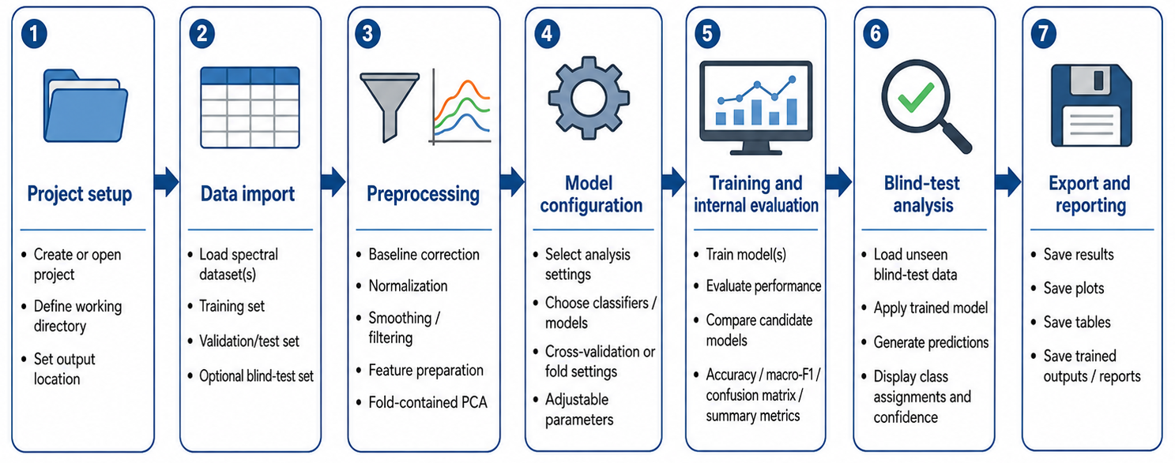
Figure 1. RAVEN GUI workflow from labelled spectral input to final reports and blind-sample model export.

2. Quick-start workflow
Use this section when running the GUI for the first time with a labelled training dataset.
- Extract the complete RAVEN_V1_01 folder to a writable location and preserve the package structure, including RAVEN_core/source_modules and the companion worker files. Do not copy or run only the launcher file.
- Open MATLAB, change the current folder to the RAVEN folder, and run RAVEN_V1_01 from the Command Window.
- In Project Setup, select Folder for a folder of class files or File(s) for one or more supported files.
- Check Uploaded files / classes, Dataset Summary, and Validation / Readiness before running.
- Open Class Manager if only a subset of classes should be included.
- Open Preprocessing, inspect the average spectra, tune preprocessing if needed, and press Save Settings.
- Choose a preset: Quick for testing, Accurate for normal analysis, or Publish for final high-rigor reporting.
- Select the output folder and root name. The default root folder is RAVEN_RUN.
- Press Run Pipeline. Use Pause only at safe polling points; use Stop if the run must be aborted.
- After completion, open Results Navigator or Open Output Folder to inspect Excel, MAT, TXT, PNG, and blind-ready model files.
- For unknown samples, press Blind Test, load FINAL_WINNER_BLIND_MODEL.mat or BestAccuracy_BLIND_MODEL.mat, load the blind sample file, set repeats, and run the blind prediction.

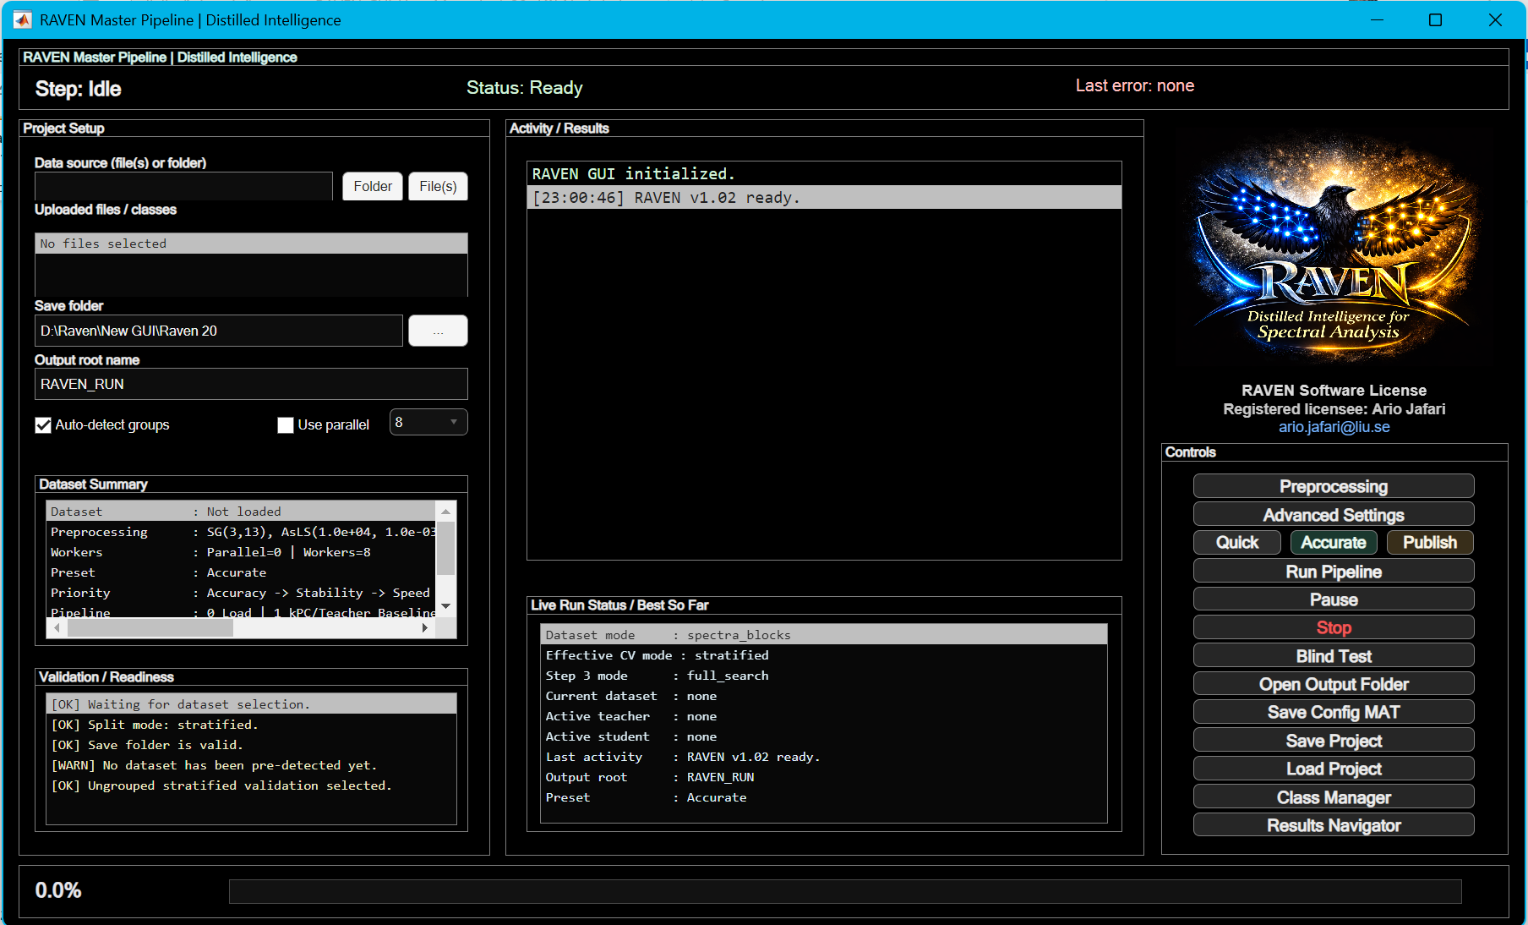
Figure 2. Main RAVEN GUI window immediately after launch, showing Project Setup, Activity / Results, Controls, and bottom progress bar.

2.1 Example workflow
For a small labelled spectral dataset, place one class in each supported file or variable using the standard spectral-block format. Launch RAVEN, import the files with Folder or File(s), and verify the detected classes, sample counts, and spectral range in Project Setup as illustrated in Figure 3.
Open Preprocessing and inspect the class-average spectra before saving the preprocessing settings as illustrated in Figure 5. Use Quick for an initial smoke test. After the data and outputs have been verified, use Accurate or Publish as appropriate, select an output location, and run the full pipeline. Training and model-selection progress can be followed in the live status panel shown in Figure 12.
After completion, inspect the selected model, final metrics, figures, and manifests through Results Navigator as shown in Figure 13. For an unknown sample, open Blind Test, load the final blind-ready package and the blind sample file, and run the post-selection prediction workflow shown in Figures 14 and 15.
The distributed RAVEN_EXAMPLE_RUN folder contains representative outputs from a completed run and can be used to understand the expected folder structure and file types. It is a reference output package and does not replace a raw example input dataset.

2.2 Expected outputs from a successful run
A completed full run should create the stage folders STEP0_PREPROC, STEP1_EMBEDDING, STEP2_LOCALIZATION, STEP3_LOCALAPPROX, and STEP4_FINAL. With the corresponding export options enabled, the run also produces final result workbooks, figures, manifests, timing records, and a blind-ready final model package. Optional benchmark and ablation outputs are generated only when those functions are enabled or reached. Section 9 and Appendix C list the expected files in detail.

3. Installation, package contents, and MATLAB requirements

3.1 Package files

Item | Description
RAVEN_V1_01.m | Main MATLAB launcher for RAVEN_V1_01. Adds the package folders to the MATLAB path, checks whether the generated core is missing or older than the source modules, rebuilds the core when needed, and starts the GUI. It is no longer the large one-file GUI.
build_RAVEN_V1_01_core_from_modules.m | Source builder for the modular package. Concatenates the ordered files in RAVEN_core/source_modules into the generated runnable core file RAVEN_core/RAVEN_V1_01_core.m.
RAVEN_core/RAVEN_V1_01_core.m | Generated runnable GUI core. This file contains the nested GUI callbacks and shared app workspace used during execution. It should normally not be edited directly because it is rebuilt automatically from the source modules.
RAVEN_core/source_modules/ | Editable modular GUI source folder. The GUI is split into ordered modules covering startup/state, default configuration, main UI and license panel, configuration validation and I/O, advanced editor and preprocessing preview, project/run/cache callbacks, pipeline steps, data loading and preprocessing, grouped CV outputs and manifests, CV/evaluation engine, plots/exports/ablation, status/progress/logging, blind testing, teacher/student/benchmark logic, and final close/end handling.
raven_eval_teacher_worker.m | Cross-validates a teacher model for a given PCA and teacher configuration. Produces accuracy, balanced accuracy, weighted accuracy, macro-F1, weighted F1, timing, memory, confusion matrices, and ROC data when requested.
raven_build_teacher_cache.m | Builds reusable fold-specific teacher caches for Step 3 student sweeps. This avoids rebuilding the teacher repeatedly for each student candidate.
raven_eval_student_worker.m | Evaluates the student/distillation model either from a teacher cache or from raw data plus teacher/student configuration.
raven_eval_benchmark_worker.m | Runs optional publication baselines such as PCA_LINSVM, PCA_LDA, and PCA_RF.
IMG_3820.png | Optimized logo image used by the GUI in the logo/license area.
README_RAVEN_V1_01.txt | Short user note explaining how to launch RAVEN_V1_01 and where the editable modular source files are located.
RAVEN_RUN | Generated output directory created during use, not a required source-code file. It can contain Step 0-Step 4 outputs, logs, exported figures, metrics, confusion matrices, ROC data, blind-test reports, and pipeline-status files. In a clean source package this folder may be absent until the GUI is run.
RAVEN_EXAMPLE_RUN | Reference output package from a completed RAVEN run. It contains representative stage outputs, final results, figures, manifests, timing records, and a final blind-ready model package. It is not required to launch the GUI and does not contain the raw example input dataset.

3.2 Installation
RAVEN does not require a separate installer. Extract the complete RAVEN_V1_01 directory to a writable local folder and keep the internal folder structure unchanged.
The launcher depends on RAVEN_core, RAVEN_core/source_modules, the builder, and the companion worker files. If the generated core is missing or older than the editable source modules, RAVEN rebuilds RAVEN_core/RAVEN_V1_01_core.m automatically at launch. The package folder must therefore be writable when a rebuild is required.
After extraction, open MATLAB, change the current folder to RAVEN_V1_01, and run RAVEN_V1_01. The manuscript-facing release is documented using MATLAB R2026a.

3.3 MATLAB requirements
- MATLAB with graphics support for the GUI.
- Statistics and Machine Learning Toolbox is required. The code uses PCA, ECOC/SVM-style classification, LDA, random forest/bagged ensemble utilities, k-means, and table/Excel operations.
- Parallel Computing Toolbox is optional but recommended for large searches. Without it, RAVEN continues in serial mode.
- Excel export functions require MATLAB write support for .xlsx files.
- For large datasets and Publish mode, use sufficient RAM and avoid running unrelated heavy programs during analysis.

3.4 Launching the GUI
Recommended MATLAB commands:
cd('path_to_Raven_V1_01_folder')
RAVEN_V1_01
Startup behavior
On startup, the GUI clears the command window, closes existing figures, initializes random seed 2468, creates the main GUI, sets the default preset to Accurate, and prepares the status panels.

4. Data formats and dataset preparation

4.1 Standard spectral-block format
The standard mode expects one class dataset per numeric matrix/table. Each class block must have this shape:
[nW x (1 + Nspec)] where column 1 = spectral variable / wavenumber, columns 2:end = spectra
- nW is the number of spectral variables, for example Raman shift points.
- Nspec is the number of spectra for that class.
- All values must be finite numeric values after import. Rows containing NaN/Inf are removed during sanitization, and completely empty rows/columns are discarded.
- Spectral variables are sorted ascending during import if needed.
- In preserve-axis mode, all class blocks must share the same spectral-variable axis after cropping.

4.2 Supported input sources
Item | Description
MAT file | One variable per class. Valid numeric matrices or tables are detected as classes. Variable names become class labels after MATLAB-safe name conversion.
Folder | Folder scan accepts .mat, .csv, .txt, .xlsx, and .xls files. Each valid file or valid sheet/variable becomes one class.
Multiple files | The File(s) button supports selecting multiple supported files. The data-source field stores the paths separated by semicolons.
CSV/TXT | One valid numeric table per file. The file name becomes the class label.
Excel | Each valid sheet can be treated as one class. If only one valid sheet exists, the file name is used as the class name.
Base workspace | If the data-source field is empty, the loader scans MATLAB base workspace variables for suitable matrices or tables.
Feature-matrix mode | Advanced mode for MAT files containing X [N x D] and y [N x 1], with optional groupVector and groupNames. This bypasses spectral-block preprocessing.
Blind data exclusion during training
Training data whose detected class name contains “blind” is filtered out by the main training loader. Blind samples should be evaluated from the Blind Test window, not included as training classes.

4.3 Import verification
After import, verify the detected class names, class counts, total number of spectra, spectral dimension, spectral range, and Validation / Readiness messages before preprocessing or model selection. Figure 3 shows the Project Setup checks after a dataset has been loaded. If the detected classes, sample counts, or spectral axis do not match the source data, correct the input files or import settings before continuing.
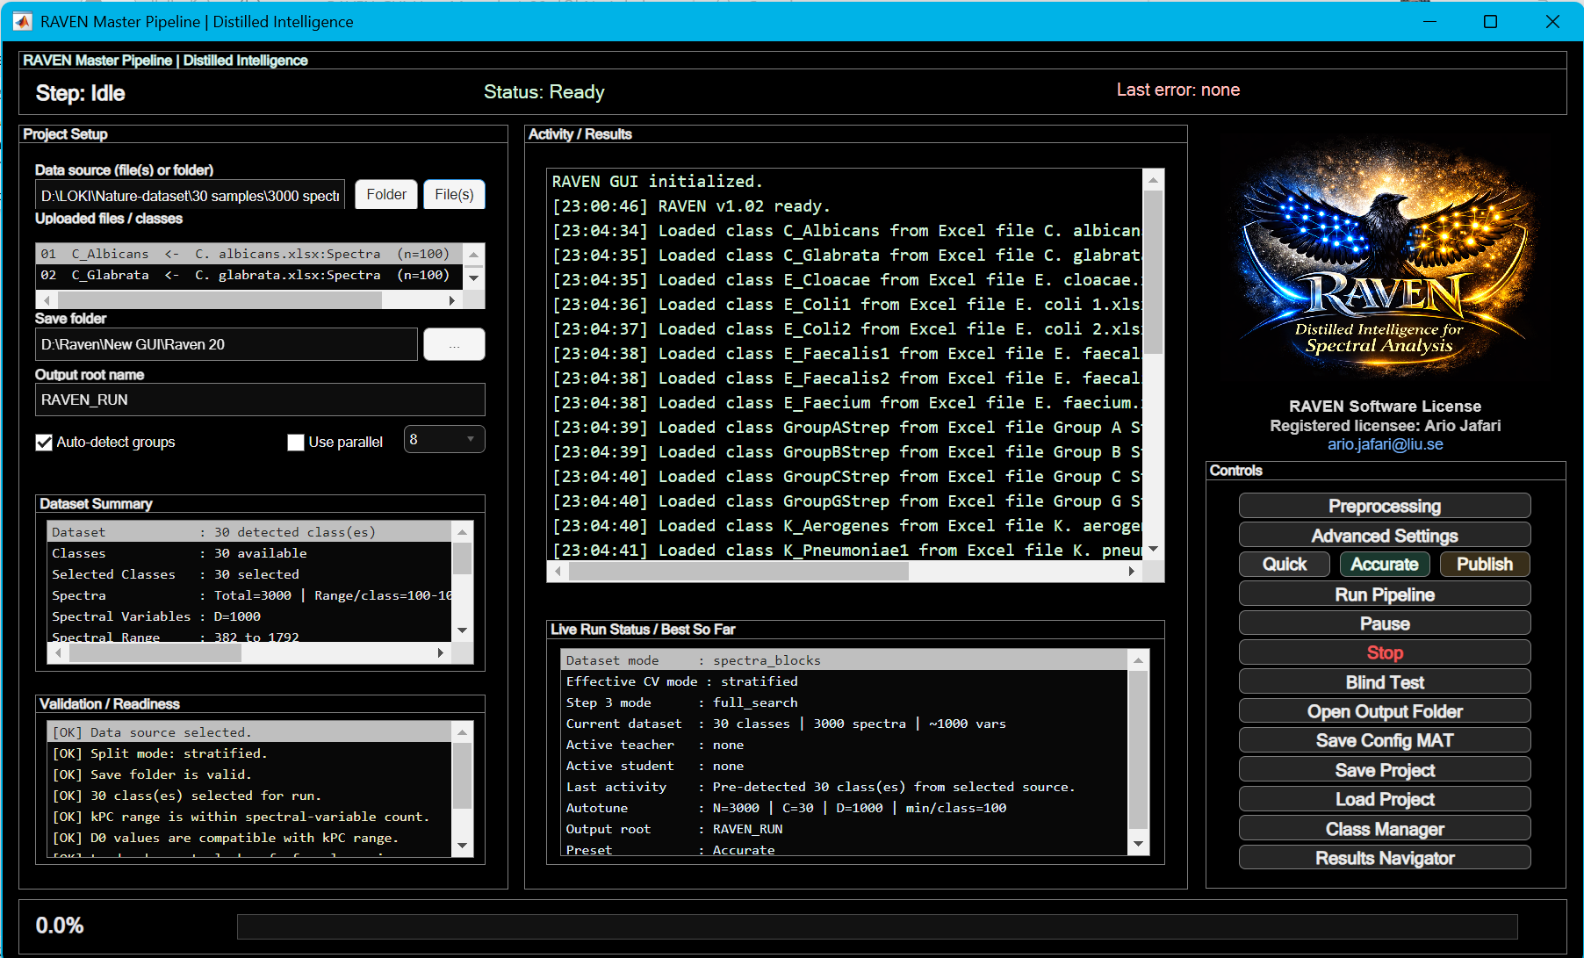
Figure 3. Project Setup panel after loading a dataset, showing detected classes, sample counts, spectral range, and readiness messages.

5. Main window guide
The main window is divided into four operational regions: top status banner, left Project Setup panel, center Activity / Results panel, and right Controls panel.

5.1 Top status banner
Item | Description
Step | Current stage, for example Idle, Step 0 | Load + Preprocess, Step 3 | Student Search, or Completed.
Status | Current run state such as Ready, Running, Finished, or Stopped with error.
Last error | Most recent error message captured by the GUI.

5.2 Project Setup panel
Item | Description
Data source field | Path to a folder, file, or semicolon-separated list of files. Leave empty to scan MATLAB base workspace.
Folder | Browse for a folder containing supported training files.
File(s) | Browse for one or more supported files.
Uploaded files / classes | Detected files and class blocks. Use this list to confirm that the intended classes were detected.
Save base directory | Parent directory where the run root folder will be created.
Root name | Name of the run output folder, default RAVEN_RUN.
Auto-detect groups | Main class/file detection is automatic. Grouped-CV validity is checked separately when groupVector exists.
Use parallel | Enables MATLAB parallel pool use for candidate evaluations when available.
Worker menu | Number of local workers requested when parallel mode is active.
Dataset Summary | Shows class count, selected class count, total spectra, spectral dimension, spectral range, and output information.
Validation / Readiness | Shows whether required paths, output directory, classes, split mode, and grouped-CV conditions are valid.

5.3 Activity / Results panel
Item | Description
Log list | Chronological run messages. It records candidate results, active stage, parallel status, output paths, and errors.
Live Run Status / Best So Far | Compact dashboard with current step, progress, dataset mode, effective CV mode, Step 3 search mode, active teacher, active student, latest activity, best final result, and output root.
Bottom progress bar | Approximate progress indicator updated by pipeline action tracking.

5.4 Controls panel
Item | Description
Preprocessing | Opens the preprocessing preview window with average spectra, standard-deviation shading, class legend, and preprocessing controls.
Advanced Settings | Opens the step-paged configuration editor for Step 0 through Step 4, runtime/CV, and benchmark settings.
Quick | Fast reduced search for smoke tests and debugging. Fewer repeats and smaller grids.
Accurate | Default balanced setting. Uses data-aware auto-tuning when a dataset is loaded.
Publish | Higher-rigor setting for final reporting. Increases repeats and ROC points and expands search lists.
Run Pipeline | Starts Step 0 through Step 4 and optional benchmarks.
Pause | Toggles pause/resume. Pause is checked at safe boundaries, not instantaneously inside every computation.
Stop | Requests a stop at the next safe boundary. A stopped run writes an ERROR timestamp and LATEST_ERROR file.
Blind Test | Opens the blind-sample prediction window using saved blind-ready model packages.
Open Output Folder | Opens the current run root folder if it exists.
Save Config MAT | Saves current app.cfg configuration only.
Save Project | Saves configuration and current state to a project MAT file.
Load Project | Loads a saved RAVEN project MAT file.
Class Manager | Selects which detected classes are included in the pipeline.
Results Navigator | Lists key output folders and files and opens the selected item.

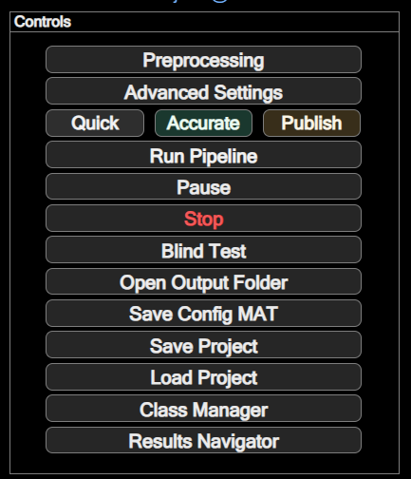
Figure 4. Controls panel with Quick, Accurate, Publish, Run Pipeline, Pause, Stop, Blind Test, project-save, class-manager, and results-navigation buttons.

6. Preprocessing preview and settings
The Preprocessing window lets the user inspect average spectra before full pipeline execution. It computes class mean spectra and standard-deviation shading after the selected preprocessing steps.

6.1 Preprocessing controls
Item | Description
Skip all preprocessing | Bypasses smoothing, derivative, baseline correction, despiking, and normalization. Cropping still applies.
Enable smoothing / derivative | Applies a Savitzky-Golay kernel. Derivative order can be 0, 1, or 2.
SG order | Polynomial order for the Savitzky-Golay kernel. Default is 3.
SG frame | Window length for the Savitzky-Golay kernel. Even values are automatically shifted to the next odd value.
Enable baseline correction | Uses asymmetric least-squares baseline correction.
AsLS lambda | Baseline smoothness penalty. Default is 1e4.
AsLS p | Asymmetry parameter, clamped to the interval above 0 and at most 0.5. Default is 1e-3.
AsLS nIter | Number of AsLS reweighting iterations. Default is 10.
Enable normalization | Applies selected post-baseline normalization.
Normalization mode | L2, NONE, MAX, or SNV.
Cosmic despiking | Optional median-residual despiking. Points with residual greater than 6 x MAD are replaced by local median values.
xMin / xMax crop | Restricts the spectral-variable axis to a selected range.
Range windows | Keeps one or more windows using syntax such as [600 800; 1000 1200].
Update Preview | Redraws the preview using current settings without saving them to the main GUI.
Save Settings | Saves current preprocessing settings into the main pipeline configuration and exports PREPROCESSING_AVERAGE_SPECTRA.xlsx when possible.

6.2 Recommended preprocessing practice
- Start with the default SG(3,13), AsLS baseline, and L2 normalization for Raman/SERS-style spectra.
- Use cropping or range windows to remove uninformative or noisy spectral regions before PCA.
- Use cosmic despiking only when sharp isolated spikes are visible; it can suppress real narrow bands if used carelessly.
- For spectra with strong global intensity differences, compare L2 and SNV. For datasets where absolute intensity is biologically meaningful, test NONE or MAX with caution.
- After every preprocessing change, inspect whether class means remain physically plausible and whether important bands are preserved.

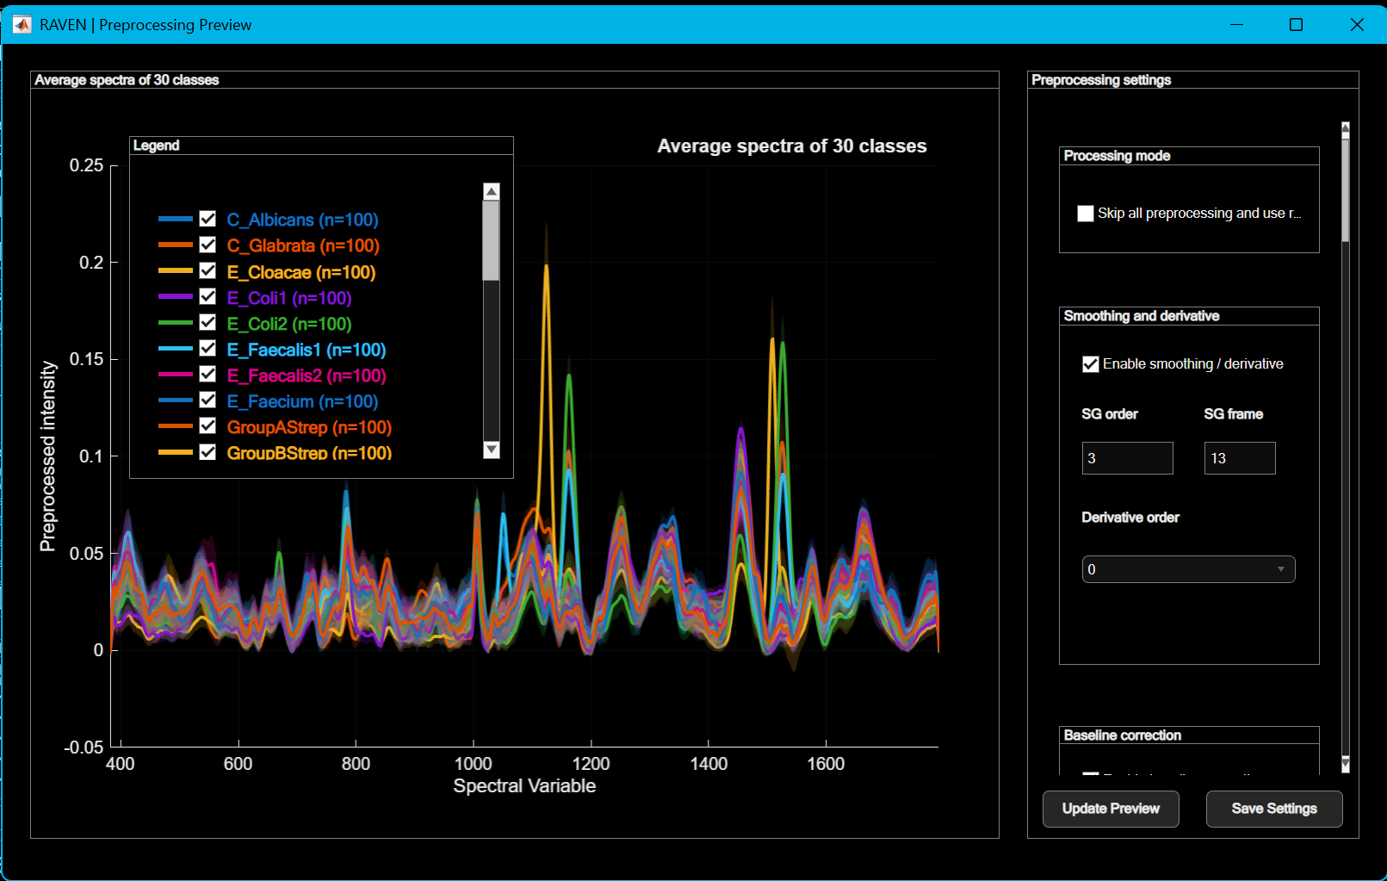
Figure 5. Preprocessing Preview window showing average spectra with standard-deviation shadows, class legend, and preprocessing settings.

7. Advanced settings pages
Advanced Settings opens a modal, step-paged editor. Use it for reproducibility and publication-quality control. The settings are grouped by pipeline stage so that preprocessing, CV, teacher search, student search, final selection, runtime, and benchmarks can be changed separately.

7.1 Step 0 - Data and Preprocessing
Item | Description
Input mode | spectra_blocks or feature_matrix.
Common axis mode | preserve, intersect, or resample. preserve requires matching axes; intersect/resample build a common axis.
Target length | Optional output length for resampling or feature-matrix truncation/padding.
Segmentation | Optional windowing of spectra/features into shorter segments using segment length and stride.
Preprocessing enable | Master switch for preprocessing operations.
SG / AsLS / normalization fields | Same preprocessing controls as the preview window.

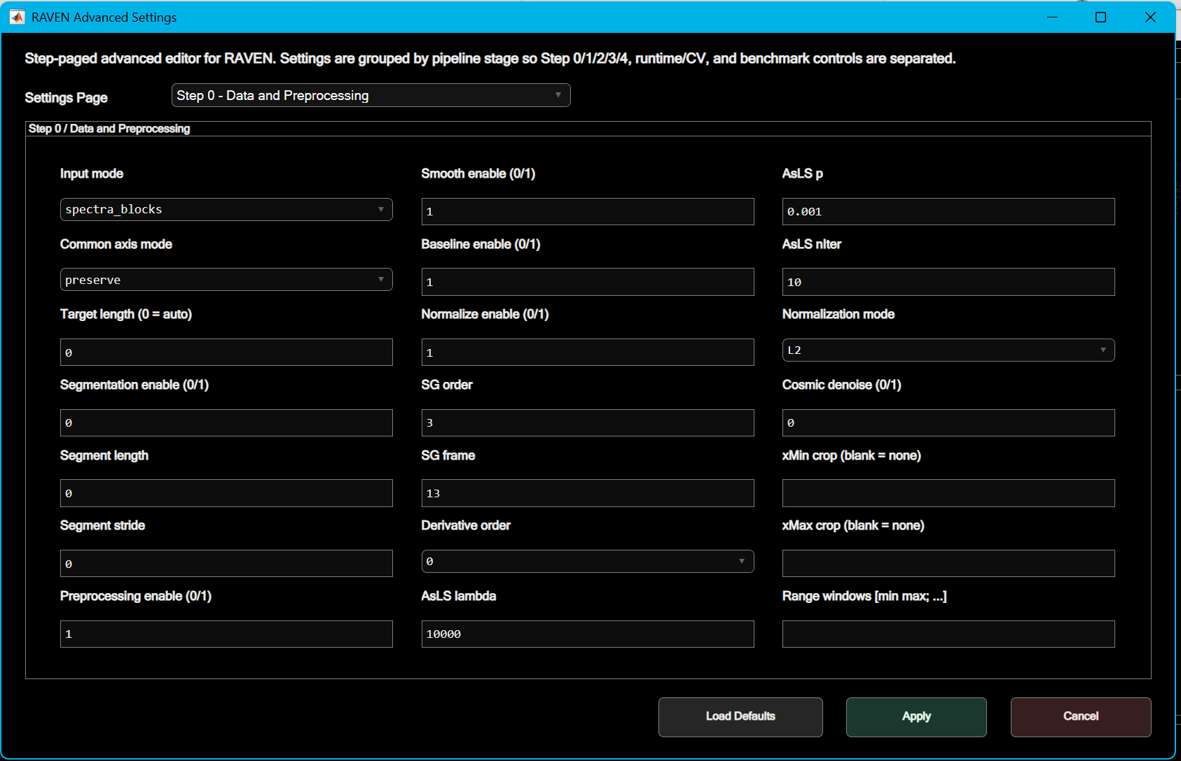
Figure 6. Advanced Settings dialog showing the Settings Page selector and Step 0 / Data and Preprocessing controls.

7.2 Step 1 - CV PCA and Teacher Baseline
Item | Description
Outer CV folds | Number of cross-validation folds. Defaults to 5 but can be auto-reduced for small class sizes.
Outer CV repeats | Number of repeated CV rounds. More repeats improve stability at higher runtime cost.
Split mode | stratified or grouped. Grouped mode requires a valid groupVector.
Seed base | Base random seed for reproducibility.
kPC list | PCA component values tested in Step 1.
PCA mode | fixedlist, single, or variance.
Teacher baseline mLand/rTeach/sigmaScale/BoxC | Teacher parameters used during initial kPC search.

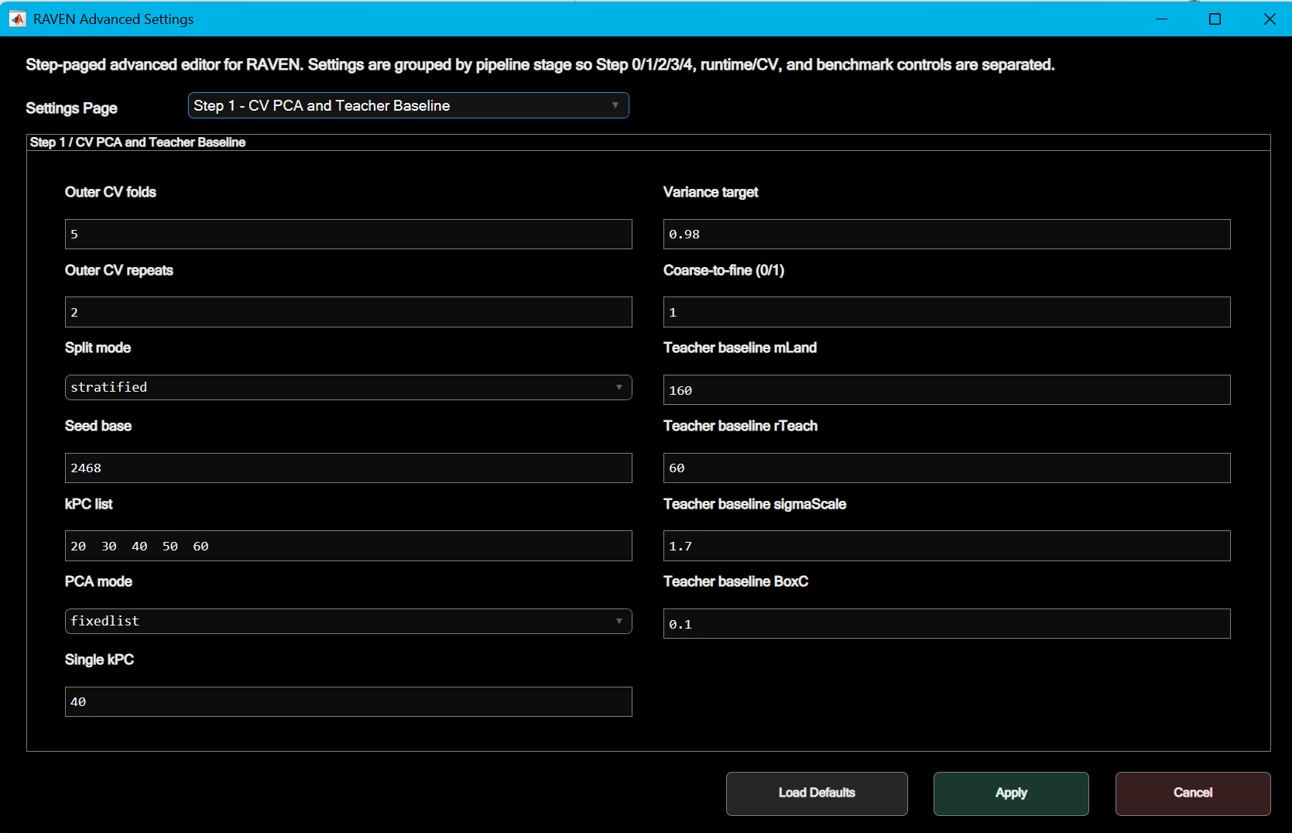

Figure 7. Advanced Settings dialog showing the Settings Page selector and Step 1 / CV PCA and Teacher Baseline

7.3 Step 2 - Teacher Search
Item | Description
Teacher mLand list | Landmark count list for teacher candidates.
Teacher rTeach list | Teacher rank/representation size list.
Teacher sigmaScale list | RBF kernel scale multipliers.
Teacher BoxC list | SVM/ECOC box-constraint list.
Shortlist N | Number of Step 2 teacher candidates carried into Step 3.
kmeans replicates | Replicates for k-means operations used in older/local components and diagnostics.
topKGate | 0 means dense gating. Positive values restrict gating to top K components where applicable.

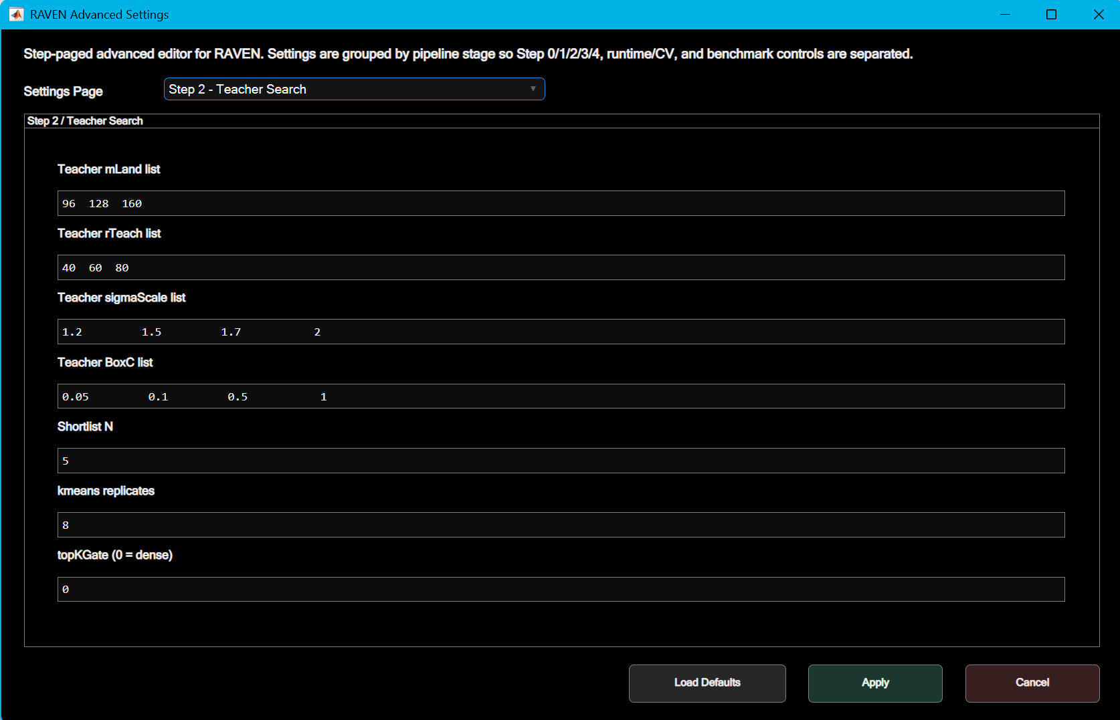
Figure 8. Advanced Settings Step 2 page for teacher search grid configuration.

7.4 Step 3 - Student Search
Item | Description
Search mode | full_search, fast_search, single_teacher_sweep, or single_candidate.
pHidden list | Number of hidden random features for the student model.
lamRidge list | Ridge regularization values for student output fitting.
alpha list | Soft-target mixing weight. Higher alpha gives more weight to teacher probabilities; lower alpha gives more weight to one-hot labels.
temp list | Temperature applied to teacher scores before soft-target construction.
skipScale list | Optional direct skip connection scale from PCA scores to student features.
ensemble list | Number of random student members to average.
Teacher shortlist N | Number of teacher configurations from Step 2 used in Step 3.
Student shortlist N | Number of top Step 3 candidates retained for final confirmation.
Minimum accuracy ratio | Filters out student candidates that fall below a minimum ratio to teacher accuracy.

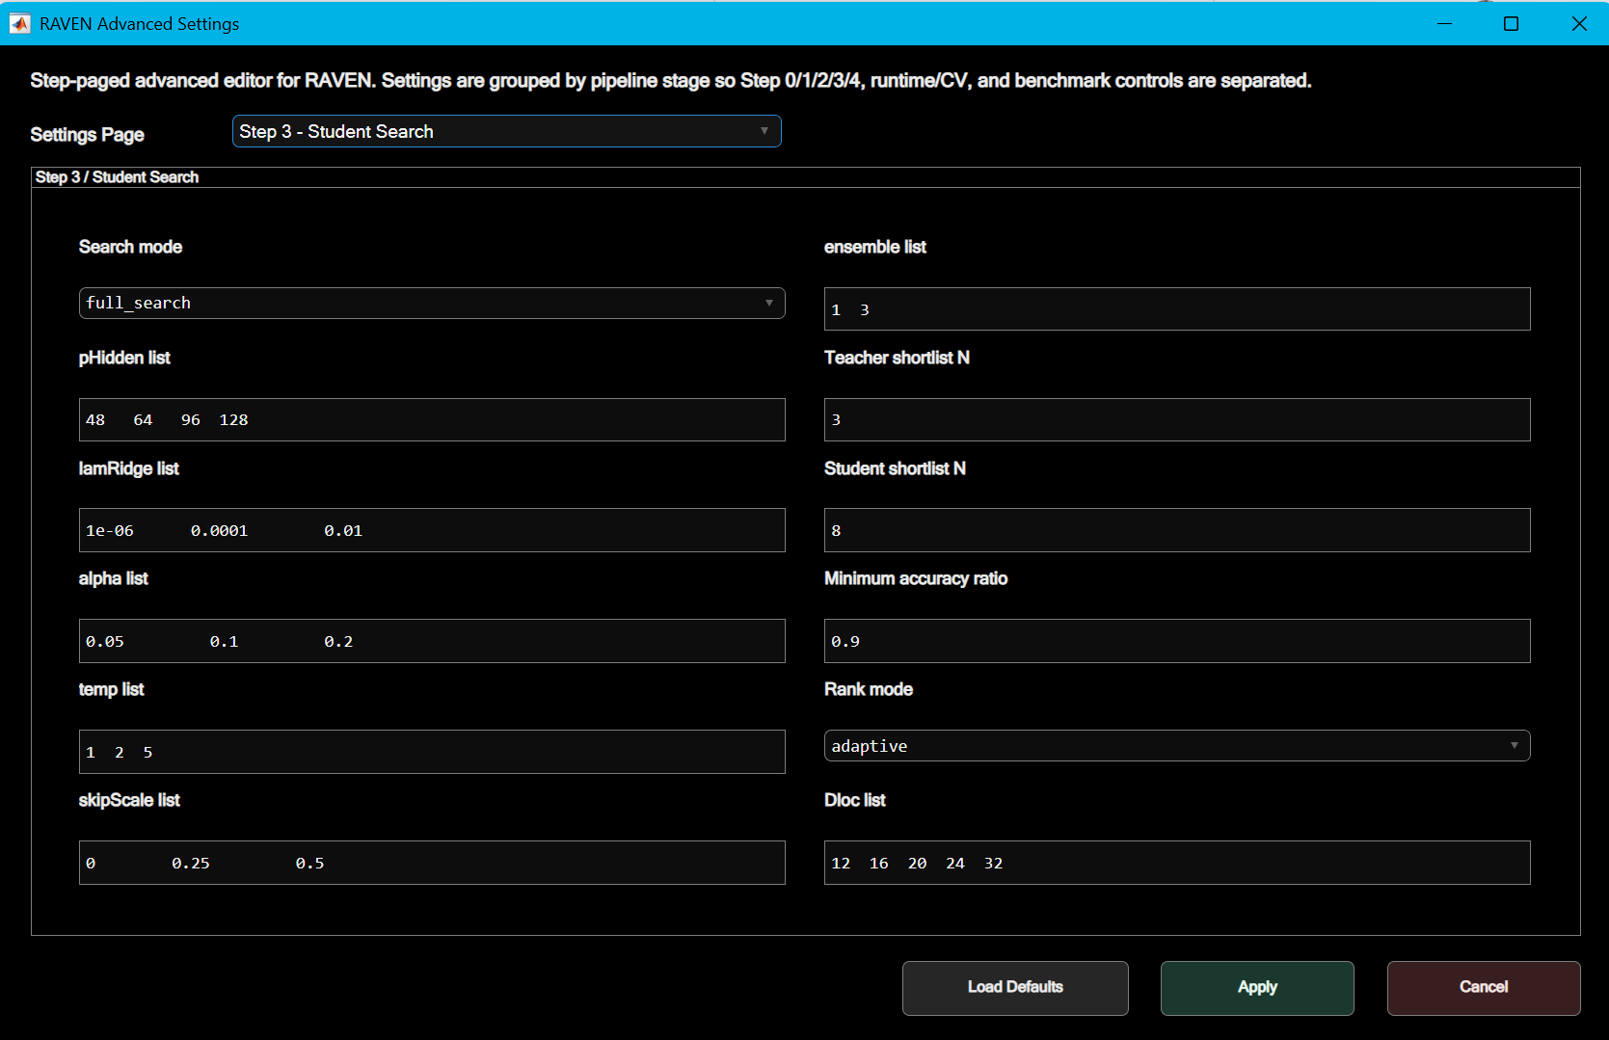
Figure 9. Advanced Settings Step 3 page for student distillation search configuration.

7.5 Step 4 - Final Selection
Item | Description
Winner policy | Bestscore or bestaccuracy. The code sorts finalists by the selected policy before choosing the final role.
Top finalists per bucket | Number of finalists retained from each bucket such as BestAccuracy, BestScore, and BestMemory.
repeatsFast | Repeat count for non-priority finalists.
repeatsBestAccuracy | Final confirmation repeat count for the best-accuracy candidate.
repeatsBestScore | Final confirmation repeat count for the best-score candidate.
repeatsBestMemory | Final confirmation repeat count for the memory-efficient candidate.
Accuracy threshold fraction | Threshold used when selecting low-memory candidates above an accuracy fraction of the best accuracy.
Number of ROC points | Resolution of ROC grid exports. Publish mode sets this higher than Quick mode.

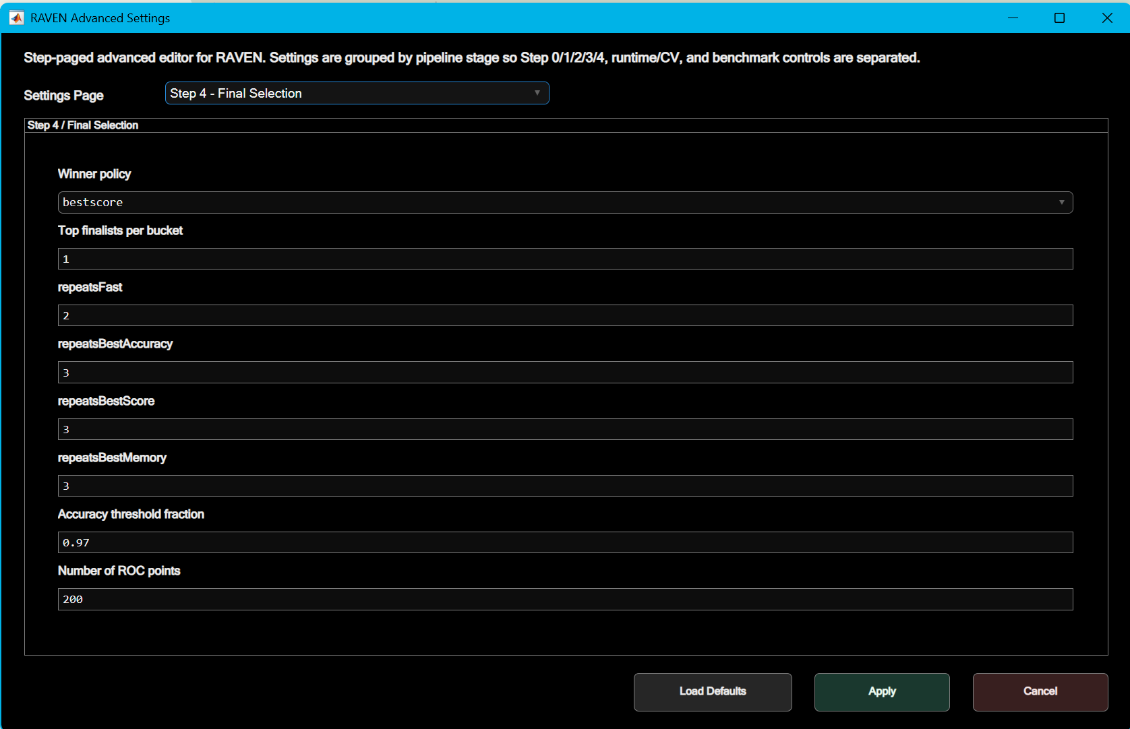
Figure 10. Advanced Settings Step 4 page for final-selection repeat counts, winner policy, and ROC resolution.

7.6 CV/runtime and benchmark pages
Item | Description
Parallel workers | Number of workers requested for parallel candidate evaluation.
Pause poll sec | Pause/stop polling interval.
Save intermediate | Controls whether intermediate MAT files are written.
Save PNG / Save Excel | Controls figure and spreadsheet exports.
Verbose / Verbose timing | Controls detailed logs and per-stage timing messages.
Save run manifest | Exports RUN_MANIFEST.mat and RUN_MANIFEST.txt.
Export split summary | Exports split and grouped-CV summaries.
Export master report | Exports consolidated MASTER_REPORT.xlsx and related metadata.
Export data disposition | Exports per-class sample-count and source-disposition information.
Benchmark methods | Optional baselines: PCA_LINSVM, PCA_LDA, and PCA_RF.

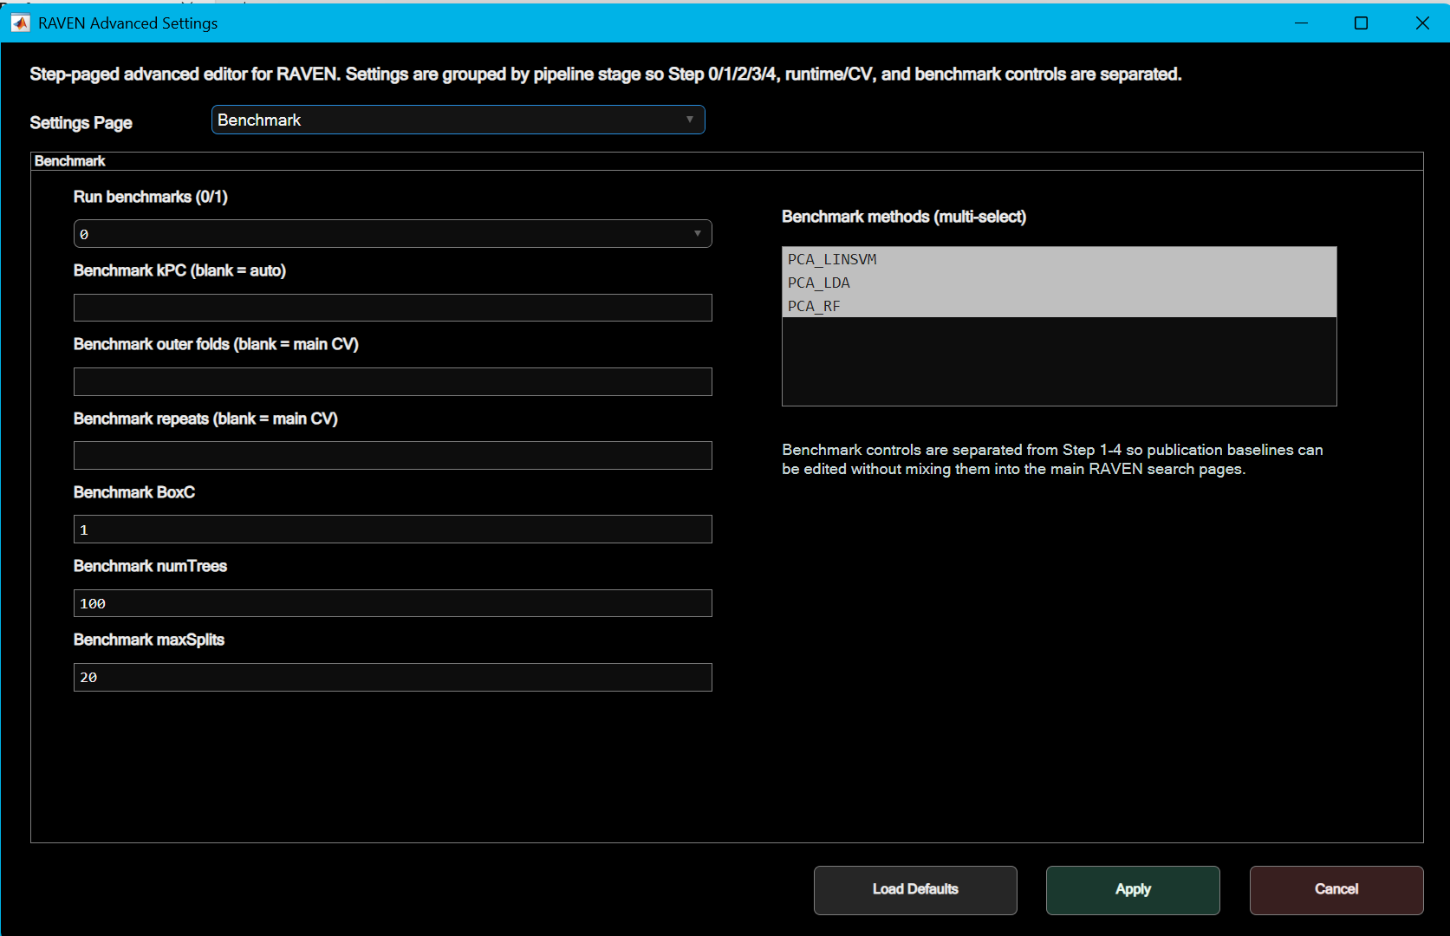
Figure 11. Advanced Settings Benchmark page with multi-select baseline methods and benchmark control fields.

8. Pipeline stages and model logic
RAVEN separates data preparation, model selection, final confirmation, and blind prediction into distinct stages. Steps 1 to 3 perform cross-validated PCA, teacher selection, and student distillation. Step 4 confirms shortlisted students and exports the selected configuration. Blind samples are excluded from model selection and are evaluated only after the final configuration has been selected.

8.1 Step 0 - Load + preprocess
Step 0 loads the selected data source, filters selected classes, adapts the input representation, applies preprocessing, and saves the preprocessed dataset. For spectra_blocks mode, each class block is converted into sample rows where each spectrum becomes one row of X_all and receives a class index in y_idx.
- Main outputs: PREPROCESSED_DATA.mat, DATA_DISPOSITION.xlsx, SPLIT_SUMMARY.xlsx/txt, and optionally GROUP_SUMMARY.xlsx/txt.
- Preprocessed MAT variables include W, X_all, y_idx, groupNames, sampleCounts, and adapterMeta.
- If axes do not match in preserve mode, Step 0 stops with a spectral-variable axis mismatch error.

8.2 Step 1 - PCA / teacher-baseline search
Step 1 searches kPC values. For each kPC, a teacher configuration is evaluated by repeated cross-validation. Selection prioritizes accuracy, then macro-F1, then score. The best kPC is carried into Step 2.
- Main outputs: STEP1_RESULTS.mat, STEP1_RESULTS.xlsx, and FIGURES/STEP1_kPC.png.
- Metrics include Acc, BalAcc, WeightedAcc, MacroF1, WeightedF1, memory per spectrum, wall time, prediction time per spectrum, feature dimension, and Score.

8.3 Step 2 - Teacher search
Step 2 uses the best kPC from Step 1 and searches the teacher grid over landmark count, teacher rank/representation size, sigma scale, and BoxC. Candidates are sorted by accuracy, macro-F1, score, and wall time. A teacher shortlist is passed to Step 3.
- Main outputs: STEP2_RESULTS.mat, STEP2_RESULTS.xlsx, and FIGURES/STEP2_teacher_search.png.
- The shortlist size is controlled by Shortlist N.

8.4 Step 3 - Student search / score distillation
Step 3 builds teacher caches for shortlisted teachers and evaluates student models over hidden-feature size, ridge penalty, soft-target mixing weight, temperature, skip-scale, and ensemble count. The student is trained to approximate a mixture of teacher soft probabilities and one-hot labels. This is the main distillation stage.
- Search modes reduce runtime by limiting teachers and/or student grid size.
- Candidates below the minimum accuracy ratio to the teacher are removed.
- Main outputs after completion: STEP3_RESULTS.mat, STEP3_RESULTS.xlsx, STEP3_BEST_TEACHER_COMPARISON.xlsx/mat, and Step 3 figures.
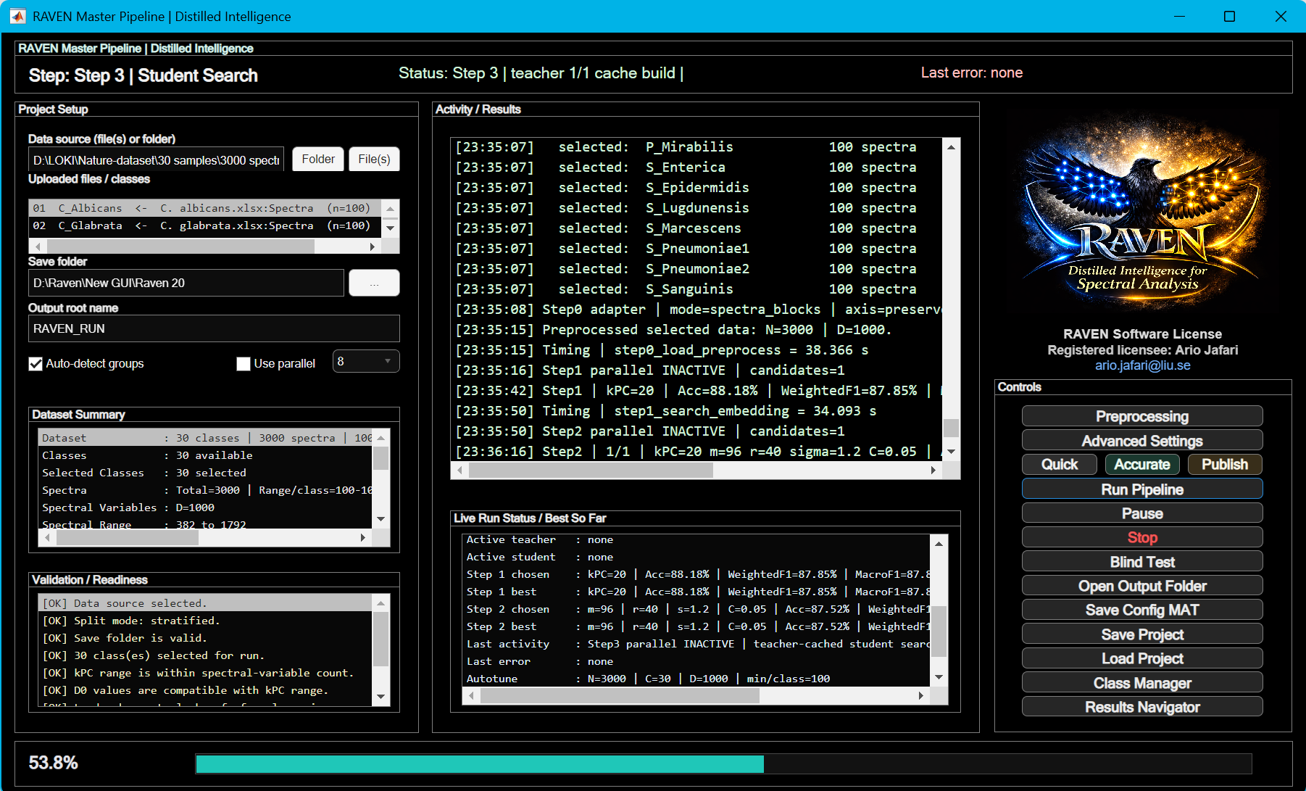
Figure 12. Live Run Status / Best So Far panel during Step 3 student search, showing active teacher, active student, current candidate, and best-so-far metrics.

8.5 Step 4 - Final confirmation and export
Step 4 selects finalists from the Step 3 table, reruns them with stronger repeat counts, exports final plots and tables, chooses the final winner, saves blind-ready model packages, and exports an ablation suite.
- Primary finalist buckets: BestAccuracy, BestScore, and BestMemory or memory-efficient candidates above the accuracy threshold.
- Main outputs: STEP4_SELECTION_SUMMARY.xlsx, FINAL_RESULTS.xlsx, STEP4_WINNER.txt, ALL_FINAL_SELECTIONS.mat, final confusion matrices, ROC plots, and blind model packages.
- Blind-ready packages include FINAL_WINNER_BLIND_MODEL.mat and, when available, BestAccuracy_BLIND_MODEL.mat.

8.6 Prediction behavior
During cross-validation, predictions are generated only for spectra held out from the active training fold. The Step 4 confirmation stage repeats evaluation of the shortlisted finalists before the final role is selected.
For blind prediction, the saved blind-ready package stores the locked preprocessing settings, selected model configuration, training data, and metadata required by the blind module. For each blind repeat, the selected finalist is refitted on the full training data and then applied to the blind spectra. Votes are aggregated across spectra and repeats. Blind majority-vote percentages therefore summarize repeated predicted-label agreement and should not be interpreted as calibrated probabilities.

9. Exporting results and generated files
RAVEN writes outputs to the run root defined by Save base directory and Root name. The exact file set depends on the enabled export, benchmark, and ablation settings, but completed stages use standardized folder and file names so that a run can be traced from preprocessing through final selection.
The GUI creates the run root folder from Save base directory + Root name. By default, this becomes RAVEN_RUN. Each run creates standardized subfolders.
Item | Description
STEP0_PREPROC | Preprocessed dataset, data disposition, split summary, group summary, preprocessing average spectra workbook.
STEP1_EMBEDDING | Step 1 MAT and Excel results.
STEP2_LOCALIZATION | Step 2 MAT and Excel results.
STEP3_LOCALAPPROX | Step 3 candidate table, top candidates, teacher comparison, and associated MAT/Excel files.
STEP4_FINAL | Finalist reports, final results, winner text, blind-ready models, and per-finalist folders.
BENCHMARKS | Optional baseline benchmark results.
FIGURES | Pipeline-level PNG figures such as kPC search, teacher search, final confusion matrices, and ROC curves.
ABLATION_EXPORT | Ablation summary and per-selection spreadsheets produced after final confirmation.
root-level files | RUN_MANIFEST, OUTPUT_MANIFEST, OUTPUT_METADATA, MASTER_REPORT, TIMING_REPORT, and ERROR logs when applicable.

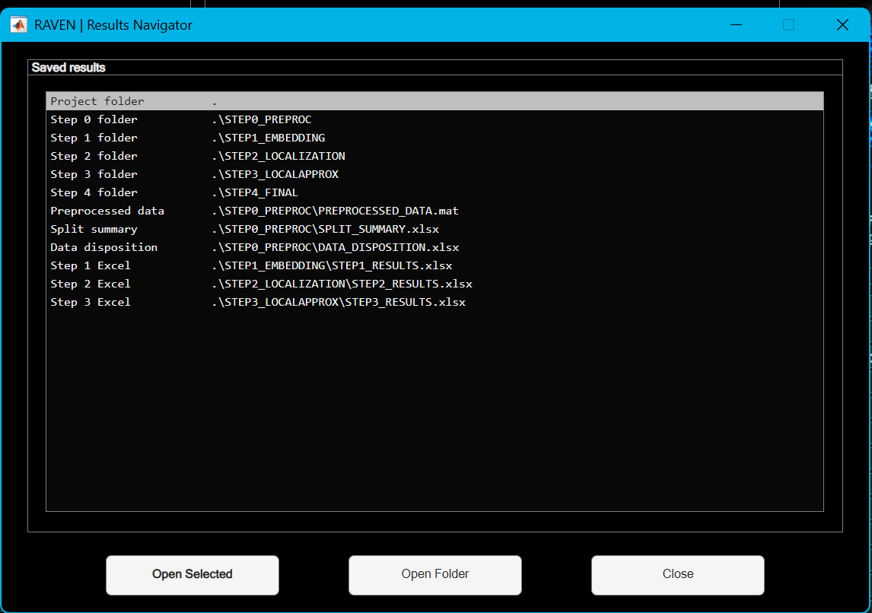
Figure 13. Results Navigator window after a successful run, showing key folders and files that can be opened directly from the GUI.

9.1 Key final files
Item | Description
FINAL_RESULTS.xlsx | Main final-result workbook: summary, configuration, per-class metrics, confusion matrices, ROC AUC, ROC grid, and micro/macro ROC tables.
STEP4_SELECTION_SUMMARY.xlsx | Finalist comparison and candidate configuration sheets.
STEP4_WINNER.txt | Plain-text summary of final winner role, candidate ID, and key metrics.
FINAL_WINNER_BLIND_MODEL.mat | Blind-ready package for the selected final winner. It stores the locked configuration, training data, preprocessing state, and metadata needed for post-selection refit-and-vote blind prediction.
BestAccuracy_BLIND_MODEL.mat | Optional blind-ready package for the best-accuracy finalist when that role is exported. It is used by the same post-selection refit-and-vote blind workflow.
MASTER_REPORT.xlsx | Consolidated workbook combining major tables across stages.
TIMING_REPORT.xlsx/txt | Per-stage runtime summary.
LATEST_ERROR.txt | Created only when an error or user stop is recorded. It contains the most recent error or stop message and is useful for troubleshooting.

10. Interpreting results

10.1 Core classification metrics
Item | Description
Acc | Overall accuracy: fraction of spectra classified correctly.
BalAcc | Balanced accuracy: average recall across classes.
WeightedAcc | Class-support-weighted recall; useful when class sizes are unequal.
MacroF1 | Unweighted mean F1 across classes. Important when all classes should be treated equally.
WeightedF1 | Class-support-weighted F1. Useful when reporting performance under class imbalance.
RatioToTeacher | Student accuracy divided by teacher accuracy. Used to avoid choosing students that compress too aggressively.
Score | Composite selection score combining accuracy/F1, teacher-ratio, speed, and memory terms depending on stage.
PredictMsPerSpec | Deployment-oriented prediction time per spectrum reported by the evaluation and export routines.
MemMiBPerSpec | Software-derived deployment memory proxy per spectrum used for relative model comparison. It is not total system RAM usage.
MacroAUC / MicroAUC | ROC area summaries when ROC export is enabled.

10.2 Recommended interpretation hierarchy
- First check whether every class has adequate support and whether cross-validation mode is valid.
- Use Accuracy together with MacroF1 and Balanced Accuracy. Accuracy alone can hide minority-class failure.
- For publication, report WeightedF1 and MacroF1 together when classes are imbalanced.
- Inspect confusion matrices before claiming strain-level or species-level discrimination.
- Use prediction time and memory to justify deployment claims, not biological or analytical validity.
- Treat blind-sample majority vote as an application result from the saved model, not a substitute for independent test-set validation.

11. Blind-sample testing
The Blind Test window uses a saved blind-ready package to evaluate an unknown sample after model selection. The package contains the locked preprocessing and model configuration together with the training data required for the blind workflow. For each requested repeat, RAVEN refits the selected finalist on the full training data, predicts the blind spectra, and aggregates class votes across spectra and repeats..
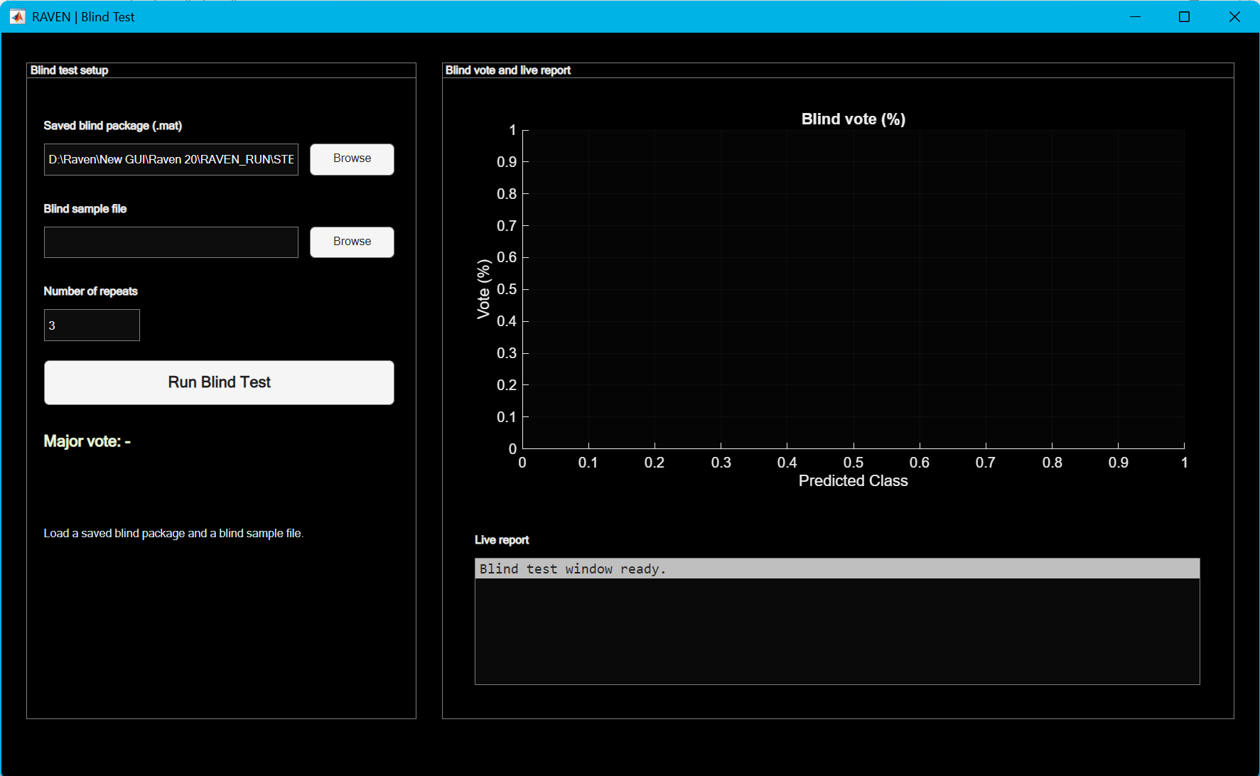
Figure 14. Blind Test window before running, showing saved model package path, blind sample file path, repeat count, and Run Blind Test button.

11.1 Blind-sample input format
The blind file must contain one valid spectral block with first column as spectral variable and columns 2:end as blind spectra. Supported blind files include MAT, CSV/TXT, and Excel when the loader finds exactly one valid block.
- Use the same wavenumber/spectral axis as the training data.
- Do not add a class label column. Blind spectra are unknown samples.
- Do not include multiple valid blocks in the same blind file unless you intend to split them manually.

11.2 Blind-test outputs
Item | Description
BLIND_TEST_RESULTS.xlsx | Summary, mean votes, votes by repeat, and first-repeat per-spectrum predictions with class scores.
Blind_vote_percentages.png | Bar plot of mean class vote percentage with standard deviation over repeats.
BLIND_EVALUATION_SUMMARY.txt | Plain-text summary with blind file, package role, number of spectra, major class, and mean vote by class.

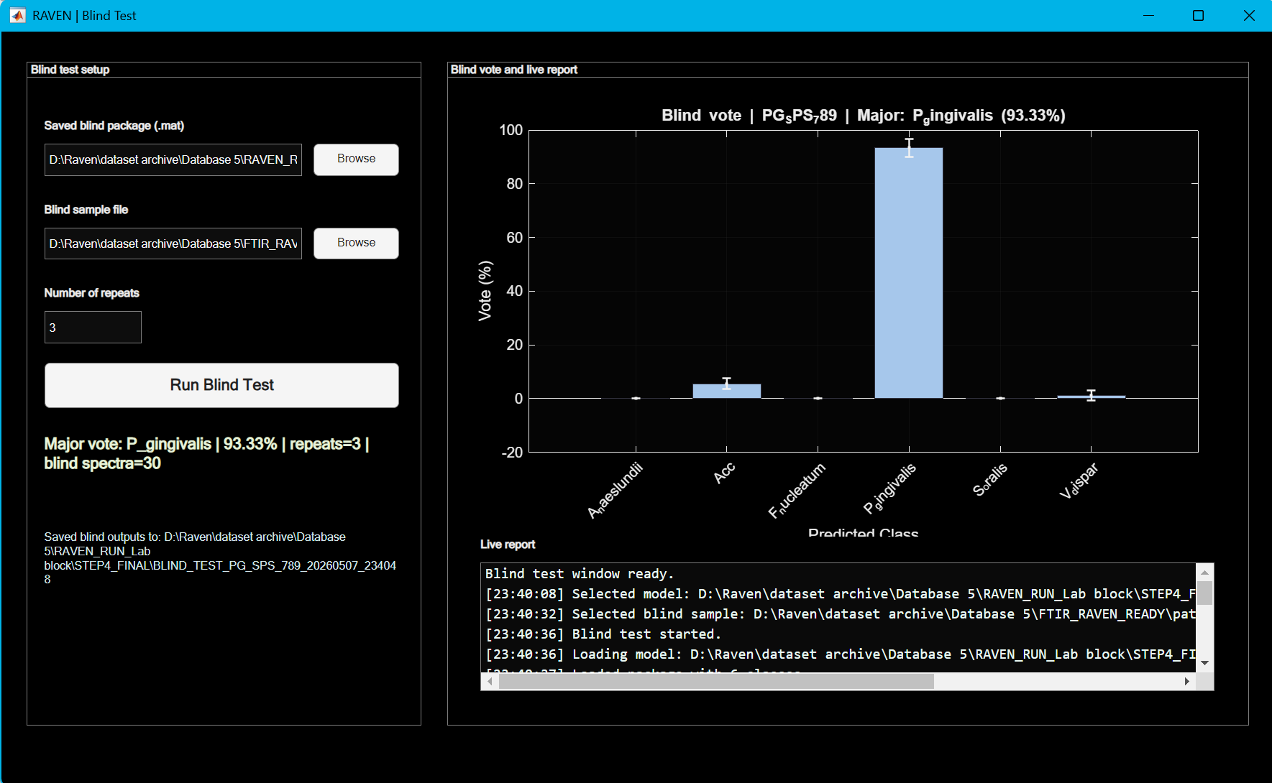
Figure 15. Blind Test window after prediction, showing major vote, live report, and saved output path.

12. Saving/loading configurations and projects
Item | Description
Save Config MAT | Saves only app.cfg. Use this to preserve preprocessing, search, CV, runtime, and benchmark settings without saving large state/results.
Save Project | Saves cfg and state. Use this when you want to preserve detected data, run state, and current results.
Load Project | Loads a MAT project file with cfg and state. The GUI validates whether the file has the expected RAVEN project fields.
Recommended naming | Use dataset, date, and preset in filenames, for example RAVEN_Ecoli_Saureus_Publish_2026-05-05_PROJECT.mat.

13. Troubleshooting and quality-control checklist

13.1 Common errors
Item | Description
No suitable datasets found | The file/folder does not contain a numeric matrix/table with at least 10 rows and at least two columns. Check import formatting and remove text-only columns.
Spectral-variable axis mismatch | Class blocks do not share the same axis in preserve mode. Use common-axis intersect/resample or prepare files with identical axes.
Chosen x-axis limits removed all wavenumbers | Crop or range-window settings exclude all spectral variables. Correct xMin/xMax or range windows.
Grouped CV fallback | Grouped split was requested but groupVector was missing, wrong length, had missing values, or did not contain enough groups per fold/class.
No student configuration reached minimum accuracy ratio | Step 3 students were too weak relative to teacher. Lower minAccRatio, enlarge pHidden, increase ensemble, or inspect teacher settings.
Stopped by user | Stop was pressed during a safe boundary. The run writes ERROR_*.txt and LATEST_ERROR.txt. Outputs from completed earlier steps remain usable.
Parallel setup failed | MATLAB could not start or match the requested parallel pool. The GUI continues serially.
Blind axis mismatch | Blind sample spectral axis does not match the trained package. Re-export blind spectra on the same axis used for training.
Missing RAVEN_core or source_modules | The package was extracted incompletely or only the launcher was copied. Restore the complete RAVEN_V1_01 directory, including RAVEN_core/source_modules and the companion worker files.
Generated core rebuild failed | RAVEN could not rebuild RAVEN_core/RAVEN_V1_01_core.m. Confirm that the package structure is complete and that the RAVEN_V1_01 folder is writable, then launch RAVEN_V1_01 again.
Excel or figure export failed | Confirm that the output folder is writable, the target workbook is not locked by another program, and the corresponding Save Excel or Save PNG option is enabled. Completed numerical stages may still be available in MAT files.

13.2 Pre-run QC checklist
- Confirm that the complete RAVEN_V1_01 package is extracted to a writable folder and that MATLAB can locate the launcher and required worker files.
- Confirm that Statistics and Machine Learning Toolbox is available before starting model selection. Enable Parallel Computing Toolbox only when parallel execution is required.
- Confirm each class has enough spectra for the requested number of CV folds.
- Confirm class names are correct and no blind/unknown file is included in training.
- Confirm axes are identical or choose a common-axis strategy.
- Inspect preprocessing preview before running full searches.
- Use Quick first to verify data loading and outputs; use Accurate or Publish only after the smoke test succeeds.
- Check whether parallel workers are realistic for available CPU/RAM.
- Keep one output root per experimental run to avoid overwriting previous results.

13.3 Post-run QC checklist
- Open STEP4_WINNER.txt and verify the winner role and candidate ID.
- Open FINAL_RESULTS.xlsx and inspect Summary, PerClassMetrics, CM_Counts, CM_RowPct, and ROC_AUC.
- Inspect confusion matrices visually before writing claims.
- Check TIMING_REPORT.xlsx before making speed claims.
- Check RUN_MANIFEST.txt and OUTPUT_METADATA.xlsx before sharing the run package.
- For manuscript figures, use exported PNGs together with their corresponding Excel source sheets.

Appendix A. Settings glossary
Item | Description
kPC | Number of principal components retained from PCA before teacher/student modelling.
mLand | Number of landmarks used in teacher/Nyström-style approximations.
rTeach | Teacher representation/rank parameter used by the RAVEN teacher search.
sigmaScale | Multiplier applied to automatic kernel width estimation.
BoxC | Classification regularization/box-constraint term for teacher models.
pHidden | Student hidden-feature count.
lamRidge | Ridge penalty used when fitting student outputs.
alpha | Soft-target mixing weight between teacher probabilities and one-hot labels.
temp | Temperature used to soften teacher score distributions.
skipScale | Direct skip contribution from PCA scores into the student model.
ensemble | Number of random student members averaged together.
minAccRatio | Minimum accepted student-to-teacher accuracy ratio.
topKGate | Restriction of soft gating to top K gates; 0 means dense/full gating.
rho | Adaptive rank energy threshold in legacy/local approximation components.
ridge | Numerical/kernel ridge term in legacy/local approximation components.
numROC | Number of points in ROC export grid.

Appendix B. Data-format examples

B.1 MAT file with one variable per class
% Each variable is [nW x (1+Nspec)]
EC25922 = [wavenumber, ec_spectra_matrix];
SA25923 = [wavenumber, sa_spectra_matrix];
save('training_classes.mat','EC25922','SA25923')

B.2 Feature-matrix MAT mode
% Advanced Settings > Step 0 > Input mode = feature_matrix
X = feature_matrix; % [N x D]
y = class_labels; % [N x 1]
groupVector = batch_id; % optional, for grouped CV
groupNames = {'Class_A','Class_B'};
save('features.mat','X','y','groupVector','groupNames')

Appendix C. Output tree
RAVEN_RUN/
STEP0_PREPROC/
PREPROCESSED_DATA.mat
DATA_DISPOSITION.xlsx
SPLIT_SUMMARY.xlsx / SPLIT_SUMMARY.txt
GROUP_SUMMARY.xlsx / GROUP_SUMMARY.txt
PREPROCESSING_AVERAGE_SPECTRA.xlsx
STEP1_EMBEDDING/
STEP1_RESULTS.mat
STEP1_RESULTS.xlsx
STEP2_LOCALIZATION/
STEP2_RESULTS.mat
STEP2_RESULTS.xlsx
STEP3_LOCALAPPROX/
STEP3_RESULTS.mat
STEP3_RESULTS.xlsx
STEP3_BEST_TEACHER_COMPARISON.xlsx
STEP4_FINAL/
STEP4_SELECTION_SUMMARY.xlsx
FINAL_RESULTS.xlsx
STEP4_WINNER.txt
FINAL_WINNER_BLIND_MODEL.mat
BestAccuracy_BLIND_MODEL.mat
FIGURES/
STEP1_kPC.png
STEP2_teacher_search.png
STEP3_dim_vs_F1.png
FINAL_CM_counts.png
FINAL_CM_rowpct.png
FINAL_ROC.png
BENCHMARKS/
BENCHMARK_RESULTS.xlsx
BENCHMARK_SUMMARY.txt
ABLATION_EXPORT/
ABLATION_SUMMARY.xlsx
ABLATION_SUMMARY.txt
RUN_MANIFEST.txt
MASTER_REPORT.xlsx
OUTPUT_MANIFEST.txt
OUTPUT_METADATA.xlsx
TIMING_REPORT.xlsx
LATEST_ERROR.txt % only if an error or user stop occurs

