

**Coding Academy By Orange**

**Camertaic Platform**

**By**

**Jafer Basel Al-Dakhily**

**Table of Contents**

|  |  |
| --- | --- |
| TITLE | PAGE |
| ACKNOWLEDGEMENT | **I** |
| ABSTRACT | **II** |
| CHAPTER ONE: INTRODUCTION AND BACKGROUND | **1** |
| 1.1 Background | 2 |
| 1.2 Objective | 3 |
| 1.3 Research Methodology | 7 |
| CHAPTER TWO: REQUIREMENTS AND ANALYSIS | **13** |
| 2. Requirements and Analysis | 14 |
| 2.1. Functional Requirements | 14 |
| 2.1.1 User | 17 |
| 2.1.2 Admin | 17 |
| 2.2 Non-Functional Requirements | 17 |
| 2.2.1 Security |  |
| 2.3 Test Case |  |
| CHAPTER THREE: SYSTEM DESIGN AND METHODOLOGY | **25** |
| 3. Methodology | 26 |
| 3.1 Technologies and tools | 26 |
| 3.2 Methodology Process | 27 |
| 3.3 Some Website pages |  |
| CHAPTER FOUR: CONCLUSION & FUTURE WORK | **25** |
| 4. Conclusion & Future work | 26 |
| 4.1 Conclusion | 26 |
| 4.2 Future work | 27 |

## Acknowledgement

**Abstract**

This Platform is important for photographers who are looking to share their images and helps them to find new oppuirtinites.

# Chapter One

**Introduction and Background**

## Background

Camertaic is a social media platform built to help people especially (photographers) who they looking for a platform to communicate with between them, so we provide them camertaic platform, which helps them to see new pins (posts, images) and gives them the ability to write their opinion as a comment, and then can download the favorites images or save it, and they can create their own pin and so on.

## Objective

The main objectives of the project are:

Allow photographers to share their experiences.

Ability to improve their opportunities for new jobs

Sharing amazing pics to allow people to see it.

## Research Methodology

The data has been collected and analyzed, then attempted the design for the system after that the implementation and evaluation has been done.

# Chapter Two Requirements and Analysis

* 1. **FUNCTIONAL REQUIREMENTS**

## USER

* + - * Home page.
      * Register and Login.
      * User can view services.
      * User can view our consultants.
      * User can book an appointment.

## Admin

* + - * Dashboard.
      * Login.
      * Admin can view and delete services.
      * Admin can view and delete users.
      * Admin can view, and delete consultants.
      * Admin can view, the appointment.

## Non-Functional Requirements

* Ease of use: The website is user-friendly, simple, and responsive.
  + 1. **security**
* SQL injection attacks
* User login authentication system

# Chapter Three

**System Design and Methodology**

## Technologies and tools

* + - **Front-end (HTML5, CSS3, Tailwind CSS, JavaScript, React JS):**

front end development is that the tools and techniques used to create the front end of a website change constantly and so the developer needs to constantly be aware of how the field is developing.

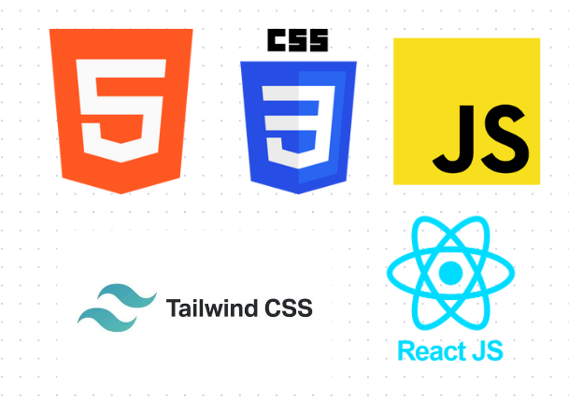

## Back-end

* + - * **PHP (Laravel framework):**

Laravel is primarily used for building custom web apps using PHP. It’s a web framework that handles many things that are annoying to build yourself, such as routing, templating HTML, and authentication. Laravel is entirely server-side, due to running on PHP, and focuses heavily on data manipulation and sticking to a Model-View-Controller design.



## PHP my admin (MySQL):

MySQL is an open-source SQL relational database management system that’s developed and supported by Oracle. MySQL is just one popular system that can store and manage that data for you.

* + - **Tools:**
      * **VS code:**

Visual Studio Code is a code editor in layman’s terms. Visual Studio Code is “a free-editor that helps the programmer write code, helps in debugging and corrects the code using the intelli sense method”. In normal terms, it facilitates users to write the code in an easy manner.



## Figma:

To draw the wireframe and mockup.



## Trello:

a collaboration tool that organizes your projects into boards.



## Methodology Process

Elegant Website has been developed based on the Scrum framework. It has been generated based on 4 sprints, where a sprint is the basic unit of work for a Scrum team. This is the main feature that marks the difference between Scrum and other models for agile development

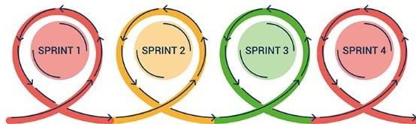

* Sprint 1: Front End for Website and dashboard
* Sprint 2: Back End for website
* Sprint 3: Back End for dashboard
* Sprint 4: Documentation and presentation

**3.2 Some website pages**

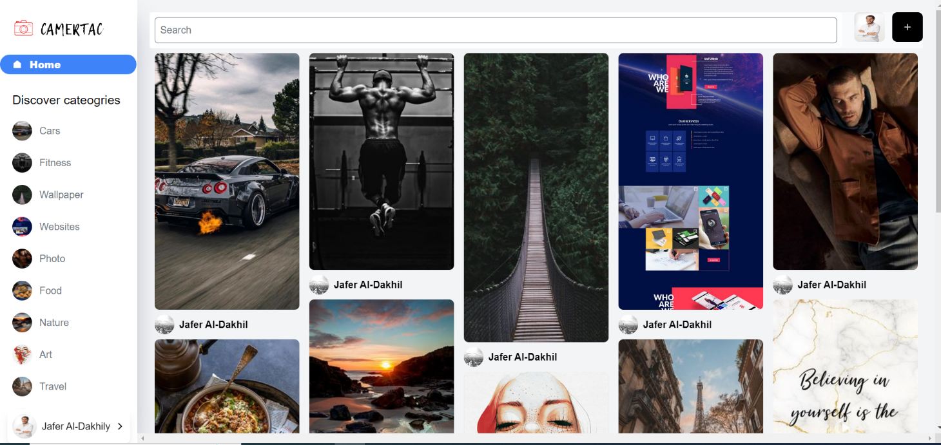

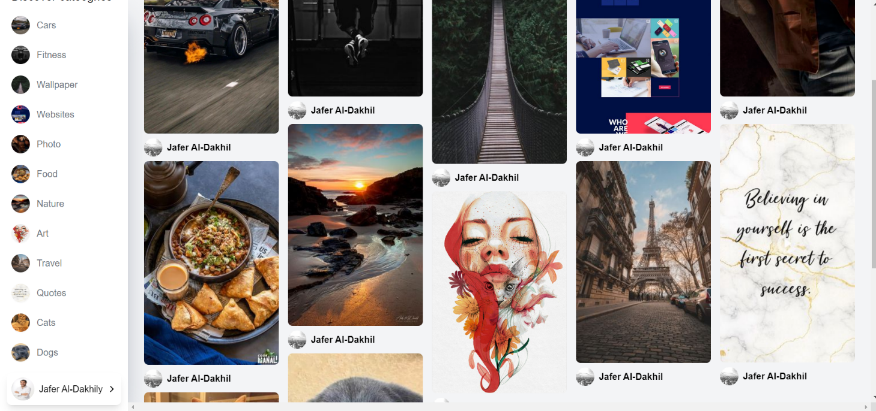

# Chapter four Conclusion & Future work

## Conclusion

Camertaic helps qualified photographers to find new job opportunities and share their amazing work.

* 1. **Future Work**
     + Following system.
     + Ability to pay the image copyrights.
     + Chat rooms