1. Create a new GitHub repository.
Cloning the repository to local machine using SSH
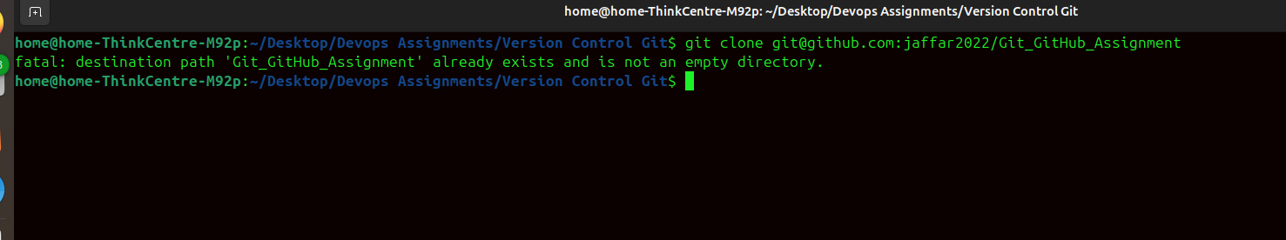

Created new branch named Tutedude
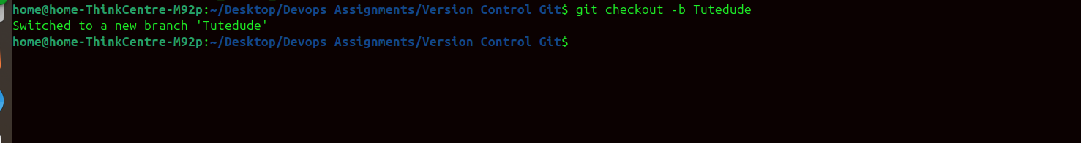
Added Flask project to branch Tutedude
Commit the changes and merge the branch into the main branch.

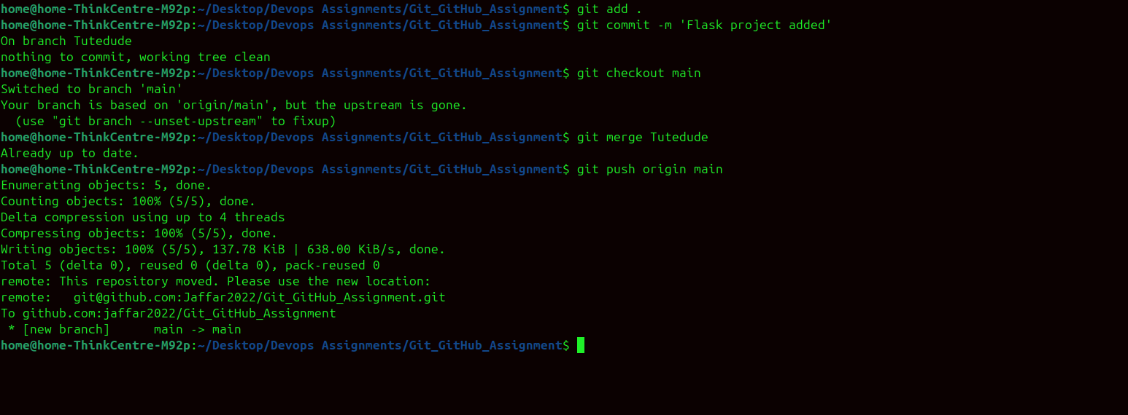

2. Created a new branch named jaffar1
Updated JSON content and merged to main branch. Added resolved changes and pushed to remote repository.
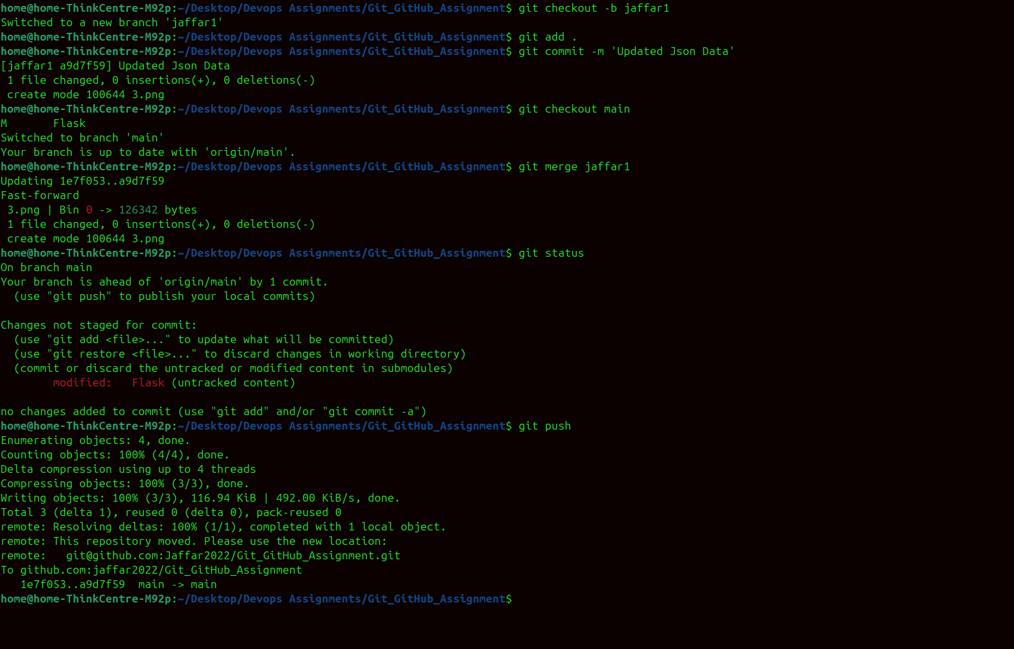

3. Branch Creation
Created two new branches and performed mentioned changes and merged both branches to main branch.
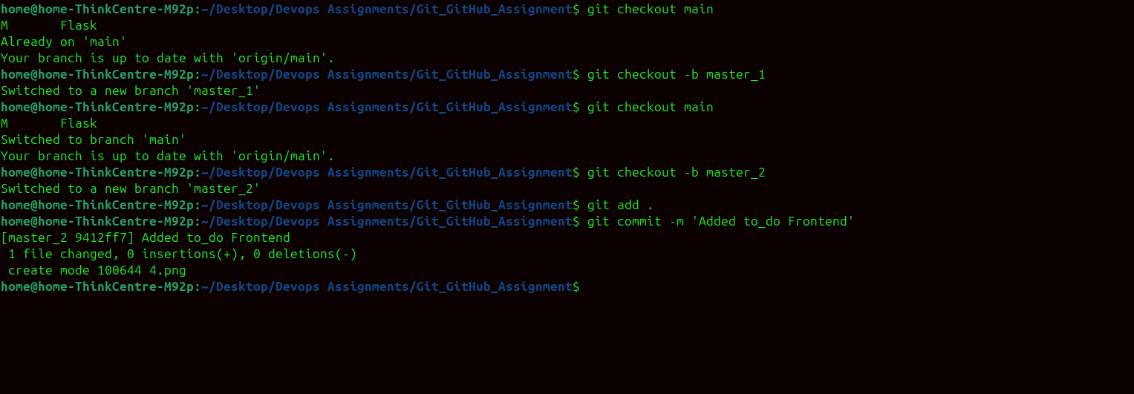

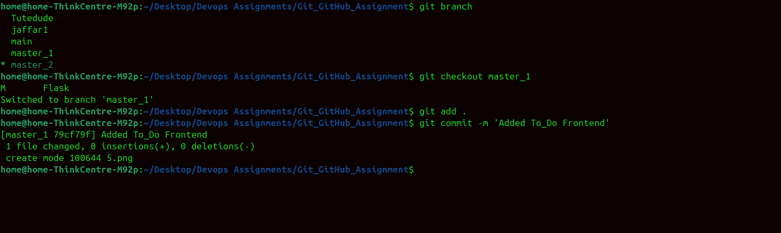

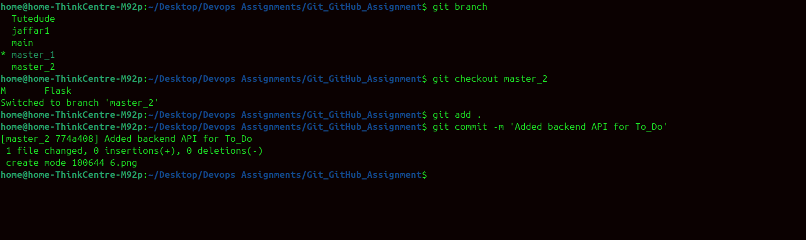

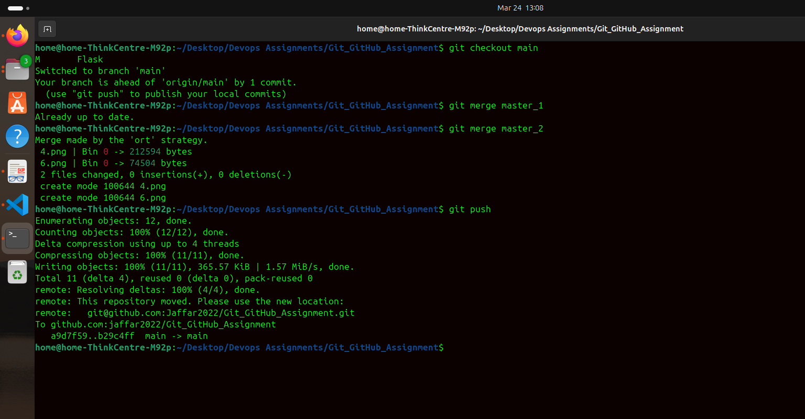

4. Enhancing the To-Do Form in master_1:
Committing changes.
Merging to main:
Merge the master_1 branch into the main branch.
Git Reset and Commit Deletion.
Rebasing Changes.
Rebase the updated changes in the main branch to the master_1 branch.​
