1. Creating and Renaming Files/Directories
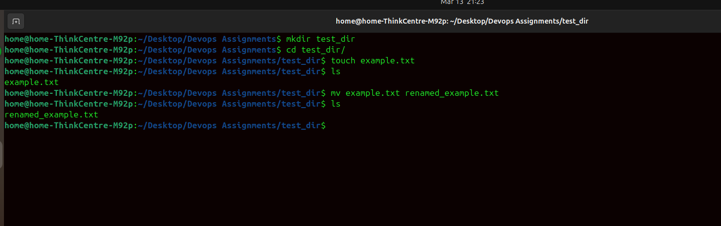

Explanation:
mkdir
cd
touch
mv
- mkdir - to create directory
- cd - to change directory (cd test_dir)
- touch example.txt – to create a file.
- mv example.txt renamed_example.txt – to rename file.

2. Viewing File Contents
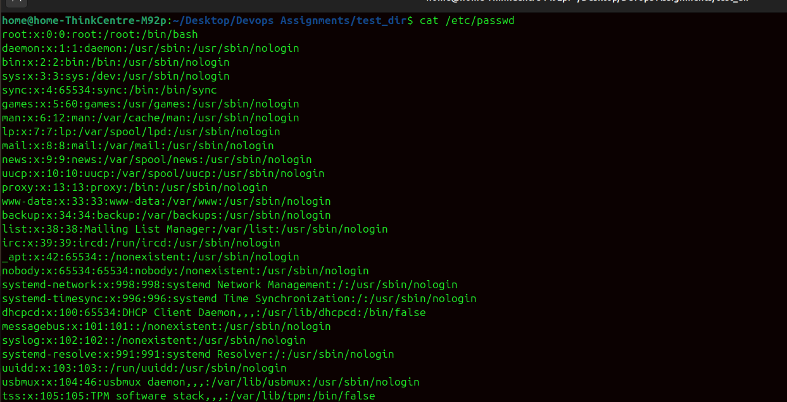


Explanation
cat /etc/passwd
head -n 5 /etc/passwd
tail -n 5 /etc/passwd
The cat command is used to display the contents of a file. The /etc/passwd file stores user account information in Linux.
The head command displays the first few lines of a file. Using -n 5 shows the first 5 lines.
The tail command shows the last lines of a file. Using -n 5 displays the last 5 lines.

3.Searching for Patterns
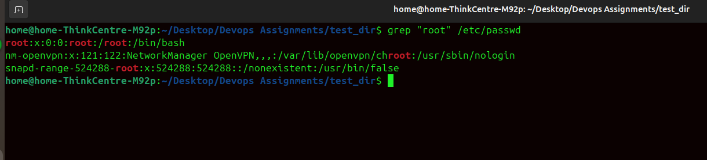
Explanation
grep "root" /etc/passwd
The grep command searches for a specific pattern in a file. This command finds all lines containing the word root in the /etc/passwd file.

4. Zipping and Unzipping
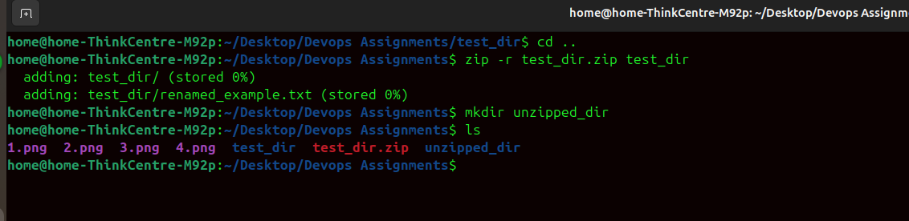
Explanation
mkdir unzipped_dir
unzip test_dir.zip -d unzipped_dir
The zip command compresses files and directories. The -r option recursively compresses all files inside the directory.

5. Downloading Files
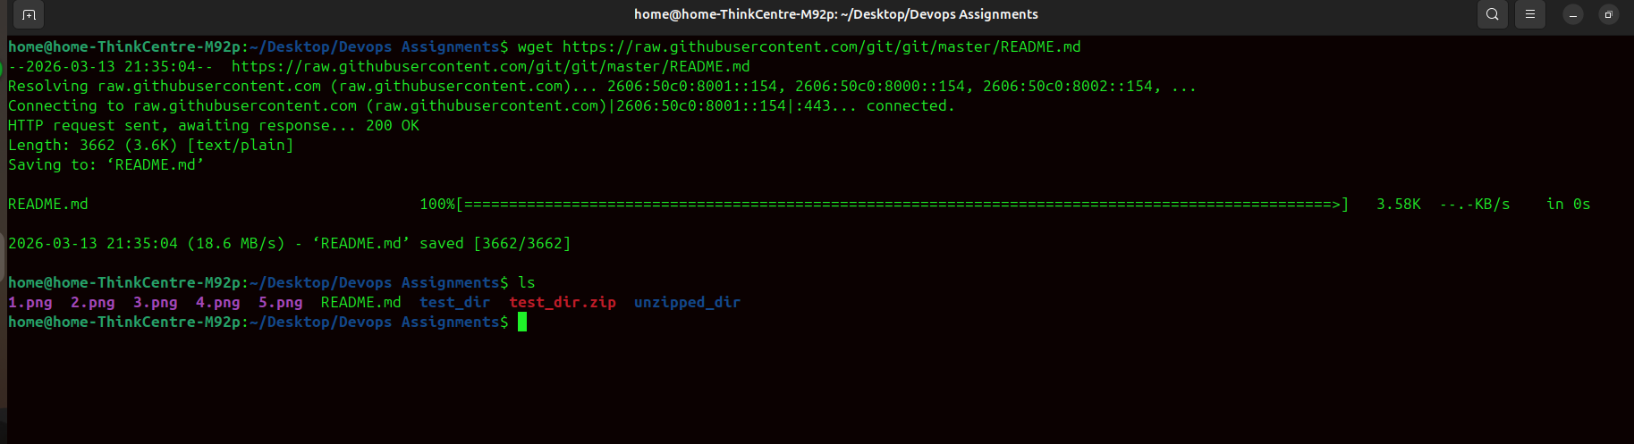

Explanation
wget -O sample.txt https://raw.githubusercontent.com/git/git/master/README.md
The wget command downloads files from the internet. The -O option saves the file with a custom name.
(Insert screenshot)

6. Changing Permissions
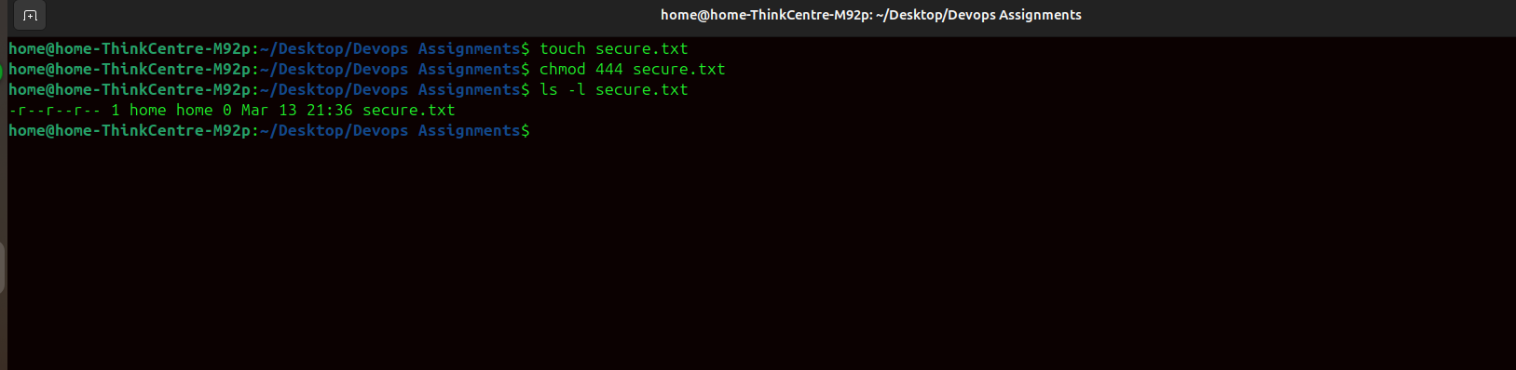

Explanation
touch secure.txt
chmod 444 secure.txt
touch creates a new file.
chmod 444 sets the file permissions to read-only for all users.

7. Working with Environment Variables
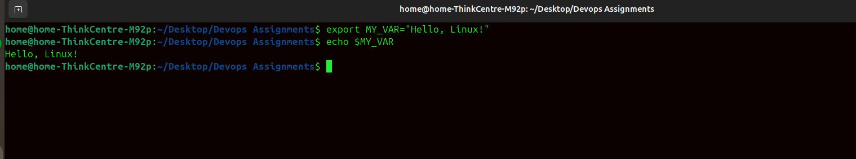

Explanation
export MY_VAR="Hello, Linux!"
echo $MY_VAR
The export command creates an environment variable. echo is used to display the variable value.

