Syed Ali Johar Jaffri

FA17-BECE-0013

Task_1:

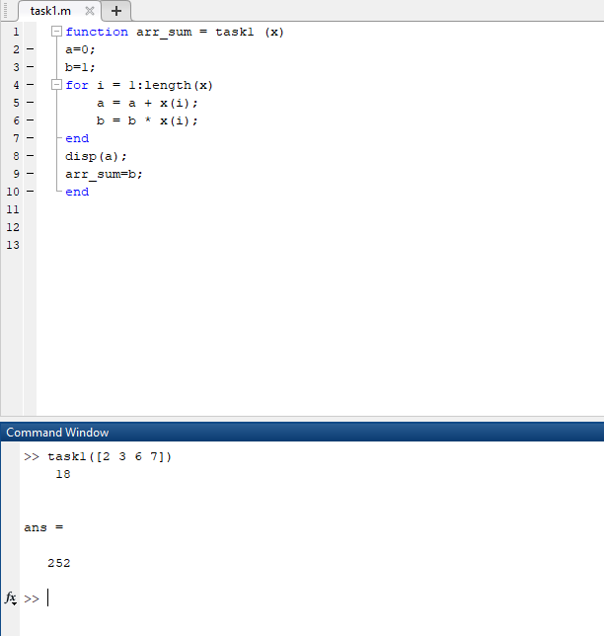

Task_2

1. **The number of rows and columns in A**

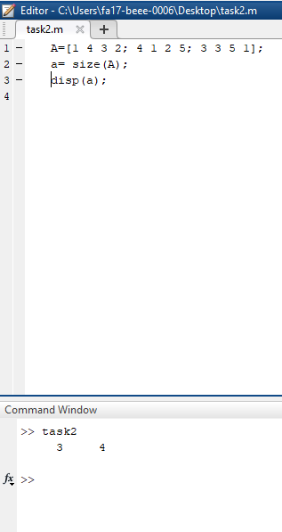

1. **The maximum and minimum element values in A**

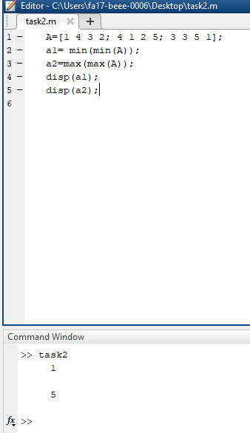

1. **The maximum and minimum element values in each row of A**

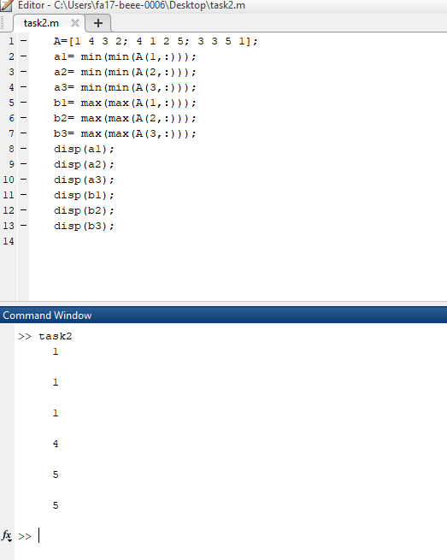

1. The average value in each column

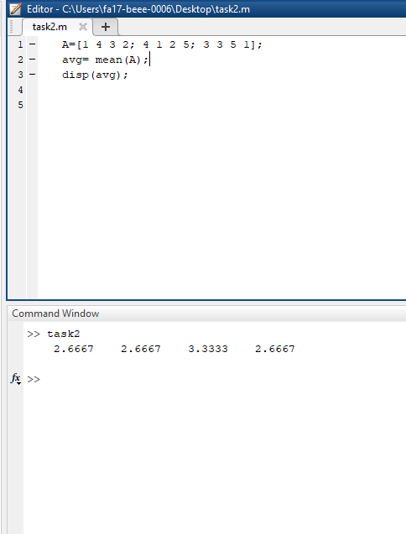

1. The average of all element values

