OS LAB_07

Task 01
Code:
#include <stdlib.h>
#include <sys/types.h>
#include <unistd.h>
#include <stdio.h>
int main()
{

int child_pid = fork();

if (child_pid == 0)
{
printf("I am Parent");
sleep(50);

}
else
{
printf("I am Child \n");
exit(0);
}
return 0;
}

Result:
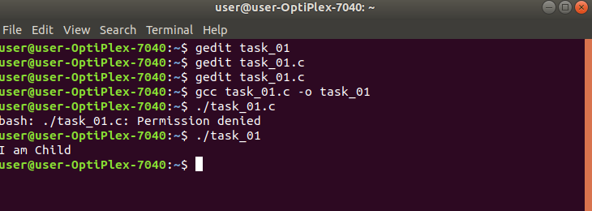

Task 02
Code
#include <stdlib.h>
#include <sys/types.h>
#include <unistd.h>
#include <stdio.h>
int main()
{

int child_pid = fork();

if (child_pid >0)
{
printf("I am Parent \n");
}
else if( child_pid == 0)
{
sleep(50);
}
return 0;
}

Result:
