OS-LAB_14
Syed Ali Johar Jaffri
Fa17-BECE-0013

Task_2:
1_module:
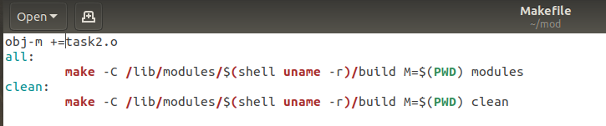
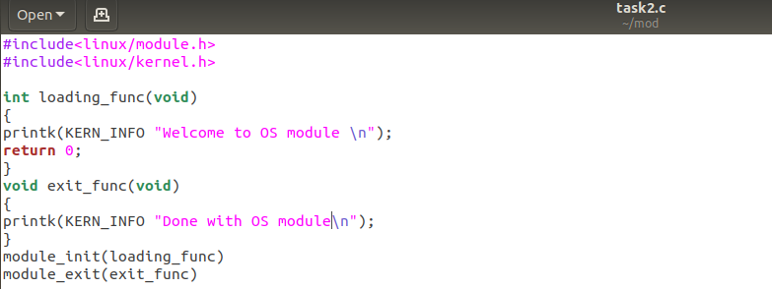
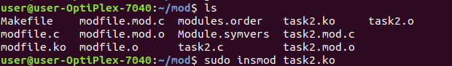
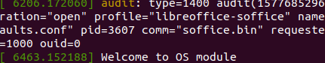
2_module
