# Significant data structures

The data structures that will mainly be used on the Android application are ArrayLists. The reason ArrayList has been chosen over an Array is because, in Java an Array is a fixed length data structure whereas an ArrayList is a variable length Collection class. This means the ArrayList will re-size itself when it reaches its capacity. This is required because the size of the arrays we will be using will not be known until after elements have been entered into it.

## WalkLocation

An object of the WalkLocation class will hold variables which contain data about the current location the user is at, such as:

* coordinates
  + The latitude and longitude value of the location.
* name
  + The name given to the location by the user.
* description
  + A description of the location given by the user.
* photo
  + An image of the current location selected by the user.
* timestamp
  + The date and time of the current moment when the user creates the WalkLocation object.

## Walk

An object of the Walk class will hold variables which contain data about the walk tour the user created such as:

* title
  + The name given to the walk tour.
* shortDescription
  + A short summary of the walk tour.
* longDescription
  + A full description of the walk tour.
* locations
  + An ArrayList of WalkLocation objects.

## POST Message

The application will need a method of sending a walk tour to the server, when the user decides to upload their walk tour. The POST message will be sent from the android application to the PHP server; the server will then populate the PHP object and save to the MYSQL database.

## Class Diagram

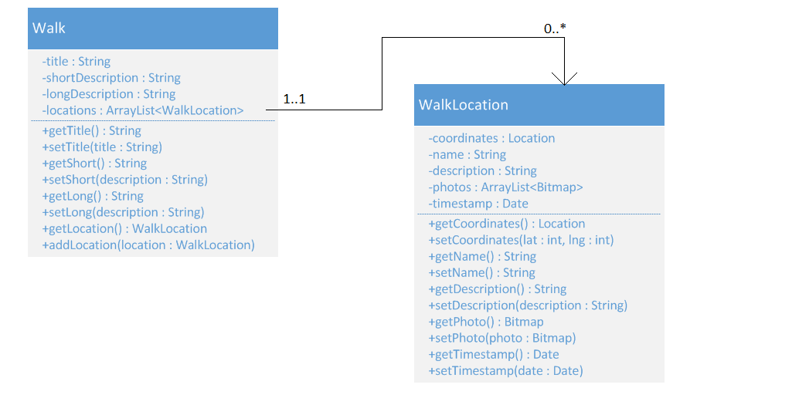

# Object Diagram

