SCAMPER

Improving Products and Services

Generating new ideas to develop a product or service is a key skill in business. It helps you to stay ahead of the competition and keep your audience satisfied. But, it can often be difficult to come up with new ideas when you're focusing on an existing product.

This is where a tool like SCAMPER can help. It's useful for generating ideas for new products and services by encouraging you to think about how you could improve existing ones.

In this article,, we'll look at the meaning of SCAMPER, and demonstrate how to use the technique.

**About the Tool**

**SCAMPER** stands for:

* **Substitute**.
* **Combine**.
* **Adapt**.
* **Modify**.
* **Put** to another use.
* **Eliminate**.
* **Reverse**.

SCAMPER is a quick, easy and direct form of creative brainstorming. You use the tool by asking questions about existing products, using each of the seven prompts above. These questions help you come up with creative ideas for developing new products, and for improving current ones.

Alex Osborn, credited by many as the originator of brainstorming, originally came up with many of the questions used in the technique. However, it was Bob Eberle, an education administrator and author, who organized these questions into the SCAMPER mnemonic.

Note:

Remember that the word "products" doesn't only refer to physical goods. Products can also include processes, services, and even people. You can therefore adapt this technique to a wide range of situations.

**How to Use the Tool**

First, take an existing product or service. This could be one that you want to improve, one that you're currently having problems with, or one that you think could be a good starting point for future development.

Then, ask questions about the product you've identified, using the mnemonic to guide you. Brainstorm as many questions and answers as you can. (We've included some example questions, below.)

Some ideas that you generate using the tool may be impractical or may not suit your circumstances. Don't worry about this – the aim is to generate as many ideas as you can.

Finally, look at the answers that you came up with. Do any stand out as viable solutions? Could you use any of them to create a new product, or develop an existing one? If any of your ideas seem viable, then you can explore them further.

**SCAMPER** Questions

Let's look at some of the questions you could ask for each letter of the mnemonic:

**Substitute**

* What materials or resources can you substitute or swap to improve the product?
* What other product or process could you use?
* What rules could you substitute?
* Can you use this product somewhere else, or as a substitute for something else?
* What will happen if you change your feelings or attitude toward this product?

**Combine**

* What would happen if you combine this product with another, to create something new?
* What if you combine purposes or objectives?
* What could you combine to maximize the uses of this product?
* How could you combine talent and resources to create a new approach to this product?

**Adapt**

* How could you adapt or readjust this product to serve another purpose or use?
* What else is the product like?
* Who or what could you emulate to adapt this product?
* What else is like your product?
* What other context could you put your product into?
* What other products or ideas could you use for inspiration?

**Modify**

* How could you change the shape, look, or feel of your product?
* What could you add to modify this product?
* What could you emphasize or highlight to create more value?
* What element of this product could you strengthen to create something new?

**Put to Another Use**

* Can you use this product somewhere else, perhaps in another industry?
* Who else could use this product?
* How would this product behave differently in another setting?
* Could you recycle the waste from this product to make something new?

**Eliminate**

* How could you streamline or simplify this product?
* What features, parts, or rules could you eliminate?
* What could you understate or tone down?
* How could you make it smaller, faster, lighter, or more fun?
* What would happen if you took away part of this product? What would you have in its place?

**Reverse**

* What would happen if you reversed this process or sequenced things differently?
* What if you try to do the exact opposite of what you're trying to do now?
* What components could you substitute to change the order of this product?
* What roles could you reverse or swap?
* How could you reorganize this product?

Example

To demonstrate how SCAMPER works, let's imagine that you need to improve a simple thermal flask aimed at the morning commuter. We'll work through some of the questions above to think of ways to develop this product.

Substitute: You could replace the metal cap with a plastic one to reduce heat loss. And perhaps there is a more environmentally-friendly manufacturing process you could use instead, that would make the product more appealing to green-minded consumers.

Combine: You could work with artists and designers to make the flasks more attractive and unique.

Adapt: Flasks are similar in shape to telescopes, though much shorter. Explore how you could adapt the materials and design so that your flask could extend like an old-fashioned spyglass to hold more liquid.

Modify: The flask isn't especially easy or comfortable to hold. You could add a rubber sleeve to aid grip, or make the bottle thinner so that it can be held in one hand.

Put to another use: So far, you've designed the flask around individual commuters, but there are many other groups of people who could also use the product. Take traveling couples, for example. They won't want to carry a flask each, so think about redesigning the flask to include detachable compartments which can be used as mugs. Then two people can share the drink from one flask.

Eliminate: You could eliminate the handle on the side of the bottle so that it fits more easily into a work bag or backpack.

Reverse: If you tried to do the exact opposite, you'd end up with a cold drink rather than a hot one! But this would be useful in summer months or hotter climates. So, explore ways of keeping liquid cool in the flask instead of hot.

Tip:

To get the greatest benefit, use SCAMPER alongside other creative brainstorming and lateral thinking techniques such as Random Input, Provocation, Reversal, and Metaphorical Thinking.

**Key Points**

SCAMPER helps you develop new products and services. Many of the questions it uses were created by Alex Osborn, but Bob Eberle developed the mnemonic.

SCAMPER stands for:

Substitute.

Combine.

Adapt.

Modify.

Put to another use.

Eliminate.

Reverse.

To use SCAMPER, you simply go down the list and ask questions regarding each element. Remember, not every idea you generate will be viable; however, you can take good ideas and explore them further.

Scamper: How to Use the Best Ideation Methods

The SCAMPER method helps you generate ideas for new products and services by encouraging you to ask seven different types of questions, which will help you understand how you can innovate and improve existing products, services, problems and ideas. Here, you’ll learn how to use the method. SCAMPER is surprisingly easy to start using and very efficient in innovation and ideations sessions.

SCAMPER Method

SCAMPER refers to a series of thought sparkers or provocations which help you to innovate on an existing product, service or situation by looking through different lenses. There are seven provocation lenses in the SCAMPER method:

Substitute

Combine

Adapt

Modify (Also Magnify and Minify)

Put to another use

Eliminate

Rearrange

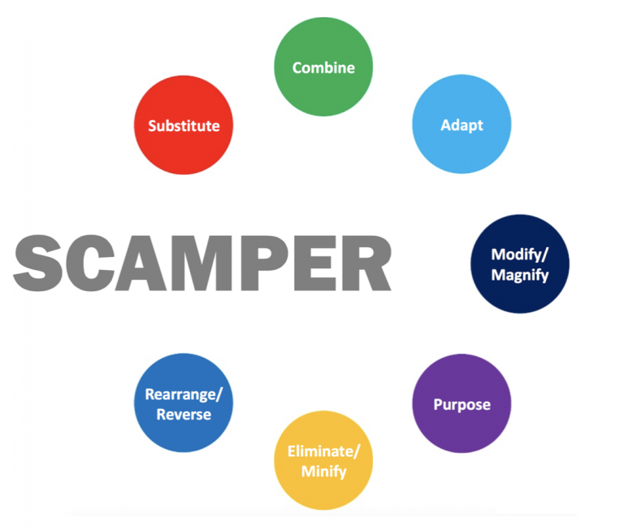

How to Use SCAMPER

First, take an existing product or service. It could be an existing product, service or idea which you want to improve or which could be a great starting point for future development.

Then, simply go down the list and ask questions regarding each of the seven elements. Please see our step-by-step guide below.

**Apply the questions to values, benefits, services, touch points, product attributes, pricing, markets and essentially any other related aspect you might be able to think of that has relevance to your ideation needs.**

Look at the answers that you came up with. Do any of the answers stand out as viable solutions? Could you use any of them to create a new product, or develop an existing one?

Take the good ideas and explore them further.

Example – McDonald’s

McDonald’s would come to be a larger-than-life household name; it may seem hard to see in the 21st century, but the philosophy behind its ‘formula’ revolutionised the old style of restaurant experience.

Take, for example, McDonald’s founder, Ray Kroc. As he’s already done all the hard work, it’s now easy for us to identify some of the ideas he used in the SCAMPER method:

Put to other uses: Selling restaurants and real estate instead of just simply hamburgers.

Eliminate: Letting customers serve themselves and thereby avoiding the use of expensive waiters.

Rearrange: Having customers pay before they eat.

Step-by-step Guide

Substitute

Overall, the question to think about here is this: What can I substitute or change in my product, problem or process? You should think about substituting part(s) of your product or process for something else.

Guiding questions:

What can I substitute so as to make an improvement?

How can I substitute the place, time, materials or people?

Can I substitute one part for another or change any parts?

Can I replace someone involved?

Can I change the rules?

Should I change the name?

Can I use other ingredients or materials?

Can I use other processes or procedures?

Can I change its shape, colour, roughness, sound or smell?

Can I use this idea for other projects?

Can I change my feelings or attitude towards it?

Use these instead of starting with: ‘I can ...’

Combine

The overall question to think about here is: How can I combine two or more parts of my product, problem, or process so as to achieve a different product, problem, or process to enhance synergy? Creative thinking involves combining previously unrelated ideas, products, or services in order to create something new and innovative.

Guiding questions:

What ideas, materials, features, processes, people, products, or components can I combine?

Can I combine or merge this or that with other objects?

What can I combine so as to maximize the number of uses?

What can I combine in order to lower the costs of production?

Which materials could I combine?

Where can I build synergy?

Which are the best elements I can bring together so as to achieve a particular result?

Adapt

Overall, the question you need to think about is: What can I adapt in my product, problem, or process? Think about which parts of the product or process you could adapt so as to solve your problem.

Guiding questions:

Which part of the product could I change?

Could I change the characteristics of a component?

Can I seek inspiration in other products or processes, but in a different context?

Does the history offer any solutions?

Which ideas could I adapt, copy, or borrow from other people’s products?

What processes should I adapt?

Can I adapt the context or target group?

What can I adapt in this or that way in order to make this result?

Modify (Also Magnify and Minify)

Overall, the question you need to focus on is this: What can I modify or put more or less emphasis on in my product, problem, or process? Can I change the item in some way?

Can I change meaning, colour, motion, sound, smell, form, or shape? It’s time to magnify or exaggerate your idea, product, problem, or process—or to minify it. These questions will give you new insights about which components are the most important ones. Think about changing part or all of the current situation or product. Alternatively, distort the product in an unusual way.

Guiding questions:

What can I magnify or make larger?

What can I tone down or delete?

Could I exaggerate or overstate buttons, colours, size…?

Could I grow the target group?

What can be made higher, bigger, or stronger?

Can I increase its speed or frequency?

Can I add extra features?

How can I add extra value?

What can you remove or make smaller, condensed, lower, shorter or lighter—or streamline, split up or understate?

What can I change in this way or that way so as to achieve such and such a result?

Put to Another Use

The overall question to consider here is this: How can I put the thing to other uses? What are new ways to use the product or service? Can I reach out to other users if I modify the product? Is there another market for the product? It’s time to work out how you may be able to put your current product or idea to other uses and purposes.

Guiding questions:

What else can it be used for?

How would a child use it?—an older person?

How would people with different disabilities use it?

Which other target group could benefit from this product?

What other kind of user would need or want my product?

Who or what else may be able to use it?

Can it be used by people other than those it was originally intended for?

Are there new ways to use it in its current shape or form?

Would there be other possible uses if I were to modify the product?

How can I reuse something in a certain way by doing what to it?

Eliminate

Your overall question to consider here is: What can I eliminate or simplify in my product, design, or service? Think of what might happen if you were to eliminate, simplify, reduce, or minimise parts of your idea. If you continue to trim your idea, service, or process—you can gradually narrow your challenge down to that part or function that is most important.

Guiding questions:

What can I remove without altering its function?

Can I reduce time or components?

What would happen if I removed a component or part of it?

Can I reduce effort?

Can I cut costs?

How can I simplify it?

What’s non-essential or unnecessary?

Can I eliminate the rules?

Can I make it smaller?

Can I split my product into different parts?

I can eliminate what by doing what?

Rearrange

Overall, you have to ask yourself this question: How can I change, reorder, or reverse the product or problem? What would I do if I had to do this process in reverse?

Guiding questions:

What can I rearrange in some way – can I interchange components, the pattern, or the layout?

Can I change the pace or schedule?

What would I do if part of your problem, product or process worked in reverse?

I can rearrange what in what way such that this happens?

Historical Background

Alex Osborn, the originator of the brainstorming method, originally came up with many of the questions used in the SCAMPER technique. However, it was Bob Eberle, an education administrator and author, who organised these questions into the SCAMPER mnemonic.

The Take Away

The SCAMPER method helps you generate ideas for new products and services by encouraging you to ask seven different types of questions, which will help you understand how you can innovate and improve existing products, services, problems and ideas. SCAMPER is an acronym formed from the abbreviation of: Substitute, Combine, Adapt, Modify (Also magnify and minify), Put to another use , Eliminate, and Reverse. SCAMPER is a lateral thinking technique which challenges the status quo and helps you explore new possibilities.

The 5 Stages in the Design Thinking Process

1.8k shares

What is Design Thinking and Why Is It So Popular?

1.5k shares

Bad Design vs. Good Design: 5 Examples We can Learn From

1.4k shares

Personas – A Simple Introduction

1.4k shares

10 Great Sites for UI Design Patterns

1.4k shares

Top Topics

User Experience (UX) Design

Design Thinking

User Research

Usability

User Interface (UI) Design

25% off UX Design courses

Footer navigation

Interaction Design Foundation Logo

With 140,879 graduates, the Interaction Design Foundation is the biggest online design school globally. We were founded in 2002.

Connect With Us

Reach us at hello@interaction-design.org or through our online contact form.

Facebook page

Instagram page

Twitter page

Linkedin page

Youtube page

Have questions? Check our frequently asked questions.

Get Inspired Weekly

Join 309,795 designers and get weekly inspiration and design tips in your inbox.

Email

Your email

Subscribe

UX Courses

Beginner UX Courses

Intermediate UX Courses

Advanced UX Courses

Community

Master Classes

Local Groups

Discussions

Literature

UX Daily Articles

UX Topics

UX Books

About

About Us

The People Behind

Contact Us

Careers

Terms of Use / Privacy

For companies

What is UX Design?

Give as gift