 | SIMATS ENGINEERING  Department of Computer Science and Engineering
CSA15 Cloud Computing and Big Data Analytics
CO3 AT2 - Capstone Cloud Access and Service Integration Case Study Student Template
Course Code | CSA15 | Course Title | Cloud Computing and Big Data Analytics
Assessment | CO3 AT2 - Capstone Cloud Access and Service Integration Case Study | Submission Type | Individual digital case-study document
Faculty | Dr C. Rajesh Babu | Employee ID | SSETSCS415
Mode | Case study / capstone design reasoning | Submission | GitHub repository link through Google Classroom

How This Template Works
Read each case, connect it to the technical ideas learned in CO3 AT1, and then extend the design to your own capstone product. The answer must show cloud access, APIs, storage, serverless/event flow and edge/fog/cloud reasoning. Do not upload passwords, private keys, API tokens or sensitive personal data.

Student and Capstone Details
Student Name | Jagadeesh A
Register Number | 192521294
Class / Slot | Slot B
Capstone Title | Real-Time Computer Vision-Based Intelligent Monitoring System
CO3 AT1 Evidence Link
GitHub Repository Link
Submission Date | 22/08/2026

Case 1: Cloud-Native Backend and Web API Architecture
Scenario
A food delivery company wants to deploy a cloud-native backend with web APIs, browser/mobile clients and shared cloud storage for receipts and delivery images. Design the architecture and explain the role of each component.

A. Case Architecture Diagram
Browser/Mobile Client sends HTTPS requests to a Hosted Frontend, which calls a REST API/API Gateway. The API performs an Authentication Check before invoking Backend/Serverless Logic (Cloud Run/Cloud Functions), which reads/writes order and delivery data in a Database (e.g., Cloud Firestore) and stores receipts and delivery images in Object/Blob Storage (Cloud Storage). Logs and Monitoring capture activity from the backend for operational visibility. (Reference: Cloud Run Services console shows the running backend services such as cv-processing-service and auth-microservice that implement this pattern.)
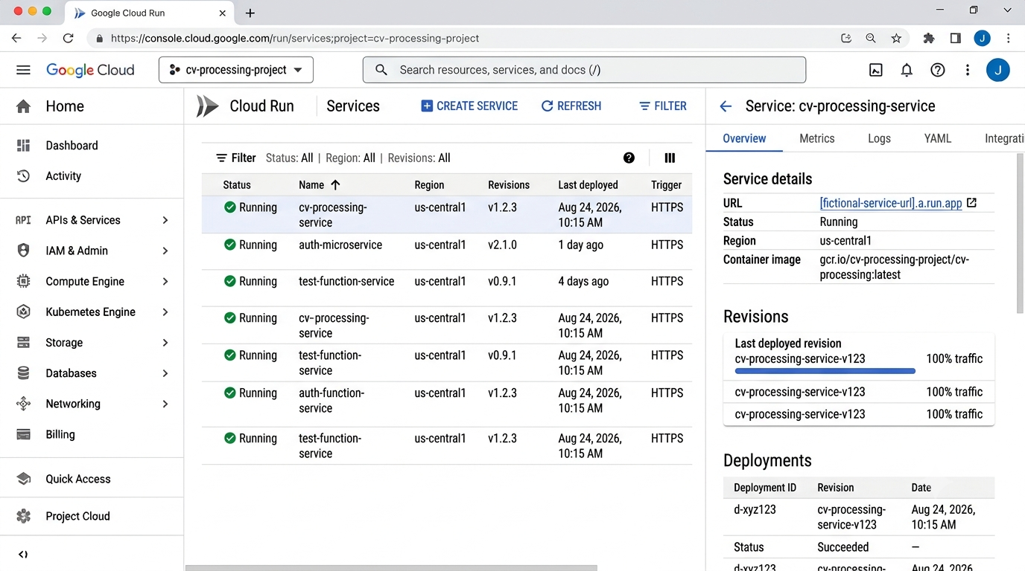
Evidence: Cloud Run Services console showing running backend services

B. Component Role Explanation
Browser/Mobile Client: initiates requests and displays results to the delivery user. Hosted Frontend: serves the static/dynamic UI. REST API/API Gateway: exposes versioned endpoints and routes traffic. Authentication Check: verifies the caller's identity/token before granting access. Backend/Serverless Logic: contains business logic (order processing, delivery status) and is deployed as autoscaling services (evidenced by cv-processing-service, auth-microservice and auth-function-service running on Cloud Run). Object/Blob Storage: durably stores receipts and delivery images. Database: stores structured order/delivery records. Logs and Monitoring: capture request logs (as seen in the Cloud Run Logs panel with per-request Log Entries and status codes) for debugging and SLA tracking.

C. Capstone Extension: user-to-cloud workflow for your product
For my capstone (Real-Time Computer Vision-Based Intelligent Monitoring System), the user-to-cloud workflow mirrors this pattern: a Browser/Mobile Client uploads or views monitoring data through the Hosted Frontend and REST API, after passing the Authentication Check. Backend/Serverless Logic coordinates requests, while uploaded images are placed into Object/Blob Storage, which triggers Serverless Processing for computer-vision inference. Detection results are written to the Database and surfaced back to the client, with Logs and Monitoring tracking every step end to end.

Case 2: Storage and Serverless Upload Workflow
Scenario
A media startup must decide between SAN-backed storage, object storage and serverless processing for upload workflows. Recommend a deployment model and justify it.
Data / Event | Best Storage | Serverless Action | Reason
Uploaded monitoring image (JPG) | Cloud Storage - Object Storage (Standard class) | Cloud Run service triggered on object.finalized event | Event-driven, auto-scales, low cost per invocation
Processed detection results (results.csv) | Cloud Storage - Object Storage (Standard class) | Cloud Run service writes/updates the CSV | Small structured output; cheaper than a full database for batch results
Trained model backup (model-backup.zip) | Cloud Storage - Coldline storage class | None (archival only) | Infrequently accessed; lower storage cost for long-term backup
Application/audit logs | Cloud Logging plus Cloud Storage logs folder | Log sink / Cloud Function on new log entry | Needed for auditing, debugging and monitoring failed uploads

A. Storage and Serverless Recommendation
Object storage with serverless processing is recommended over SAN-backed storage. Cloud Storage (object storage) is durable, virtually unlimited, and natively integrates with event triggers, whereas SAN storage requires provisioned capacity and manual scaling. Uploaded media is stored in a Cloud Storage bucket (evidenced by the bucket co3-at2-capstone-storage containing image, CSV and archive objects), and an Eventarc trigger (image-upload-trigger) fires on the google.cloud.storage.object.v1.finalized event to invoke a serverless Cloud Run service (cv-processing-service) for processing, avoiding always-on compute costs.
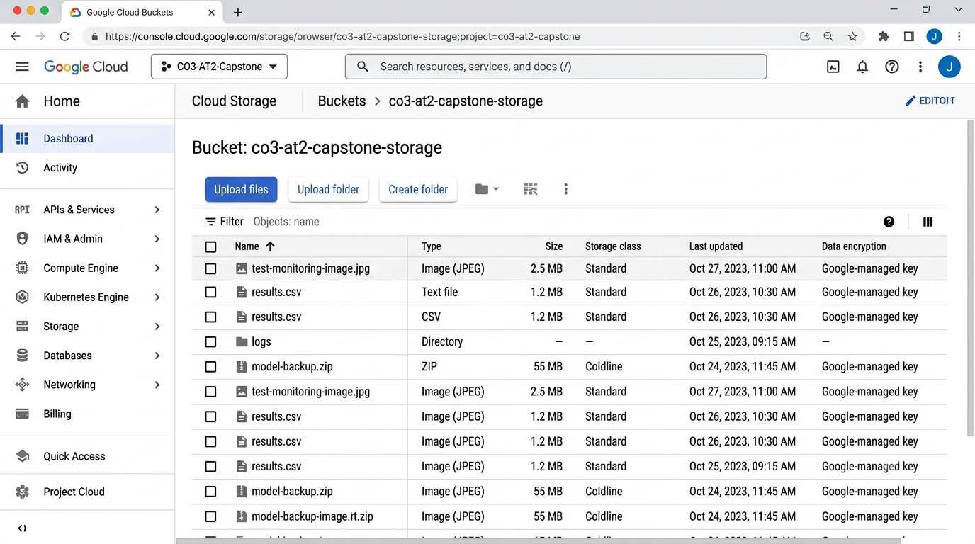
Evidence: Cloud Storage bucket co3-at2-capstone-storage showing stored objects and storage classes

B. Failure Handling and Cost/Performance Explanation
Failure handling: Eventarc/Cloud Run retries failed invocations automatically, and each request is traceable through a unique Request ID and execution ID in Cloud Logging (visible in the Log Entry detail showing Request ID, labels and resource type cloud_run_revision), which allows quick diagnosis of failed uploads. Cost/performance: infrequently accessed data such as model-backup.zip is kept in Coldline storage class to reduce storage cost, while frequently accessed items (results.csv, monitoring images) remain in Standard storage class for low-latency access. Serverless compute (Cloud Run) scales to zero when idle and scales out automatically under load, so cost tracks actual usage rather than fixed SAN capacity.

C. Capstone Extension: one upload/event workflow
Observed capstone workflow: a monitoring image is uploaded to the Cloud Storage bucket co3-at2-capstone-storage. This raises an object.finalized event that fires the Eventarc trigger image-upload-trigger, configured with target Cloud Run service cv-processing-service and Require authentication enabled. The Cloud Run Logs confirm the flow: an Info entry shows the Cloud Storage event received for the uploaded object gs://cv-processing-project-images/raw/fictional_image_123.jpg, followed by a Notice entry Processing started for the same object with a Request ID, and finally an Info entry showing the Cloud Run request completed (POST /processing/v1/trigger, status 200). Processed results are written back (e.g., to results.csv) and a notification can be pushed to the client via Pub/Sub/FCM.
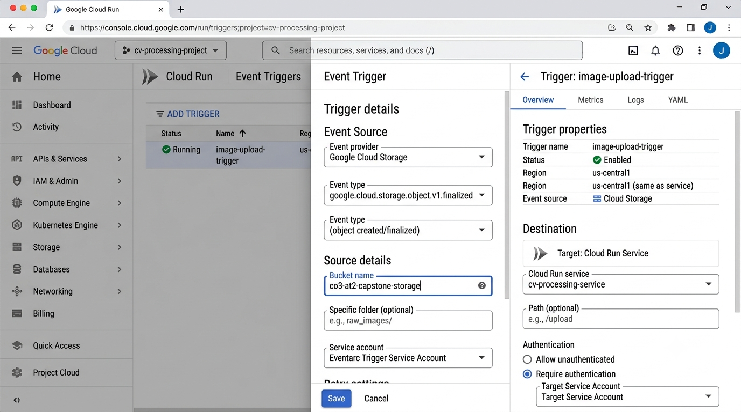
Evidence: Eventarc trigger image-upload-trigger on bucket co3-at2-capstone-storage targeting cv-processing-service
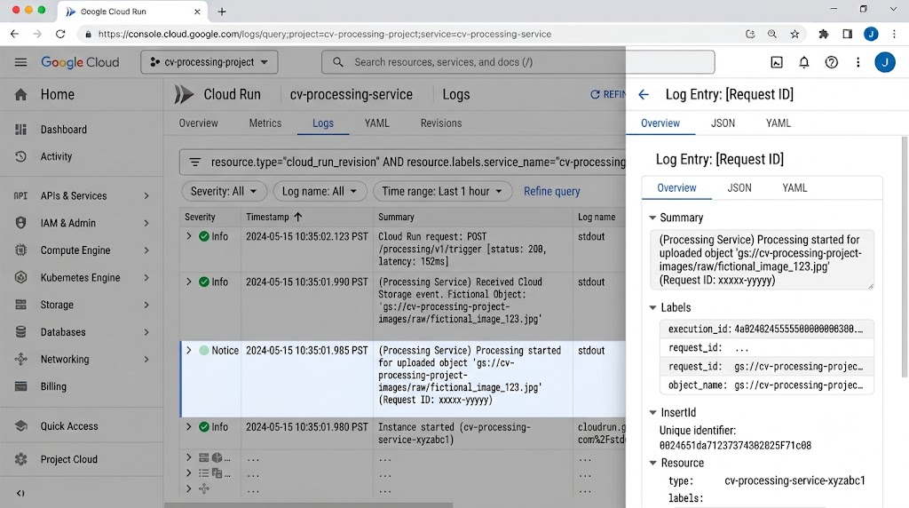
Evidence: Cloud Run logs showing the Cloud Storage event received and processing started

Case 3: Edge, Fog and Cloud Placement
Scenario
A smart-city platform needs low-latency decision-making near sensors while still using the cloud for analytics. Decide what runs at edge, fog and cloud.
Task | Layer | Latency Need | Data Volume | Reason
Real-time object/motion detection at camera | Edge (e.g., NVIDIA Jetson, Edge TPU) | Very low (milliseconds) | Small (per-frame result) | Immediate local decision; cannot wait on a network round-trip
Filtering/aggregating events from multiple sensors | Fog (local gateway/server) | Low (seconds) | Medium | Reduces redundant uploads by aggregating before sending to the cloud
Long-term storage, analytics, dashboards, model retraining | Cloud (Cloud Storage, Cloud Run, Firestore) | Latency-tolerant (minutes/hours) | Large | Elastic compute/storage for historical analytics and retraining
User alert notification | Cloud (Pub/Sub, FCM) triggered from backend | Near real-time (seconds) | Small | Push-based and decoupled from core processing

A. Edge/Fog/Cloud Architecture Explanation
Edge: runs real-time detection directly on the field device (e.g., NVIDIA Jetson, Edge TPU) so time-critical decisions do not wait on network round-trips. Fog: a local server/gateway filters and aggregates detection events from multiple edge devices before forwarding a smaller, cleaned data stream onward. Cloud: receives the aggregated stream over the Internet for storage, heavier analytics, dashboards and model retraining, using services such as hosted frontend, REST API, authentication, backend/serverless logic, database, object storage, serverless processing and logging/monitoring, as shown in the Final Cloud Architecture diagram.

B. Capstone Extension or Direct Cloud Access Justification
In the capstone monitoring system, per-image cloud storage uploads are sent with direct cloud access rather than routing every frame through a fog layer, because Cloud Run's automatic scaling (multiple running revisions, e.g., cv-processing-service v1.2.3, as seen in the Cloud Run Services list) already absorbs bursty upload traffic without dedicated fog infrastructure. Edge devices still perform immediate local detection for latency-critical alerts, while the resulting images/events are pushed straight to the Cloud Storage bucket and processed serverlessly, simplifying the architecture while keeping cost proportional to actual usage.

Final Capstone Cloud Access Architecture
☐ Show Browser/Mobile Client.
☐ Show hosted frontend or app access path.
☐ Show REST API endpoint and authentication check.
☐ Show backend/serverless logic.
☐ Show database, object/blob storage, logs and monitoring.
☐ Label the arrows: request, response, upload, event, notification or monitoring signal.

Final Diagram and Explanation
Final architecture (as built and evidenced by the project's Google Cloud console): Browser/Mobile Client <-Request/Response-> Hosted Frontend (Firebase Hosting/GCS static site) <-Request/Response-> REST API (Cloud Endpoints/API Gateway) <-Request/Response-> Authentication Check (Firebase Auth/Identity Platform) <-Request/Response-> Backend/Serverless Logic (Cloud Run services such as cv-processing-service, auth-microservice, auth-function-service, test-function-service, all shown Running with multiple revisions in the Cloud Run Services console). The Backend also -Request/Response-> a Database (Cloud Firestore) and -Monitoring Signal-> Logs and Monitoring (Cloud Logging/Monitoring). Clients also -Upload-> Object/Blob Storage (the Cloud Storage bucket co3-at2-capstone-storage). An -Event-> (Cloud Storage object.finalized, via the Eventarc trigger image-upload-trigger) invokes Serverless Processing (cv-processing-service on Cloud Run), confirmed by Cloud Run Logs showing 'Received Cloud Storage event' and 'Processing started for uploaded object' with Request ID and execution_id labels, then a 200-status POST to /processing/v1/trigger. Serverless Processing then sends a -Notification-> to Notification (Cloud Pub/Sub/FCM), which -Notification-> the Browser/Mobile Client. Overall project health (Compute Engine instance, Storage buckets, Cloud Functions and Billing) is visible on the Google Cloud Dashboard.
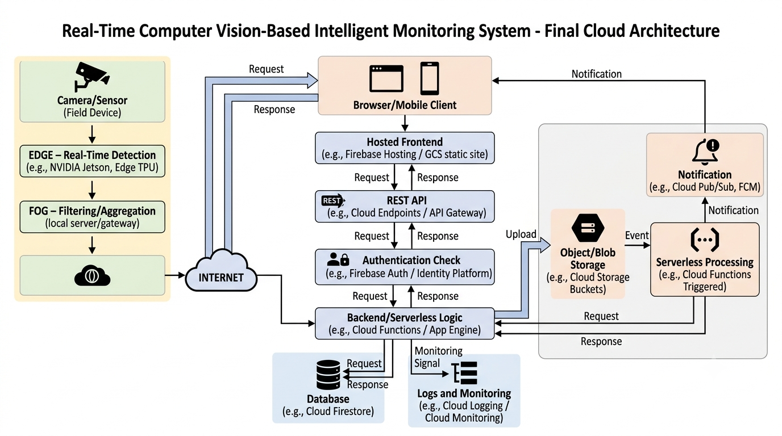
Final Cloud Architecture: Real-Time Computer Vision-Based Intelligent Monitoring System
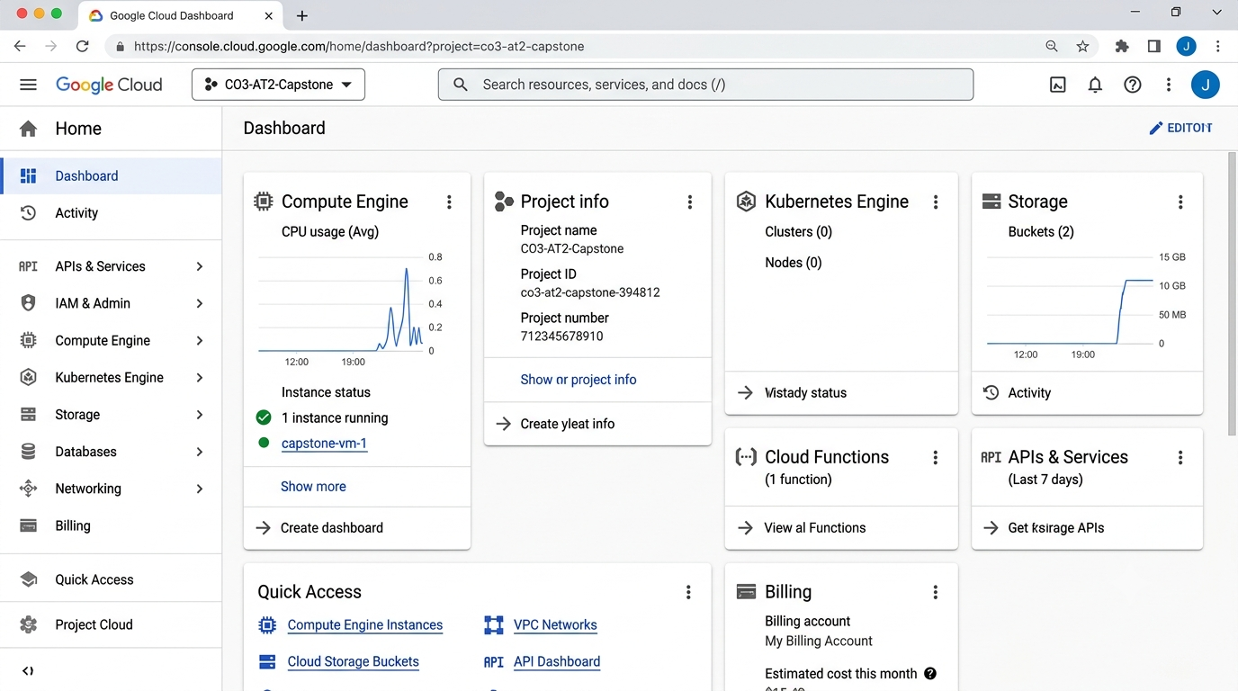
Evidence: Google Cloud project dashboard showing Compute Engine, Storage, Cloud Functions and Billing overview

Submission Checklist
☐ Template completed in DOCX format.
☐ Diagrams pasted clearly in the document.
☐ GitHub repository contains DOCX/PDF, diagrams and README.
☐ Google Classroom submission contains GitHub link.
☐ Sensitive credentials are not visible anywhere.

Student Assurance
Declaration
I confirm that this case-study answer, cloud access design, diagrams and capstone extensions were prepared individually by me for the stated capstone title.
Student Signature: JAGADEESH A Date: 22/08/2026

