NOTE ON COMPLETION STATUS: Track B (Local VM - Tiny Core) is filled in with real evidence: VM settings, boot/terminal output, and a recovery snapshot. Docker evidence is partly filled (version check + hello-world + nginx container start confirmed); the browser test at localhost:8080, docker logs output, and container stop/remove are still marked [Rework] pending those screenshots. Track A (Azure) was not used. Fields still marked [TO BE COMPLETED] - GitHub link, submission date, reflection answers, defense statement, and signature - need to be added by the student.
 | SIMATS ENGINEERING  Department of Computer Science and Engineering  CSA15 Cloud Computing and Big Data Analytics  CO2 AT2 - VM Configuration and Security Evidence Workbook  Guided practical workbook for Azure VM, local VM, Docker container, security checks, recovery evidence and GitHub submission
Assessment Metadata
Course Code | CSA15
Course Title | Cloud Computing and Big Data Analytics
Assessment | CO2 AT2 - VM Configuration and Security Evidence
Submission Type | Individual digital workbook based on the same capstone title used in CO1 and CO2 AT1
Faculty | Dr C. Rajesh Babu
Employee ID | SSETSCS415
Submission Mode | Completed workbook, evidence screenshots and GitHub repository link through Google Classroom
How This Workbook Works
- Use the same capstone title carried from CO1 and CO2 AT1.
- Read each procedure block, perform the action, verify the checkpoint and then fill the response table.
- Use Azure first when account activation is available. Use the local VM path when Azure is blocked. Use Docker for container comparison. Use simulation only when practical deployment is blocked.
- Screenshots must show the student's actual configuration or verified simulation work. Hide credentials, keys, tokens and sensitive account details.
- Upload the completed workbook and evidence to GitHub, then submit the GitHub repository link through Google Classroom.
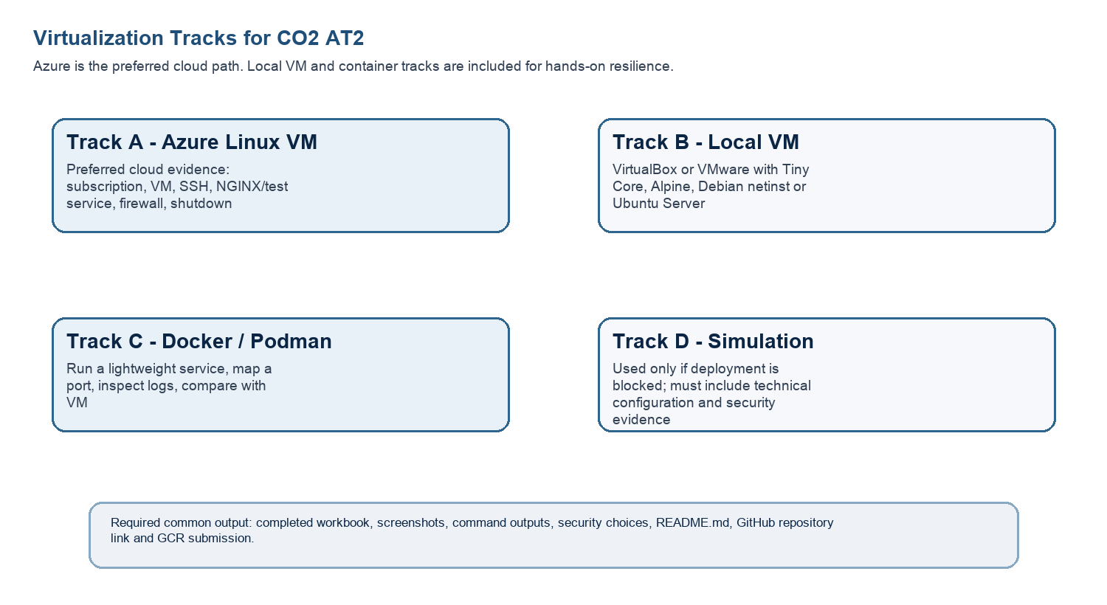
Technical Orientation
The practical work is not limited to clicking through screens. Each checkpoint requires observation: what appeared on screen, why it appeared, what it proves and how it connects to the capstone infrastructure plan.
Part 1: Student and Capstone Baseline
Student Name | Jagadeesh A
Register Number | 192521294
Class / Slot | Slot B
Capstone Title | CrowdCare - Cloud Event Safety Platform With Density Estimation and Incident Routing
CO2 AT1 Recommended VM Size | vCPU: 2 RAM: 4 GB Disk: 25 GB [confirm against your actual CO2 AT1 document]
Selected Practical Track | [SELECT: Azure VM / Local VM / Docker / Simulation - based on your account/device access]
GitHub Repository Link | [https://github.com/Jaga-A5/CSA15-CO--Assessments-192521294/tree/main]
Google Classroom Submission Date | [11/08/2026]
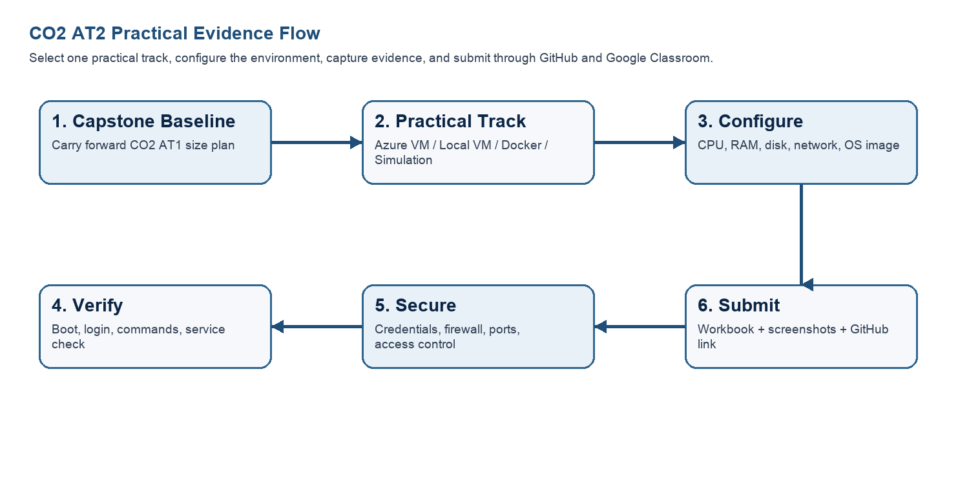
Capstone Infrastructure Element | Carry-Forward from CO2 AT1
Workload type | Real-time event-safety monitoring platform combining live crowd density estimation with automated incident routing and alerting.
Main application modules | Density estimation module (crowd counting from camera/sensor feed), incident routing/alerting service, event control dashboard, backend API.
Expected users / traffic assumption | Bursty load concentrated during live events (event stewards, security control room, admins); near-idle between events.
Database need | Relational/document database to store incident records, zone-wise density history and event metadata.
File storage need | Storage for video frames/snapshots, model artifacts and incident evidence images.
AI/Python/analytics need | Python-based density estimation model performing inference on incoming camera/sensor frames in near real time.
Security concern | Protecting camera feed privacy and preventing unauthorized access to the incident-routing/alerting pipeline.
Recovery concern | Avoiding loss of live density/alert state during an active event; needs fast VM/container restart and state recovery.
Part 2: OS Image Selection Guide
Select the operating system image based on the available network, device capacity and learning objective. The objective is to complete VM creation, boot, login, basic command verification, snapshot/clone planning and security reflection.

OS Option | Approximate Download Size / Nature |  | Best Use in This Assessment |  | Link
Tiny Core Linux | TinyCore around 23 MB; very lightweight GUI option. |  | Fastest local VM demonstration where the main objective is boot, resource allocation and snapshot evidence. |  | https://distro.ibiblio.org/tinycorelinux/downloads.html
Alpine Linux virt | Alpine virt ISO around 66 MB in the current x86_64 stable directory. |  | Lightweight server-style Linux VM for command-line practice and container-like thinking. |  | https://dl-cdn.alpinelinux.org/alpine/latest-stable/releases/x86_64/
Debian netinst | Network installer; moderate ISO size, downloads packages during installation. |  | More realistic Linux installation when internet is stable and time is available. |  | https://www.debian.org/download
Ubuntu Server | Larger server ISO; familiar cloud VM image. |  | Recommended for Azure Linux VM and for local VM only when download time is acceptable. |  | https://ubuntu.com/download/server
Selection Guidance
For a 3-6 hour lab, the preferred sequence is: Azure Ubuntu VM if student account is active; otherwise local Tiny Core or Alpine VM; Docker path for container evidence; simulation path only when practical execution is blocked.
Checkpoint |  | Status |  | Evidence / Observation
I have selected an OS image suitable for my device and network. |  | [ ] Yes [ ] Rework
I have recorded the official download page or cloud image name. |  | [ ] Yes [ ] Rework
I have checked whether the ISO is small enough for the lab duration. |  | [ ] Yes [ ] Rework
Student Entry: Selected OS image, version, reason and link used

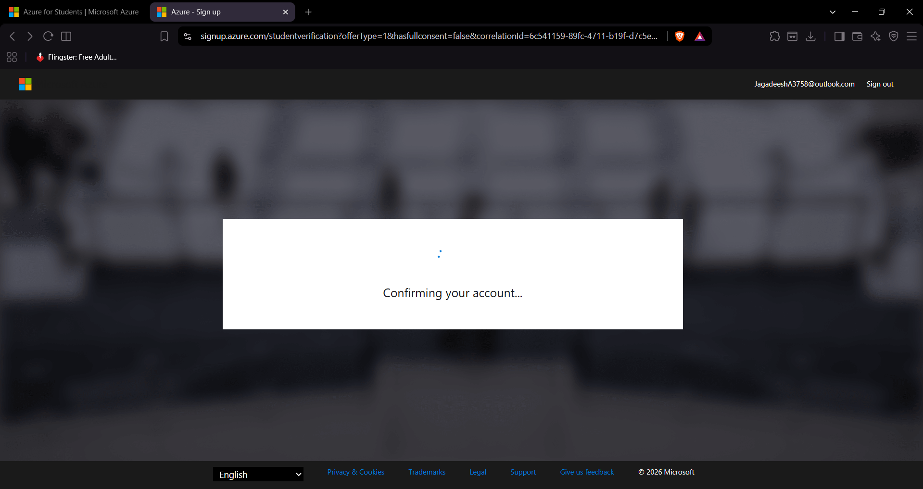

Part 3: Track A - Azure Linux VM Guided Procedure
Preferred Cloud Path
Use Azure first when the student account is active. Azure for Students currently provides a student-focused cloud account with credit and no credit card requirement at sign-up, subject to Microsoft eligibility and verification rules.
Azure for Students: https://azure.microsoft.com/en-us/free/students
Azure for Students offer details: https://azure.microsoft.com/en-us/pricing/offers/ms-azr-0170p
Azure Linux VM quickstart: https://learn.microsoft.com/en-us/azure/virtual-machines/linux/quick-create-portal
A. Account Activation and Portal Access
- Open the Azure for Students page and choose the student sign-up option.
- Sign in using the official student email account when available.
- Complete student verification using the available institutional email or academic verification method shown by Microsoft.
- Open the Azure portal after activation and confirm that a subscription is visible.
- Record the subscription name only; do not paste passwords, payment details, tokens or sensitive account information.
Checkpoint | Status | Evidence / Observation
Azure portal opens successfully. | [ ] Yes [ ] Rework
A student or valid Azure subscription is visible. | [ ] Yes [ ] Rework
The student understands that resources must be stopped or deleted after evidence capture. | [ ] Yes [ ] Rework
Evidence Space: Paste account activation/portal screenshot with sensitive details hidden

B. Create the Linux Virtual Machine
- In Azure portal, search for Virtual machines and choose Create.
- Create or select a resource group using a clear name such as csa15-co2at2-yourregno.
- Enter a VM name such as csa15-vm-yourregno.
- Select a nearby Azure region available in the subscription.
- Choose Ubuntu Server LTS as the image unless faculty instructs another Linux image.
- Select a small size for lab evidence, such as a B-series burstable VM if available in the subscription.
- Select SSH public key or password according to faculty guidance. Do not share credentials in the workbook.
- Allow SSH port 22 only when required. If a web service is tested, add HTTP port 80 only for the test window.
- Review and create the VM. Wait until deployment succeeds.
Azure Setting |  | Student Value
Resource group
VM name
Region
Image
VM size
vCPU
RAM
Disk type and size
Authentication method |  | SSH key / password - do not paste secret
Open inbound ports
Checkpoint | Status |  | Evidence / Observation
VM deployment status shows success. | [ ] Yes [ ] Rework
VM overview page shows running status. | [ ] Yes [ ] Rework
Public IP or connection method is visible. | [ ] Yes [ ] Rework
The selected VM size is compared with CO2 AT1 sizing recommendation. | [ ] Yes [ ] Rework
Evidence Space: Paste VM overview and configuration screenshot

C. Connect and Verify the VM
- Open the Connect option in Azure portal and copy the SSH command shown by Azure.
- Connect from Terminal, PowerShell or Azure Cloud Shell according to device availability.
- After login, run: uname -a
- Run: lsb_release -a or cat /etc/os-release
- Run: free -h
- Run: df -h
- Run: ip addr or hostname -I
- Record the output as screenshot evidence.
Verification Command | Expected Purpose | Student Observation
uname -a | Kernel and OS environment
cat /etc/os-release | Linux distribution details
free -h | RAM allocation
df -h | Disk allocation
hostname -I | Private IP / network evidence
Evidence Space: Paste command output screenshot or copied terminal output

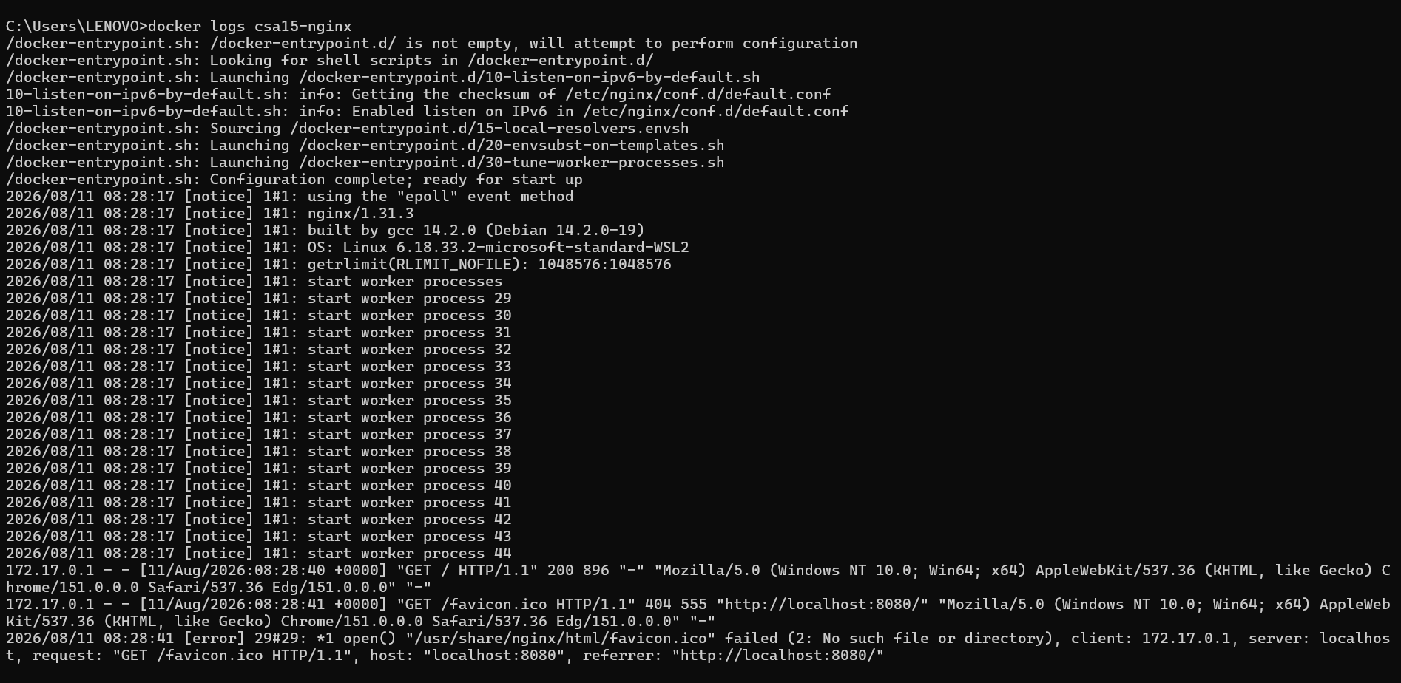

D. Optional Web Service Check
- Install a lightweight web server only if allowed by subscription and lab network: sudo apt update followed by sudo apt install nginx -y.
- Start or verify the service: systemctl status nginx.
- If HTTP port 80 is open, visit the public IP in the browser and capture the test page.
- If port 80 is not opened, record the reason and keep SSH-only evidence.
Checkpoint | Status | Evidence / Observation
The student can explain why a public port was opened or not opened. | [ ] Yes [ ] Rework
The service status or browser test was captured. | [ ] Yes [ ] Rework
The public exposure was kept temporary for the assessment. | [ ] Yes [ ] Rework
E. Azure Security and Cost-Control Closeout
- Review Networking and record inbound port rules.
- Confirm that no unnecessary public ports are open.
- Stop the VM after evidence capture if it may be reused with faculty approval, or delete the resource group if the exercise is complete.
- Capture stopped/deallocated or deletion evidence.
- Record what would change for a production capstone deployment.
Security / Cost-Control Item | Student Evidence / Decision
Inbound ports allowed
Authentication method used
Public IP required?
Stopped/deallocated or deleted?
Reason for closeout choice
Evidence Space: Paste networking rule and shutdown/deletion screenshot
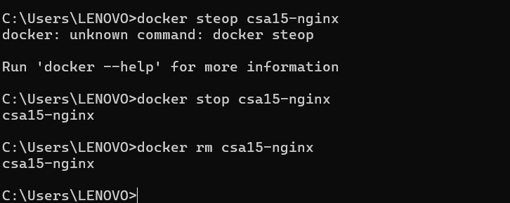

Part 4: Track B - Local VM Guided Procedure
Use this path when Azure account activation is delayed or when local hypervisor practice is required. VirtualBox is recommended for broad accessibility. VMware Workstation/Fusion may be used where available.
VirtualBox downloads: https://www.virtualbox.org/wiki/Downloads
VMware Workstation and Fusion: https://www.vmware.com/products/desktop-hypervisor/workstation-and-fusion
A. Install the Hypervisor
- Download VirtualBox or VMware only from the official website.
- Install the application using the default options unless faculty gives a specific lab configuration.
- Restart the system if the installer requests it.
- Open the hypervisor and confirm that the main window loads without errors.
- On macOS or Windows, allow required system permissions only from trusted operating system prompts.
Item |  | Student Entry
Hypervisor selected |  | VirtualBox
Version
Host operating system |  | Windows
Host CPU and RAM |  | [Add host CPU/RAM - check Task Manager > Performance]
Reason for selected hypervisor |  | Free, widely supported, fastest path to local VM evidence without Azure account activation delay.
Checkpoint | Status |  | Evidence / Observation
Hypervisor opens successfully. | [X] Yes [ ] Rework
Student can locate New VM/Create VM option. | [X] Yes [ ] Rework
Student has downloaded or selected a suitable OS image. | [X] Yes [ ] Rework
B. Create the VM
- Choose New VM or Create a New Virtual Machine.
- Enter a clear VM name such as csa15-localvm-yourregno.
- Select Linux as the type and the closest version available.
- Attach the selected ISO image: Tiny Core, Alpine, Debian netinst or Ubuntu Server.
- Allocate CPU based on CO2 AT1 sizing, but keep within safe host limits.
- Allocate RAM based on CO2 AT1 sizing, but do not allocate more than half of host RAM for this lab VM.
- Create a virtual disk. For Tiny Core or Alpine, 2-8 GB is enough for evidence. For Debian/Ubuntu, use 15-25 GB when storage permits.
- Finish creation and start the VM.
VM Setting | Recommended Lab Range | Student Value
VM name | csa15-localvm-regno | crowdcare-localvm-192521294
OS image | Tiny Core / Alpine / Debian / Ubuntu | Tiny Core Linux
vCPU | 1-2 for lightweight OS; 2+ if host allows | [Add vCPU count set in VirtualBox settings]
RAM | 512 MB-2 GB lightweight; 2-4 GB Ubuntu | 3.0 GB (per free -h output)
Virtual disk | 2-8 GB lightweight; 15-25 GB Debian/Ubuntu | 2.7 GB (rootfs, per df -h output)
Network mode | NAT for normal lab use | NAT (eth0, 10.0.2.15 - default VirtualBox NAT range)
Display / boot mode | Default unless OS requires change | Default
Host Safety Guidance
Do not allocate all host resources to the VM. Keep enough CPU and RAM for the host operating system, browser and documentation work. If the host has 8 GB RAM, a 1 GB or 2 GB VM is more appropriate than a 6 GB VM.
Evidence Space: Paste VM settings screenshot before first boot

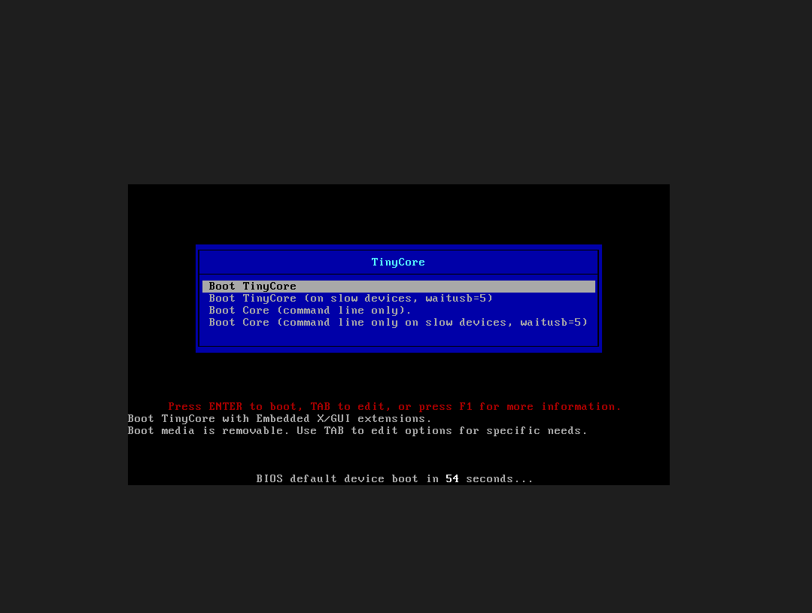
TinyCore boot menu prior to VM startup.
C. Boot and Verify the VM
- Start the VM and wait for the OS boot screen.
- For Tiny Core, confirm that the graphical desktop appears.
- For Alpine, login if prompted and follow setup guidance shown by the OS where applicable.
- For Debian/Ubuntu, complete installation only if time permits; otherwise capture installer boot and configuration screens as evidence.
- Open terminal inside the VM where possible.
- Run or record equivalent commands: uname -a, free -h, df -h and ip addr.
Checkpoint | Status | Evidence / Observation
VM starts without boot error. | [X] Yes [ ] Rework | Boot menu appeared cleanly, TinyCore booted to desktop within seconds.
OS screen or terminal is visible. | [X] Yes [ ] Rework | TinyCore desktop and terminal confirmed via screenshot.
CPU/RAM/disk allocation is verified. | [X] Yes [ ] Rework | free -h and df -h confirm 3.0G RAM, 2.7G root filesystem.
Network mode is recorded. | [X] Yes [ ] Rework | ifconfig confirms eth0 with inet addr 10.0.2.15 (NAT range) - note: 'ip addr' command not available on TinyCore, ifconfig used instead.
Evidence Space: Paste VM boot/login/terminal screenshots

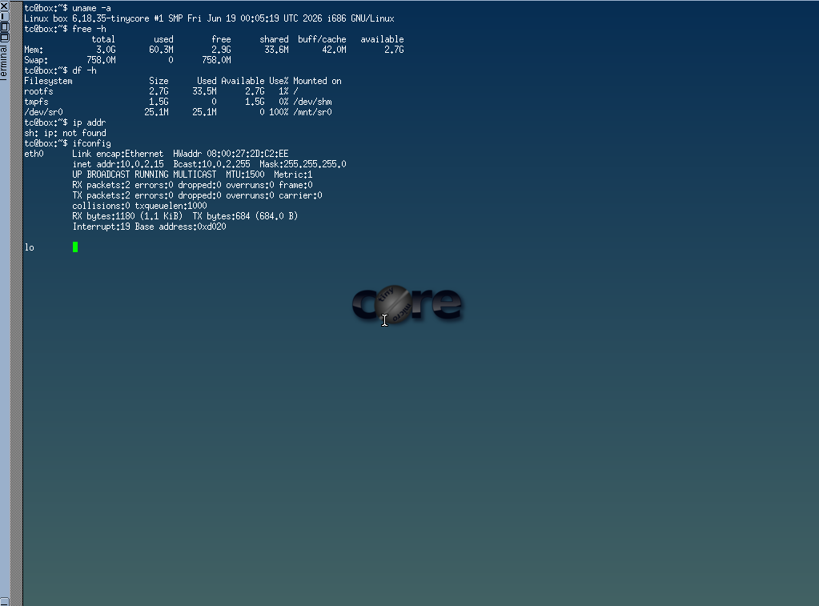
TinyCore terminal: uname -a, free -h, df -h, ifconfig output.
D. Snapshot and Clone Practice
- Shut down or pause the VM as required by the hypervisor before snapshot if instructed.
- Create a snapshot named before-update-or-demo.
- Record snapshot name, date and reason.
- Create a linked clone or full clone if the device has enough storage. If not, write the reason and create a clone plan.
- Start the VM again and confirm it still boots.
Recovery Item | Student Evidence / Decision
Snapshot name | -demo
Snapshot timing | 04/08/2026 10:29 AM
Snapshot reason | Checkpoint of clean VM state before further configuration changes, to allow rollback.
Clone attempted? | [Add Yes/No - not visible in current evidence]
Clone type | [Add Full / Linked / Not attempted]
Storage impact observed | Minimal - rootfs shows 33.5M used of 2.7G available at snapshot time.
Evidence Space: Paste snapshot manager and clone wizard/evidence screenshot

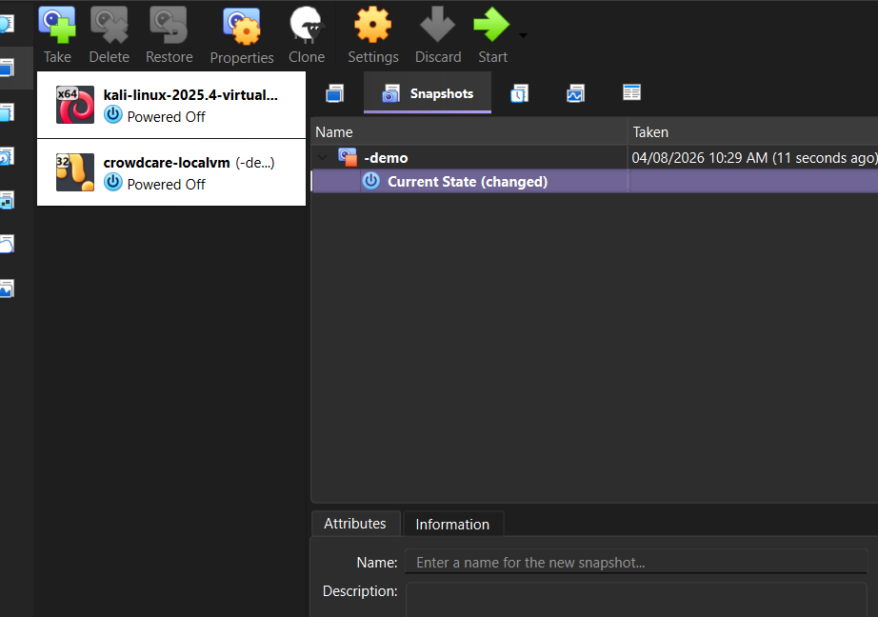
VirtualBox Snapshot Manager showing '-demo' snapshot taken 04/08/2026 10:29 AM.
E. Local VM Security Reflection
Security Area | Student Decision
VM network mode | NAT / Bridged / Host-only / Other
Why this mode is selected
Guest password policy
Shared folders enabled? | Yes / No
Clipboard/drag-drop enabled? | Yes / No
Risk if VM is exposed to public network

Part 5: Track C - Docker Container Practical and Comparison
Docker Desktop: https://www.docker.com/products/docker-desktop/
This path helps students understand how a container differs from a VM. A VM virtualizes hardware and runs a guest OS. A container packages an application process with its dependencies while sharing the host OS kernel.
Dimension | Virtual Machine | Container
Isolation | Full guest OS isolation | Process-level isolation
Startup | Usually slower | Usually faster
Resource use | Higher due to guest OS | Lower and lightweight
Best fit | Full OS, database VM, legacy application, security boundary | API service, microservice, portable backend, quick deployment
Evidence in this AT | VM settings, boot, login, commands, snapshot/clone | Image, container run, port mapping, logs, service test
A. Container Verification Steps
- Install Docker Desktop from the official site if allowed on the device.
- Open Terminal or PowerShell and run: docker --version.
- Run a lightweight container such as: docker run --rm hello-world.
- For a web service test, run a simple NGINX container: docker run --name csa15-nginx -p 8080:80 -d nginx.
- Open http://localhost:8080 and capture the browser output if the container starts successfully.
- Check logs using: docker logs csa15-nginx.
- Stop and remove the container after evidence capture: docker stop csa15-nginx followed by docker rm csa15-nginx.
Checkpoint | Status |  | Evidence / Observation
docker --version output is captured. | [X] Yes [ ] Rework |  | Docker version 29.6.2, build dfc4efb.
A container run command is captured. | [X] Yes [ ] Rework |  | hello-world ran successfully; nginx container started with docker run --name csa15-nginx -p 8080:80 -d nginx.
Port mapping or service evidence is captured if web test is used. | [ ] Yes [X] Rework |  | Container started with port mapping 8080:80 - browser confirmation at localhost:8080 still pending.
Container logs or status are captured. | [ ] Yes [X] Rework |  | Pending - run docker logs csa15-nginx and capture output.
Container is stopped/removed after evidence capture. | [ ] Yes [X] Rework |  | Pending - run docker stop csa15-nginx && docker rm csa15-nginx after evidence capture.
Docker Evidence |  | Student Observation
Docker version |  | 29.6.2, build dfc4efb
Image used |  | hello-world, nginx
Container name |  | csa15-nginx
Port mapping |  | 8080:80
Service URL tested |  | http://localhost:8080 [pending browser screenshot]
Log/status observation |  | [Add docker logs csa15-nginx output]
Stop/remove evidence |  | [Add screenshot/output of docker stop and docker rm]
Evidence Space: Paste Docker command and browser/service screenshots

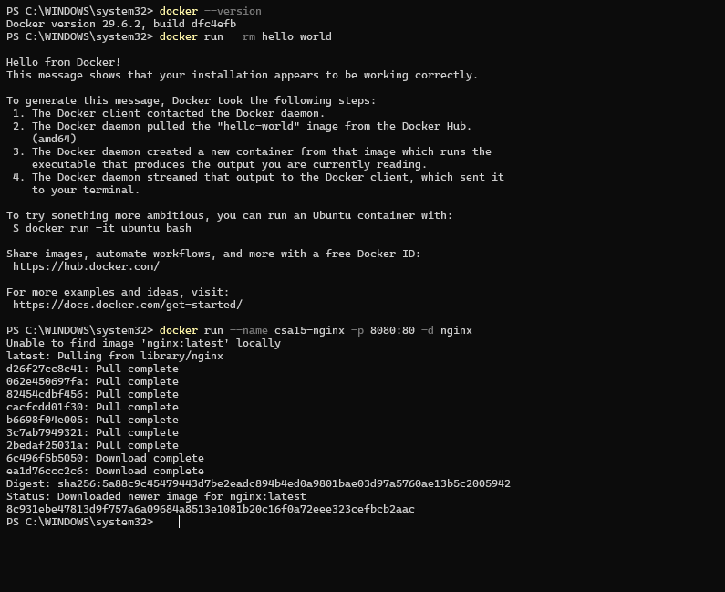
Docker version check, hello-world run, and nginx container start (port 8080:80).
B. Capstone Module Decision
Capstone Module | VM / Container / Managed Service | Technical Reason
Frontend | Container | Stateless UI, scales horizontally, fast redeploy for dashboard updates.
Backend/API | Container | Needs fast startup and easy scaling during event-time traffic spikes.
Database | Managed Service | Durability, automated backups and recovery matter more than raw control.
File storage | Managed Service | Cheap, durable storage for video frames/snapshots without managing disks.
AI/Python module | VM | Density-estimation inference needs consistent, higher CPU/GPU resources than a typical container limit.
Analytics/dashboard | Container | Lightweight, rebuilt/updated frequently.
Notification/background job | Container | Short-lived, event-driven, scales independently of the main API.
C. Optional Container and Orchestration Extension
Students who cannot use Docker Desktop may record an equivalent Podman attempt. Students with stronger device support may add a Minikube/Kubernetes observation, but this is an extension and not a replacement for the VM evidence.
Podman: https://podman.io/
Minikube: https://minikube.sigs.k8s.io/docs/start/
Kubernetes documentation: https://kubernetes.io/docs/home/
Optional Tool | Possible Evidence | Student Observation
Podman | podman --version, image pull/run, logs, stop/remove evidence
Minikube | minikube start/status, kubectl get nodes/pods evidence
Kubernetes | Simple deployment/service YAML or command evidence if attempted

Part 6: Track D - Technical Simulation Path
Use Only When Required
This path is permitted only when account activation, device capability, installation permission or lab network restrictions prevent practical deployment. The student must record the blocker clearly and still produce engineering-level configuration evidence.
CloudSim: https://github.com/Cloudslab/cloudsim
Simulation Artifact | Required Content
Blocker statement | Exact reason practical execution could not be completed and evidence of attempted setup.
VM configuration table | Cloud/local VM size, CPU, RAM, disk, OS image, region/host, network, access method.
Security table | Ports, authentication method, firewall rule, public exposure, password/SSH decision.
Snapshot/clone plan | Names, timing, retention and rollback purpose.
Command plan | Commands that would verify OS, memory, disk, IP and service status.
Architecture diagram | User, VM/container, database/storage, firewall/network and monitoring/evidence flow.
Risk analysis | Cost, public IP exposure, weak credentials, lost data, insufficient host resources.
Blocker Evidence and Justification

Planned Configuration | Student Value
Platform | Azure / VirtualBox / VMware / Docker
OS image
vCPU
RAM
Disk
Network mode / firewall
Access method
Service to verify
Paste or draw the simulation architecture diagram here

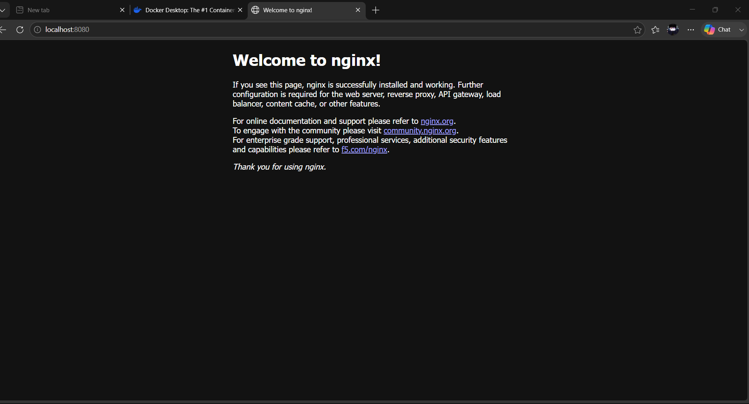

Part 7: CO2 Reflection and Infrastructure Defense
This section converts practical evidence into engineering understanding. The student must explain how the selected VM, container or simulation work supports the capstone infrastructure plan.
Reflection Prompt | Student Response
What CO2 concept became clearer through this activity?
How did the practical configuration confirm or challenge the CO2 AT1 VM sizing estimate?
Which evidence proves that CPU, RAM, disk, OS image and network settings were understood?
Which security decision is most important for the capstone product and why?
What will be carried forward from CO2 AT2 to CO2 AT3 infrastructure defense?
Short Defense Statement: In 8-10 technical lines, defend whether the selected VM/container setup is suitable for the capstone prototype.

Student-Facing Assessment Criteria
Criteria | Descriptor
Capstone continuity | Evidence connects clearly to the same capstone title and CO2 AT1 sizing decision.
Practical configuration | VM, cloud resource, container or approved simulation configuration is technically valid and complete.
Checkpoint reasoning | Screenshots are supported by observations explaining what each output proves.
Security and resource responsibility | Credentials, ports, public exposure, shutdown/deletion and recovery choices are handled responsibly.
Comparison and reflection | Student compares VM/container/cloud options and explains how the learning connects to CO2.
Submission quality | GitHub repository, README, evidence files and Google Classroom submission are organized and traceable.
Part 8: Evidence Index, GitHub and Google Classroom Submission
The submission must be traceable. The GitHub repository is the digital evidence folder, while Google Classroom is the official submission channel.
Repository Item |  | Expected Content
README.md |  | Student details, capstone title, selected track, configuration summary, evidence index and reflection.
Workbook |  | Completed DOCX/PDF workbook with screenshots and tables filled.
Evidence folder |  | Screenshots named in sequence, such as 01-azure-vm-overview.png.
Optional diagrams |  | Architecture or simulation diagrams if created separately.
Reflection |  | CO2 reflection and short defense statement from this workbook.
Evidence No. | File / Screenshot Name |  | What It Proves
1 | 01-tinycore-boot-menu.png |  | Proves VM was created and boots to the TinyCore boot menu.
2 | 02-tinycore-terminal.png |  | Proves OS, RAM (3.0G) and disk (2.7G rootfs) allocation via uname -a, free -h, df -h, ifconfig.
3 | 03-vm-snapshot.png |  | Proves a recovery snapshot ('-demo') was taken for rollback capability.
4 | 04-docker-terminal.png |  | Proves Docker installed (v29.6.2), hello-world container ran, and nginx container started with port mapping 8080:80.
5
6
7
8
Checkpoint | Status |  | Evidence / Observation
Repository is created under student's GitHub account. | [ ] Yes [ ] Rework
README.md is complete. | [ ] Yes [ ] Rework
Workbook is uploaded. | [ ] Yes [ ] Rework
Screenshots are uploaded and named clearly. | [ ] Yes [ ] Rework
Google Classroom submission contains the GitHub repository link. | [ ] Yes [ ] Rework
No passwords, private keys, tokens or sensitive account details are uploaded. | [ ] Yes [ ] Rework
Student Assurance
I confirm that this workbook, evidence screenshots, analysis and repository submission were prepared individually by me for the stated capstone title. I have not uploaded passwords, tokens, private keys or sensitive account information.
Student Name | Jagadeesh A
Register Number | 192521294
Signature | [Sign after completing all practical evidence]
Date | [Add date of completion]
Faculty Verification
Faculty Name | Dr C. Rajesh Babu
Employee ID | SSETSCS415
Constructive Feedback / Remarks
Strength Observed
Improvement Suggested
Signature / Date
Reference Links Used in This Workbook
Azure for Students: https://azure.microsoft.com/en-us/free/students
Azure for Students offer details: https://azure.microsoft.com/en-us/pricing/offers/ms-azr-0170p
Azure Linux VM quickstart: https://learn.microsoft.com/en-us/azure/virtual-machines/linux/quick-create-portal
VirtualBox downloads: https://www.virtualbox.org/wiki/Downloads
VMware Workstation and Fusion: https://www.vmware.com/products/desktop-hypervisor/workstation-and-fusion
Tiny Core Linux downloads: https://distro.ibiblio.org/tinycorelinux/downloads.html
Alpine Linux downloads: https://alpinelinux.org/downloads/
Alpine virt ISO directory: https://dl-cdn.alpinelinux.org/alpine/latest-stable/releases/x86_64/
Debian netinst: https://www.debian.org/download
Debian network install: https://www.debian.org/CD/netinst/
Ubuntu Server: https://ubuntu.com/download/server
Docker Desktop: https://www.docker.com/products/docker-desktop/
Podman: https://podman.io/
Minikube: https://minikube.sigs.k8s.io/docs/start/
Kubernetes: https://kubernetes.io/docs/home/
CloudSim: https://github.com/Cloudslab/cloudsim

