***DATASPARK: ILLUMINATING INSIGHTS FOR GLOBAL ELECTRONICS***

**Comprehensive Data Analysis and Strategic Recommendations for Global Electronics**

**Company Name**

**GLOBAL ELECTRONICS**

**Submitted by:** Jagadeesan. V

**DataSpark – Illuminating Insights for Global Electronics**

**PROJECT OVERVIEW**

This project, **DataSpark**, focuses on retail analytics within the electronics industry. Our objective is to perform a comprehensive **Exploratory Data Analysis (EDA)** on various datasets provided by **Global Electronics**, a leading retailer of consumer electronics. By analyzing customer behavior, sales trends, product performance, and store operations, we aim to uncover actionable insights that enhance customer satisfaction, optimize business processes, and drive growth.

**PROBLEM STATEMENT**

The analytics team at Global Electronics is tasked with unlocking insights from their data to **enhance customer satisfaction, optimize operations, and improve business growth**. The company has shared datasets containing customer demographics, product performance, store data, sales figures, and currency exchange rates.  
The goal is to provide actionable recommendations that address key business challenges, including better targeting of customers, optimizing pricing strategies, improving inventory management, and forecasting demand.

**DOMAIN**

**Retail Analytics in the Electronics Industry**

**Skills Applied in the Project**

* Data Cleaning and Preprocessing
* Exploratory Data Analysis (EDA)
* Python
* Data Management using SQL
* Visualization with Power BI / Tableau

**Business Use Cases**

1. **Marketing Optimization:**

Understand customer demographics and behaviors to improve marketing campaigns.

1. **Inventory Management:**

Identify popular and underperforming products to manage stock levels efficiently.

1. **Sales Forecasting:**

Recognize trends and seasonality for accurate sales predictions.

1. **International Pricing Strategy:**

Assess the impact of exchange rates on sales for better currency-based pricing.

1. **Store Expansion and Optimization:**

Evaluate store performance to plan expansions and optimizations.

**ANALYSIS STEPS AND APPROACH**

**1. Customer Analysis**

* **Demographic Distribution:**

Analyze customer distribution by **gender, age** (calculated from birthdate), **location** (city, state, country, continent).

* **Purchase Patterns:**

Explore the **average order value**, purchase frequency, and preferred products.

* **Customer Segmentation:**

Segment customers based on demographics and purchasing behavior to identify key customer groups.

**2. Sales Analysis**

* **Overall Sales Performance:**

Track **total sales over time** and identify trends or seasonal patterns.

* **Sales by Product:**

Determine the **top-performing products** by quantity sold and revenue.

* **Sales by Store:**

Assess individual store performance based on total sales.

* **Sales by Currency:**

Examine how sales figures are influenced by different currencies and **exchange rate trends**.

**3. Product Analysis**

* **Product Popularity:**

Identify the most and least popular products based on sales data.

* **Profitability Analysis:**

Calculate **profit margins** by comparing **unit cost** and **unit price** for each product.

* **Category Analysis:**

Analyze the performance of different **product categories** and **subcategories**.

**4. Store Analysis**

* **Store Performance:**

Evaluate store performance based on **sales figures, store size (square meters),** and **operational data** (e.g., open date).

* **Geographical Analysis:**

Analyze sales by **store location** to identify high-performing regions and opportunities for expansion.

**FINDINGS AND RECOMMENDATIONS**

**Customer Analysis Recommendations:**

* **Target Marketing Campaigns:** Focus on specific **age groups or locations** with high purchase potential.
* **Loyalty Programs:** Create personalized offers to retain high-value customer segments.

**Sales Analysis Recommendations:**

* **Promotions During Peak Seasons:** Offer time-sensitive discounts based on **seasonal trends** to boost sales.
* **International Currency Strategy:** Optimize pricing based on **exchange rate trends**, especially for high-value currencies like **AUD**.

**Product Analysis Recommendations:**

* **Discontinue Low-Performing Products:** Replace or promote **underperforming products** to optimize inventory.
* **Focus on High-Margin Products:** Prioritize stocking and promoting **high-margin products** to maximize profitability.

**Store Analysis Recommendations:**

* **Optimize Store Layouts:** Improve layouts in underperforming stores to increase customer engagement.
* **Expand in High-Performing Regions:** Open new stores or increase capacity in **top-performing regions** based on sales data.

**Data set Explanation:**

|  |  |  |  |  |  |
| --- | --- | --- | --- | --- | --- |
| **Table** | **Field** |  | **Description** |  |  |
| Sales | Order Number | Unique ID for each order | | |  |
| Sales | Line Item | Identifies individual products purchased as part of an order | | | |
| Sales | Order Date | Date the order was placed | | |  |
| Sales | Delivery Date | Date the order was delivered | | |  |
| Sales | CustomerKey | Unique key identifying which customer placed the order | | | |
| Sales | StoreKey | Unique key identifying which store processed the order | | | |
| Sales | ProductKey | Unique key identifying which product was purchased | | | |
| Sales | Quantity | Number of items purchased | | |  |
| Sales | Currency Code | Currency used to process the order | | |  |
| Customers | CustomerKey | Primary key to identify customers | | |  |
| Customers | Gender | Customer gender | |  |  |
| Customers | Name | Customer full name | |  |  |
| Customers | City | Customer city | |  |  |
| Customers | State Code | Customer state (abbreviated) | | |  |
| Customers | State | Customer state (full) | |  |  |
| Customers | Zip Code | Customer zip code | |  |  |
| Customers | Country | Customer country | |  |  |
| Customers | Continent | Customer continent | |  |  |
| Customers | Birthday | Customer date of birth | |  |  |
| Products | ProductKey | Primary key to identify products | | |  |
| Products | Product Name | Product name | |  |  |
| Products | Brand | Product brand | |  |  |
| Products | Color | Product color | |  |  |
| Products | Unit Cost USD | Cost to produce the product in USD | | |  |
| Products | Unit Price USD | Product list price in USD | |  |  |
| Products | SubcategoryKey | Key to identify product subcategories | | | |
| Products | Subcategory | Product subcategory name | | |  |
| Products | CategoryKey | Key to identify product categories | | |  |
| Products | Category | Product category name | |  |  |
| Stores | StoreKey | Primary key to identify stores | | |  |
| Stores | Country | Store country | |  |  |
| Stores | State | Store state |  |  |  |
| Stores | Square Meters | Store footprint in square meters | | |  |
| Stores | Open Date | Store open date | |  |  |
| Exchange Rates | Date | Date |  |  |  |
| Exchange Rates | Currency | Currency code | |  |  |
| Exchange Rates | Exchange | Exchange rate compared to USD | | |  |

**SQL QUERIES**

DEMOGRAPHIC DISTRIBUTION

*Select customer KEY, gender, city, country, continent, count (*) from newmerged_data1 group by 1,2,3,4,5,*

PURCHASE PATTERNS

*Select Customer KEY,*

*COUNT (DISTINCT Order Number) AS Purchase_Frequency,*

*AVG (UnitPriceUSD * Quantity) AS Average_Order_Value,*

*GROUP_CONCAT (DISTINCT ProductName ORDER BY ProductName SEPARATOR ', ') AS Preferred_Products*

*FROM*

*newMerged_Data1*

*GROUP BY*

*Customer KEY;*

SEGMENTAITION

*Select*

*Customerkey,*

*CASE*

*WHEN COUNT(DISTINCT OrderNumber) > 10 THEN 'High Frequency'*

*WHEN COUNT(DISTINCT OrderNumber) BETWEEN 5 AND 10 THEN 'Medium Frequency'*

*ELSE 'Low Frequency'*

*END AS Purchase_Frequency_Segment,*

*CASE*

*WHEN SUM(UnitPriceUSD * Quantity) > 1000 THEN 'High Value'*

*WHEN SUM(UnitPriceUSD * Quantity) BETWEEN 500 AND 1000 THEN 'Medium Value'*

*ELSE 'Low Value'*

*END AS Customer_Value_Segment,*

*-- Example demographic fields*

*Gender,*

*country,*

*continent*

*FROM*

*newMerged_Data1*

*GROUP BY*

*Customerkey, Gender, country, continent;*

*select monthname(orderdate) as sales_month,year(orderdate) as sales_year,quarter(orderdate)as segmented_year ,gender,country,continent,sum((unitpriceUSD)* quantity) as total_sales*

*from newmerged_data1 group by sales_month,sales_year,segmented_year,gender,country,continent order by sales_month,sales_year,segmented_year;*

SALE ANALYSIS

*select ProductName,gender,continent ,sum(quantity) as TotalQuantity_sold ,sum((UNITPRICEUSD)*quantity ) as Total_revenue from*

*newmerged_data1 group by ProductName,gender,continent order by Total_revenue desc;*

STORE ANALYSIS

*select storekey, gender,continent,country,city,avg(squaremeters) as average_storesize,sum((UNITPRICEUSD)*quantity ) as Total_sales*

*from newmerged_data1 group by 1,2,3,4,5 order by total_sales desc;*

*select storekey, gender,continent,country,city,avg(squaremeters) as average_storesize,sum((UNITPRICEUSD)*quantity ) as Total_sales*

*from newmerged_data1 group by 1,2,3,4,5 order by total_sales desc, average_storesize desc limit 10;*

*select storekey, gender,continent,country,city,avg(squaremeters) as average_storesize,sum((UNITPRICEUSD)*quantity ) as Total_sales*

*from newmerged_data1 group by 1,2,3,4,5 order by total_sales asc, average_storesize asc limit 10;*

PRODUCT PROFITABILITY

*Select productname,productkey ,avg(UNITPRICEUSD-UNITCOSTUSD) as totalprofit_margin,avg(UNITPRICEUSD) as average_selling_price,avg(UNITCOSTUSD)*

*as Average_cost from newmerged_data1 group by productname,productkey order by totalprofit_margin desc;*

CAT-SUBCATEGORYANALYSIS

*Select gender,productname,brand,name,color,category,subcategory,avg(UNITPRICEUSD*quantity) over(partition by category,subcategory ,gender )*

*as avg_price from newmerged_data1 ;*

STORE ANALYSIS

*Geographical Analysis: Analyze sales by store location to identify high-performing regions.*

*select country,state,sum((UNITPRICEUSD)*quantity) as total_sales from newmerged_data1 group by 1,2;*

EXCHANGERATES

*SELECT * FROM globalelectronics.exchange_rates;*

*SELECT*

*year(date) as year,*

*MONTHNAME(DATE) AS month_name,*

*DAY(DATE) AS day,*

*currency,*

*AVG(exchange) AS average_exchange_rate*

*FROM*

*exchange_rates*

*GROUP BY*

*1,2,3,4;*

**Analysis and Insights:**

Customer Demographic Analysis Overview

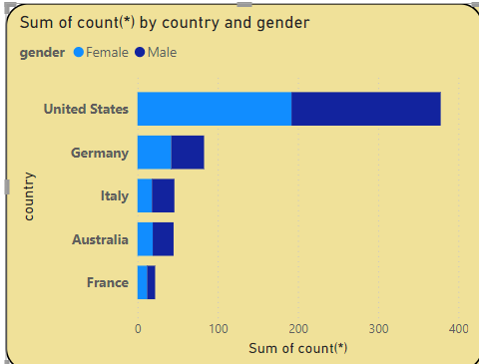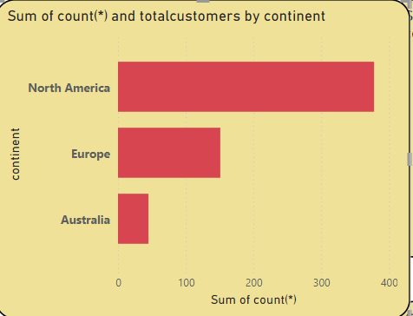

* **Focus on Low-Count Regions:** Target marketing efforts in France, Australia, Germany, and Italy to boost customer acquisition in these areas.
* **Leverage U.S. Success:** Enhance customer loyalty programs and referrals in the U.S. to maintain high engagement and attract new customers.
* **Create Inclusive Campaigns:** Develop gender-neutral marketing strategies that appeal to both male and female customers equally.
* **Analyze and Adapt:** Continuously monitor customer demographics and feedback to refine marketing approaches and improve outreach effectiveness.

**Analyzing Purchase Patterns:**

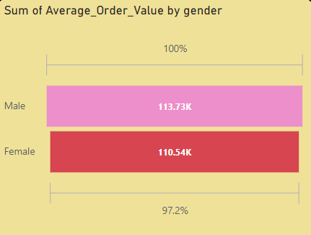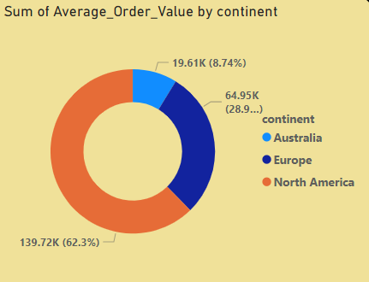

* Target North America with promotions since it contributes 62.3% of the total value.
* Boost engagement in Europe and Australia with region-specific campaigns to tap into their potential (28.9% and 8.74%).
* Leverage data-driven strategies to personalize offers and optimize customer experience across all regions.
* 4. Offer gender-specific incentives to both males and females to bridge the slight value gap.
* Personalize marketing campaigns for female buyers, as they represent 97.2% of male order value potential.

**Customer Segmentation:**

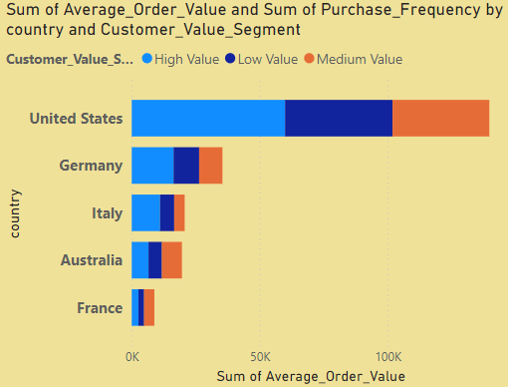

* Focus on high-value customers in the U.S. with loyalty programs and exclusive deals.
* Boost medium and low-value segments in Germany, Italy, and Australia with personalized offers to increase order size and frequency.
* Identify opportunities to upgrade low-value customers in France and Italy through cross-sells and bundles.
* Analyze purchase frequency trends to encourage repeat purchases in underperforming segments.

**Sales Trends and Seasonality:**

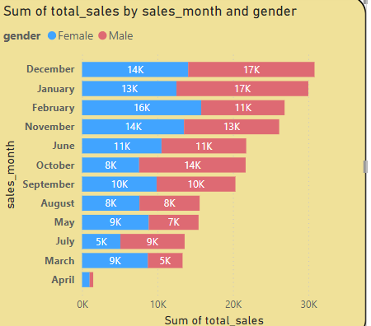

* **Target Promotions for April**

Implement targeted promotions in April to attract customers.

* **Extend Holiday Campaigns**

Extend holiday campaigns in December and January to capture ongoing demand.

* **Female-Focused Marketing**

Develop marketing strategies focused on female customer preferences.

* **Male Customer Engagement**

Introduce promotions and products specifically for male customers to enhance engagement

**Top Product Sales Analysis:**

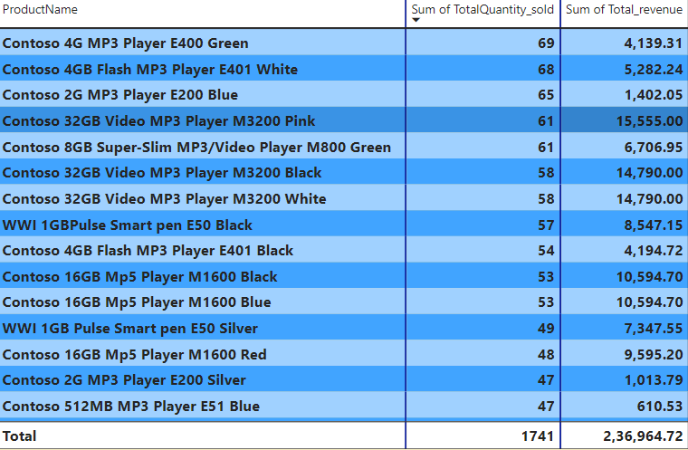

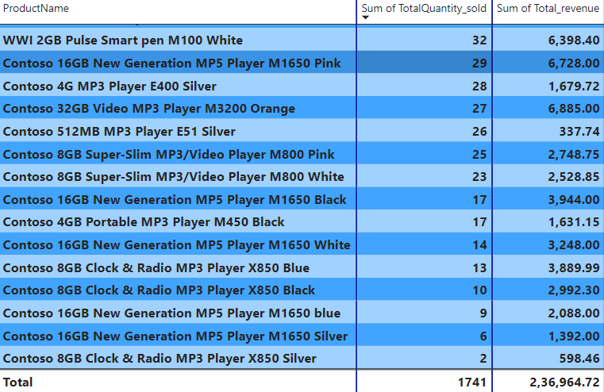

* **Promote Fast Movers:** Run targeted promotions and discounts on top-selling products to capitalize on their demand.
* **Bundle Offers:** Pair slow-moving products with fast-moving ones in combo deals to boost overall sales.
* **Inventory Optimization:** Reduce stock levels of slow movers and focus replenishment on high-demand products.
* **Customer Engagement:** Use data-driven marketing to recommend best-sellers and create exclusive offers for loyal customers.

**Store Sales Performance Analysis:**

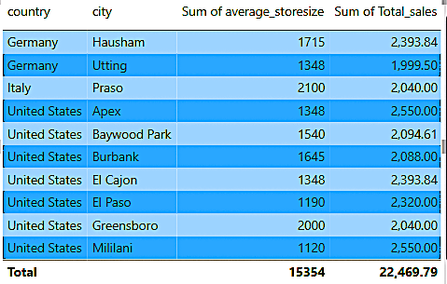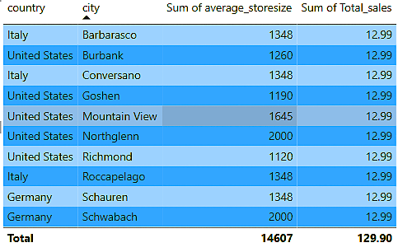

* **Optimize Product Mix:** Identify top-selling products from small stores and introduce them in larger ones.
* **Personalized Marketing:** Target customers with location-based promotions tailored to specific store performance.
* **Smart Inventory Management:** Use data to stock smaller stores with high-demand items and reduce underperforming stock in larger stores.
* **Store Format Adjustments:** Experiment with store layouts to replicate small-store success in bigger spaces.
* **Exclusive Deals by Location:** Offer exclusive discounts or product bundles based on regional preferences to attract more local customers.
* **Focus on In-Store Experience:** Enhance ambiance and customer service in larger stores to drive foot traffic and engagement.

**Sales Performance by Category**

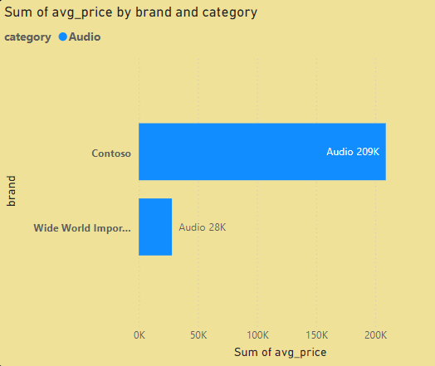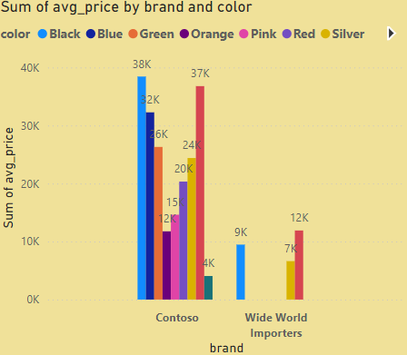

**Price Optimization by Brand:**

* Introduce mid-range Contoso products to attract more buyers.
* Maintain premium pricing for black Contoso items but offer discounts/bundles.

**Color-Specific Promotions:**

* Focus on promoting black color Contoso products for their high demand.
* Expand green color products under Contoso, inspired by Wide World Importers success.

**Brand Positioning:**

* Market Contoso as a premium brand with superior features.
* Position Wide World Importers as a value-for-money alternative for budget-conscious customers.

**Inventory & Cross-Promotions:**

* Ensure black and green products are always in stock.
* Run Contoso-Wide World Importers bundles to maximize sales across segments.

**Currency Impact on Sales:**

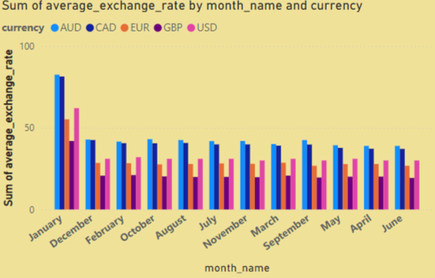

**Optimize Pricing in Non-AUD Markets:**

* Offer strategic discounts in CAD, EUR, GBP, and USD markets to increase sales.

**Capitalize on January Exchange Rates:**

* Launch time-sensitive promotions in AUD during January to leverage favourable rates.

**Expand Market Reach:**

* Strengthen presence in AUD-dominant regions and grow sales in other currency regions.

**Mitigate Exchange Rate Risks:**

* Implement hedging strategies to protect against currency fluctuations.

**Conclusion**

Through this project, we utilized **data analysis techniques** to provide valuable insights into customer behaviour, product performance, and store operations for Global Electronics. The findings offer actionable strategies for **improving marketing, inventory management, pricing, and store planning**. These insights will help the company optimize operations, **increase profitability**, and enhance overall **customer satisfaction**.

**Future Work**

* **Predictive Modeling:** Develop machine learning models for **sales forecasting** and customer churn prediction.
* **Real-time Dashboards:** Create dynamic dashboards in **Power BI/Tableau** for continuous monitoring of key metrics.
* **Advanced Segmentation:** Use clustering algorithms for deeper customer segmentation.

**Appendix**

1. **Tools Used:**
   * Python (for data cleaning and EDA)
   * SQL (for data management and queries)
   * Power BI / Tableau (for data visualization)
2. **Datasets Used:**
   * **Customer Data:** Includes demographics and purchase history
   * **Product Data:** Contains product names, categories, prices, and costs
   * **Sales Data:** Records of sales transactions with currency details
   * **Store Data:** Store information such as location, size, and operational details
   * **Currency Exchange Rates:** Exchange rates for multiple currencies over time
   * **Newmerged_data1:** Newmerged data1 is a consolidated dataset created by combining cleaned customer, product, sales, and store data.

This documentation outlines the full scope of the DataSpark project, guiding the analysis from data exploration to actionable recommendations for **Global Electronics growth and success**.