Software Requirements Specification (SRS) Document
<Vehicle Booking Application ,P.Jagadeesh and Ch.Nagaraju

Brief problem statement
The website or web-application that we are going to make is an vehicle booking application. The user can use this application to book a ride from one location to any another location by choosing the pick-up place and destination place in the map.

System requirements
This web application will be implemented in Java-script,MySQL and some other frameworks.

Users profile
Basic Computer Skills
  - Can manipulate a mouse
  - Can click and drag with a mouse.
  - Can respond appropriately to dialogs and pop-ups.

Feature requirements (described using use cases)

No. | User Case Name | Description | Release
 | Register | When the user opens the web application for the first-time ,he would be asked for sign-in and verification.
 | Login | The registered users can directly login into the web application and proceed further.
 | Pick Up Location | The user would be asked to choose the Pick Up Location
 | Drop Location | The user would be asked to choose the Destination Location to book the ride .
 | Confirm Ride | The user would be asked to confirm the ride .
6. | Message/E-mail | The user will get the message and e-mail about the booking details.
7. | Track Ride | The user can track the booked ride.
8. | Cancel Ride | The user can cancel the ride.
9. | Payment | The payment can be made to the driver.
10.
11.
12.
13.

This will be updated when we add any extra features to our project.

Use case diagram
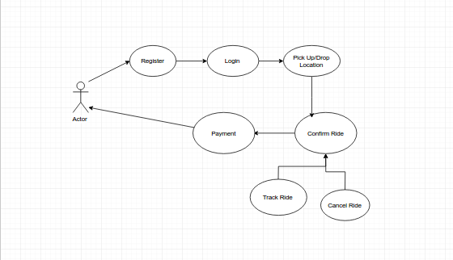

Use case description

Use Case Number: | UC-01,2,3,4
Use Case Name: | Pick -Up Location/Drop Location
Overview: | The user would be able to choose the Pick Up Location and Drop Location
Actors: | User
Pre condition: | The user should be registered and logged in.
Flow: | Main (success) Flow: Steps should be numbered.  1.User should choose the location from the pop-up menu appeared.  2.The location will be saved in the pick up location.  3.The user should choose the drop location.
Post Condition: | The locations will gets stored in the server.

Use Case Number: | UC-05,6,7
Use Case Name: | Confirm Ride/Track Ride /Cancel Ride
Overview: | The user should confirm the ride which has chosen.
Actors: | User
Pre condition: | Logged-in,Save the Locations.
Flow: | Main (success) Flow:  1.User should confirm the ride.  2.Message or E-mail will be sent to the registered number.
Post Condition: | The ride will be confirmed and user can track the ride or user can cancel the ride.

