1. Nominal Capacity (𝑬ₘₐₓ)
Equation (Wh):

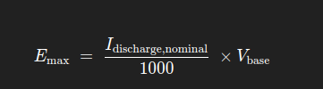

Where Idischarge,nominal is in mA and Vbase in volts
Code (constructor):
total_discharge_current_ = num_batteries_ * discharge_current_;
total_power_ = (total_discharge_current_ / 1000.0f) * base_voltage_;

Here total_power_ is Emax in Wh.

2. Discrete Energy Update (Coulomb Counting)
Equation (per second):
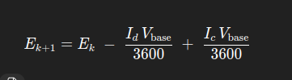

Clamped so 0≤E≤Emax
Code (update_battery()):
// convert mA→A and seconds→hours via /(60*60*1000)
power_ -= discharge_rate_ * base_voltage_;
power_ += recharge_rate_ * base_voltage_;

// clamp energy
power_ = std::max(0.0f, std::min(power_, total_power_));
- discharge_rate_ = I_d/(60*60*1000)
- recharge_rate_ = I_c/(60*60*1000)
Thus discharge_rate_ * base_voltage_ = Ld*Vb/3600

3. Terminal Voltage Curve V(E)

a) Linear Model
Equation:
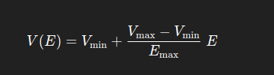

A degree-1 polynomial fit
Code (setup_discharge_model()):
case DischargeModel::Linear:
eq_deg = 1;
data.push_back({ total_power_, max_voltage_ });
data.push_back({ total_power_*0.75f, min_voltage_ + d_voltage*0.75f });
data.push_back({ total_power_*0.5f, min_voltage_ + d_voltage*0.5f });
data.push_back({ total_power_*0.25f, min_voltage_ + d_voltage*0.25f });
data.push_back({ 0, min_voltage_ });
break;
// ...
eq_.fit(eq_deg, data);

These five (E,V) points lie exactly on the line above, so the fit produces the linear relation.

b) Exponential & Inverse Models
Equation (degree-4 or 7 polynomial):
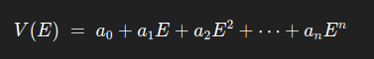

Coefficients alpha(i) found by least-squares on chosen breakpoints

Code (excerpt):
case DischargeModel::Exponential:
eq_deg = 4;
data.push_back({ total_power_, max_voltage_ });
data.push_back({ total_power_*0.9f, min_voltage_ + d_voltage*0.98f });
// ... more points down to (0, min_voltage_)
break;
case DischargeModel::Inverse:
eq_deg = 7;
// similar push_back calls for 0.9Emax…0.1Emax
break;
// After filling `data`:
eq_.fit(eq_deg, data);

- fit() solves the normal equations via Gaussian elimination (in fit.hpp).
- Later, each tick uses eq_.evaluate(power_) to compute voltage_.

4. State-of-Charge (SOC) Estimation
Equation (linear voltage→SOC):


Or, under the linear fit, SOC=100E/Emax
Code (update_battery()):
voltage_ = eq_.evaluate(power_);
voltage_ = std::clamp(voltage_, min_voltage_, max_voltage_);
percent_ = map_number(voltage_, min_voltage_, max_voltage_, 0, 100);

map_number() implements the affine mapping above.

5. Initialization & Reset
Initial SOC to Energy:


in code via power_ = map_number(initial_percent_, 0, 100, 0, total_power_).
Reset Callback sets percent_, power_, voltage_ = base_voltage_, and zeroes rates.

