NAME: JAGADEESH R
SRN: PES1UG24CS195
SECTION: D
EPICS
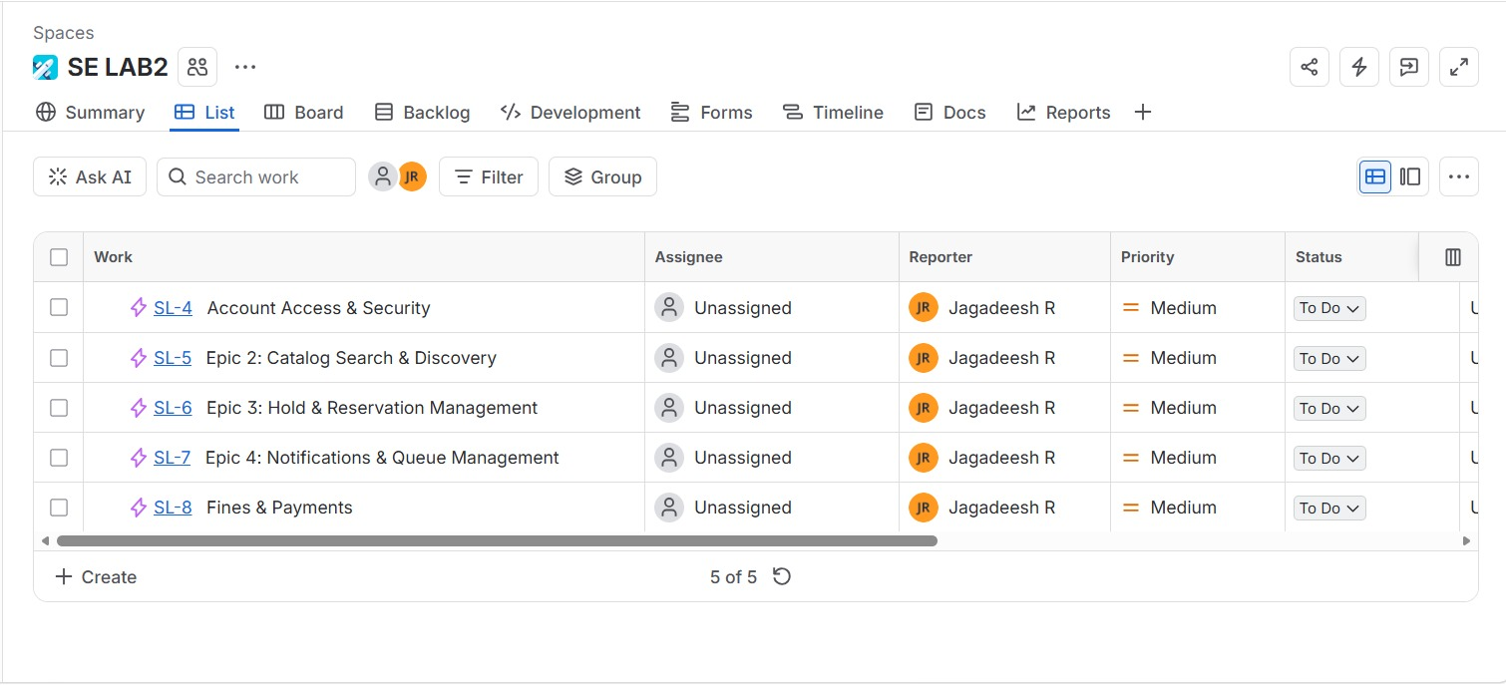
STORY WITH STORY POINTS
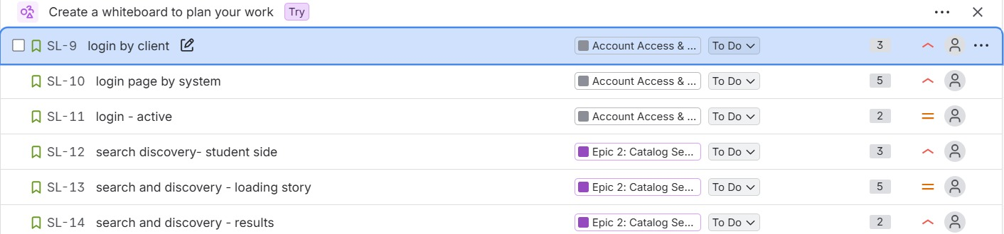
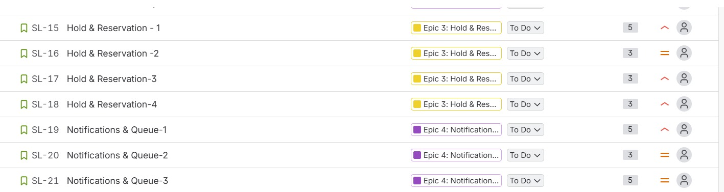

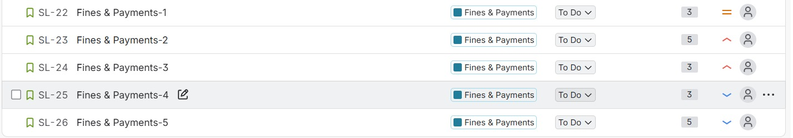

ACTIVE SPRINTS
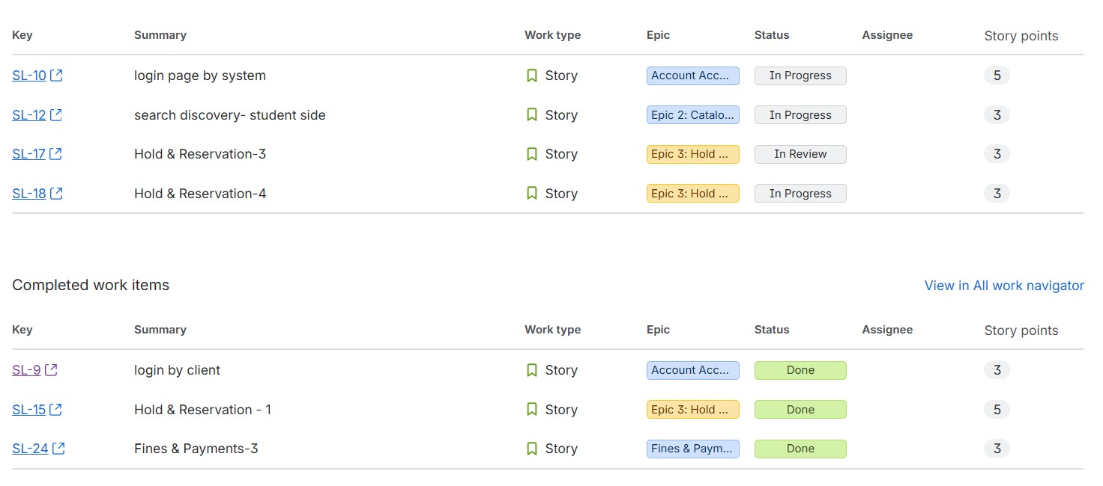
BURNDOWN CHART
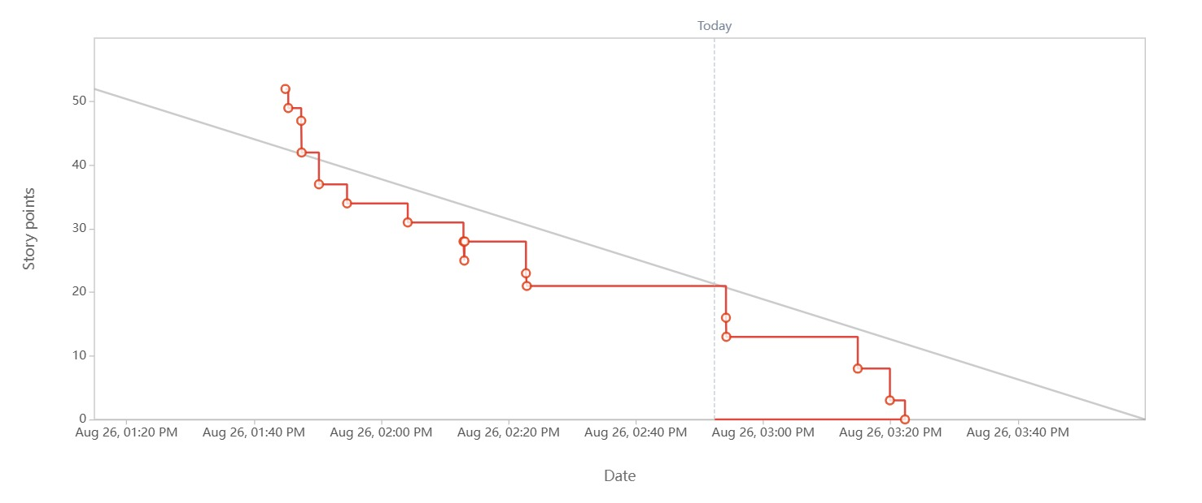
1. Did your estimations reflect the actual effort?
Not fully — since this was a simulated sprint compressed into about 2 hours rather than a real week, the Fibonacci points (mostly 2, 3, and 5) were assigned based on perceived complexity, not measured effort. The burndown consistently stayed below the ideal guideline line, which suggests the estimates were somewhat inflated relative to how quickly items were actually marked Done in the simulation. In a real sprint with actual development time, simpler stories (like UI-only notification stories rated 5) would likely need to be re-estimated lower, while stories with real backend logic (like Login/Authentication or Verify Membership Eligibility) would more fairly justify their points.
2. Was your backlog well-prioritized?
Yes, largely. High-priority foundational stories — Login (UC-00), Place Hold (UC-02), and blocking holds when fines exceed the threshold (FR-005) — were correctly flagged High/Medium and pulled into Sprint 1 first. This matches proper Agile sequencing: core access and reservation flows before secondary features like fine waivers or transaction reporting, which stayed in the backlog for a later sprint.
3. How did your simulated sprint align with your plan?
Reasonably well, with a minor gap. Sprint 1 selected 52 of the 66 total backlog points. The burndown shows all 52 points reaching 0, but the sprint report snapshot (taken mid-sprint) shows a few stories — like "login page by system" and "Hold & Reservation-3/4" — still sitting in In Progress or In Review rather than Done. This means the sprint didn't close cleanly in one pass; those items needed an extra status update before the sprint could be marked fully complete.
4. What insights did the burndown chart give about your team's capacity?
The red line staying consistently below the grey guideline throughout the sprint is a classic sign of finishing faster than planned — usually meaning either the team is highly efficient, or (more likely here, since it's a single-person simulation) the stories were slightly over-pointed for the actual work involved. If this were a real multi-week sprint, this pattern would suggest the team has room to commit to more story points in Sprint 2 rather than fewer.

