REPORT

ON

“Multi-page responsive website”

SUBMITTED FOR THE PARTIAL FULFILLMENT OF THE

REQUIREMENT FOR THE AWARD OF THE INTERNSHIP IN

WEB DEVELOPMENT

SUBMITTED BY

B.JAGADEESH

B.TECH [ECE]

3RD YEAR

JNTU HYDERABAD

SUBMITTED TO

Exposys data labs

1

Abstract

This web development guide introduces the process of creating a multi-page responsive website using HTML and CSS. It emphasizes the importance of combining these languages to build visually appealing and interactive websites that adapt to different devices. The guide outlines the essential pages of the website, including the index page, services page, contact page, and a portfolio section showcasing previous works. It highlights the goal of creating a responsive design to optimize user experience across various screen sizes.

Throughout the guide, the goal is to help readers develop their web development skills and create captivating websites using HTML and CSS. By following the instructions and focusing on responsive design principles, they can bring their ideas to life and deliver an exceptional user experience on the web.

2

CONTENTS Pg No.

1. Introduction 4
2. Methodology 5-8
   1. Idea 5
   2. Pages 6-8
3. Implementation 9-24
   1. Codes 9-22
   2. Pictures 23-24
4. Conclusion 25

3

1.Introduction

In this project, we will explore the process of creating a multi-page responsive website using HTML and CSS which is a IT company named as LightCode. This website will consist of several essential pages, including an index page, services page, contact page, and a showcase of some of our previous works.

Building a website from scratch involves combining different technologies and coding languages. HTML (Hypertext Markup Language) provides the structure and content of web pages, while CSS (Cascading Style Sheets) is responsible for the design and layout. By using these two languages in conjunction, we can create visually appealing and interactive websites that adapt to different screen sizes and devices.

4

2.methodology

2.1 Idea

Our website with title Light Code will begin with an index page, which serves as the landing page for visitors. It will contain a brief introduction, along with navigation links to other pages. The services page will highlight the various offerings we provide, explaining them in detail and potentially showcasing relevant images or videos. The contact page will allow users to get in touch with us, providing a form for inquiries or messages.

To make our website more engaging, we will also include a section displaying some of our previous works. This portfolio section will showcase our skills and expertise, potentially using images, descriptions, and links to demonstrate the range and quality of our work.

Throughout this guide, we will focus on creating a responsive website. Responsiveness ensures that our site adapts and looks great on different devices, such as desktop computers, laptops, tablets, and smartphones. By utilizing responsive design techniques, we can optimize user experience across various screen sizes and orientations.

So, whether you're new to web development or looking to enhance your existing skills, join us on this journey to create a captivating multi-page responsive website using HTML and CSS.

5

2.2 pages

This website will consist of several essential pages mentioned below

* Index Page.
* Services Page.
* Works Page.
* Contact us Page.

**Index page**

The index page serves as the landing page for our website. Its purpose is to capture the attention of visitors and provide them with an overview of our offerings. The brief for this page includes:

* A visually appealing and attention-grabbing introduction that highlights the unique aspects of our business or services.
* Clear and intuitive navigation menu or links that direct users to other pages on the website.
* Engaging content that encourages visitors to explore further and learn more about what we have to offer.
* An eye-catching call-to-action (CTA) button or section that prompts users to take a desired action, such as contacting us or exploring our services.
* The index page is the home page of the website.
* It includes a header with a logo and navigation menu.
* The main content section has a hero image and a heading with a call-to-action button.
* The page provides a brief introduction to the company and its services.
* It also includes links to other pages such as services and work.

**Services Page**

The services page is dedicated to providing detailed information about the range of services we offer. The brief for this page includes:

* A clear and concise headline that introduces the page and highlights the main services we provide.
* Descriptions and explanations of each service, outlining their key features, benefits, and any unique selling points.

6

* Visual elements, such as images or videos, that help illustrate the services and showcase their quality or effectiveness.
* Testimonials or case studies that provide social proof and demonstrate the positive impact our services have had on previous clients.
* Clear calls-to-action throughout the page, guiding users to take the next step, such as contacting us or requesting a quote.
* The services page provides information about the services offered by the company.
* It includes a header with a logo and navigation menu.
* The main content section includes a heading and a description of the services.
* The page showcases different services with icons, headings, and descriptions.
* Each service description explains the importance and benefits of the service.

**Works Page**

The portfolio or works page is dedicated to showcasing our previous projects or works to demonstrate our capabilities and expertise. The brief for this page includes:

* A visually appealing layout that presents the portfolio items in an organized and attractive manner.
* High-quality images, videos, or other media that effectively represent the showcased works.
* Descriptions or captions accompanying each portfolio item, highlighting key features, challenges, or results achieved.
* Links or buttons to learn more about each project, potentially leading to case studies or in-depth details.
* Navigation options or filtering mechanisms to help users easily browse and explore different categories or types of works.
* The works page displays examples of the company's previous works or projects.
* It includes a header with a logo and navigation menu.
* The main content section includes a heading and a description of the works.

7

* The page showcases images of different projects as examples of the company's expertise.
* The images are displayed in a grid or a row.

**Contact Page**

The contact page is essential for users to get in touch with us. The brief for this page includes:

* A contact form that collects necessary information from users, such as their name, email address, and message.
* Clear and concise instructions on how to contact us via phone or email, in case users prefer direct communication.
* Information about our physical address or office location, if applicable.
* Social media links or icons, allowing users to connect with us on various platforms.
* Any additional contact details or instructions specific to our business, such as operating hours or availability.
* The contact page provides contact information and a contact form.
* It includes a header with a logo and navigation menu.
* The main content section includes a heading and a description of how to contact the company.
* The page includes a contact form with fields for name, email, subject, and message.
* There is also a submit button to send the form.

8

3.Implementation

To Implement above discussed pages as a part of multi-page responsive project which includes HTML for each page and CSS code for styling the website which can written below.

3.1 codes

**1.INDEX**

<!DOCTYPE html>

<html lang="en">

<head>

<meta charset="UTF-8" />

<meta http-equiv="X-UA-Compatible" content="IE=edge" />

<meta name="viewport" content="width=device-width, initial-scale=1.0" />

<link

rel="stylesheet"

href="https://cdnjs.cloudflare.com/ajax/libs/font-awesome/5.15.3/css/all.min.css"

integrity="sha512-iBBXm8fW90+nuLcSKlbmrPcLa0OT92xO1BIsZ+ywDWZCvqsWgccV3gFoRBv0z+8dLJgyAHIhR35VZc2oM/gI1w=="

crossorigin="anonymous"

referrerpolicy="no-referrer"

/>

<link rel="stylesheet" href="style.css">

<title>IT Company || Home Page</title>

</head>

<body>

<header>

<div class="main-nav">

<a href="index.html" class="logo">LightCode.</a>

<ul>

<li><a href="index.html">home</a></li>

<li><a href="services.html">services</a></li>

<li><a href="work.html">work</a></li>

</ul>

</div>

<div class="sub-nav">

<ul>

<li>

<a href="#"><i class="fab fa-facebook-f"></i></a>

</li>

<li>

<a href="#">

9

<i class="fab fa-twitter"></i>

</a>

</li>

<li>

<a href="#">

<i class="fab fa-instagram-square"></i>

</a>

</li>

</ul>

</div>

</header>

<div class="container">

<div class="hero">

<div class="content">

<h1 class="heading-primary">

We are here to help you build you'r dream project

</h1>

<p>

We are thrilled to have you here. we understand the importance of turning your dreams into reality. Whether you're an aspiring entrepreneur, a seasoned professional, or someone with a passion project, we are here to help you build your dream project on your chosen domain.

</p>

<a href="contact.html" class="btn">contact now</a>

</div>

<div class="hero-img">

<img src="img/hero.jpg" alt="Hero Image">

</div>

</div>

</div>

</body>

</html>

**2.SERVICES**

<!DOCTYPE html>

<html lang="en">

<head>

<meta charset="UTF-8" />

<meta http-equiv="X-UA-Compatible" content="IE=edge" />

<meta name="viewport" content="width=device-width, initial-scale=1.0" />

10

<link

rel="stylesheet"

href="https://cdnjs.cloudflare.com/ajax/libs/font-awesome/5.15.3/css/all.min.css"

integrity="sha512-iBBXm8fW90+nuLcSKlbmrPcLa0OT92xO1BIsZ+ywDWZCvqsWgccV3gFoRBv0z+8dLJgyAHIhR35VZc2oM/gI1w=="

crossorigin="anonymous"

referrerpolicy="no-referrer"

/>

<link rel="stylesheet" href="style.css">

<title>IT Company || Services Page</title>

</head>

<body>

<header>

<div class="main-nav">

<a href="index.html" class="logo">LightCode.</a>

<ul>

<li><a href="index.html">home</a></li>

<li><a href="services.html">services</a></li>

<li><a href="work.html">work</a></li>

</ul>

</div>

<div class="sub-nav">

<ul>

<li>

<a href="#"><i class="fab fa-facebook-f"></i></a>

</li>

<li>

<a href="#">

<i class="fab fa-twitter"></i>

</a>

</li>

<li>

<a href="#">

<i class="fab fa-instagram-square"></i>

</a>

</li>

</ul>

</div>

</header>

<div class="container">

<div class="description">

<h2 class="heading-secondary">

Services that we provide

</h2>

11

<p>we take pride in delivering exceptional services that cater to your unique needs and goals. Whether you're an individual, a small business, or a large enterprise, we have the knowledge and skills to assist you in various domains.</p>

</div>

<div class="cards">

<div class="card">

<div class="icon">

<img src="img/img-1.png" alt="Image 1">

</div>

<h3 class="heading-tertiary">Digital Marketing</h3>

<p>

A successful online presence requires effective marketing strategies. Our digital marketing experts employ a data-driven approach to help you reach your target audience, increase brand visibility, and drive conversions.

</p>

</div>

<div class="card">

<div class="icon">

<img src="img/img-2.png" alt="Image 2">

</div>

<h3 class="heading-tertiary">Mobile App Development</h3>

<p>

In today's mobile-centric world, having a captivating and functional app is essential. We offer comprehensive mobile app development services across multiple platforms, including iOS and Android, ensuring a seamless user experience and innovative features.

</p>

</div>

<div class="card">

<div class="icon">

<img src="img/img-3.png" alt="Image 3">

</div>

<h3 class="heading-tertiary">Error Fixing</h3>

<p>

Our experienced team of developers excels in identifying and resolving errors to ensure a smooth and error-free browsing experience for your visitors. We conduct thorough website audits, address coding issues, and optimize performance to enhance the functionality and reliability of your site.

</p>

</div>

<div class="card">

<div class="icon">

<img src="img/img-4.png" alt="Image 4">

</div>

12

<h3 class="heading-tertiary">UI/UX Design</h3>

<p>

A visually appealing and intuitive user interface can significantly impact your digital presence. Our skilled designers are dedicated to creating engaging and user-centric designs that enhance the overall user experience, resulting in increased customer satisfaction and retention.

</p>

</div>

<div class="card">

<div class="icon">

<img src="img/img-5.png" alt="Image 5">

</div>

<h3 class="heading-tertiary">Web Development</h3>

<p>

Our team of talented developers specializes in creating high-quality websites tailored to your specific requirements. From simple informational sites to complex e-commerce platforms, we have the expertise to build robust and user-friendly web solutions.

</p>

</div>

<div class="card">

<div class="icon">

<img src="img/img-6.png" alt="Image 6">

</div>

<h3 class="heading-tertiary">SEO</h3>

<p>

Search Engine Optimization (SEO) is a crucial aspect of modern digital marketing that focuses on optimizing websites and online content to improve their visibility and rankings on search engine results pages (SERPs).

</p>

</div>

</div>

</div>

</body>

</html>

**3.WORKS**

<!DOCTYPE html>

<html lang="en">

<head>

<meta charset="UTF-8" />

<meta http-equiv="X-UA-Compatible" content="IE=edge" />

<meta name="viewport" content="width=device-width, initial-scale=1.0" />

<link

rel="stylesheet"

href=<https://cdnjs.cloudflare.com/ajax/libs/font-awesome/5.15.3/css/all.min.css>

13

integrity="sha512-iBBXm8fW90+nuLcSKlbmrPcLa0OT92xO1BIsZ+ywDWZCvqsWgccV3gFoRBv0z+8dLJgyAHIhR35VZc2oM/gI1w=="

crossorigin="anonymous"

referrerpolicy="no-referrer"

/>

<link rel="stylesheet" href="style.css">

<title>IT Company || Work Page</title>

</head>

<body>

<header>

<div class="main-nav">

<a href="index.html" class="logo">LightCode.</a>

<ul>

<li><a href="index.html">home</a></li>

<li><a href="services.html">services</a></li>

<li><a href="work.html">work</a></li>

</ul>

</div>

<div class="sub-nav">

<ul>

<li>

<a href="#"><i class="fab fa-facebook-f"></i></a>

</li>

<li>

<a href="#">

<i class="fab fa-twitter"></i>

</a>

</li>

<li>

<a href="#">

<i class="fab fa-instagram-square"></i>

</a>

</li>

</ul>

</div>

</header>

<div class="container">

<div class="description">

<h2 class="heading-secondary">

Some of our works

</h2>

<p>These examples showcase our expertise in creating visually appealing, user-friendly, and performance-driven solutions across a range of industries. We are dedicated to delivering exceptional results that meet the unique needs and goals of our clients.</p>

</div>

14

<div class="work mb">

<img src="img/work-1.jpg" alt="Work Image 1">

<img src="img/work-2.jpg" alt="Work Image 2">

<img src="img/work-3.jpg" alt="Work Image 3">

<img src="img/work-4.jpg" alt="Work Image 4">

<img src="img/work-5.jpg" alt="Work Image 5">

</div>

</div>

</body>

</html>

**4.CONTACT PAGE**

<!DOCTYPE html>

<html lang="en">

<head>

<meta charset="UTF-8" />

<meta http-equiv="X-UA-Compatible" content="IE=edge" />

<meta name="viewport" content="width=device-width, initial-scale=1.0" />

<link

rel="stylesheet"

href="https://cdnjs.cloudflare.com/ajax/libs/font-awesome/5.15.3/css/all.min.css"

integrity="sha512-iBBXm8fW90+nuLcSKlbmrPcLa0OT92xO1BIsZ+ywDWZCvqsWgccV3gFoRBv0z+8dLJgyAHIhR35VZc2oM/gI1w=="

crossorigin="anonymous"

referrerpolicy="no-referrer"

/>

<link rel="stylesheet" href="style.css">

<title>IT Company || Contact Page</title>

</head>

<body>

<header>

<div class="main-nav">

<a href="index.html" class="logo">LightCode.</a>

<ul>

<li><a href="index.html">home</a></li>

<li><a href="services.html">services</a></li>

<li><a href="work.html">work</a></li>

</ul>

</div>

<div class="sub-nav">

<ul>

<li>

15

<a href="#"><i class="fab fa-facebook-f"></i></a>

</li>

<li>

<a href="#">

<i class="fab fa-twitter"></i>

</a>

</li>

<li>

<a href="#">

<i class="fab fa-instagram-square"></i>

</a>

</li>

</ul>

</div>

</header>

<div class="container">

<div class="description">

<h2 class="heading-secondary">

Contact us

</h2>

<p> We are excited to connect with you and provide any assistance or information you may need. we believe in open communication and building strong relationships with our clients and visitors.No matter which method you choose, we assure you that your inquiries will receive our utmost attention and prompt response. We value your time and are committed to delivering exceptional customer service.</p>

</div>

<div class="contact-form mb">

<form>

<div class="row">

<div class="input50">

<input type="text" placeholder="First Name">

</div>

<div class="input50">

<input type="text" placeholder="Last Name">

</div>

</div>

<div class="row">

<div class="input50">

<input type="email" placeholder="Email">

</div>

<div class="input50">

<input type="text" placeholder="Subject">

</div>

</div>

16

<div class="row">

<div class="input100">

<textarea placeholder="Message"></textarea>

</div>

</div>

<div class="row">

<div class="input100">

<input type="submit" value="Send"></input>

</div>

</div>

</form>

</div>

</div>

</body>

</html>

**STYLE CSS CODE:**

:root {

--primary-color:rgb(62, 35, 80);

--color-white: #fff;

--color-black: rgb(46, 38, 24);

}

*,

*::before,

*::after {

margin: 0;

padding: 0;

box-sizing: border-box;

}

body {

font-family: sans-serif;

font-size: 1.3rem;

min-height: 100vh;

line-height: 1.6;

}

/* utility */

.container {

padding: 0 5%;

}

a {

color: var(--color-white);

text-decoration: none;

}

17

p {

color: var(--color-black);

}

.mb {

margin-bottom: 4rem;

}

.heading-primary {

font-size: 2.5rem;

font-weight: 300;

line-height: 1;

color: var(--primary-color);

margin-bottom: 1rem;

}

.heading-secondary {

font-size: 2rem;

font-weight: 300;

line-height: 1;

color: var(--primary-color);

margin-bottom: 1.5rem;

}

.heading-tertiary {

font-size: 1.5rem;

color: var(--primary-color);

margin-bottom: .5rem;

}

/* header */

header {

height: 10vh;

display: flex;

}

.main-nav {

width: 70%;

background-color: var(--primary-color);

padding-left: 5%;

display: flex;

align-items: center;

justify-content: space-between;

}

.main-nav ul,

.sub-nav ul {

list-style: none;

display: flex;

}

18

.main-nav ul li a {

text-transform: capitalize;

padding-right: 2rem;

}

.logo {

font-size: 1.5rem;

}

.sub-nav {

width: 30%;

padding-right: 5%;

display: flex;

align-items: center;

justify-content: flex-end;

}

.sub-nav ul li a {

color: var(--primary-color);

padding-left: 1.5rem;

}

/* hero */

.hero {

height: calc(100vh - 10vh);

display: flex;

justify-content: space-between;

}

.content {

flex: 0 0 50%;

display: flex;

flex-direction: column;

align-items: flex-start;

justify-content: center;

padding-right: 1rem;

}

.hero-img {

flex: 0 0 50%;

}

.hero-img img {

width: 100%;

height: 100%;

}

.btn {

display: inline-block;

background-color: var(--primary-color);

19

padding: 0.5rem 1.5rem;

margin-top: 4rem;

}

/* services */

.description {

height: 50vh;

width: 90%;

display: flex;

flex-direction: column;

justify-content: center;

}

.cards {

display: grid;

grid-template-columns: repeat(auto-fit, minmax(300px, 1fr));

gap: 4rem;

text-align: center;

margin-top: 4rem;

}

.card {

margin-bottom: 2rem;

}

.card .icon img {

width: 7rem;

height: auto;

margin-bottom: 3rem;

}

/* work */

.work {

display: grid;

grid-template-columns: repeat(auto-fit, minmax(300px, 1fr));

gap: 2rem;

}

.work img {

width: 100%;

height: 100%;

}

/* contact */

.contact-form form {

width: 80%;

}

.contact-form .row {

width: 100%;

20

display: flex;

}

.input50 {

width: 50%;

margin: 0 10px;

}

.input100 {

width: 100%;

margin: 0 10px;

}

.contact-form .row input,

.contact-form .row textarea {

font-size: 1.2rem;

font-weight: 300;

width: 100%;

border: 1px solid rgba(0, 0, 0, 0.2);

color: var(--color-black);

padding: 10px;

outline: none;

margin: 10px 0;

}

.contact-form .row textarea {

height: 150px;

}

.contact-form .row input[type="submit"] {

background-color: var(--primary-color);

color: var(--color-white);

border: 0;

cursor: pointer;

}

@media(max-width:950px) {

.hero-img,

.sub-nav {

display: none;

}

.content {

flex: 0 0 100%;

}

.main-nav {

width: 100%;

}

21

.contact-form form {

width: 100%;

}

.contact-form .row {

flex-direction: column;

}

.contact-form .input100,

.contact-form .input50 {

width: 100%;

}

}

22

3.2 PICTURES

**1.INDEX PAGE**

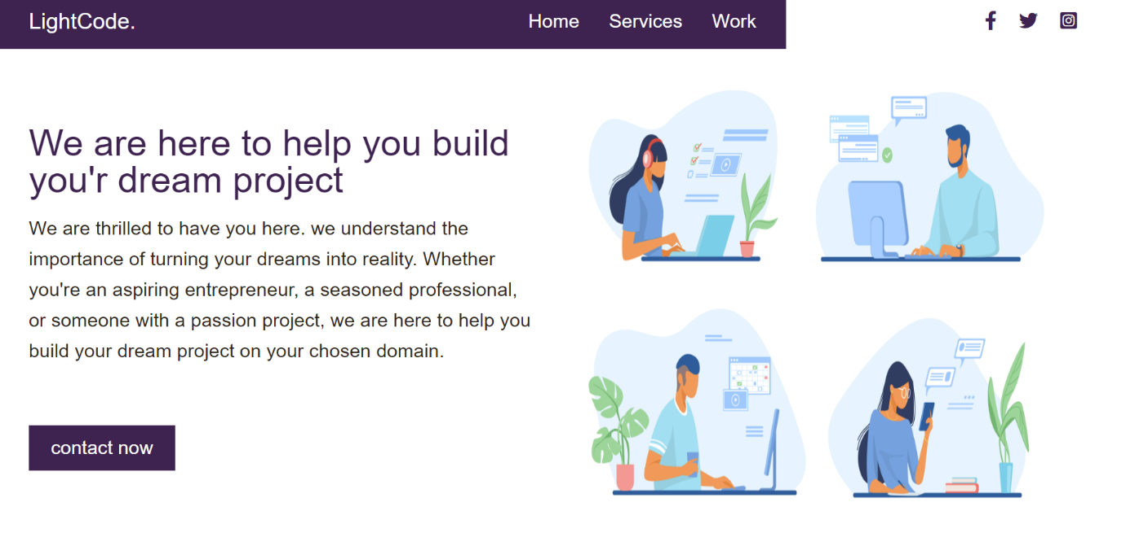

**2.SERVICES PAGE**

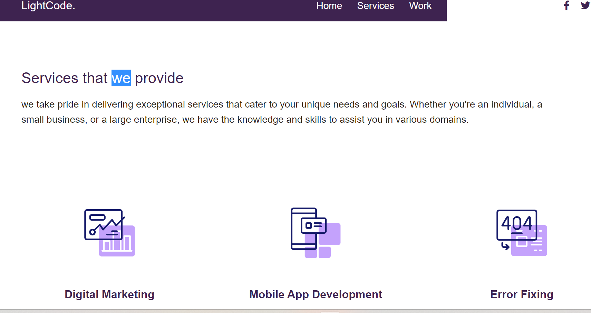

23

**3.WORKS PAGE**

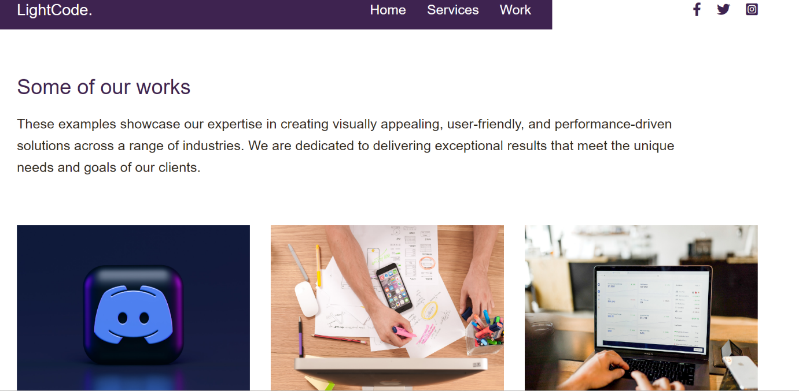

**4.CONTACT PAGE**

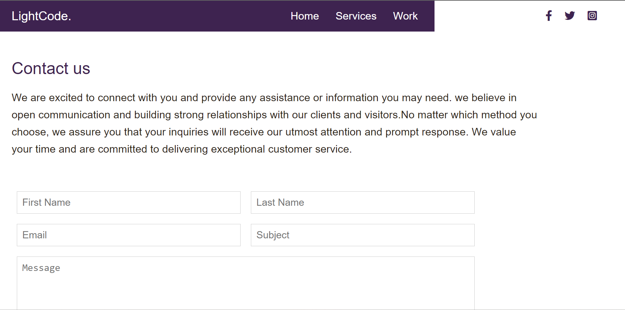

24

4.conclusion

The website for an IT company is composed of four HTML files (index.html, services.html, work.html, and contact.html) and a style.css file. Together, these files form the foundation of the company's online presence. Each HTML file represents a distinct page on the website, catering to different aspects of the company's offerings and interactions with visitors.

The index.html file serves as the main landing page, welcoming visitors and providing a glimpse into the company's services. It offers a brief introduction and intuitive navigation links to guide users to other sections of the website. The services.html page dives deeper into the company's service offerings, providing comprehensive descriptions, visuals, and potential testimonials to showcase their expertise. The work.html page features a portfolio section that highlights the company's previous projects, presenting them through captivating visuals and descriptive information. Lastly, the contact.html page enables visitors to connect with the company, offering a contact form and other means of communication.

To ensure a visually appealing and cohesive user experience, the style.css file defines the design elements and layout for all the web pages. It specifies the fonts, colors, spacing, and other visual attributes that maintain a consistent branding and aesthetic throughout the website. The CSS file also incorporates responsive design techniques, allowing the website to adapt and look great on various devices and screen sizes.

In summary, this collection of HTML files and the accompanying style.css file work together to create an engaging and informative website for an IT company. Through these web pages, visitors can explore the company's services, view their previous works, and easily get in touch. The CSS file adds the finishing touch by providing a visually appealing and consistent design across the entire website.

25