Project 04: Retail Analysis

Code:-

FILENAME REFFILE '/folders/myfolders/Retail Analysis_Dataset.xlsx';

PROC IMPORT DATAFILE=REFFILE DBMS=XLSX OUT=WORK.IMPORT;

GETNAMES=YES;

RUN;

PROC CONTENTS DATA=WORK.IMPORT;

RUN;

PROC Print;

run;

/* Perform descriptive statistics for the dataset */

proc univariate data=import nobyplot;

var sales profit;

run;

/* Check significance of independent variables */

Title "Correlation";

Proc corr data=import;

var sales profit;

run;

/* Perform Regression Test */

Title "Regression";

Proc reg data=import;

model sales = profit discount;

output out = reg p=predicted;

run;

proc print;

run;

/* Create New Dataset with exponential, cube, squared and log values for each variable */

data import2;

set import;

sales2= exp(sales);

salessq=sqrt(sales);

salescu=sales*sales*sales;

saleslog=log(sales);

discount2=exp(discount);

discountsq=discount*discount;

discountcu=discount*discount*discount;

discountlog=log(discount);

profit2=exp(profit);

profitsq=profit*profit;

profitcu=profit*profit*profit;

profitlog=log(profit);

run;

/* Perform Regreesion test on new dataset*/

Title "Regression";

Proc reg data=import2;

model sales=profit discount;

output out=reg p=predicted;

run;

Proc print;

run;

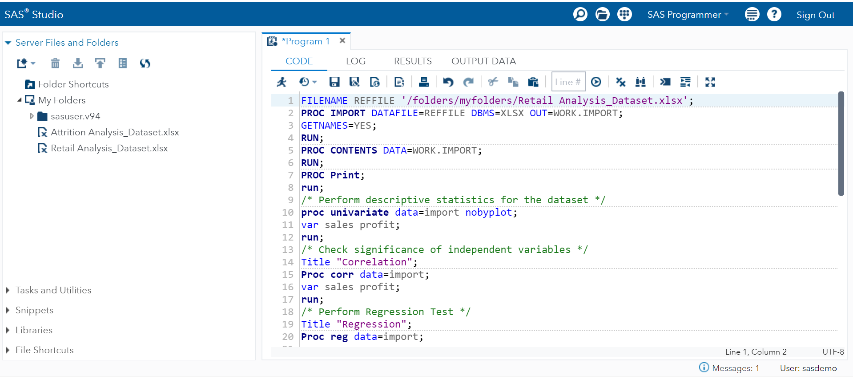

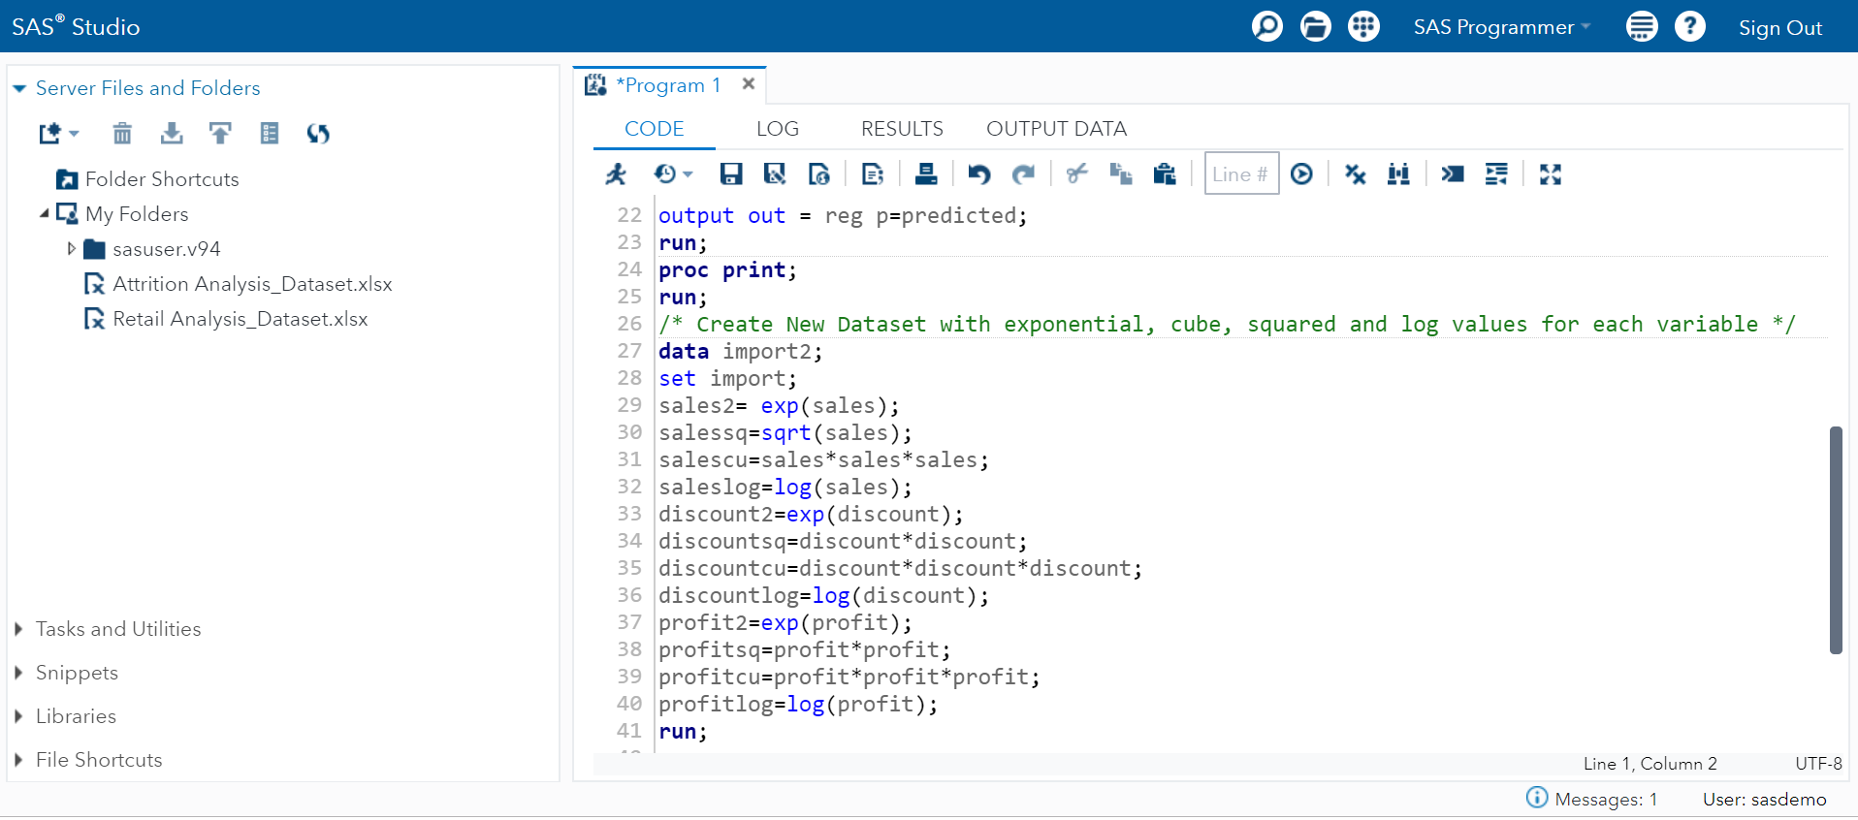

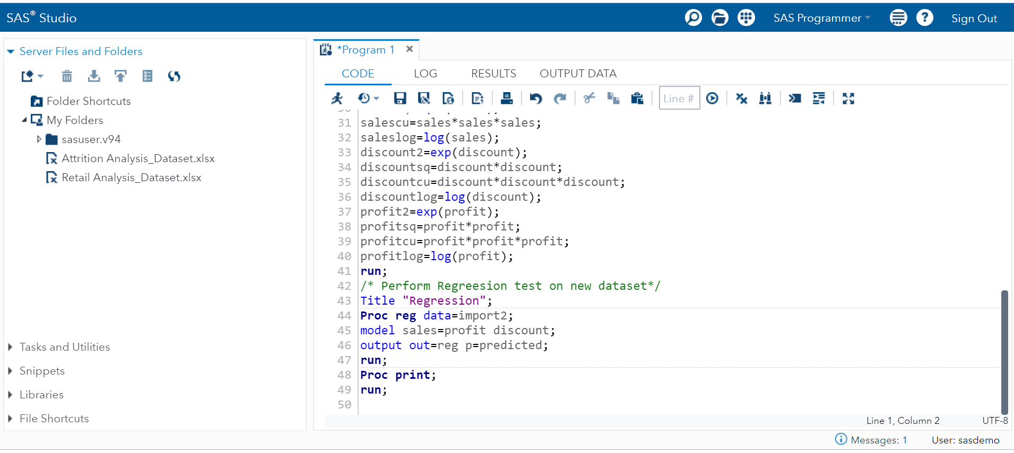

Results:

**The CONTENTS Procedure**

|  |  |  |  |
| --- | --- | --- | --- |
| **Data Set Name** | WORK.IMPORT | **Observations** | 30 |
| **Member Type** | DATA | **Variables** | 7 |
| **Engine** | V9 | **Indexes** | 0 |
| **Created** | 05/05/2019 22:43:14 | **Observation Length** | 56 |
| **Last Modified** | 05/05/2019 22:43:14 | **Deleted Observations** | 0 |
| **Protection** |  | **Compressed** | NO |
| **Data Set Type** |  | **Sorted** | NO |
| **Label** |  |  |  |
| **Data Representation** | SOLARIS_X86_64, LINUX_X86_64, ALPHA_TRU64, LINUX_IA64 |  |  |
| **Encoding** | utf-8 Unicode (UTF-8) |  |  |

| **Engine/Host Dependent Information** | |
| --- | --- |
| **Data Set Page Size** | 65536 |
| **Number of Data Set Pages** | 1 |
| **First Data Page** | 1 |
| **Max Obs per Page** | 1166 |
| **Obs in First Data Page** | 30 |
| **Number of Data Set Repairs** | 0 |
| **Filename** | /tmp/SAS_work20D500001018_localhost.localdomain/SAS_workE14100001018_localhost.localdomain/import.sas7bdat |
| **Release Created** | 9.0401M6 |
| **Host Created** | Linux |
| **Inode Number** | 671580 |
| **Access Permission** | rw-rw-r-- |
| **Owner Name** | sasdemo |
| **File Size** | 128KB |
| **File Size (bytes)** | 131072 |

| **Alphabetic List of Variables and Attributes** | | | | | | |
| --- | --- | --- | --- | --- | --- | --- |
| **#** | **Variable** | **Type** | **Len** | **Format** | **Informat** | **Label** |
| **5** | Discount | Num | 8 | BEST. |  | Discount |
| **1** | Order_ID | Num | 8 | BEST. |  | Order_ID |
| **2** | Products | Char | 8 | $8. | $8. | Products |
| **6** | Profit | Num | 8 | NLMNY15.1 |  | Profit |
| **4** | Quantity | Num | 8 | BEST. |  | Quantity |
| **3** | Sales | Num | 8 | NLMNY15.1 |  | Sales |
| **7** | Shipping_Cost | Num | 8 | NLMNY15.1 |  | Shipping Cost |

| **Obs** | **Order_ID** | **Products** | **Sales** | **Quantity** | **Discount** | **Profit** | **Shipping_Cost** |
| --- | --- | --- | --- | --- | --- | --- | --- |
| **1** | 110001 | Product1 | $220.0 | 2 | 0.01 | $135.6 | $13.6 |
| **2** | 110002 | Product2 | $104.0 | 1 | 0.03 | $20.9 | $2.1 |
| **3** | 110003 | Product3 | $149.0 | 4 | 0.01 | $63.0 | $6.3 |
| **4** | 110004 | Product4 | $222.0 | 4 | 0.03 | $115.4 | $11.5 |
| **5** | 110005 | Product5 | $199.0 | 3 | 0.05 | $89.2 | $8.9 |
| **6** | 110006 | Product6 | $111.0 | 2 | 0.01 | $28.8 | $2.9 |
| **7** | 110007 | Product7 | $33.0 | 4 | 0.01 | $8.3 | $0.8 |
| **8** | 110008 | Product8 | $250.0 | 3 | 0.05 | $132.5 | $13.3 |
| **9** | 110009 | Product9 | $83.0 | 4 | 0.05 | $20.8 | $2.1 |
| **10** | 110010 | Product1 | $192.0 | 3 | 0.03 | $94.7 | $9.5 |
| **11** | 110011 | Product2 | $65.0 | 4 | 0.03 | $16.3 | $1.6 |
| **12** | 110012 | Product3 | $130.0 | 5 | 0.01 | $43.5 | $4.4 |
| **13** | 110013 | Product4 | $220.0 | 5 | 0.03 | $107.0 | $10.7 |
| **14** | 110014 | Product5 | $104.0 | 5 | 0.02 | $13.6 | $1.4 |
| **15** | 110015 | Product6 | $149.0 | 4 | 0.05 | $39.2 | $3.9 |
| **16** | 110016 | Product7 | $222.0 | 3 | 0.04 | $115.4 | $11.5 |
| **17** | 110017 | Product8 | $199.0 | 5 | 0.02 | $99.1 | $9.9 |
| **18** | 110018 | Product1 | $111.0 | 5 | 0.05 | $3.2 | $0.3 |
| **19** | 110019 | Product2 | $33.0 | 1 | 0.03 | $33.0 | $3.3 |
| **20** | 110020 | Product3 | $149.0 | 4 | 0.01 | $63.0 | $6.3 |
| **21** | 110021 | Product4 | $83.0 | 1 | 0.05 | $83.0 | $8.3 |
| **22** | 110022 | Product5 | $192.0 | 2 | 0.02 | $104.3 | $10.4 |
| **23** | 110023 | Product6 | $65.0 | 2 | 0.04 | $32.5 | $3.3 |
| **24** | 110024 | Product7 | $130.0 | 3 | 0.01 | $46.1 | $4.6 |
| **25** | 110025 | Product8 | $220.0 | 3 | 0.01 | $133.4 | $13.3 |
| **26** | 110026 | Product9 | $192.0 | 2 | 0.02 | $104.3 | $10.4 |
| **27** | 110027 | Product1 | $220.0 | 3 | 0.01 | $133.4 | $13.3 |
| **28** | 110028 | Product2 | $130.0 | 3 | 0.01 | $46.1 | $4.6 |
| **29** | 110029 | Product3 | $220.0 | 3 | 0.01 | $133.4 | $13.3 |
| **30** | 110030 | Product4 | $192.0 | 2 | 0.02 | $104.3 | $10.4 |

**The UNIVARIATE Procedure**

**Variable: Sales (Sales)**

| **Moments** | | | |
| --- | --- | --- | --- |
| **N** | 30 | **Sum Weights** | 30 |
| **Mean** | 152.966667 | **Sum Observations** | 4589 |
| **Std Deviation** | 63.1759903 | **Variance** | 3991.20575 |
| **Skewness** | -0.3528421 | **Kurtosis** | -1.063775 |
| **Uncorrected SS** | 817709 | **Corrected SS** | 115744.967 |
| **Coeff Variation** | 41.3004948 | **Std Error Mean** | 11.534305 |

| **Basic Statistical Measures** | | | |
| --- | --- | --- | --- |
| **Location** | | **Variability** | |
| **Mean** | 152.9667 | **Std Deviation** | 63.17599 |
| **Median** | 149.0000 | **Variance** | 3991 |
| **Mode** | 220.0000 | **Range** | 217.00000 |
|  |  | **Interquartile Range** | 116.00000 |

| **Tests for Location: Mu0=0** | | | | |
| --- | --- | --- | --- | --- |
| **Test** | **Statistic** | | **p Value** | |
| **Student's t** | **t** | 13.26189 | **Pr > |t|** | <.0001 |
| **Sign** | **M** | 15 | **Pr >= |M|** | <.0001 |
| **Signed Rank** | **S** | 232.5 | **Pr >= |S|** | <.0001 |

| **Quantiles (Definition 5)** | |
| --- | --- |
| **Level** | **Quantile** |
| **100% Max** | 250 |
| **99%** | 250 |
| **95%** | 222 |
| **90%** | 221 |
| **75% Q3** | 220 |
| **50% Median** | 149 |
| **25% Q1** | 104 |
| **10%** | 65 |
| **5%** | 33 |
| **1%** | 33 |
| **0% Min** | 33 |

| **Extreme Observations** | | | |
| --- | --- | --- | --- |
| **Lowest** | | **Highest** | |
| **Value** | **Obs** | **Value** | **Obs** |
| 33 | 19 | 220 | 27 |
| 33 | 7 | 220 | 29 |
| 65 | 23 | 222 | 4 |
| 65 | 11 | 222 | 16 |
| 83 | 21 | 250 | 8 |

**The UNIVARIATE Procedure**

**Variable: Profit (Profit)**

| **Moments** | | | |
| --- | --- | --- | --- |
| **N** | 30 | **Sum Weights** | 30 |
| **Mean** | 72.1063333 | **Sum Observations** | 2163.19 |
| **Std Deviation** | 44.6008984 | **Variance** | 1989.24014 |
| **Skewness** | -0.0087696 | **Kurtosis** | -1.5149638 |
| **Uncorrected SS** | 213667.663 | **Corrected SS** | 57687.9641 |
| **Coeff Variation** | 61.8543426 | **Std Error Mean** | 8.14297272 |

| **Basic Statistical Measures** | | | |
| --- | --- | --- | --- |
| **Location** | | **Variability** | |
| **Mean** | 72.1063 | **Std Deviation** | 44.60090 |
| **Median** | 73.0200 | **Variance** | 1989 |
| **Mode** | 104.3200 | **Range** | 132.35000 |
|  |  | **Interquartile Range** | 74.50000 |

**Note: The mode displayed is the smallest of 2 modes with a count of 3.**

| **Tests for Location: Mu0=0** | | | | |
| --- | --- | --- | --- | --- |
| **Test** | **Statistic** | | **p Value** | |
| **Student's t** | **t** | 8.855038 | **Pr > |t|** | <.0001 |
| **Sign** | **M** | 15 | **Pr >= |M|** | <.0001 |
| **Signed Rank** | **S** | 232.5 | **Pr >= |S|** | <.0001 |

| **Quantiles (Definition 5)** | |
| --- | --- |
| **Level** | **Quantile** |
| **100% Max** | 135.600 |
| **99%** | 135.600 |
| **95%** | 133.400 |
| **90%** | 133.400 |
| **75% Q3** | 107.000 |
| **50% Median** | 73.020 |
| **25% Q1** | 32.500 |
| **10%** | 14.925 |
| **5%** | 8.250 |
| **1%** | 3.250 |
| **0% Min** | 3.250 |

| **Extreme Observations** | | | |
| --- | --- | --- | --- |
| **Lowest** | | **Highest** | |
| **Value** | **Obs** | **Value** | **Obs** |
| 3.25 | 18 | 132.5 | 8 |
| 8.25 | 7 | 133.4 | 25 |
| 13.60 | 14 | 133.4 | 27 |
| 16.25 | 11 | 133.4 | 29 |
| 20.75 | 9 | 135.6 | 1 |

**Correlation**

**The CORR Procedure**

|  |  |
| --- | --- |
| **2 Variables:** | Sales Profit |

| **Simple Statistics** | | | | | | | |
| --- | --- | --- | --- | --- | --- | --- | --- |
| **Variable** | **N** | **Mean** | **Std Dev** | **Sum** | **Minimum** | **Maximum** | **Label** |
| **Sales** | 30 | 152.96667 | 63.17599 | 4589 | 33.00000 | 250.00000 | Sales |
| **Profit** | 30 | 72.10633 | 44.60090 | 2163 | 3.25000 | 135.60000 | Profit |

| **Pearson Correlation Coefficients, N = 30 Prob > |r| under H0: Rho=0** | | |
| --- | --- | --- |
|  | **Sales** | **Profit** |
| **Sales**  **Sales** | 1.00000 | 0.89522  <.0001 |
| **Profit**  **Profit** | 0.89522  <.0001 | 1.00000 |

**Regression**

**The REG Procedure**

**Model: MODEL1**

**Dependent Variable: Sales Sales**

|  |  |
| --- | --- |
| **Number of Observations Read** | 30 |
| **Number of Observations Used** | 30 |

| **Analysis of Variance** | | | | | |
| --- | --- | --- | --- | --- | --- |
| **Source** | **DF** | **Sum of Squares** | **Mean Square** | **F Value** | **Pr > F** |
| **Model** | 2 | 92832 | 46416 | 54.69 | <.0001 |
| **Error** | 27 | 22913 | 848.63850 |  |  |
| **Corrected Total** | 29 | 115745 |  |  |  |

|  |  |  |  |
| --- | --- | --- | --- |
| **Root MSE** | 29.13140 | **R-Square** | 0.8020 |
| **Dependent Mean** | 152.96667 | **Adj R-Sq** | 0.7874 |
| **Coeff Var** | 19.04428 |  |  |

| **Parameter Estimates** | | | | | | |
| --- | --- | --- | --- | --- | --- | --- |
| **Variable** | **Label** | **DF** | **Parameter Estimate** | **Standard Error** | **t Value** | **Pr > |t|** |
| **Intercept** | Intercept | 1 | 58.54308 | 14.50126 | 4.04 | 0.0004 |
| **Profit** | Profit | 1 | 1.27293 | 0.12244 | 10.40 | <.0001 |
| **Discount** | Discount | 1 | 102.74492 | 353.09921 | 0.29 | 0.7733 |

**Regression**

**The REG Procedure**

**Model: MODEL1**

**Dependent Variable: Sales Sales**

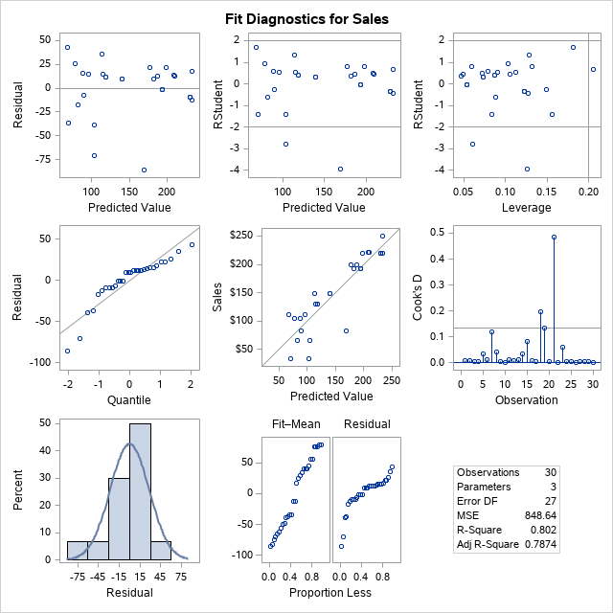

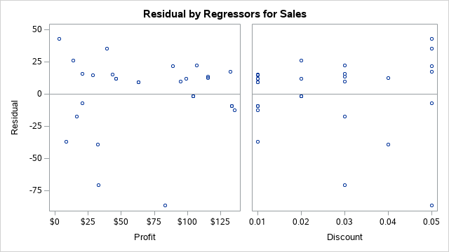

**Regression**

| **Obs** | **Order_ID** | **Products** | **Sales** | **Quantity** | **Discount** | **Profit** | **Shipping_Cost** | **predicted** |
| --- | --- | --- | --- | --- | --- | --- | --- | --- |
| **1** | 110001 | Product1 | $220.0 | 2 | 0.01 | $135.6 | $13.6 | 232.180 |
| **2** | 110002 | Product2 | $104.0 | 1 | 0.03 | $20.9 | $2.1 | 88.204 |
| **3** | 110003 | Product3 | $149.0 | 4 | 0.01 | $63.0 | $6.3 | 139.816 |
| **4** | 110004 | Product4 | $222.0 | 4 | 0.03 | $115.4 | $11.5 | 208.471 |
| **5** | 110005 | Product5 | $199.0 | 3 | 0.05 | $89.2 | $8.9 | 177.162 |
| **6** | 110006 | Product6 | $111.0 | 2 | 0.01 | $28.8 | $2.9 | 96.206 |
| **7** | 110007 | Product7 | $33.0 | 4 | 0.01 | $8.3 | $0.8 | 70.072 |
| **8** | 110008 | Product8 | $250.0 | 3 | 0.05 | $132.5 | $13.3 | 232.344 |
| **9** | 110009 | Product9 | $83.0 | 4 | 0.05 | $20.8 | $2.1 | 90.094 |
| **10** | 110010 | Product1 | $192.0 | 3 | 0.03 | $94.7 | $9.5 | 182.198 |
| **11** | 110011 | Product2 | $65.0 | 4 | 0.03 | $16.3 | $1.6 | 82.311 |
| **12** | 110012 | Product3 | $130.0 | 5 | 0.01 | $43.5 | $4.4 | 114.943 |
| **13** | 110013 | Product4 | $220.0 | 5 | 0.03 | $107.0 | $10.7 | 197.829 |
| **14** | 110014 | Product5 | $104.0 | 5 | 0.02 | $13.6 | $1.4 | 77.910 |
| **15** | 110015 | Product6 | $149.0 | 4 | 0.05 | $39.2 | $3.9 | 113.579 |
| **16** | 110016 | Product7 | $222.0 | 3 | 0.04 | $115.4 | $11.5 | 209.498 |
| **17** | 110017 | Product8 | $199.0 | 5 | 0.02 | $99.1 | $9.9 | 186.746 |
| **18** | 110018 | Product1 | $111.0 | 5 | 0.05 | $3.2 | $0.3 | 67.817 |
| **19** | 110019 | Product2 | $33.0 | 1 | 0.03 | $33.0 | $3.3 | 103.632 |
| **20** | 110020 | Product3 | $149.0 | 4 | 0.01 | $63.0 | $6.3 | 139.816 |
| **21** | 110021 | Product4 | $83.0 | 1 | 0.05 | $83.0 | $8.3 | 169.334 |
| **22** | 110022 | Product5 | $192.0 | 2 | 0.02 | $104.3 | $10.4 | 193.390 |
| **23** | 110023 | Product6 | $65.0 | 2 | 0.04 | $32.5 | $3.3 | 104.023 |
| **24** | 110024 | Product7 | $130.0 | 3 | 0.01 | $46.1 | $4.6 | 118.253 |
| **25** | 110025 | Product8 | $220.0 | 3 | 0.01 | $133.4 | $13.3 | 229.380 |
| **26** | 110026 | Product9 | $192.0 | 2 | 0.02 | $104.3 | $10.4 | 193.390 |
| **27** | 110027 | Product1 | $220.0 | 3 | 0.01 | $133.4 | $13.3 | 229.380 |
| **28** | 110028 | Product2 | $130.0 | 3 | 0.01 | $46.1 | $4.6 | 118.253 |
| **29** | 110029 | Product3 | $220.0 | 3 | 0.01 | $133.4 | $13.3 | 229.380 |
| **30** | 110030 | Product4 | $192.0 | 2 | 0.02 | $104.3 | $10.4 | 193.390 |

**Regression**

**The REG Procedure**

**Model: MODEL1**

**Dependent Variable: Sales Sales**

|  |  |
| --- | --- |
| **Number of Observations Read** | 30 |
| **Number of Observations Used** | 30 |

| **Analysis of Variance** | | | | | |
| --- | --- | --- | --- | --- | --- |
| **Source** | **DF** | **Sum of Squares** | **Mean Square** | **F Value** | **Pr > F** |
| **Model** | 2 | 92832 | 46416 | 54.69 | <.0001 |
| **Error** | 27 | 22913 | 848.63850 |  |  |
| **Corrected Total** | 29 | 115745 |  |  |  |

|  |  |  |  |
| --- | --- | --- | --- |
| **Root MSE** | 29.13140 | **R-Square** | 0.8020 |
| **Dependent Mean** | 152.96667 | **Adj R-Sq** | 0.7874 |
| **Coeff Var** | 19.04428 |  |  |

| **Parameter Estimates** | | | | | | |
| --- | --- | --- | --- | --- | --- | --- |
| **Variable** | **Label** | **DF** | **Parameter Estimate** | **Standard Error** | **t Value** | **Pr > |t|** |
| **Intercept** | Intercept | 1 | 58.54308 | 14.50126 | 4.04 | 0.0004 |
| **Profit** | Profit | 1 | 1.27293 | 0.12244 | 10.40 | <.0001 |
| **Discount** | Discount | 1 | 102.74492 | 353.09921 | 0.29 | 0.7733 |

**Regression**

**The REG Procedure**

**Model: MODEL1**

**Dependent Variable: Sales Sales**





|  |  |  |  |  |  |  |  |  |  |  |  |  |  |  |  |  |  |  |  |  |
| --- | --- | --- | --- | --- | --- | --- | --- | --- | --- | --- | --- | --- | --- | --- | --- | --- | --- | --- | --- | --- |
| **Regression** | |  |  |  |  |  |  |  |  |  |  |  |  |  |  |  |  |  |  |  |
|  |  |  |  |  |  |  |  |  |  |  |  |  |  |  |  |  |  |  |  |  |
| **Obs** | **Order_ID** | **Products** | **Sales** | **Quantity** | **Discount** | **Profit** | **Shipping_Cost** | **sales2** | **salessq** | **salescu** | **saleslog** | **discount2** | **discountsq** | **discountcu** | **discountlog** | **profit2** | **profitsq** | **profitcu** | **profitlog** | **predicted** |
| **1** | 110001 | Product1 | $220.0 | 2 | 0.01 | $135.6 | $13.6 | 3.51E+95 | 14.8324 | 10648000 | 5.39363 | 1.01005 | 0.0001 | 0.000001 | -4.60517 | 7.77E+58 | 18387.36 | 2493326 | 4.90971 | 232.18 |
| **2** | 110002 | Product2 | $104.0 | 1 | 0.03 | $20.9 | $2.1 | 1.47E+45 | 10.198 | 1124864 | 4.64439 | 1.03045 | 0.0009 | 0.000027 | -3.50656 | 1.17E+09 | 435.97 | 9103.15 | 3.03879 | 88.204 |
| **3** | 110003 | Product3 | $149.0 | 4 | 0.01 | $63.0 | $6.3 | 5.13E+64 | 12.2066 | 3307949 | 5.00395 | 1.01005 | 0.0001 | 0.000001 | -4.60517 | 2.39E+27 | 3974.04 | 250523.6 | 4.14377 | 139.816 |
| **4** | 110004 | Product4 | $222.0 | 4 | 0.03 | $115.4 | $11.5 | 2.59E+96 | 14.8997 | 10941048 | 5.40268 | 1.03045 | 0.0009 | 0.000027 | -3.50656 | 1.26E+50 | 13307.93 | 1535203 | 4.74806 | 208.471 |
| **5** | 110005 | Product5 | $199.0 | 3 | 0.05 | $89.2 | $8.9 | 2.66E+86 | 14.1067 | 7880599 | 5.2933 | 1.05127 | 0.0025 | 0.000125 | -2.99573 | 5.22E+38 | 7947.72 | 708539.5 | 4.49032 | 177.162 |
| **6** | 110006 | Product6 | $111.0 | 2 | 0.01 | $28.8 | $2.9 | 1.61E+48 | 10.5357 | 1367631 | 4.70953 | 1.01005 | 0.0001 | 0.000001 | -4.60517 | 3.15E+12 | 828.29 | 23838.14 | 3.35968 | 96.206 |
| **7** | 110007 | Product7 | $33.0 | 4 | 0.01 | $8.3 | $0.8 | 2.15E+14 | 5.7446 | 35937 | 3.49651 | 1.01005 | 0.0001 | 0.000001 | -4.60517 | 3827.63 | 68.06 | 561.52 | 2.11021 | 70.072 |
| **8** | 110008 | Product8 | $250.0 | 3 | 0.05 | $132.5 | $13.3 | ######## | 15.8114 | 15625000 | 5.52146 | 1.05127 | 0.0025 | 0.000125 | -2.99573 | 3.50E+57 | 17556.25 | 2326203 | 4.88658 | 232.344 |
| **9** | 110009 | Product9 | $83.0 | 4 | 0.05 | $20.8 | $2.1 | 1.11E+36 | 9.1104 | 571787 | 4.41884 | 1.05127 | 0.0025 | 0.000125 | -2.99573 | 1.03E+09 | 430.56 | 8934.17 | 3.03255 | 90.094 |
| **10** | 110010 | Product1 | $192.0 | 3 | 0.03 | $94.7 | $9.5 | 2.42E+83 | 13.8564 | 7077888 | 5.2575 | 1.03045 | 0.0009 | 0.000027 | -3.50656 | 1.37E+41 | 8971.88 | 849816.3 | 4.55093 | 182.198 |
| **11** | 110011 | Product2 | $65.0 | 4 | 0.03 | $16.3 | $1.6 | 1.69E+28 | 8.0623 | 274625 | 4.17439 | 1.03045 | 0.0009 | 0.000027 | -3.50656 | 11409992 | 264.06 | 4291.02 | 2.78809 | 82.311 |
| **12** | 110012 | Product3 | $130.0 | 5 | 0.01 | $43.5 | $4.4 | 2.87E+56 | 11.4018 | 2197000 | 4.86753 | 1.01005 | 0.0001 | 0.000001 | -4.60517 | 7.79E+18 | 1892.25 | 82312.88 | 3.77276 | 114.943 |
| **13** | 110013 | Product4 | $220.0 | 5 | 0.03 | $107.0 | $10.7 | 3.51E+95 | 14.8324 | 10648000 | 5.39363 | 1.03045 | 0.0009 | 0.000027 | -3.50656 | 2.95E+46 | 11449 | 1225043 | 4.67283 | 197.829 |
| **14** | 110014 | Product5 | $104.0 | 5 | 0.02 | $13.6 | $1.4 | 1.47E+45 | 10.198 | 1124864 | 4.64439 | 1.0202 | 0.0004 | 0.000008 | -3.91202 | 806129.8 | 184.96 | 2515.46 | 2.61007 | 77.91 |
| **15** | 110015 | Product6 | $149.0 | 4 | 0.05 | $39.2 | $3.9 | 5.13E+64 | 12.2066 | 3307949 | 5.00395 | 1.05127 | 0.0025 | 0.000125 | -2.99573 | 1.06E+17 | 1536.64 | 60236.29 | 3.66868 | 113.579 |
| **16** | 110016 | Product7 | $222.0 | 3 | 0.04 | $115.4 | $11.5 | 2.59E+96 | 14.8997 | 10941048 | 5.40268 | 1.04081 | 0.0016 | 0.000064 | -3.21888 | 1.26E+50 | 13307.93 | 1535203 | 4.74806 | 209.498 |
| **17** | 110017 | Product8 | $199.0 | 5 | 0.02 | $99.1 | $9.9 | 2.66E+86 | 14.1067 | 7880599 | 5.2933 | 1.0202 | 0.0004 | 0.000008 | -3.91202 | 1.09E+43 | 9820.81 | 973242.3 | 4.59613 | 186.746 |
| **18** | 110018 | Product1 | $111.0 | 5 | 0.05 | $3.2 | $0.3 | 1.61E+48 | 10.5357 | 1367631 | 4.70953 | 1.05127 | 0.0025 | 0.000125 | -2.99573 | 25.79 | 10.56 | 34.33 | 1.17865 | 67.817 |
| **19** | 110019 | Product2 | $33.0 | 1 | 0.03 | $33.0 | $3.3 | 2.15E+14 | 5.7446 | 35937 | 3.49651 | 1.03045 | 0.0009 | 0.000027 | -3.50656 | 2.15E+14 | 1089 | 35937 | 3.49651 | 103.632 |
| **20** | 110020 | Product3 | $149.0 | 4 | 0.01 | $63.0 | $6.3 | 5.13E+64 | 12.2066 | 3307949 | 5.00395 | 1.01005 | 0.0001 | 0.000001 | -4.60517 | 2.39E+27 | 3974.04 | 250523.6 | 4.14377 | 139.816 |
| **21** | 110021 | Product4 | $83.0 | 1 | 0.05 | $83.0 | $8.3 | 1.11E+36 | 9.1104 | 571787 | 4.41884 | 1.05127 | 0.0025 | 0.000125 | -2.99573 | 1.11E+36 | 6889 | 571787 | 4.41884 | 169.334 |
| **22** | 110022 | Product5 | $192.0 | 2 | 0.02 | $104.3 | $10.4 | 2.42E+83 | 13.8564 | 7077888 | 5.2575 | 1.0202 | 0.0004 | 0.000008 | -3.91202 | 2.02E+45 | 10882.66 | 1135279 | 4.64746 | 193.39 |
| **23** | 110023 | Product6 | $65.0 | 2 | 0.04 | $32.5 | $3.3 | 1.69E+28 | 8.0623 | 274625 | 4.17439 | 1.04081 | 0.0016 | 0.000064 | -3.21888 | 1.30E+14 | 1056.25 | 34328.13 | 3.48124 | 104.023 |
| **24** | 110024 | Product7 | $130.0 | 3 | 0.01 | $46.1 | $4.6 | 2.87E+56 | 11.4018 | 2197000 | 4.86753 | 1.01005 | 0.0001 | 0.000001 | -4.60517 | 1.05E+20 | 2125.21 | 97972.18 | 3.83081 | 118.253 |
| **25** | 110025 | Product8 | $220.0 | 3 | 0.01 | $133.4 | $13.3 | 3.51E+95 | 14.8324 | 10648000 | 5.39363 | 1.01005 | 0.0001 | 0.000001 | -4.60517 | 8.61E+57 | 17795.56 | 2373928 | 4.89335 | 229.38 |
| **26** | 110026 | Product9 | $192.0 | 2 | 0.02 | $104.3 | $10.4 | 2.42E+83 | 13.8564 | 7077888 | 5.2575 | 1.0202 | 0.0004 | 0.000008 | -3.91202 | 2.02E+45 | 10882.66 | 1135279 | 4.64746 | 193.39 |
| **27** | 110027 | Product1 | $220.0 | 3 | 0.01 | $133.4 | $13.3 | 3.51E+95 | 14.8324 | 10648000 | 5.39363 | 1.01005 | 0.0001 | 0.000001 | -4.60517 | 8.61E+57 | 17795.56 | 2373928 | 4.89335 | 229.38 |
| **28** | 110028 | Product2 | $130.0 | 3 | 0.01 | $46.1 | $4.6 | 2.87E+56 | 11.4018 | 2197000 | 4.86753 | 1.01005 | 0.0001 | 0.000001 | -4.60517 | 1.05E+20 | 2125.21 | 97972.18 | 3.83081 | 118.253 |
| **29** | 110029 | Product3 | $220.0 | 3 | 0.01 | $133.4 | $13.3 | 3.51E+95 | 14.8324 | 10648000 | 5.39363 | 1.01005 | 0.0001 | 0.000001 | -4.60517 | 8.61E+57 | 17795.56 | 2373928 | 4.89335 | 229.38 |
| **30** | 110030 | Product4 | $192.0 | 2 | 0.02 | $104.3 | $10.4 | 2.42E+83 | 13.8564 | 7077888 | 5.2575 | 1.0202 | 0.0004 | 0.000008 | -3.91202 | 2.02E+45 | 10882.66 | 1135279 | 4.64746 | 193.39 |

