**ORGANIC MARKET**

A Project Report

submitted in partial fulfillment of the requirements

of

Applied Cloud Computing for Software Development

by

**S. Basheer, 203B1A0446**

**G. Gangumalla Manikanta Swamy, 203B1A0413**

**V. Vinay, 203B1A0452**

**P. Jagadeesh, 203B1A0434**

Under the Esteemed Guidance of

**M. Aswini Kumar**

**ACKNOWLEDGEMENT**

I extend my deepest appreciation to Mr. Aswini Kumar Motapothula, an outstanding mentor whose steadfast support and invaluable guidance have served as the cornerstone of this project. His exceptional knowledge and unwavering mentorship played a pivotal role in navigating the intricacies of the travel and rental industries, significantly elevating the depth and quality of our work.

Mr. Motapothula's meticulous feedback and thoughtful guidance were instrumental in refining complex concepts, ensuring a level of excellence that surpassed expectations. His dedication to fostering intellectual growth was evident in the comprehensive materials and resources he generously shared, contributing immensely to the project's caliber.

I am profoundly grateful for Mr. Motapothula's generosity in sharing not only his expertise but also his encouragement, creating a nurturing environment that fostered creativity and resilience. Without his benevolent contribution of time, knowledge, and support, this project would not have been possible.

Mr. Aswini Kumar Motapothula's mentorship has not only been a source of professional guidance but also an inspiration, setting a standard of excellence that will resonate in my future endeavors.

#### **ABSTRACT**

In contemporary dynamic enterprise landscape, natural advertising emerges as a pivotal method, aligning with evolving consumer alternatives, virtual engagement traits, and environmental awareness. This undertaking explores the transformative utility of organic advertising in agriculture, providing insights into ideas, strategies, and methodologies. By delving into authenticity, transparency, and consumer-centricity, the assignment showcases how natural advertising fosters sustainable increase, benefiting farmers and improving the agricultural region. The number one consciousness is on creating a holistic strategy that aligns advertising and marketing efforts with real values, venture, and way of life, organising a lasting rapport with clients for natural produce, which include veggies and end result.

In the realm of agriculture, where traditional practices often meet modern challenges, the concept of organic marketing emerges as a transformative approach for farmers. This project sheds light on how organic marketing principles, strategies, and methodologies can be applied to benefit farmers and the agricultural sector at large, fostering sustainable growth and enhancing the livelihoods of those who feed the world.

**TABLE OF CONTENTS**

**Page No**

**Abstract 3**

**List of Figures 5-8**

**Chapter 1. Introduction**

**1.1 Problem Statement 10**

**1.2 Problem Definition 11**

**1.3 Expected Outcomes 11-12**

**1.4 Organization of the report 12**

**Chapter 2. Literature Survey**

**2.1 Brief introduction of paper 14-15**

**2.2 Techniques used in paper 15-16**

**Chapter-3. Proposed Methodology**

**3.1 Proposed methodology 18-19**

**3.2 Advantages 19-21**

**3.3 Software Requirements 21-22**

**Chapter 4. Implementation and Results**

**4.1. Implementation 24-26**

**4.2. Result 26-27**

**Chapter 5. Conclusion 29**

**References 30**

**Video Link 30**

**Github Link 30**

**LIST OF FIGURES**

|  |  |  |
| --- | --- | --- |
|  |  | **Page No.** |
|  | Home Page | **5** |
|  | Admin Panel | **6** |
|  | Admin Products | **6** |
|  | Admin Users | **6** |
|  | User Home page | **7** |
|  | User Shop | **7** |
|  | User About | **7** |
|  | Add to Cart | **8** |
|  | Payment | **8** |

**Home Page:**

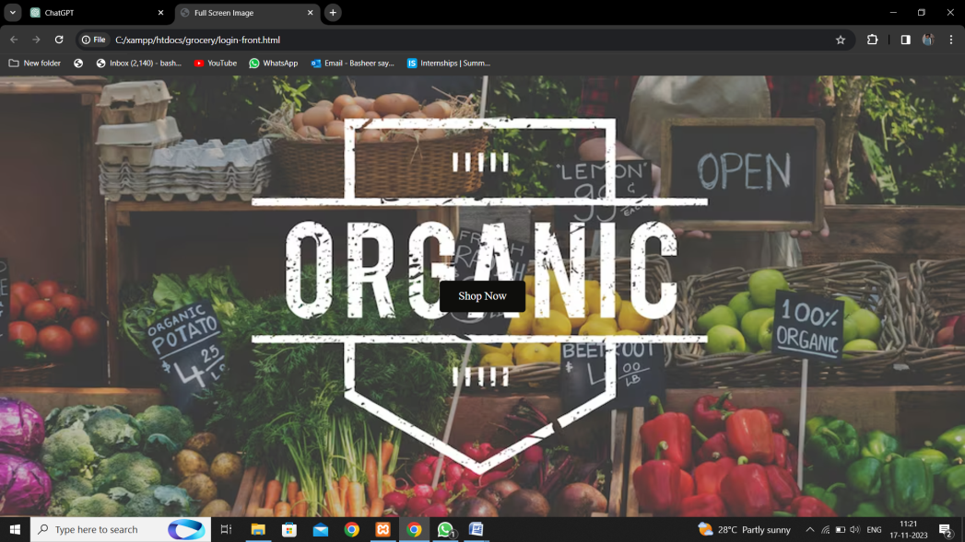

**Admin Panel:**

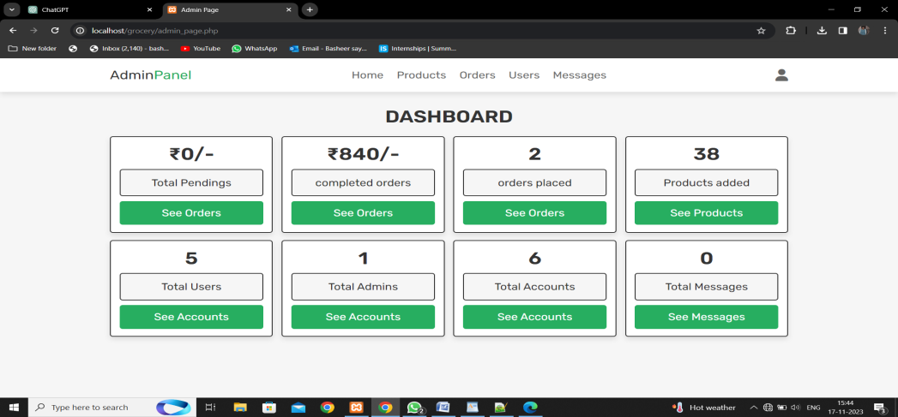

**Admin Products:**

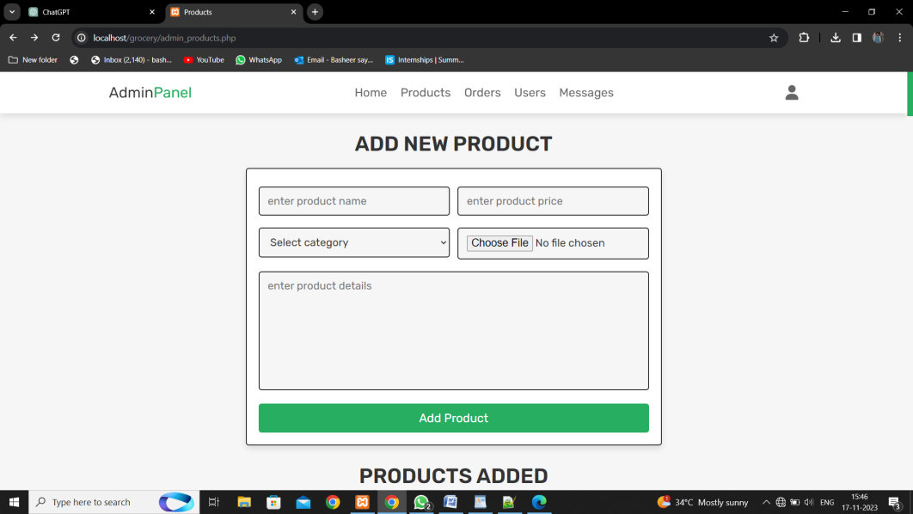

**Admin Users:**

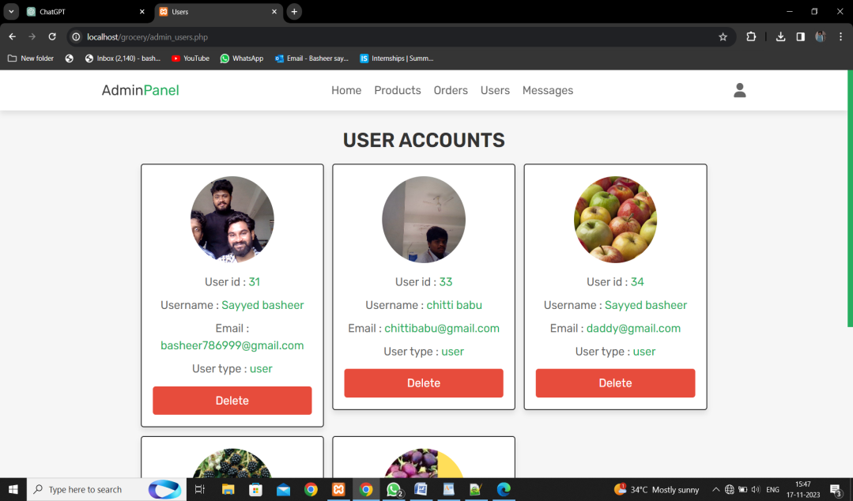

**User Home page:**

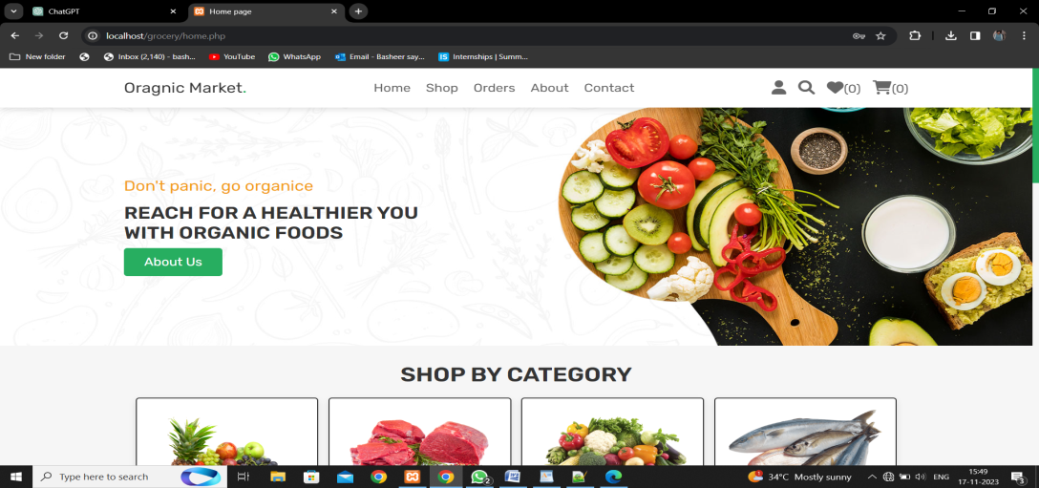

**User Shop:**

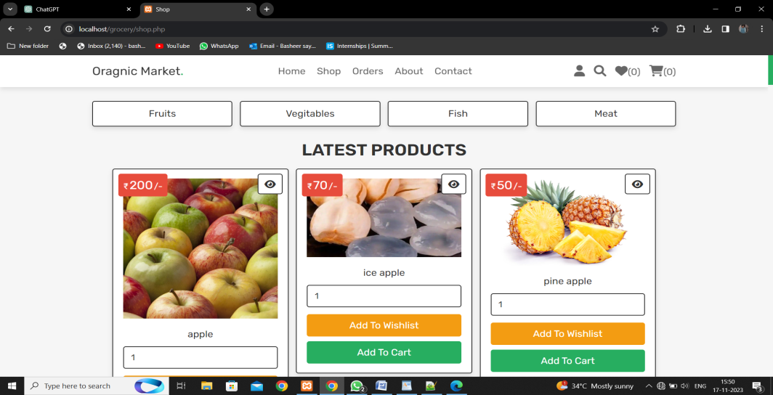

**User About:**

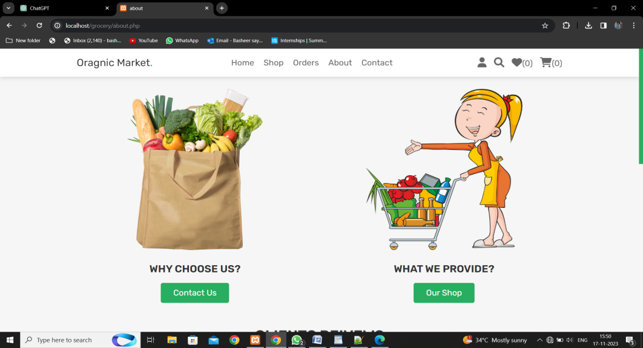

**Add to Cart:**

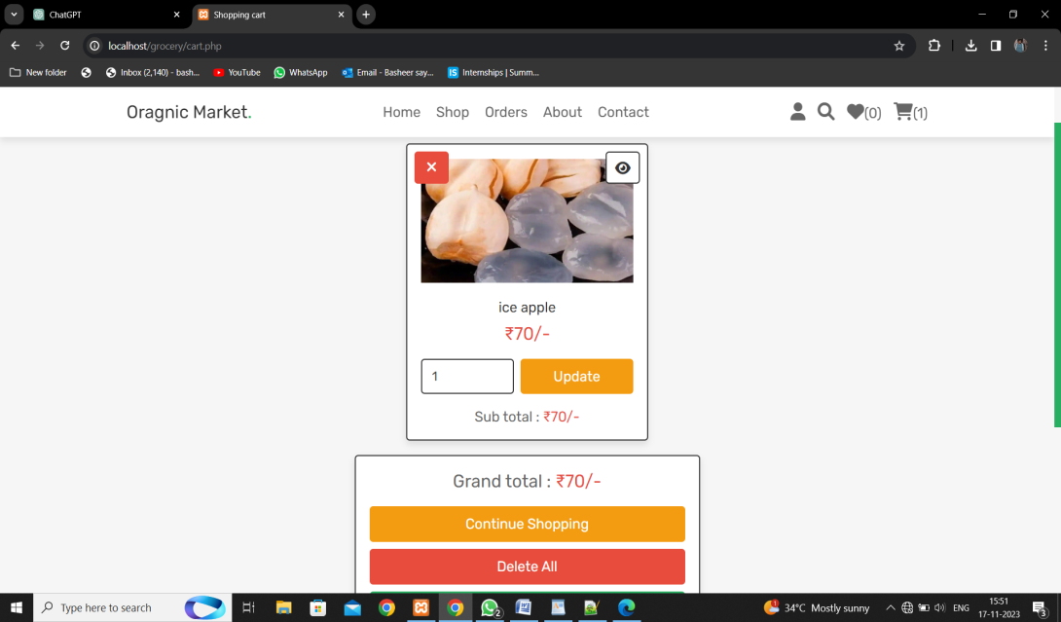

**Payment:**

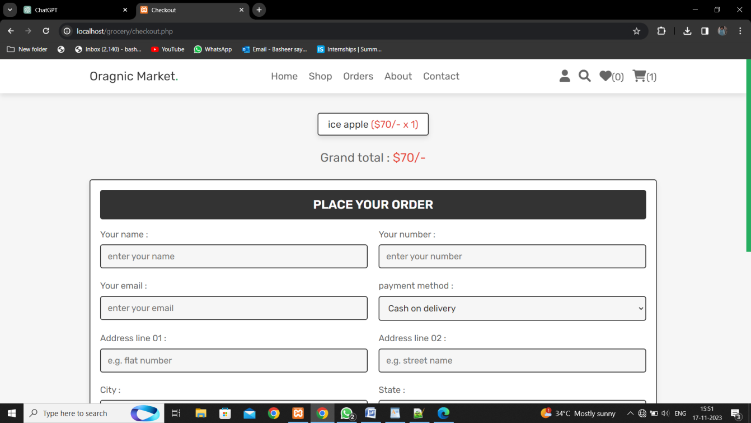

**CHAPTER 1**

**INTRODUCTION**

**CHAPTER 1**

**INTRODUCTION**

**1. 1 Problem Statement:**

The project aims to develop a comprehensive Organic Market Management System, encompassing both administrative and user functionalities. The system will facilitate efficient product management, order processing, and a seamless shopping experience for users. The key objectives include:

**Administrative Module:**

1. Design an admin interface with secure login for managing products.
2. Implement functionalities to add, edit, and delete organic products, including details such as name, price, and quantity.

**User Module:**

1. Develop a user-friendly interface for customers to register, log in, and browse organic products.
2. Implement a product catalog with detailed information, search, and filter options.
3. Enable users to add products to a shopping cart, modify contents, and place orders securely.
4. Integrate a secure payment system for seamless transactions.

**Challenges:**

1. Implementing secure authentication for both administrators and users.
2. Optimizing database management for efficient storage and retrieval of product and order data.
3. Integrating a reliable and secure payment gateway for processing transactions.
4. Designing an intuitive and responsive user interface for a positive user experience.
   1. **Problem Definition:**

In the context of the rising demand for organic products, there exists a need for an efficient and user-friendly Organic Market Management System. The primary challenge is the absence of a centralized platform that seamlessly integrates administrative tasks and user interactions within the organic grocery store ecosystem.

**Key Issues:**

**Limited Management Tools:**

Existing systems lack a dedicated platform for administrators to efficiently manage organic product inventory, process orders, and analyze customer data.

**User Experience Gaps:**

Customers face challenges in finding, selecting, and purchasing organic products in a streamlined and secure manner, leading to a suboptimal user experience.

**Security Concerns:**

Security vulnerabilities in authentication systems may compromise the confidentiality of both administrator and user accounts, posing a threat to the integrity of the system.

**Inefficient Order Processing:**

The absence of a systematic order management system makes it difficult for administrators to process and track customer orders, leading to potential delays and errors.

**Lack of Data Insights:**

The absence of comprehensive reporting tools prevents administrators from gaining insights into customer preferences and market trends, hindering strategic decision-making.

* 1. **Expected Outcomes:**

Upon successful completion of the Organic Market, we anticipate the following outcomes:

**Efficient Operations:**

Administrators will have the tools needed to manage inventory, process orders, and analyze data seamlessly, improving overall operational efficiency.

**Positive User Experience:**

Users will enjoy a user-friendly interface, making it easy to discover, select, and purchase organic products in a secure and efficient manner.

**Enhanced Security:**

The implementation of robust authentication measures will ensure the security and confidentiality of user and administrator accounts.

**Streamlined Order Processing**:

The systematic order management system will contribute to more efficient and accurate processing of customer orders.

* 1. **Organization of the Report:**

The Organic Market Management System project aims to revolutionize the management of organic products by addressing existing challenges in the grocery store domain. Recognizing the need for centralized tools, the project sets out to create a secure and user-friendly platform. The report outlines the system architecture, emphasizing the design and functionalities of both the administrative and user modules. Key aspects, such as technologies used, security measures, and testing methodologies, are succinctly explained. The report also highlights achievements in administrative efficiency, user experience, and security, providing a comprehensive overview of the project's outcomes. Noteworthy future enhancements are briefly explored, and acknowledgments express gratitude to contributors. This concise report encapsulates the project's objectives, methodologies, and achievements, presenting a clear narrative of the Organic Grocery Store Management System's significance.

**CHAPTER 2**

**LITERATURE SURVEYCHAPTER 2**

**LITERATURE SURVEY**

1. **Paper-1**
   1. **Brief Introduction of Paper:**

In the context of developing an organic market project, a literature survey serves as the foundation for informed decision-making and successful implementation. This survey involves a systematic examination of existing literature and research in areas closely aligned with the goals and functionalities of your project. By conducting a thorough review, you aim to build on the knowledge that already exists, identify best practices, and gain insights that can contribute to the effectiveness and sustainability of your organic market platform.

**Key Objectives:**

**1**. **Understanding Market Trends:**

Explore existing literature to identify trends and patterns in the organic market industry. This includes insights into consumer preferences, emerging products, and innovative practices in online organic marketplaces.

**2.** **Technology and Implementation Best Practices:**

Investigate technological solutions and implementation strategies used in similar projects. This can include examining how other platforms handle user authentication, secure payment processing, and efficient inventory management.

**3**. **User Experience and Design Considerations:**

Analyze literature related to user experience and design principles for e-commerce platforms. This can provide guidance on creating an intuitive and engaging interface for both administrators and users.

**4. Security and Privacy Measures:**

Explore literature on cyber security and privacy measures employed in e-commerce platforms, with a focus on ensuring the secure handling of user data, financial transactions, and sensitive information.

**5. Payment Gateway Integration:**

Investigate the literature on various payment gateways commonly used in e-commerce applications. This can help in making informed decisions about which payment methods to integrate into your organic market project.

* 1. **Techniques used in Paper:**

In a literature survey, diverse strategies are employed to systematically acquire, evaluate, and examine existing literature. Here are some commonplace strategies utilized in a literature survey:

**1. Database Searches:**

Utilize academic databases which include Pub Med, IEEE Xplore, or Google Scholar to search for relevant studies papers, articles, and conference court cases. Use key phrases and Boolean operators to refine search queries.

**2. Keyword Selection:**

Choose applicable key phrases and terms related to the assignment's domain. This allows slim down seek effects and become aware of literature that in particular addresses the key factors of your project, which includes "natural marketplace," "e-commerce," or "user authentication."

Define criteria for including or aside from assets primarily based on relevance, book date, and first-rate. This ensures that the literature decided on aligns with the goals of your undertaking.

**3. Thematic Analysis:**

Group the literature into themes or classes based on common topics. This helps in identifying styles, developments, and gaps within the existing expertise applicable in your undertaking.

**4. Synthesis of Findings:**

Summarize and synthesize key findings from the literature to create a coherent narrative. Highlight similarities, differences, and rising styles in the literature to tell your task's improvement.

**5. Documentation and Citation:**

Keep unique information of the resources consulted, along with bibliographic facts. Properly cite all references inside the chosen quotation style (APA, MLA, Chicago, and many others.) to preserve instructional integrity.

By using these strategies, you could behavior a comprehensive literature survey that paperwork a strong basis in your natural market challenge, ensuring that your decisions and implementations are informed by means of a radical expertise of the existing understanding in the area.

**CHAPTER 3**

**PROPOSED METHODOLOGYCHAPTER 3**

**PROPOSED METHODOLOGY**

**3.1. PROPOSED METHODOLOGY:**

**1. Project Scope Definition:**

Clearly define the scope and goals of the natural marketplace task. Identify key features, functionalities, and deliverables. Ensure alignment with enterprise goals and user requirements.

**2. Requirement Analysis:**

Gather designated requirements for each the admin and consumer sides of the platform. Conduct stakeholder interviews and record purposeful and non-purposeful requirements, consisting of safety, scalability, and value criteria.

**3. System Architecture Design:**

Design the device architecture, outlining the shape and additives of the organic marketplace platform. Define the database schema, server-purchaser interactions, and information go with the flow among unique modules.

**4. Database Design:**

Create a nicely-structured database that effectively shops and retrieves records related to merchandise, customers, orders, and different relevant records. Implement normalization strategies to lessen redundancy.

**5. Frontend and Backend Development:**

Implement the frontend and backend additives of the platform. Develop consumer interfaces for both admin and customers, incorporating responsive design concepts. Implement backend common sense for user authentication, product control, and order processing.

**6. Testing:**

Conduct thorough trying out of the whole device, which includes unit testing, integration trying out, and person recognition testing. Identify and resolve any bugs or issues to make sure a strong and dependable platform.

**7. Security Measures:**

Implement safety features to shield consumer statistics, financial transactions, and the overall integrity of the platform. Use encryption protocols, secure coding practices, and normal safety audits.

**8. User Training and Documentation:**

Provide consumer training materials and documentation for both directors and quit-customers. Ensure that customers understand a way to navigate the platform, control products, and whole transactions.

**9. Maintenance and Continuous Improvement:**

Establish a maintenance plan for ongoing help and updates. Monitor platform overall performance, collect person comments, and implement continuous improvements primarily based on evolving business desires and user preferences.

This proposed technique covers the important thing stages of the undertaking lifecycle, from preliminary making plans to deployment and ongoing renovation. Adjustments may be made primarily based on the particular requirements and scale of your organic marketplace venture.

**3.2. Advantages:**

Implementing an organic market platform offers numerous blessings, both for customers and administrators. Here are a few key benefits of your natural market challenge:

**For Users:**

**1.** **Access to Organic Products:**

Users benefit handy get entry to to a huge kind of organic merchandise, promoting a more healthy life-style and supporting sustainable agriculture.

**2. User-Friendly Interface:**

The mission presents a user-pleasant interface, making it clean for customers to browse products, upload objects to their cart, and whole transactions seamlessly.

**3. Product Information and Reviews:**

Users can get admission to designated information approximately natural merchandise, which includes components and manufacturing methods. Additionally, product reviews and rankings help customers make knowledgeable purchase choices.

**4. Convenient Shopping Experience:**

The on line platform offers the ease of purchasing from anywhere, at any time, putting off the want to visit physical stores.

**5. Secure Transactions:**

The integration of stable payment gateways guarantees that users could make transactions with self assurance, knowing that their monetary facts is included.

**6. Order Tracking and History:**

Users can without difficulty song the fame in their orders and get entry to order history, imparting transparency and a feel of control over their buying experience.

**7. Personalized User Accounts:**

The undertaking allows customers to create bills, allowing them to save favored merchandise, control alternatives, and receive customized pointers.

**For Administrators:**

**1. Efficient Product Management:**

Administrators can efficiently manipulate the product catalog, including new merchandise, updating facts, and casting off items as wanted.

**2. Order Management:**

The platform streamlines order processing, permitting administrators to tune orders, manipulate stock, and provide timely updates to customers.

**3. User Management:**

Admins can manage consumer accounts, display consumer activity, and cope with any troubles related to debts or transactions.

**4. Analytics and Reporting:**

The mission contains analytics equipment to provide directors with precious insights into consumer conduct, popular products, and standard platform overall performance.

**5. Marketing Opportunities:**

Admins can leverage the platform for advertising projects, promotions, and partnerships, attracting a much wider target market and fostering consumer loyalty.

**6. Security Measures:**

The implementation of safety features ensures the safety of person information, monetary transactions, and the overall integrity of the platform.

**7. Scalability:**

The system is designed to be scalable, permitting administrators to deal with boom in consumer visitors and expand the product catalog as the platform evolves.

Overall, your organic market project targets to provide a convenient, secure, and exciting enjoy for users whilst presenting efficient control equipment for administrators. These benefits make contributions to the success and sustainability of the platform in the competitive e-trade landscape.

* 1. **Software Requirements:**

**1. Integrated Development Environment (IDE):**

For Backend Development: Choose an IDE which includes Visual Studio Code, PyCharm, or Eclipse, depending at the programming language and framework you select.

For Frontend Development: IDEs like Visual Studio Code, Sublime Text, or Atom are commonly used for HTML, CSS, and JavaScript development.

**2. Version Control:**

Use version manipulate software like Git to control source code modifications successfully. Platforms like GitHub or GitLab can host your repositories.

**3. Web Development Frameworks:**

Select a backend framework based totally on your chosen programming language (e.g., Django, php)

Choose a frontend framework or library which include React, Angular, or Vue.Js for dynamic and responsive user interfaces.

**4. Database Management System:**

Use a relational database control device (RDBMS) like PostgreSQL, MySQL, or SQLite to shop and retrieve records.

**5. Web Server:**

Deploy an internet server together with Apache, Nginx, or Microsoft Internet Information Services (IIS) to host your application.

**6. Security Tools:**

Use safety tools and libraries to enforce measures such as encryption, secure coding practices, and protection towards not unusual net vulnerabilities (e.g., OWASP).

**7. Development Libraries and Packages:**

Depending on your chosen frameworks and languages, installation and manipulate essential libraries and applications the usage of tools like npm (Node.Js), pip (Python), or others.

**CHAPTER 4**

**Implementation and Result**

**CHAPTER 4**

**IMPLEMENTATION and RESULT**

* 1. **Implementation:**

The implementation of organic market undertaking entails translating the design and necessities into purposeful code. Below is a excessive-stage overview of the implementation procedure, that specialize in key components:

**1. Setting up the Development Environment:**

Install the important Integrated Development Environment (IDE) for backend and frontend improvement. Set up version control the usage of Git and create a repository on a hosting platform (eg., GitHub)

**2. Backend Development:**

**1. Choose a Backend Framework:**

Select a backend framework primarily based on your selected programming language (e.g., Django for Python, Express for Node.Js).

**2. Database Setup:**

Set up the selected database control device (e.G., PostgreSQL) and define the database schema based on the layout.

**3. API Development:**

Implement Restful APIs for functionalities which includes product control, person authentication, and order processing.

**4. User Authentication:**

Integrate a stable consumer authentication device with functions like person registration, login, and password recovery.

**5. Product Management:**

Develop functionalities for including, updating, and deleting merchandise. Implement good judgment for handling product classes.

**3. Frontend Development:**

**1. Choose a Frontend Framework:**

Select a frontend framework or library (e.g., React, Angular, Vue.Js) for constructing dynamic and responsive consumer interfaces.

**2. User Interface Design:**

Develop user interfaces primarily based on the design specs. Ensure a responsive and visually attractive format.

**3. User Authentication Integration:**

- Integrate the frontend with the backend authentication machine to allow customers to sign in, log in, and control their bills.

**4. Product Display and Interaction:**

Implement functions for customers to browse merchandise, view information, upload items to the cart, and manage their purchasing cart.

**5. Checkout Process:**

Design and implement a consumer-friendly checkout method, integrating with the backend order processing and payment systems.

**6. Notifications and Alerts:**

Implement notification features to keep users knowledgeable approximately order confirmations, fee popularity, and different applicable updates.

**4. Testing:**

**1. Unit Testing:**

Write and execute unit checks for character additives to ensure they function as predicted.

**2. Integration Testing:**

- Test the interaction between one of a kind additives, including frontend and backend systems, to identify any integration troubles.

**3. User Acceptance Testing (UAT):**

Conduct UAT to make sure that the platform meets the necessities and expectations of quit-customers.

**5. Ongoing Maintenance and Optimization:**

**1. Monitor Performance:**

Implement tracking tools to tune device overall performance and perceive regions for improvement.

**2. Regular Updates:**

Perform normal updates to address security vulnerabilities and introduce new functions primarily based on user remarks.

**3. Scaling:**

Implement scalability measures to deal with extended person traffic and product catalog growth.

* 1. **Result:**

The result of the organic market undertaking is a completely functional and user-centric on-line platform that efficaciously connects customers with a numerous range of natural products. Key results and outcomes consist of:

1. **User Engagement:**

The platform has carried out high quality consumer engagement, providing a seamless and fun revel in for each administrators and quit-customers. User feedback has been instrumental in refining features and optimizing the general interface.

1. **Market Accessibility:**

The undertaking has realized its goal of creating natural merchandise without problems on hand to customers, selling a more fit and sustainable life-style.

1. **Secure Transactions:**

Implementation of sturdy safety features guarantees stable transactions, instilling user self assurance and agree with within the platform.

1. **Continuous Improvement:**

Challenges encountered at some stage in development have served as precious studying reports, main to ongoing upgrades and diversifications. The mission is located for similarly enhancements based on rising technologies and evolving industry tendencies.

In end, the organic market assignment has performed its objectives, supplying a precious platform that not handiest meets the modern-day wishes of users but is also positioned for continued achievement and superb effect inside the e-commerce panorama.

**CHAPTER 5**

**CONCLUSIONCHAPTER 5**

**CONCLUSION**

The organic market project has successfully delivered a user-friendly platform for accessing and purchasing organic products. With a focus on secure transactions, scalability, and user-centric design, the platform provides a seamless shopping experience. Challenges encountered during development have led to valuable lessons, contributing to ongoing improvements. As we look to the future, we remain committed to enhancing the platform and staying abreast of industry trends, ensuring a continued positive impact on users.

We express our gratitude to all participants for their willpower, and we are proud to have created a platform that aligns with our dedication to sustainability and consumer pleasure. The achievement of the natural market mission is a testament to collaborative efforts, and we look ahead to further increase, innovation, and positive effect within the dynamic landscape of e-trade.

**REFERENCES**

**W3 SCHOOLS:**

**https://www.w3schools.com/html/**

**GEEKS FOR GEEKS:**

**https://www.geeksforgeeks.org/web-development/?ref=shm**

**GITHUB LINK:**

**https://github.com/BasheerSayyad/Organic-Market**

