UNIT-III
Central Processing Unit: Introduction, General Register Organization, Stack Organization, Instruction Formats, Addressing Modes, Data Transfer and Manipulation, Program Control, Reduced Instruction Set Computer
3.1 Introduction:
- CPU is defined as a part of the computer that performs the bulk of data-processing operations. The CPU is made up of 3 major parts: Register Set, Arithmetic and Logic unit, and control unit.
- The register set stores intermediate data used during the execution of the instructions.
- The arithmetic logic unit performs the required micro operations for executing the instructions.
- The control unit supervises the transfer of information among the registers and instructs the ALU as to which operation to perform.
- The programmer uses machine language instructions. This includes the instruction formats, addressing modes, the instruction set, and the general organization of the CPU registers.

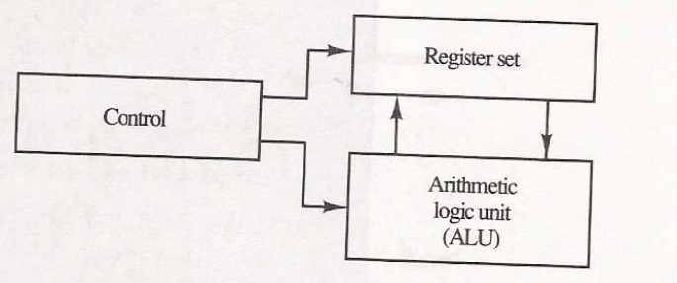
Major components of CPU
3.2 General Register Organization
A bus organization consists of 7 CPU registers. The output of each register is connected to two multiplexers to form the two buses A and B. The selection lines in each multiplexer select one register or the input data for the particular bus. The A and B buses form the inputs to a common arithmetic logic unit(ALU). The operation selected in the ALU determines the arithmetic or logic micro operation that is performed. The register set with common ALU block diagram is shown below
The four control selection variables are generated in the control unit and must be available at the beginning of a clock cycle. The data from the 2 source registers propagate through the gates in the multiplexers and the ALU, to the output bus, and into the inputs of the destination register, all during the clock cycle interval. Next clock cycle produces output to register R1 from below example.
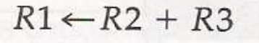
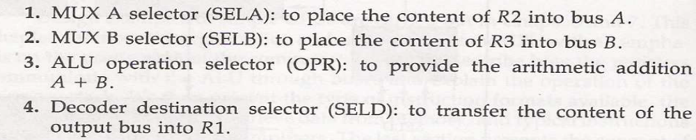

Control Word:
There are 14 selection binary inputs in the control unit, and their combined value specifies a control word. The 14-bit control word is consists of 4 fields. They are SELA, SELB, SELD, and OPR. Three field SELA, SELB, SELD contains 3-bits each and ALU OPR contains 5-bits.
The 3-bits of SELA select a source register for A input of the ALU, the 3-bits of SELA select a source register for A input of the ALU and the 3-bits of SELD select a destination register for DECODER output of the ALU. The 5-bits of ALU OPR is select one of the operations in the ALU. The encoding of the register selections is specified below in tables:
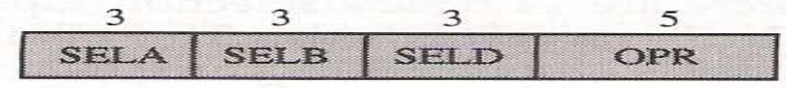
Control Word diagram

Block diagram
- A simple example for control word is shown below (R1 ← R2 - R3)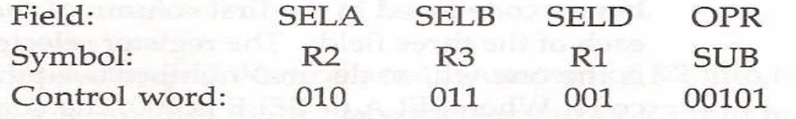
Encoding of Register Selection field
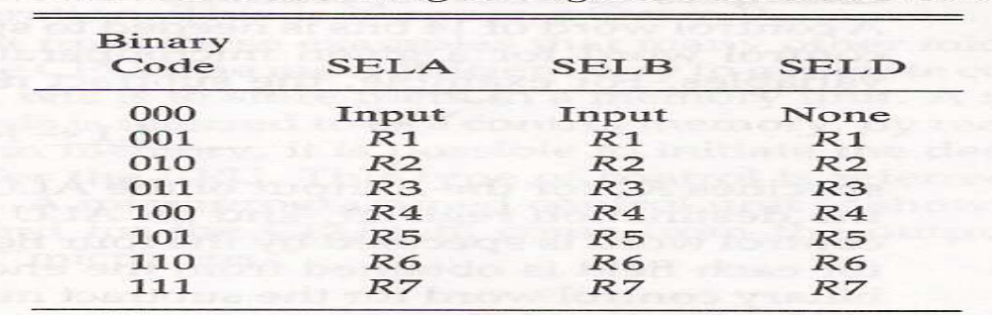

3.3 STACK ORGANIZATION:-
A stack is a storage device that stores information in a particular manner that is last-in, first out(LIFO). The stack performs two operations:
1. Insertion operation (PUSH)
2. Deletion operation (POP)
- The two operations of a stack performs insertion and deletion of items by using PUSH and POP instructions.
- The register that holds the address for the stack is called a stack pointer (SP). Its value points at the top item in the stack.
The advantages of Stack:
- Very useful feature for nested subroutines, nested loops control
- Also efficient for arithmetic expression evaluation
- Storage which can be accessed in LIFO
- Pointer: Stack Pointer(SP)
- Only PUSH and POP operations are applicable

Push, Pop micro operations
/* Initially, SP = 0, EMPTY = 1, FULL = 0 */
PUSH POP
Stack Organization
SP SP + 1, DR M[SP]
M[SP] DR ,SP SP - 1
If (SP = 0) then (FULL 1) If (SP = 0) then (EMPTY 1)
EMPTY 0 ,FULL 0

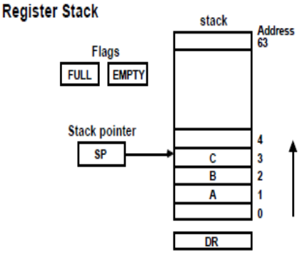
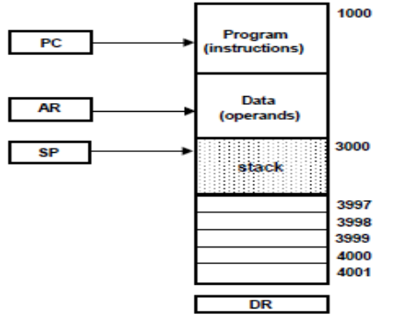

MEMORY STACK
MEMORY STACK ORGANIZATION
Memory with Program, Data, and Stack Segments
A portion of memory is used as a stack with a
processor register as a stack pointer
- PUSH: SP SP - 1
M[SP]  DR
- POP: DR M[SP]
SP SP + 1
- Most computers do not provide hardware to check
stack overflow (full stack) or underflow(empty stack)
REVERSE POLISH NOTATION
Arithmetic Expressions: A + B
A + B Infix notation
+ A B Prefix or Polish notation
A B + Postfix or reverse Polish notation
- The reverse Polish notation is very suitable for stack manipulation Evaluation of Arithmetic Expressions Any arithmetic expression can be expressed in parenthesis-free Polish notation, including reverse Polish notation
(3 * 4) + (5 * 6) 3 4 * 5 6 * +
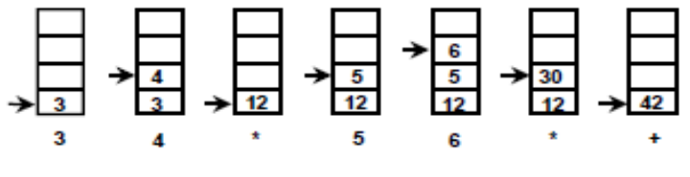
3.4 INSTRUCTION FORMAT:-
OP-code field - specifies the operation to be performed Address field - designates memory address(es) or a processor register(s) Mode field - specifies the way the operand or the effective address is determined
The number of address fields in the instruction format depends on the internal organization of registers
- The three most common CPU organizations:
Instruction Format
Single accumulator organization:
ADD X /* AC AC + M[X] */
General register organization:
ADD R1, R2, R3 /* R1 R2 + R3 */
ADD R1, R2 /* R1 R1 + R2 */
MOV R1, R2 /* R1 R2 */
ADD R1, X /* R1 R1 + M[X] */
Stack organization:
PUSH X /* TOS M[X] */
ADD
Three-Address Instructions
Program to evaluate X = (A + B) * (C + D) :
ADD R1, A, B /* R1  M[A] + M[B] */
ADD R2, C, D /* R2 M[C] + M[D] */
MUL X, R1, R2 /* M[X] R1 * R2 */
- Results in short programs
- Instruction becomes long(many bits)
Two-Address Instructions
- Computers with two-address instructions are most common
Program to evaluate X = (A + B) * (C + D) :
Instruction Format
MOV R1, A /* R1 M[A] */
ADD R1, B /* R1 R1 + M[A] */
MOV R2, C /* R2 M[C] */
ADD R2, D /* R2 R2 + M[D] */
MUL R1, R2 /* R1  R1 * R2 */
MOV X, R1 /* M[X]  R1 */
One-Address Instructions
- Use an implied AC register for all data manipulation
- Program to evaluate X = (A + B) * (C + D) :
Instruction Format
LOAD A /* AC M[A] */
ADD B /* AC AC + M[B] */
STORE T /* M[T]  AC */
LOAD C /* AC M[C] */
ADD D /* AC AC + M[D] */
MUL T /* AC AC * M[T] */ STORE X /* M[X]  AC */
Zero-Address Instructions
Can be found in a stack-organized computer
Program to evaluate X = (A + B) * (C + D) :
PUSH A /* TOS A */
PUSH B /* TOS B */
ADD /* TOS (A + B) */
PUSH C /* TOS C */
PUSH D /* TOS D */
ADD /* TOS (C + D) */
MUL /* TOS (C + D) * (A + B) */
POP X /* M[X]  TOS */
3.5 ADDRESSING MODES:-

* Addressing Modes specifies a rule for interpreting or modifying the address field of the instruction before the operand is actually referenced
* Variety of addressing modes
To give programming flexibility to the user
To use the bits in the address field of the instruction efficiently
To overcome the limitations of the hardware
To improve the processing efficiency
TYPES OF ADDRESSING MODES
Implied Mode
Address of the operands are specified implicitly in the definition of the instruction
No need to specify address in the instruction
EA = AC, or EA = Stack[SP]

Immediate Mode
Instead of specifying the address of the operand, operand itself is specified
No need to specify address in the instruction
However, operand itself needs to be specified
Sometimes, require more bits than the address
Fast to acquire an operand
Register Mode
Address specified in the instruction is the register address
Designated operand need to be in a register
Shorter address than the memory address
Saving address field in the instruction
Faster to acquire an operand than the memory addressing
EA = IR(R) (IR(R): Register field of IR)
Register Indirect Mode
Instruction specifies a register which contains the memory address of the operand
Saving instruction bits since register address is shorter than the memory address
Slower to acquire an operand than both the register addressing or memory addressing
EA = [IR(R)] ([x]: Content of x)
Register used Register Indirect Mode may have
Autoincrement or Autodecrement features
It is depends on Register indirect addressing mode, when the address in the register is used to access memory, the value in the register is incremented or decremented by 1 automatically
Direct Address Mode
Instruction specifies the memory address which can be used directly to the physical memory
Faster than the other memory addressing modes
Too many bits are needed to specify the address for a large physical memory space
EA = IR(addr) (IR(addr): address field of IR)
Indirect Addressing Mode
The address field of an instruction specifies the address of a memory location that contains the
address of the operand
- When the abbreviated address is used large physical memory can be addressed with a relatively small number of bits
- Slow to acquire an operand because of an additional memory access
- EA = M[IR(address)]
Relative Addressing Modes
The Address fields of an instruction specifies the part of the address(abbreviated address) which
can be used along with a designated register to calculate the address of the operand
- Address field of the instruction is short
- Large physical memory can be accessed with a small number of address bits
- EA = f(IR(address), R), R is sometimes implied
3 different Relative Addressing Modes depending on R:
- * 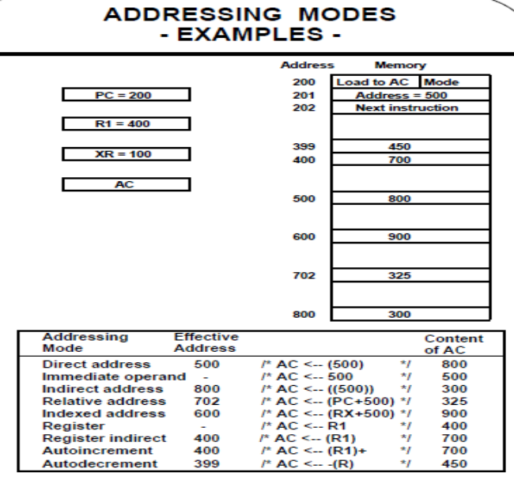
- PC Relative Addressing Mode(R = PC)
- EA = PC + IR(address)
* Indexed Addressing Mode(R = IX, where IX: Index Register)
- EA = IX + IR(address)
* Base Register Addressing Mode(R = BAR, where BAR: Base Address Register)
EA = BAR + IR(address)
3.6 Data Transfer and Manipulation Instruction:
Most computer instructions can be classified into three categories:
1. Data transfer instructions
2. Data manipulation instructions
3. Program control instructions
Hence data transfer instructions cause transfer of data from one location to another without changing the binary information content. Data manipulation instructions are those that perform arithmetic, logic, and shift operations. Program control instructions provide decision-making capabilities.
Data Transfer Instructions:
Data transfer instructions move data from one location in the computer into another location without changing the data content. The list of instructions shown in below table

Data transfer instructions
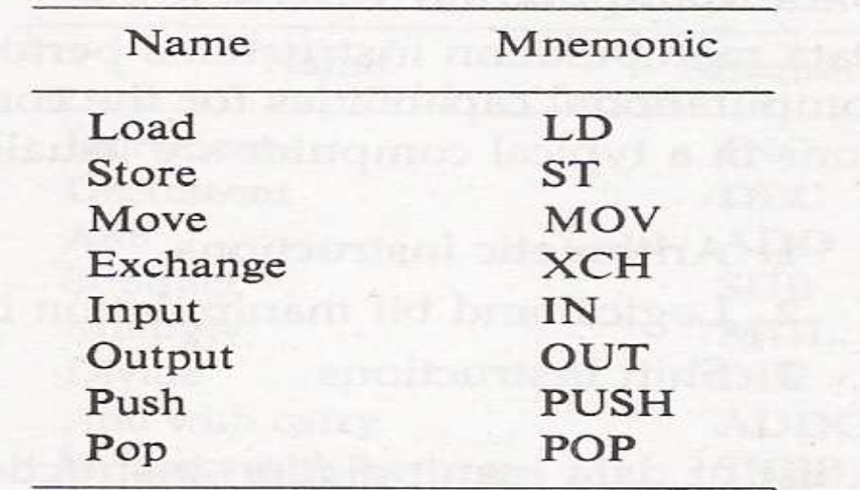
The eight addressing modes operations is shown below table
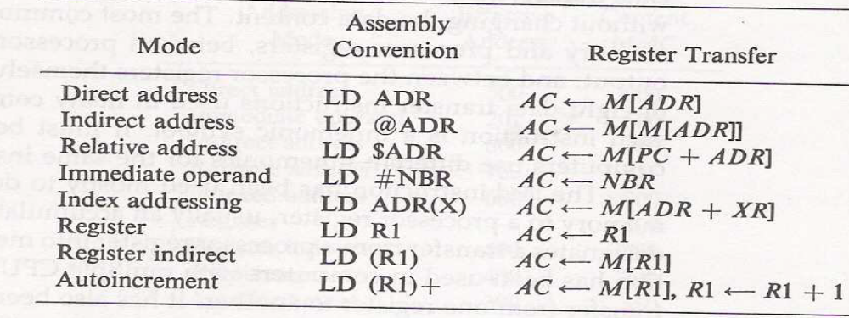
where the @ character symbolizes an indirect address. $ character represent the relative address and # character precedes the operand in an immediate-mode instruction.
DATA MANIPULATION INSTRUCTIONS:-
Data manipulation instructions perform operations on data and provide the computational capabilities for the computer. The data manipulation instructions in a typical computer are usually classified into 3 types:
1.Arithmetic instructions
2.Logical and bit manipulation instructions
3.Shift instructions
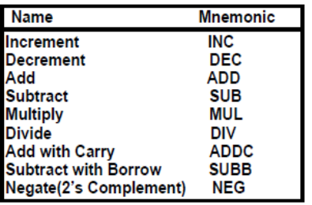
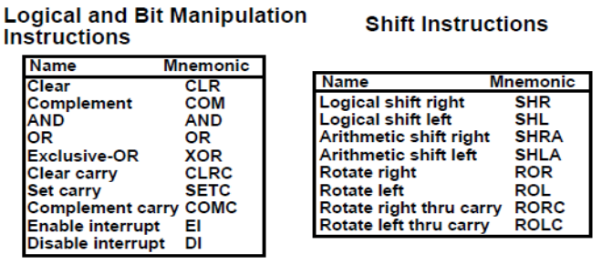

3.7 PROGRAM CONTROL INSTRUCTIONS
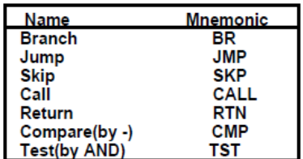
CMP and TST instructions do not retain their results of operations(- and AND, respectively).
They only set or clear certain Flags.
CONDITIONAL BRANCH INSTRUCTIONS
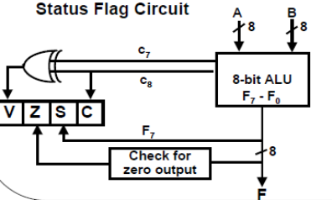
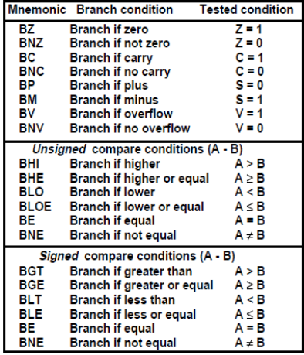

SUBROUTINE CALL AND RETURN
SUBROUTINE CALL
- Call subroutine
- Jump to subroutine
- Branch to subroutine
- Branch and save return address
Two Most Important Operations are Implied;
* Branch to the beginning of the Subroutine
- Same as the Branch or Conditional Branch
* Save the Return Address to get the address of the location in the Calling Program upon exit from the
Subroutine
Locations for storing Return Address
Fixed Location in the subroutine(Memory)
• Fixed Location in memory
• In a processor Register
• In a memory stack
- most efficient way
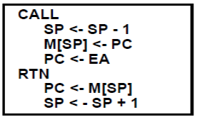
PROGRAM INTERRUPT
Types of Interrupts
1. External interrupts
External Interrupts initiated from the outside of CPU and Memory
- I/O Device -> Data transfer request
-> Data transfer complete
- Timing Device -> Timeout
- Power Failure
- Operator
2. Internal interrupts (traps)
Internal Interrupts are caused by the currently running program
- Register, Stack Overflow
- Divide by zero
- OP-code Violation
- Protection Violation
3. Software Interrupts
Both External and Internal Interrupts are initiated by the computer hardware. Software Interrupts
are initiated by the executing an instruction.
- Supervisor Call -> Switching from a user mode to the supervisor mode
-> Allows to execute a certain class of operations which are not allowed in the user mode

3.8 REDUCED INSTRUCTION SET COMPUTER:-
Historical Background
IBM System/360, 1964
- The real beginning of modern computer architecture
- Distinction between Architecture and Implementation
- Architecture: The abstract structure of a computer
seen by an assembly-language programmer
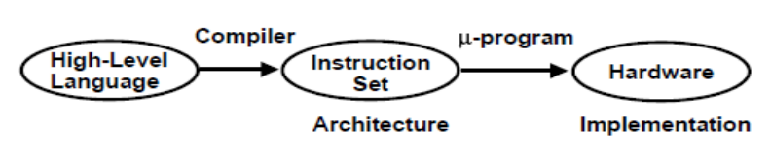
Continuing growth in semiconductor memory and microprogramming
-> A much richer and complicated instruction sets
=> CISC(Complex Instruction Set Computer)
- Arguments advanced at that time Richer instruction sets would simplify compilers
Richer instruction sets would alleviate the software crisis
- move as much functions to the hardware as possible
- close Semantic Gap between machine language and the high-level language
Richer instruction sets would improve architecture Quality
ARCHITECTURE DESIGN PRINCIPLES
Large microprograms would add little or nothing to the cost of the machine
<- Rapid growth of memory technology
-> Large General Purpose Instruction Set
* Microprogram is much faster than the machine Instructions
<- Microprogram memory is much faster than Main memory
-> Moving the software functions into
Microprogram for the high performance machines
* Execution speed is proportional to the program size
-> Architectural techniques that led to small program
-> High performance instruction set
* Number of registers in CPU has limitations
-> Very costly
-> Difficult to utilize them efficiently
COMPLEX INSTRUCTION SET COMPUTERS
Complex Instruction Set Computers - CISC
High Performance General Purpose Instructions
- Complex Instruction
-> Format, Length, Addressing Modes
-> Complicated instruction cycle control due to the complex decoding HW and decoding process
- Multiple memory cycle instructions
-> Operations on memory data
-> Multiple memory accesses/instruction
- Microprogrammed control is necessity
-> Microprogram control storage takes substantial portion of CPU chip area
-> Semantic Gap is large between machine instruction and microinstruction
- General purpose instruction set includes all the features required by individually different applications
-> When any one application is running, all the features required by the other
applications are extra burden to the application
PHYLOSOPHY OF RISC
Reduce the semantic gap between machine instruction and microinstruction
1-Cycle instruction
Most of the instructions complete their execution in 1 CPU clock cycle - like a micro operation
* Functions of the instruction (contrast to CISC)
- Very simple functions
- Very simple instruction format
- Similar to microinstructions
=> No need for microprogrammed control
* Register-Register Instructions
- Avoid memory reference instructions except Load and Store instructions
- Most of the operands can be found in the registers instead of main memory
=> Shorter instructions
=> Uniform instruction cycle
=> Requirement of large number of registers
* Employ instruction pipeline
The RISC use fewer instructions with simple constructs so they can be executed much faster within the CPU, with out having to use memory as often. This concept attempts to reduce execution time by simplifying the instruction set of the computer.

The major characteristics of a RISC processor are:-
• One instruction per cycle.
• Register to register operations.
• Few, simple addressing modes.
• Few, simple instruction formats.
• Hardwired design (no microcode).
• Fixed instruction format.
• More compile time/effort.
TWO INITIAL APPROACHES TO RISC
The Register Window Approach
- A large number of registers to store variables
- Berkeley RISC I, RISC II
• The Optimizing Compiler Approach
- A smart compiler to allocate variables most efficiently to registers
- IBM 801, Stanford MIPS
REGISTER WINDOW APPROACH
Observations
Weighted Dynamic Frequency of HLL Operations
=> Procedure call/return is the most time consuming operations
- Locality of Procedure Nesting
=> The depth of procedure activation fluctuates within a relatively narrow range
- A typical procedure employs only a few passed parameters and local variables
Solution
- Use multiple small sets of registers (windows), each assigned to a different procedure
- A procedure call automatically switches the CPU to use a different window of registers, rather than
saving registers in memory
- Windows for adjacent procedures are overlapped to allow parameter passing

CIRCULAR OVERLAPPED REGISTER WINDOWS
OVERLAPPED REGISTER WINDOWS
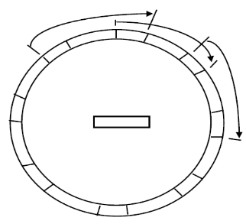
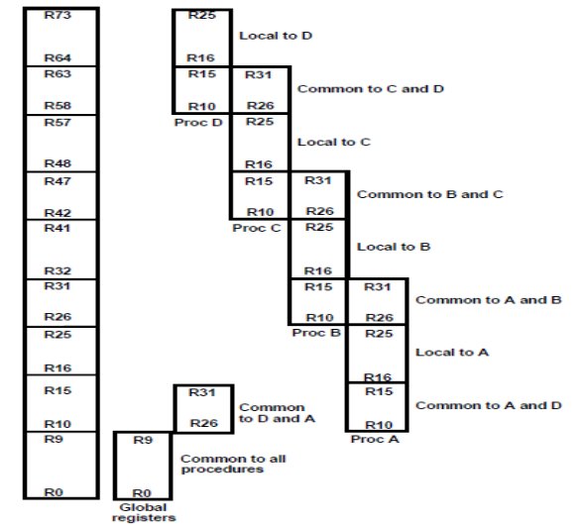
BERKELEY RISC I
- 32-bit integrated CPU
- 32-bit address, 8-, 16-, 32-bit data
- 32-bit instruction format
- total 31 instructions
- three addressing modes:
register
immediate
PC relative addressing
- 138 registers
10 global registers
8 windows of 32 registers each

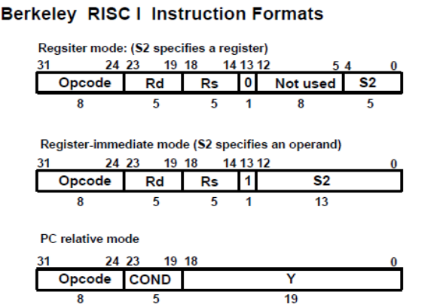
CHARACTERISTICS OF RISC
RISC Characteristics
- Relatively few instructions
- Relatively few addressing modes
- Memory access limited to load and store instructions
- All operations done within the registers of the CPU
- Fixed-length, easily decoded instruction format
- Single-cycle instruction format
- Hardwired rather than microprogrammed control
Advantages of RISC
- VLSI Realization
- Computing Speed
- Design Costs and Reliability
- High Level Language Support RISC

