Functional Dependency (FD) is a constraint that determines the relation of one attribute to another attribute in a Database Management System (DBMS). Functional Dependency helps to maintain the quality of data in the database.

A functional dependency is denoted by an arrow "→". The functional dependency of X on Y is represented by X → Y. Let's understand Functional Dependency in DBMS with example
x-> y

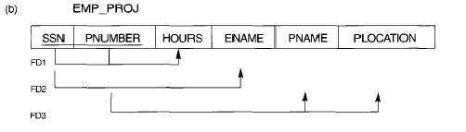

FD1: {SSN, PNUMBER} -> HOURS
FD2: SSN ->ENAME
FD3: PNUMBER -> {PNAME, PLOCATION}

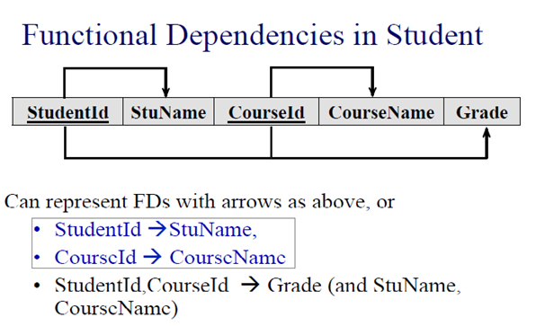

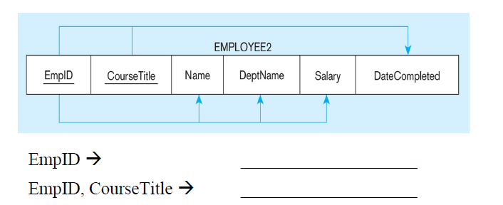

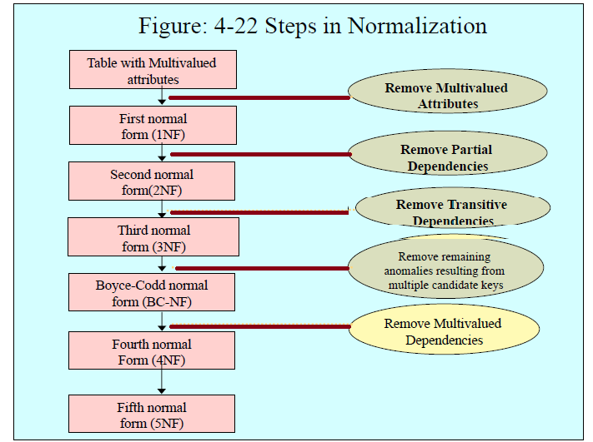

{SSN, PNUMBER} -> HOURS
SSN -> ENAME
PNUMBER -> {PNAME, PLOC}
SSN -> {ENAME, BDATE, ADR, DNUMBER}
DNUMBER -> {DNAME,DMGRSSN}

Rules for 4th Normal Form
For a table to satisfy the Fourth Normal Form, it should satisfy the following two conditions:
- It should be in the Boyce-Codd Normal Form.
- And, the table should not have any Multi-valued Dependency.
Let's try to understand what multi-valued dependency is in the next section

What is Multi-valued Dependency?
A table is said to have multi-valued dependency, if the following conditions are true,
- For a dependency A → B, if for a single value of A, multiple value of B exists, then the table may have multi-valued dependency.
- Also, a table should have at-least 3 columns for it to have a multi-valued dependency.
- And, for a relation R(A,B,C), if there is a multi-valued dependency between, A and B, then B and C should be independent of each other.
If all these conditions are true for any relation(table), it is said to have multi-valued dependency.

Time for an Example
Below we have a college enrolment table with columns s_id, course and hobby.
S_id | Course | Hobby
1 | Science | Cricket
1 | Maths | Hockey
2 | C# | Cricket
2 | Php | Hockey

As you can see in the table above, student with s_id 1 has opted for two courses, Science and Maths, and has two hobbies, Cricket and Hockey.
you must be thinking what problem this can lead to, right?
Well the two records for student with s_id 1, will give rise to two more records, as shown below, because for one student, two hobbies exists, hence along with both the courses, these hobbies should be specified.
s_id | course | hobby
1 | Science | Cricket
1 | Maths | Hockey
1 | Science | Hockey
1 | Maths | Cricket
And, in the table above, there is no relationship between the columns course and hobby. They are independent of each other.
So there is multi-value dependency, which leads to un-necessary repetition of data and other anomalies as well.

How to satisfy 4th Normal Form?
To make the above relation satify the 4th normal form, we can decompose the table into 2 tables.
Course_Opted Table Hobbies Table,

S_id | Course
1 | Science
1 | Maths
2 | C#
2 | Php
S_id | Hobby
1 | Cricket
1 | Hockey
2 | Cricket
2 | Hockey

Now this relation satisfies the fourth normal form.
A table can also have functional dependency along with multi-valued dependency. In that case, the functionally dependent columns are moved in a separate table and the multi-valued dependent columns are moved to separate tables.
Functional Dependency:
Prime Attribute → Non Prime Attributes
Partial dependency :
Part of Prime Attributes → Non Prime Attributes
Transitive Dependency:
Non Prime Attributes → Non Prime Attributes
BCNF Not allow this one
Non Prime Attributes → Prime Attributes

