Types of API's

1. SOAP (simple object access protocol) --> old technology and less companies are using soap It supports only XML format
2. REST (Representational state transfer) --> new technology and more companies are using REST It supports multiple formats like XML, JSON, HTML etc

--> API is giving the response by taking request from the user whereas the webservice is what keeps the api in the internet

--> API is the one which is not in the internet, if it is in internet then it is webservice (all webservices are api's but all api's are not webservices)

REST API request Methods/ http request

1. get --> to get the data from the database
2. post --> to create something in the database
3. put --> to update something in the database
4. patch --> to update the partial info of a record in the database
5. delete --> to delete something in the database

Response message/ validations performed

1. status code validations
2. Time taken to execute
3. size of the data

URI --> uniform resource identifier

URL --> uniform resource locator

URN --> uniform resource name

<https://google.com/articles/articlename>

https --> scheme

[https://google.com](https://google.com/) --> host

articles/articlename --> path

path --> URN

Path + host --> URI

path + host + scheme --> URL

--> the data which is sending along with request is request payload and getting along with response is response payload

Postman --> api testing tool (manual)

To create our own api we need to install nodejs, npm (node package manager) also will install automatically along with nodejs

By using npm we need to install JSON server

To check whether the the nodejs and npm istalled by using

1. Nodejs –version
2. Npm –version

To install the json server 🡪 npm install -g json-server

1. We need to have a json file in the file manager
2. We can create our own api by going to the json file location and by using json-server .json file in the command prompt

Response validations

1. Status code
2. Headers
3. Cookies
4. Response time
5. Response body

**Status Code**

To validate all these points, we need to use assertions

We need to use two types of functions to use assertions they are

1. Normal function

Ex: - pm.test(“Test name”, function () {

//assertion

} );

1. Arrow function

Ex: - pm.test (“Test name”, () => {

//assertion

} );

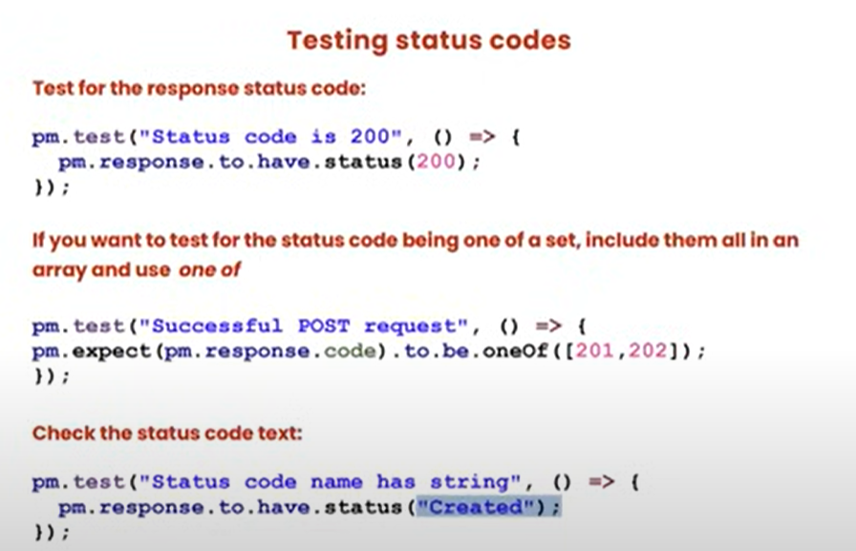

**Headers**

We need to validate Content type

pm.test(“content-type header is present”), ()=> {

pm.response.to.have.header(“Content-Type”);

});

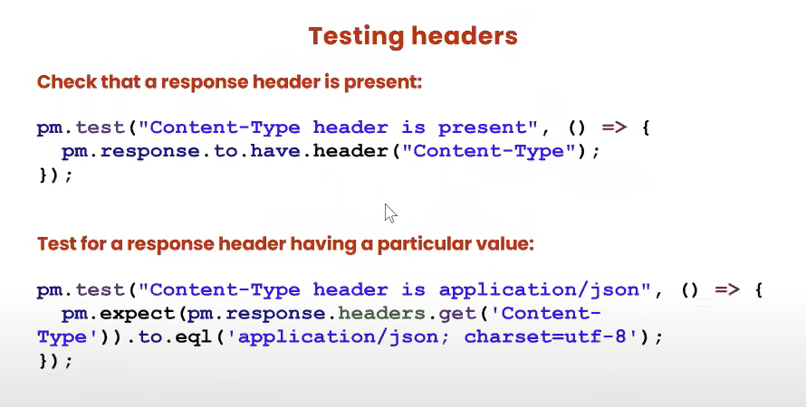

**Cookies: -**

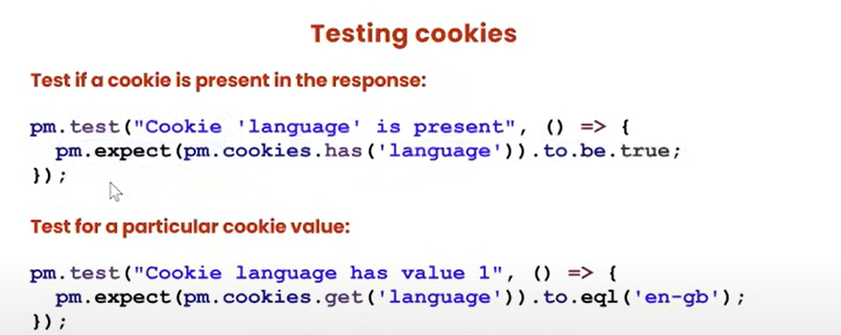

**Response Time: -**

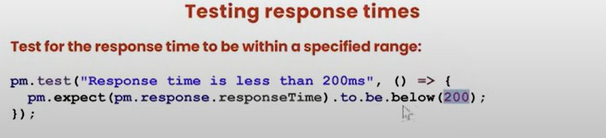

**Response Body: -**

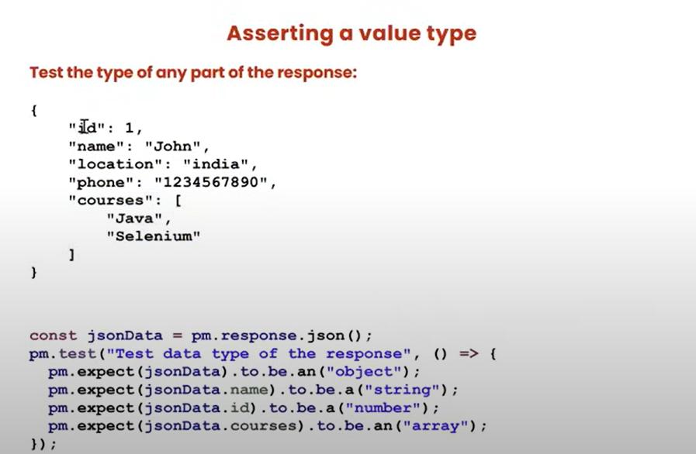

* This is only for the array type

