KUBERNETES: - It provides multiple services which docker doesn’t provide like auto scaling, auto healing, storage, enterprise level behaviour

MINIKUBE KUBERNETES CLUSTER: -
- Create a hosted zone in AWS
- Single node cluster Master and the node components are in single server
- For minikube kubernetes we need to create a VPC and Hosted DNS zone configured in Route53
scholzj/terraform-aws-minikube: Terraform module for single node Kubernetes instance bootstrapped using kubeadm (github.com) For reference
- Minikube uses centos7 and the username is centos
- Authentication config file = kubeconfig
- Default kubeconfig is in ~/.kube/config folder (cp kubeconfig .kube/config)
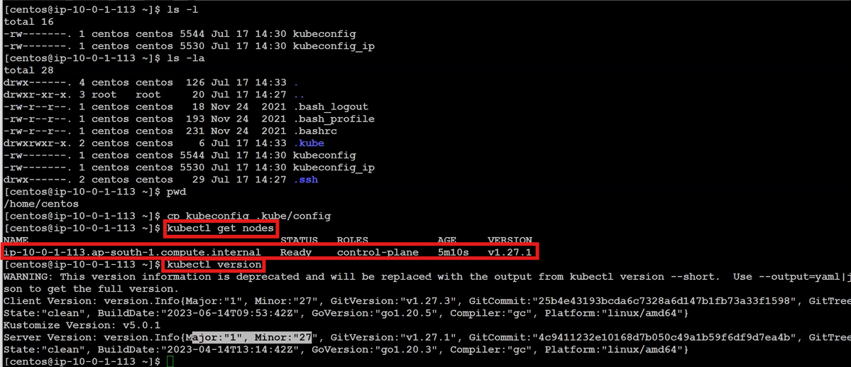
- Kubectl is a command line for Kubernetes cluster
- For giving the executive permissions and connect using docker run the following commands
- Download and install kubectl in workstation using command from internet
- Chmod +x ./kubectl
- Sudo mv kubectl /usr/local/bin
- Kubectl
- Cat kubeconfig Copy the configuration file from minikube cluster (k8 ec2)
- mkdir .kube
- cd .kube/
- vim config paste the copied configuration file in workstation (docker ec2)
- kubectl get nodes we need to get the nodes present inside the cluster

Kubernetes Resources: -
- Namespace (kubectl get namespaces): - In Kubernetes namespace is a logical isolation of resources, network, policies, rbac and everything EX: - If 2 projects using same k8 cluster, one can use ns1 and other can use ns2 without any overlap
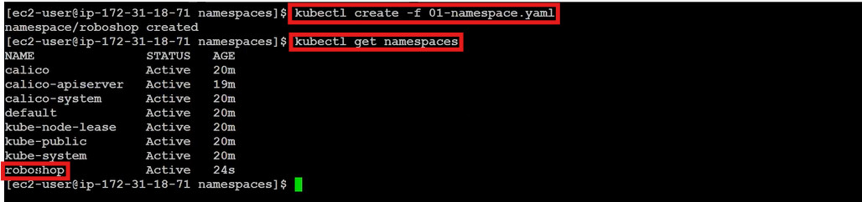
- Kubectl create -f <file-name.yaml> To create the resources
- Kubectl apply -f <file-name.yaml> if it’s not created, it will create. If created before no error
- Kubectl delete -f <file-name.yaml> To delete the resources

- Pod (kubectl get pods): - It is the smallest deployable unit in Kubernetes.
- Pod can run multiple containers
- Containers inside the pod share the same network and storage
Kubectl exec -it multipod -c almalinux –bashgo into the container

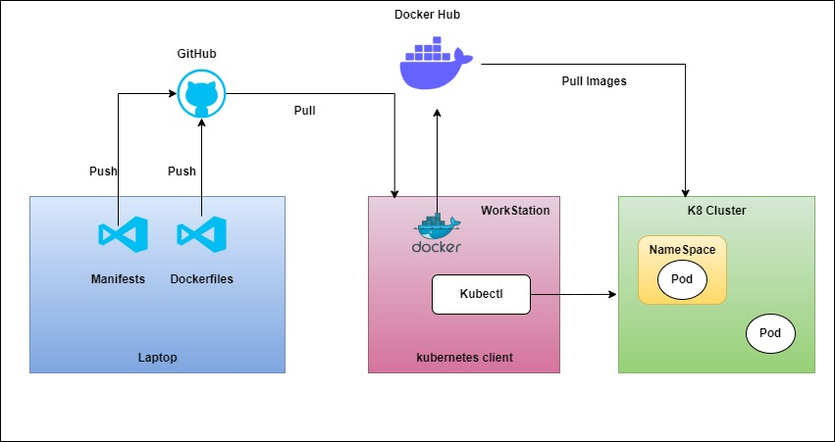

Kubernetes architecture has two nodes
- Master node (control plane)
It contains of components like
- API Server: - It is useful for exposing the Kubernetes to the external world. It is heart of the kubernetes
- ETCD: - It is used as the backup which will store as key pair values.
- Scheduler: - It will schedule the pods or the resources in Kubernetes. It will the information from api server to schedule
- Controller manager: - Replicaset is used to maintain the pod as the pods are always running. Maintaining these replicasets is by controller manager
- Cloud Controller Manager: - If we want to implement the Kubernetes in any cloud provider. The people of the cloud itself contribute to the cluster
- Worker node (Data Plane)
It contains of components like
- Kubelet: - It is responsible running and managing the pod
- Kubeproxy: - It is a networking in Kubernetes which allocates the ip to pods and load balancing
Kubeproxy works by maintaining a set of network rules on each node in the cluster, which are updated dynamically as services are added or removed. When a client sends a request to a service, the request is intercepted by kube-proxy on the node where it was received. Kube-proxy then looks up the destination endpoint for the service and routes the request accordingly.
Kube-proxy is an essential component of a Kubernetes cluster, as it ensures that services can communicate with each other
- Container runtime: - It will run the container

Kubernetes is a cluster
- The lowest level of deployment in Kubernetes is a pod
- POD: - It defines how to run a pod
- We can put multiple containers in a single pod with multiple advantages
- Shared storage
- Shared networking
- And they communicate using a local host
** Kubectl is a command line for Kubernetes which is useful to run the Kubernetes commands
KUBERNETES POD:
Ex: - kubectl get pods --> It will give the list of pods
- To install the kubectl --> Install Tools | Kubernetes
- Kubectl –version --> to check the kubectl is installed or not
- To install minikube --> minikube start | minikube (k8s.io)
- Minikube start --> Kubernetes cluster will start
- If we are using windows or mac then minikube start will first create the virtual machine and then creates a single node Kubernetes cluster
- Needs to create a pod.yml file where we have written all the requirements
- Then kubectl apply -f pod.yml / kubectl cretae -f pod.yml --> pod is got created
- Kubectl get pods --> get the list of pods
- Kubectl get pods -o wide --> get the list of pods with full details
- Kubectl get pods -w --> to watch what the pod is doing
- Kubectl get pods -v=7 --> It will gives the steps of the pods what it will gives.
- Reference of the yaml file to create pod --> Pods | Kubernetes
- Kubectl describe pod <podname> or kubectl logs <podname>--> To know complete details about the pod
- minikube ssh --> To get inside the Kubernetes cluster
- curl <ip of pod> --> To get complete details of the cluster
- Kubectl cmnds reference -->kubectl Cheat Sheet - Kubernetes (k8s-docs.netlify.app)
- To get the properties like auto scaling and auto healing deployment is kind we need to use instead of pod

KUBERNETES DEPLOYMENT:
Container: - It is used in docker, we use docker run -d <imageid> -p <port> to run a container
POD: - It is used in kubernetes and manifest a yaml file where we can build multiple containers. Using the yaml file itself we will run the containers. It is running specification of docker container
Deployment: - It is responsible for the special features that a Kubernetes have like Auto Healing, Auto Scaling etc which pods doesn’t provide
- The Deployment first create a replicaset which is a Kubernetes controller. It is the one which is implementing the autohealing
- Replicasets creates pods
- Kubectl get deploy --> It will list all the deployments
- Kubectl get all --> It will list all the pods,deployments,resources etc: -
- Reference of The yaml file to create pod --> Deployments | Kubernetes
- Kubectl get rs --> It will list all the replicasets
KUBERNETES SERVICES:
- Kuberenets services is created on top of the replicaset. Service is a load balancer(svc)
- Kubectl get svc --> get the list of services.
- If there are 3 pods then the traffic will be shared accordingly to the pods
- With the help of the ip addresses the user can access instead of ip addresses service will be as the url to access no matter what the ip addresses are
- Inorder to ignore the ip’s when the time of creating the pod labels & selectors is added to the pod. EX: - if the application is about the payments, then the label name as a payment. This label should be declared in a metadata of a pod creation
- We can create service as 3 types using yaml manifest
1. Cluster IP
2. nodeport
3. load balancing
- If we create a service using cluster ip mode, it will not change anything. It will only give the two benefits which are discovery and load balancing. It can be accessed only inside the cluster
- If we create a service using nodeport mode then the application is accessed inside the org
- If we create a service using load balancer mode then the application is accessed by everyone outside the world. This will only support on cloud provider
Advantages of Kubernetes services
- Load Balancing
- Service Discovery
- Expose to External world
INGRESS:

HELM: - Helm is a package manager for Kubernetes. Same as apt for linux ubuntu. Used to install Kubernetes controllers, applications like Prometheus, Grafana, ArgoCD, Nginx etc

Interview Questions
- What is the difference between docker and Kubernetes?
- Docker is a container platform whereas Kubernetes is a container orchestration platform that offers capabilities like auto scaling, auto healing, clustering and enterprise level support like load balancing
- What are the main components of Kubernetes architecture?
- There were 2 parts in Kubernetes architecture
- Control plane
- API Server: - Responsible for handling the api’s
- Scheduler: - Responsible for scheduling the resources on the K8’s cluster
- Controller manager: - It takes care of default controller in k8’s
- Cloud Controller Manager: - It is a Kubernetes component that enables integration with cloud provider APIs to manage resources like nodes, load balancers, and volumes.
- ETCD: - It is the k8’s object store, where all the resources of k8’s are stored as objects in k8’s
- Data plane
- Kubelet: - It is responsible for managing the pod on nodes
- Kube-proxy: - It is a networking component of k8’s which take care of ip tables
- Container Runtime: - It is the software responsible for running containers by pulling images, setting up isolated environments, and managing their lifecycle on a host system.
- What are the main differences between docker swarm and Kubernetes
- K8’s is better suited for large scale organizations as it offers more scalability, network capabilities like policies and huge third-party ecosystem support.
- What is the difference between Docker container and Kubernetes pod
- A Pod in k8’s is a runtime specification of a container in docker. A Pod provides more declarative way of defining using YAML and we can run more than one container in a pod

- What is a namespace in Kubernetes
- A Namespace is a logical partition of resources, network, policies etc…
If there are 2 projects / teams working on same k8’s cluster. One can use NS1 and the other can use NS2 without any overlap and authentication problems, so that One NS cannot disturb another one
- What is the role of kubeproxy
- Kube-Proxy is a Kubernetes network component that runs on each node and manages network rules to enable communication between services and pods by forwarding traffic based on service definitions. It updates the IP tables
- What are the different types of services within Kubernetes
- There are 3 types of services in k8’s. They are
- Cluster IP mode
- Node port mode
- Load balancer mode
- What is the difference between Node Port and LoadBalancer type service?
- When a service is created a Node Port type, The Kube-proxy updates the IPTables with Node IP address and port that is chosen in the service configuration to access the pods.
Whereas if you create a Service as type LoadBalancer, the cloud control manager creates an external load balancer IP using the underlying cloud provider logic in the C-CM. Users can access services using the external IP
- What is the role of kubelet
- Kubelet manages the containers that are scheduled to run on that node. It ensures that the containers are running and healthy, and that the resources they need are available.
Kubelet communicates with the Kubernetes API server to get information about the containers that should be running on the node, and then starts and stops the containers as needed to maintain the desired state. It also monitors the containers to ensure that they are running correctly, and restarts them if necessary.
- Day to day activities on Kubernetes

