**API**

* API is anApplicationProgramming Interface that is a collection of communication protocols used by various programs to communicate between them.
* In Java, API refers to set of classes, interfaces, methods, and protocols provided by libraries or frameworks that developers can use to interact with the functionality provided by those libraries and frameworks.
* JDKs include Java APIs, which are integrated components of software. Java's APIs offer a communication interface and interface between various programs.

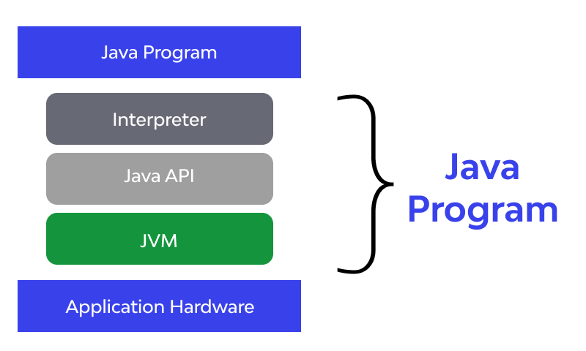

API in Java is delivered via Java Development Kit or JDK. JDK is made up of three entities.

1. **Java compiler:** A pre-quoted program used for breaking the complex user-written codes into simple and computer-understandable codes, known as byte-code.
2. **Java Virtual Machine (JVM):** Allotted to process the byte code and generate an easy-to-understand output.
3. **Java API:** The pre-integrated software components used for establishing a communication between desired software/platforms/components.

‍**The Java REST API work**

[REST API](https://www.wallarm.com/what/differences-soap-vs-rest#what_is_rest_) is one of the most widely used API in Java, along with Web API, Java Help, Facebook.4J, and Twitter.4J. It makes code available and usable for every related application/program. While one is using REST API in Java, the basic rules to be followed are:

* **Stateless:** REST follows client-server architecture to remain state-independent.
* ‍**Uniform interface:** Applications using REST API in Java and beyond will be requiring the undeviating client and server interface via HTTP and URIs
* ‍**Client-server:** Client and servers, involved in the communication, are independent of each other.
* ‍**Cache:** Cache is an imperative part of REST API in Java as its presence makes recording intermediate responses easier than ever.
* ‍**Layered:** REST API features layered structure and each layer is independent.

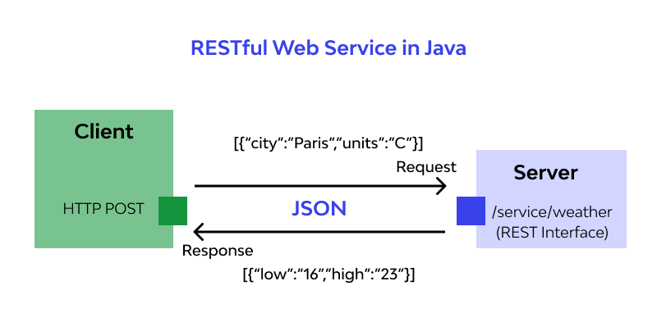

**Types of Java APIs**

The five acceptable types of Java API are explained next:

1. Public Java APIs are often referred to as open Java API as they are part of JDK and don’t need any extra payment. Also, they are free from the areas and use cases of their implementation.
2. Private or internal Java API is designed by a particular developer/organization and is accessible only to authorized professionals.
3. Partner Java APIs are the third-party APIs offered to businesses for specific operations.
4. Composite Java API is basically microservices developed using clubbing different kinds of APIs.
5. Web Java API is accessed via HTTP protocol and is used to establish a communication bridge for browser-based applications/services like web storage and web notifications.