A Course Based Project Report on
CLIENT INTELLIGENCE CENTER
Submitted to the
Department of CSE - (CyS, DS) and AI&DS

in partial fulfilment of the requirements for the completion of course
BIG DATA COMPUTING LABORATORY (22PC2DS303)

BACHELOR OF TECHNOLOGY
IN
CSE-Data Science
Submitted by
J. JAGADEESWAR 23071A67F4
K. PARVEZ ALAM 23071A67F5
K. VARSHITH REDDY 23071A67F7
M. NEHAL REDDY 23071A67G1

Under the guidance of
Mrs. P. Swathi
Assistant Professor


Department of CSE - (CyS, DS) and AI&DS
VALLURUPALLI NAGESWARA RAO VIGNANA JYOTHI INSTITUTE OF ENGINEERING & TECHNOLOGY
An Autonomous Institute, NAAC Accredited with ‘A++’ Grade, NBA
Vignana Jyothi Nagar, Pragathi Nagar, Nizampet (S.O), Hyderabad – 500 090, TS, India

MAY - 2026
VALLURUPALLI NAGESWARA RAO VIGNANA JYOTHI INSTITUTE OF ENGINEERING AND TECHNOLOGY
An Autonomous, ISO 21001:2018& QS I-Gauge Diamond Rated Institute, Accredited by NAAC with ‘A++’ Grade
NBA Accreditation for B.Tech. CE,EEE,ME,ECE,CSE,EIE,IT,AME, M.Tech. STRE, PE, AMS, SWEProgrammes
Approved by AICTE, New Delhi, Affiliated to JNTUH, NIRF (2024) Rank band:151-200in EngineeringCategory
College with Potential for Excellence by UGC,JNTUH-Recognized Research Centres:CE,EEE,ME,ECE,CSEVignana Jyothi Nagar, Pragathi Nagar, Nizampet (S.O.), Hyderabad – 500 090, TS, India.
Telephone No: 040-2304 2758/59/60, Fax: 040-23042761
E-mail: postbox@vnrvjiet.ac.in, Website: www.vnrvjiet.ac.in

Department of CSE - (CyS, DS) and AI&DS


CERTIFICATE

This is to certify that the project report entitled “CLIENT INTELLIGENCE CENTER” is a bona fide work done under our supervision and is being submitted by Mr. JAGADEESWAR (23071A67F4), Mr. K. PARVEZ ALAM (23071A67F5), Mr. K.VARSHITH REDDY (23071A67F7), Mr. M. NEHAL REDDY (23071A67G1) in partial fulfilment for the award of the degree of Bachelor of Technology in CSE-Data Science, of the VNRVJIET, Hyderabad during the academic year 2025-2026.

Mrs. P. Swathi Dr. G. Ramesh Chandra
Assistant Professor Professor and I/C HOD
Dept of CSE - (CyS, DS) and AI&DS Dept of CSE -(CyS,DS) and AI&DS

VALLURUPALLI NAGESWARA RAO VIGNANA JYOTHI INSTITUTE OF ENGINEERING AND TECHNOLOGY
An Autonomous Institute, NAAC Accredited with ‘A++’ Grade,
VignanaJyothi Nagar, Pragathi Nagar, Nizampet(SO), Hyderabad-500090, TS, India


Department of CSE - (CyS, DS) and AI&DS
DECLARATION

We declare that the course based project work entitled “CLIENT INTELLIGENCE CENTER” submitted in the Department of CSE - (CyS, DS) and AI&DS, Vallurupalli Nageswara Rao Vignana Jyothi Institute of Engineering and Technology, Hyderabad, in partial fulfilment of the requirement for the award of the degree of Bachelor of Technology in CSE-Data Science is a bonafide record of our own work carried out under the supervision of Mrs. P. Swathi, Assistant Professor, Department of CSE - (CyS, DS) and AI&DS, VNRVJIET. Also, we declare that the matter embodied in this thesis has not been submitted by us in full or in any part thereof for the award of any degree/diploma of any other institution or university previously.
Place: Hyderabad.

J. Jagadeeswar  (23071A67F4) | K. Parvez Alam  (23071A67F5) | K. Varshith Reddy  (23071A67F7) | M. Nehal Reddy  (23071A67G1)

ACKNOWLEDGEMENT

We express our deep sense of gratitude to our beloved President, Sri. D. Suresh Babu, VNR Vignana Jyothi Institute of Engineering & Technology for the valuable guidance and for permitting us to carry out this project.
With immense pleasure, we record our deep sense of gratitude to our beloved Principal, Dr. C.D Naidu, for permitting us to carry out this project.
We express our deep sense of gratitude to our beloved Professor Dr. T. Sunil Kumar, Professor and Head of Department of CSE-(CyS, DS) and AI&DS, VNR Vignana Jyothi Institute of Engineering & Technology, Hyderabad-500090 for the valuable guidance and suggestions, keen interest and through encouragement extended throughout the period of project work.
We take immense pleasure to express our deep sense of gratitude to our beloved Guide, Mrs. P. Swathi, Assistant Professor in CSE - (CyS, DS) and AI&DS, VNR Vignana Jyothi Institute of Engineering & Technology, Hyderabad, for his/her valuable suggestions and rare insights, for constant source of encouragement and inspiration throughout my project work.
We express our thanks to all those who contributed for the successful completion of our project work.

Mr. JAGADEESWAR (23071A67F4)

Mr. K. PARVEZ ALAM (23071A67F5)

Mr. K. VARSHITH REDDY (23071A67F7)

Mr. M. NEHAL REDDY (23071A67G1)

TABLE OF CONTENTS

S No. | Title | Page No.
1 | Abstract | 1
1 | Introduction | 2
2 | Methodology | 3
3 | Test Cases | 5
4 | Results | 6
5 | Discussion | 7
6 | Conclusion | 8
7 | References | 9

ABSTRACT

The Client Intelligence Center project leverages the Hadoop ecosystem to analyze user behavior data, uncovering patterns and trends critical for enhancing customer engagement and experience. Utilizing Hadoop Distributed File System (HDFS) for data storage, MapReduce for data processing, Hive for data querying, and Pig for data transformation, this project enables efficient handling and analysis of vast amounts of user data. Sqoop is implemented to facilitate seamless integration between traditional SQL databases and Hadoop, ensuring comprehensive data availability for analysis. This project aims to provide actionable insights into customer behavior, driving informed business decisions.

CHAPTER-1
INTRODUCTION

In the digital age, understanding user behavior is paramount for businesses aiming to stay competitive. The sheer volume of data generated by user interactions necessitates robust tools and frameworks for efficient analysis. The Hadoop ecosystem, with its distributed storage and processing capabilities, presents an ideal solution for managing and analyzing large datasets. In this project, we will create a comprehensive analysis pipeline for user data using the Hadoop ecosystem. We will store and process large datasets containing user interactions, then analyze and extract meaningful insights. The project will involve setting up a Hadoop Distributed File System (HDFS) for data storage, processing the data with MapReduce, querying with Hive, and scripting data transformations with Pig. We will also use Sqoop to facilitate data transfer between SQL databases and Hadoop

CHAPTER-2
METHODOLOGY
2.1 Overview and Architecture
Data Collection and Storage:
- HDFS: User interaction data is ingested and stored in the Hadoop Distributed File System (HDFS). Below is an example of how data might be stored in HDFS using Hadoop.
Commands:
hadoop fs -put /local/path/to/user_interaction_data /user/hadoop/data/

Data Integration:
- Sqoop: Data from existing SQL databases is imported into HDFS using Sqoop. Here's a snippet demonstrating Sqoop usage to import data from MySQL:
sqoop import connect jdbc:mysql://mysql_server/blogspot_db -username user password pass -table user_interactions -target-dir/user/hadoop/data/

Data Processing:
- MapReduce: MapReduce jobs are implemented for processing large datasets in a distributed manner.
Here's a simplified example of a MapReduce program to count user interactions:
public class UserInteractionCount {
public static void main(String[] args) throws Exception {
Job job = Job.getInstance(new Configuration(), "User Interaction Count");
job.setJarByClass(UserInteractionCount.class);
FileInputFormat.addInputPath(job, new Path("/user/hadoop/data/user_interactions"));
FileOutputFormat.setOutputPath(job, new Path("/user/hadoop/output/interaction_count"));
job.setMapperClass(InteractionMapper.class);
job.setReducerClass(InteractionReducer.class);
job.setOutputKeyClass(Text.class);
job.setOutputValueClass(IntWritable.class);
System.exit(job.waitForCompletion(true) ? 0 : 1);
}
}
2.2 Implementation Steps
Data Querying:

- Hive: Hive queries are used for data querying and analysis. Here's an example of a Hive query to find the average user interaction duration:
SELECT user_id, AVG(duration) AS avg_duration
FROM user_interactions
GROUP BY user_id;

Data Transformation:

- Pig: Pig scripts are utilized for data transformation tasks. Below is an example of a Pig script to filter and transform user interaction data:
user_interactions = LOAD '/user/hadoop/data/user_interactions' USING PigStorage(',') AS (user_id:int, action:chararray, timestamp:long);
filtered_interactions = FILTER user_interactions BY action == 'click';
grouped_by_user = GROUP filtered_interactions BY user_id;
user_interaction_count = FOREACH grouped_by_user GENERATE group AS user_id, COUNT(filtered_interactions) AS click_count;
STORE user_interaction_count INTO '/user/hadoop/output/user_interaction_count' USING PigStorage(',');

Data Analysis and Visualization:

Insights extracted through Hive queries and Pig scripts can be visualized using tools like Tableau or custom dashboards. Visualization aids in interpreting user behavior patterns effectively

TEST CASES/OUTPUT

Test Case-1:
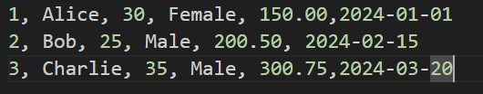

Test Case-2:


Test Case-3:

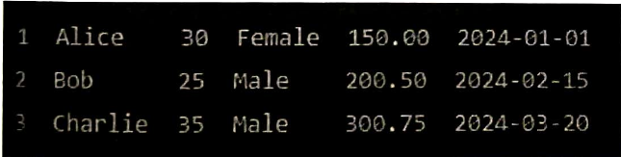

Test Case-4:


RESULTS
Import customer data from MySQL. to HDFS.

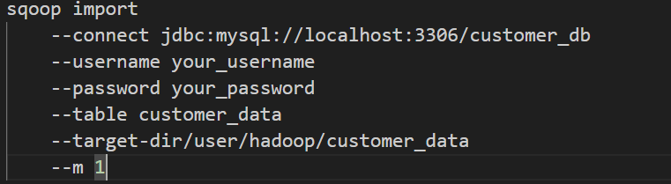

Result: Data was successfully imported to HDFS

Analyze customer data to derive insights such as average purchase amount by gender. 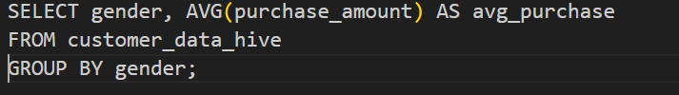

Result: Successfully derived insights from the customer data. 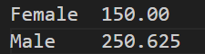

DISCUSSION

- Hadoop Distributed File System (HDFS):
  - HDFS serves as the foundational storage layer in the project. It accommodates large volumes of user interaction data in a distributed manner, ensuring reliability and scalability. This capability is crucial as it allows the project to handle vast amounts of data generated from user interactions across various channels.

- MapReduce:
  - MapReduce is employed for data processing tasks within the project. It facilitates parallel processing of large datasets across a distributed network of nodes. By breaking down complex data processing tasks into smaller manageable tasks (maps and reduces), MapReduce enables efficient computation and aggregation of user behavior patterns and trends.

- Hive:
  - Hive is utilized for querying and analyzing the processed data stored in HDFS. Its SQL-like interface simplifies data exploration and extraction of insights from structured data sets. This capability is instrumental in enabling analysts and data scientists to derive actionable insights into customer behavior through ad-hoc queries and data summarization.

- Pig:
  - Pig complements MapReduce by offering a high-level data flow language. It allows for the scripting of data transformations and manipulations that are executed on Hadoop. This flexibility is valuable in handling diverse data processing requirements, such as cleansing, transforming, and preparing data for analysis.

- Sqoop:
  - Sqoop facilitates seamless data integration between traditional SQL databases and the Hadoop ecosystem. It supports the efficient import and export of data, ensuring that all relevant data sources are accessible for analysis within the Hadoop environment. This capability enables the project to leverage existing data assets from relational databases, enhancing the comprehensiveness of insights derived from user behavior data.

CONCLUSION

The Customer Insights Hub project successfully demonstrates the power of the Hadoop ecosystem in analyzing user behavior data. By leveraging HDFS for storage, MapReduce for processing, Hive for querying, Pig for data transformation, and Sqoop for integration, the project provides a comprehensive solution for extracting actionable insights from large datasets. These insights can drive informed business decisions, ultimately enhancing customer engagement and experience. The Hadoop ecosystem's scalability and flexibility make it an invaluable tool for businesses looking to harness the full potential of their data

REFERENCES

- Hadoop: https://hadoop.apache.org
- Sqoop: https://sqoop.apache.org/docs/1.4.6/index.html
- Hive: https://hive.apache.org/
- White, T. (2015): Hadoop: The Definitive Guide (4th Edition). O'Reilly Media.
https://www.oreilly.com/library/view/hadoop-the-definitive/9781491901687/
- Pig: https://pig.apache.org/
- Dean, J., & Ghemawat, S. (2008): MapReduce: Simplified Data Processing on Large Clusters. Communications of the ACM, 51(1), 107-113.
- Google Research: https://research.google/pubs/pub62/

