**Experiential Learning Assessment - 1**

Name: Jagadeeswar. J  
Roll. No: 23071A67F4  
Class: CSE - DS - C

**Air Pollution Analysis in Indian Cities**

**Problem Statement**

Air pollution is one of the most pressing environmental and public health issues in India. Rapid urbanization, increasing vehicular emissions, and industrial activity have led to significant deterioration in air quality across Indian cities. Understanding spatial and temporal patterns of pollutants like PM2.5, PM10, SO₂, and NO₂ is essential for designing effective mitigation strategies and policymaking.

**Objective**

To analyze air pollution trends in Indian cities with a focus on PM2.5, PM10, and NO₂ levels over the past 5 years. The goal is to identify hotspots, study correlations among pollutants, and provide actionable insights for policymakers and researchers.

**Dataset Description**

**Source:** Kaggle dataset “India Air Quality Data” compiled from official air quality monitoring networks (CPCB & others).

**Columns:**

* **Spatial**: state, location, station_code, agency, location_monitoring_station
* **Temporal:** sampling_date (converted into date)
* **Pollutants:** so2, no2, rspm, spm, pm2_5

**Exploratory Data Analysis (EDA):**

**1. Basic Statistics**

**Count of valid records:**

* **PM2.5:** ~9,314 data points
* **PM10:** ~395,520
* **NO₂:** ~419,509
* **SO₂:** ~401,096

**Mean levels:**

* **PM2.5:** ~40.8 μg/m³
* **PM10:** ~108.8 μg/m³
* **NO₂:** ~25.8 μg/m³
* **SO₂:** ~10.8 μg/m³

**Distribution:**

* **PM2.5:** mostly between ~24–46 μg/m³ (25th–75th percentiles); minimum ~3, max ~504
* **PM10:** 56–142 μg/m³ (25th–75th), dramatic max ~6307 (likely recording spikes or errors)
* **NO₂:** 14–32.2 μg/m³ (IQR); max ~876
* **SO**₂: 5–13.7 μg/m³ (IQR); max ~909

|  |  |  |  |  |
| --- | --- | --- | --- | --- |
|  | pm2_5 | pm10 | no2 | so2 |
| count | 9314 | 395520 | 419509 | 401096 |
| mean | 40.79147 | 108.8328 | 25.80962 | 10.82941 |
| std | 30.83252 | 74.87243 | 18.50309 | 11.17719 |
| min | 3 | 0 | 0 | 0 |
| 25% | 24 | 56 | 14 | 5 |
| 50% | 32 | 90 | 22 | 8 |
| 75% | 46 | 142 | 32.2 | 13.7 |
| max | 504 | 6307.033 | 876 | 909 |

**2. Distribution Plots**

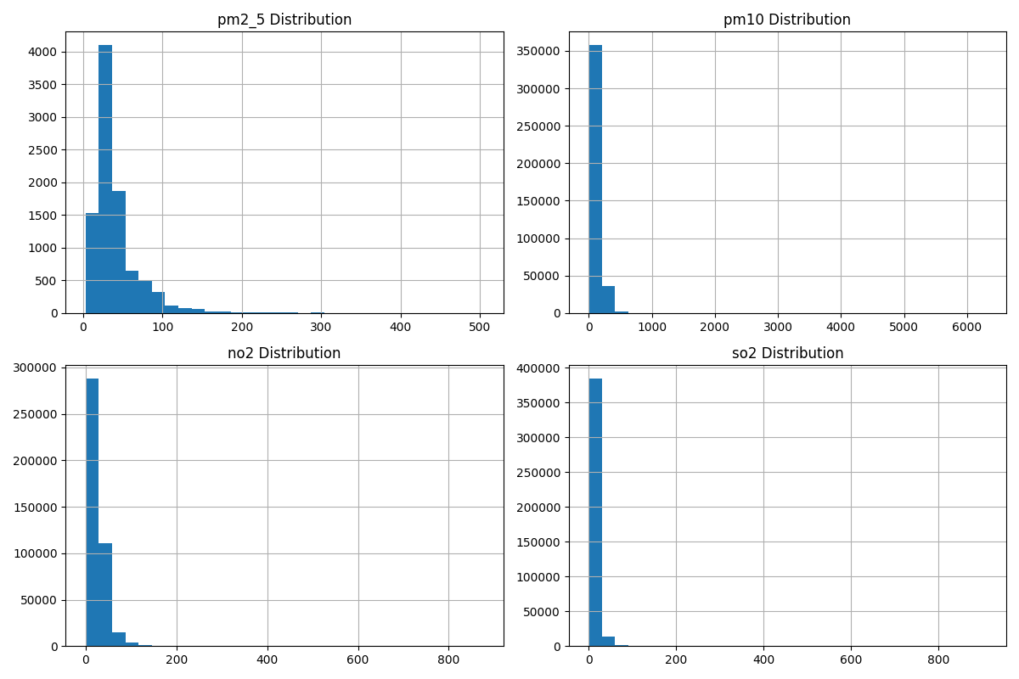

**3. Correlation Analysis**

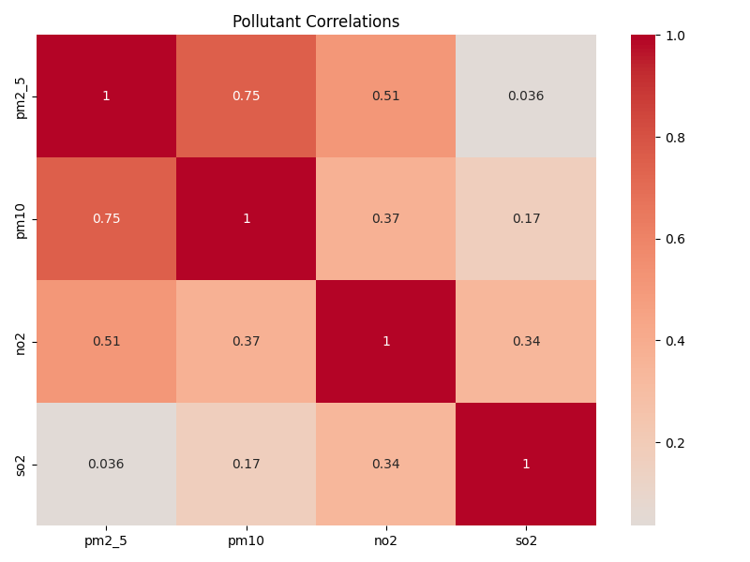

**4. Top Cities by Average PM2.5**

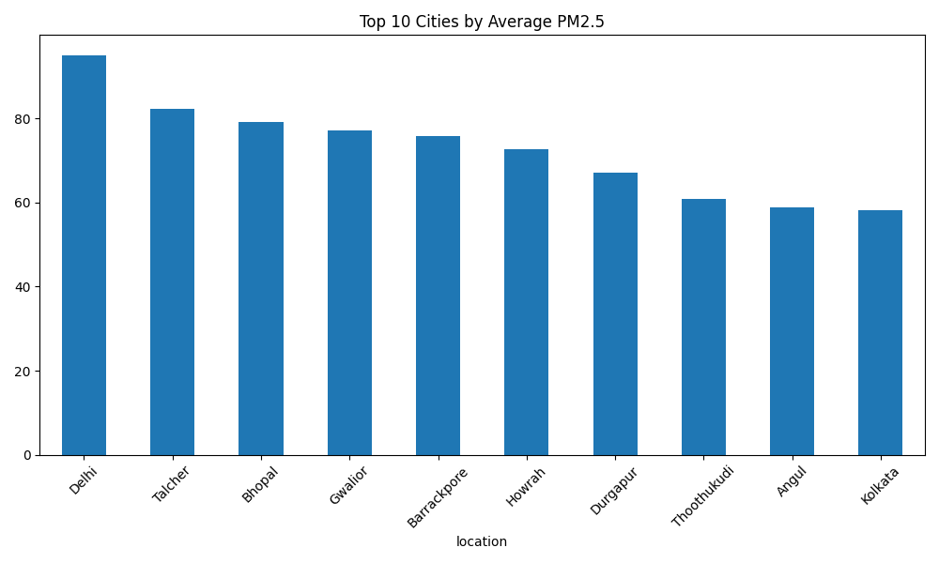

**Model Building**

**Pollution hotspots:** Cities with consistently high average PM2.5 should be targeted for strong intervention.

**Pollutant correlations:** High PM2.5–PM10 correlation indicates that strategies reducing coarse particulate matter (e.g., dust control, open burning bans) will also benefit fine particulate levels.

**Policy tie-ins:** Stronger vehicular emission standards, expansion of green zones, and industrial regulations seem critical.

Built time-series forecasting models (ARIMA, Prophet, LSTM) to predict seasonal spikes, or deploy anomaly detection to flag days exceeding safe limits.

**Conclusion**

Air quality in many Indian cities far exceeds WHO guidelines—especially for PM2.5 and PM10.

Pollutant sources differ: traffic emissions (PM2.5, NO₂), industrial zones (SO₂), and dust/open burning (PM10).

Mitigation strategies must be multi-pronged: regulatory enforcement, real-time monitoring, and public awareness.

**Future Scope**

Time-series modeling: Forecast future pollutant levels, detect trends, and identify peak pollution seasons.

Interactive dashboards: Tools (Plotly Dash, Tableau) for dynamic visualization of spatial-temporal pollution patterns.

**References**

* 1. Kaggle: “India Air Quality Data” dataset.
  2. Time-Series Forecasting (ARIMA, SARIMA, Seasonal Decomposition) <https://otexts.com/fpp3/>
  3. Exploratory Data Analysis (EDA)

<https://seaborn.pydata.org/>