Author - Jagadeesh
Language – Python

What is Python?
Python is a very popular general-purpose interpreted, interactive, object-oriented, and high-level programming language. Python is dynamically-typed and garbage-collected programming language.
It was created by Guido van Rossum during 1985- 1990.

Characteristics of Python
- It supports functional and structured programming methods as well as OOP.
- It can be used as a scripting language or can be compiled to byte-code for building large applications.
- It provides very high-level dynamic data types and supports dynamic type checking.
- It supports automatic garbage collection.
- It can be easily integrated with C, C++, COM, ActiveX, CORBA, and Java.
Applications of Python
- In Data Science, Python libraries like Numpy, Pandas, and Matplotlib are used for data analysis and visualization.
- Python frameworks like Django, and Pyramid, make the development and deployment of Web Applications easy.
- This programming language also extends its applications to computer vision and image processing.
- It is also favoured in many tasks like Automation, Job Scheduling, GUI development, etc.
Features of Python
- Easy-to-learn − Python has few keywords, simple structure, and a clearly defined syntax. This allows the student to pick up the language quickly.
- Easy-to-read − Python code is more clearly defined and visible to the eyes.
- Easy-to-maintain − Python's source code is fairly easy-to-maintain.
- A broad standard library − Python's bulk of the library is very portable and cross-platform compatible on UNIX, Windows, and Macintosh.
- Interactive Mode − Python has support for an interactive mode that allows interactive testing and debugging of snippets of code.
- Portable − Python can run on a wide variety of hardware platforms and has the same interface on all platforms.
- Extendable − You can add low-level modules to the Python interpreter. These modules enable programmers to add to or customize their tools to be more efficient.
- Databases − Python provides interfaces to all major commercial databases.
- GUI Programming − Python supports GUI applications that can be created and ported to many system calls, libraries, and Windows systems, such as Windows MFC, Macintosh, and the X Window system of Unix.
- Scalable − Python provides a better structure and support for large programs than shell scripting.

*** Python is a Case-sensitive language.

- C, C++, Java – compiler is used to convert machine language – 0010100
- Python – Interpreter is used to convert machine language – 0010100

Compiler –
A compiler is a software program that translates human-readable source code (high-level languages like C, C++, or Java) into low-level machine code or bytecode that a computer's processor can execute.
It scans the entire program at once, translating it into a standalone executable file, which generally results in faster program execution.
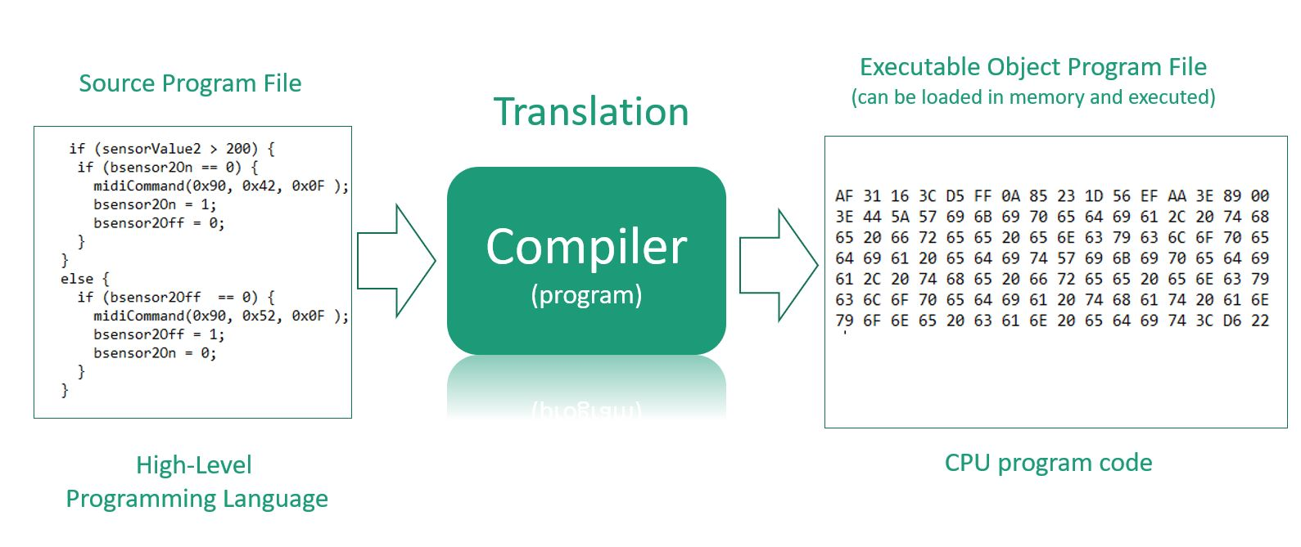
Interpreter –
An interpreter is a computer program that translates and executes high-level source code line-by-line into machine code at runtime, rather than all at once. Popular for languages like Python, JavaScript, and Ruby, it allows immediate execution and easier debugging but is generally slower than compiled code.

Files Required for Python
  - Python from official website
  - VS Code editor
    - . run
    - Python
    - Python debugger
    - Pylance

Practicals:
In Python, comments are created using the hash symbol (#) for single-line comments
# This is a comment that explains the next line of code
print("Hello, World!")
# This is a multiline comment
# that spans across several lines
# using multiple hash symbols.

String literals enclosed in triple quotes (''' or """) are ignored by the interpreter if they are not assigned to a variable.
"""
This is also a multiline comment,
created using a triple-quoted string.
It will be ignored because it is not
assigned to a variable.
"""

Printing in python
# Printing the values
print("Hello World")
Variables in Python
X = 5
** x is a variable
Data Types
1. Integer eg = 1,2,3,4
2. String eg = “Jagadeesh” or ‘Mohan’
3. Float eg = 1.2,2.333,4.2
4. Boolean eg = True or Flase
5. none eg = 0 – will change it in futher
----------------------------------------------------------------------------
Example -
x = 5 # Integer
y = "jagadeesh" # String
a = 5.234 # Float
b = True # Boolean
c = None

# Printing the variables
print(x)
print(y)
print(a)
print(b)
print(None)
Keywords in Python
Keyword Description
- and A logical operator
- as To create an alias
- assert For debugging
- async Define an asynchronous function
- await Wait for and get a result from an awaitable
- break To break out of a loop
- case Pattern in a match statement
- class To define a class
- continue To continue to the next iteration of a loop
- def To define a function
- del To delete an object
- elif Used in conditional statements, same as else if
- else Used in conditional statements
- except Used with exceptions, what to do when an exception occurs
- False Boolean value, result of comparison operations
- finally Used with exceptions, a block of code that will be executed no matter if there is an exception or not
- for To create a for loop
- from To import specific parts of a module
- global To declare a global variable
- if To make a conditional statement
- import To import a module
- in To check if a value is present in a list, tuple, etc.
- is To test if two variables are equal
- lambda To create an anonymous function
- match Start a match statement (compare a value against cases)
- None Represents a null value
- nonlocal To declare a non-local variable
- not A logical operator
- or A logical operator
- pass A null statement, a statement that will do nothing
- raise To raise an exception
- return To exit a function and return a value
- True Boolean value, result of comparison operations
- try To make a try...except statement
- while To create a while loop
- with Used to simplify exception handling
- yield To return a list of values from a generator
Variables - Rules
- Allowed characters: Names can only contain letters (A-z), digits (0-9), and underscores (_).
- Cannot start with a number: A variable name must begin with a letter or an underscore. For example, _age or name1 are valid, but 1name is invalid.
- Case-sensitive: Variable names are case-sensitive, meaning age, Age, and AGE are considered three different variables.
- No keywords: You cannot use any of Python's reserved keywords (e.g., if, else, for, while, print) as a variable name.
- No spaces or special characters: Spaces or special characters like -, !, #, or @ are not allowed.
# This is Single line comment
# This is India

"""
This is multi line comment
This is bangalore
This is Karnataka
This is Python Programming
"""

'''
This is also Multi line Programming
This is bangalore
This is Guntur
This is Python multi line commands
'''

# This is Fitst printing in Python
"""
print("This is Python print - double cots")
print('This python print - single cots')
print("This is 'Core python' language")
print("This is 'core engineering' systel level")
"""

# First Program to add two numbers
a=10
b=5
c=a+b
print("The sum of a+b =",c)
print("The sub of a-b =",(a-b))
# Program with 2 functions
"""
def add(x, y):

print("sum = ",x+y)

def message():
print("Welcome to Python")
# Call the Function
add(10, 20)
message()
# How Python will see the variable
a=2
b=a
print("The value a =",a)
print("The value b =",b)
# Data Types in Python
A datatype represents the type of data stored into a variable or memory.
Built-in data types and user defined data types
Build-in Data types are:
1. None type
2. Numeric type
3. Sequence
4. Sets
5. Mapping

# 1. None type
# In Python, the ‘None’ datatype represents an object that does not contain any value.
def check_even(number):
if number % 2 == 0:
return "Even"
else:
return None # No result

print(check_even(4))
print(check_even(5))
# 2. Numaric data Type
The Numeric Data type represent numbers
1. int - 10,20,-50,-25
2. Flot - 50.256,2.56,-5.35,22.3e3
3. Complex - 6+2j, 5+1j

# 3. Python progrm to display the sum of 2 numbers
c1 = 2.5+5.2j
c2 = 6.1+2.1j
c3 = c1+c2
print("sum = ",c3)
……………………................................................
# Converting Data types Explicitly
x = 5
y = int(x)
z = float(x)
a = complex(x)

print(y)
print(z)
print(a)
print(complex(x, z))

# A program to convert numbers from octal, binary and hexadecimal systems into decimal number systems.
n1 = 0o17
n2 = 0B1110010
n3 = 0x1c2
str = "1c2"

n=int(n1)
print("octal 17 = ",n)

n=int(n2)
print("Binary 0B1110010 = ",n)

n=int(n3)
print("Hexa decimal 0x1c2 = ",n)

n=int(str, 16)
print("The string hexadecimal = ",n)
"""
# python program to convert into decimal number system with base numbers
"""
S1 = "17"
S2 = "1110010"
S3 = "1c2"

n=int(S1, 8)
print('octal 17 = ',n)

n=int(S2, 2)
print("binary 1110010 = ",n)

n=int(S3, 16)
print("Hexa decimal = ",n)

a=10
b=bin(a)
print(b)

b=hex(a)
print(b)

b=oct(a)
print(b)
"""

# Bool Datatype
a=10
b=20
if(a<b): print("Hello")
a=10>5
print(a)
print(int(a))
b=5>10
print(b)
print(int(b))

