1. Fix the bugs in below snippet

<html lang="en">

    <head>

        <title>Document

                guvi

        </title>

    </head>

    <body>

    <div>

        Lorem ipsum dolor sit amet consectetur adipisicing elit.

    </div>

        <div>

                Guvi Geek Network

        </div>

    </body>

</html>

**3.Design a contact us form with all fields as required.**

<!DOCTYPE html>

<html lang="en">

<head>

    <meta charset="UTF-8">

    <meta http-equiv="X-UA-Compatible" content="IE=edge">

    <meta name="viewport" content="width=device-width, initial-scale=1.0">

    <title>Document</title>

    <style>

        fieldset{

            border: 0px;

            width: 30px;

        }

        div{

            text-align: center;

            font-size: 25px;

            font-family: cursive;

             color: purple;

        }

        p{

            text-align: center;

            font-weight: bolder;

            font-size: 20px;

        }

        input{

            border-radius: 7px;

            border-width: 1px;

            height: 30px;

        }

        .btn{

            text-align: center;

            font-size: 20px;

            font-family: -apple-system, BlinkMacSystemFont, 'Segoe UI', Roboto, Oxygen, Ubuntu, Cantarell, 'Open Sans', 'Helvetica Neue', sans-serif;

            background-color: springgreen;

            width: 450px;

            height: 35px;

        }

    </style>

</head>

<body>

    <form>

    <fieldset>

    <div><h2>Guvi</h2></div>

    <p>Customer Contact Form</p>

    <table>

        <tr>

            <td>

                <label for="fname" style="display:block; text-align:left">First Name</label>

                <input type="text" id="fname" name="fname" size="27px" placeholder="First Name" required>

            </td>

            <td>

                <label for="lname" style="display:block; text-align:left">Last Name</label>

                <input type="text" id="lname" name="lname" size="27px" placeholder="Last Name" required>

            </td>

        </tr>

        <tr>

            <td colspan="2">

                <label for="email">Email Address</label><br>

                <input type="email" id="email" name="email" size="60px" placeholder="Email Address" required>

            </td>

        </tr>

        <tr>

            <td colspan="2">

                <label for="phone">Phone Number</label>

                <input type="text" id="phone" name="phone" size="60px" placeholder="Phone Number" required>

            </td>

        </tr>

        <tr>

            <td colspan="2">

                <label for="query">Query</label><br>

                <input type="tel" id="query" name="query" size="60px" placeholder="Query" required>

            </td>

        </tr>

        <tr>

            <td colspan="2">

                <br>

                <button class="btn"id="submit">Contact Us</button>

            </td>

        </tr>

    </table>

    </fieldset>

    </form>

</body>

</html>

**OUTPUT:**

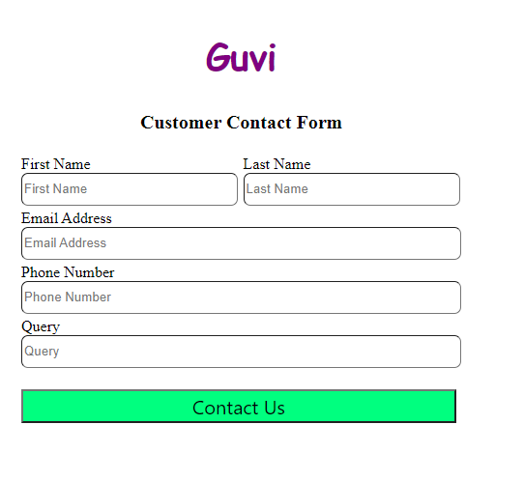

1. **Use certain HTML elements to display the following in a HTML page.**

<!DOCTYPE html>

<html lang="en">

<head>

    <meta charset="UTF-8">

    <meta http-equiv="X-UA-Compatible" content="IE=edge">

    <meta name="viewport" content="width=device-width, initial-scale=1.0">

    <title>Document</title>

</head>

<body>

    <p>

        <ul>

            <li>Programming Language</li>

            <ul>

                <li>JavaScript</li>

                <ol type="a">

                    <li>Angular</li>

                    <li>React</li>

                    <li>Vue.js</li>

                </ol>

                <li>Python</li>

                <ol type="a">

                    <li>Django Framework</li>

                    <li>Flask Framework</li>

                </ol>

                <li>Java</li>

                <ol type="a">

                    <li>Spring</li>

                    <li>Maven</li>

                    <li>Hibernate</li>

                </ol>

            </ul>

            <li>Database</li>

            <ul>

                <li>MySQL</li>

                <li>MongoDB</li>

                <li>Cansandra</li>

            </ul>

        </ul>

    </p>

</body>

</html>

**OUTPUT:**

* Programming Language
  + JavaScript
    1. Angular
    2. React
    3. Vue.js
  + Python
    1. Django Framework
    2. Flask Framework
  + Java
    1. Spring
    2. Maven
    3. Hibernate
* Database
  + MySQL
  + MongoDB
  + Cansandra

5.Create an element that helps you to open the **[https://google.com](https://google.com/)** in separate new tab.

<!DOCTYPE html>

<html lang="en">

<head>

    <meta charset="UTF-8">

    <meta http-equiv="X-UA-Compatible" content="IE=edge">

    <meta name="viewport" content="width=device-width, initial-scale=1.0">

    <title>Google</title>

</head>

<body>

    <a href="https://www.google.com" target="_blank">Google</a>

</body>

</html>

**6. In the form, add two radio buttons with grouping them for employee type(Salaried and own business)**

<!DOCTYPE html>

<html lang="en">

<head>

    <meta charset="UTF-8">

    <meta http-equiv="X-UA-Compatible" content="IE=edge">

    <meta name="viewport" content="width=device-width, initial-scale=1.0">

    <title>Radio button</title>

</head>

<body>

    <form>

        <div>

            <b>Employee Type:</b><br>

            <br>

            <input type="radio">Salaried

            <input type="radio">Own business

        </div>

    </form>

</body>

</html>

**OUTPUT:**

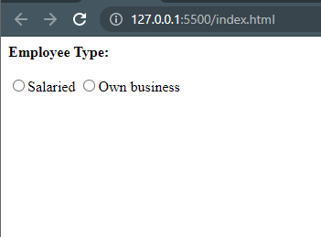

## Design form shown in the link (<http://evc-cit.info/cit040/formguide/card_0.png>)

<!DOCTYPE html>

<html lang="en">

<head>

  <meta charset="UTF-8">

  <title>Table</title>

    <style>

        p{

            background-color: red;

            color: white;

            text-align: center;

            font-size: 20px;

            height:25px;

        }

        fieldset{

            border: 5px solid black;

            width: 30%;

        }

        input{

            border: none;

            border-bottom: 2px solid black;

            font-

        }

    </style>

</head>

<body>

<form>

    <fieldset>

        <p>Yes! I want to subscribe to <b><i>Mag-O-Zine</i></b></p>

        <table>

            <tr>

                <td colspan="3">

                <input type="text" id="firstname"  name="firstname" size="22">

                <label for="firstname" style="display:block; text-align:left">First Name</label>

                </td>

                <td colspan="3">

                <input type="text" id="lastname" name="lastname" size="25">

                <label for="lastname" style="display:block; text-align:left">Last Name</label>

                </td>

            </tr>

            <tr>

                <td colspan="6">

                    <input type="text" id="address"  name="address" size="50" >

                    <label for="address" style="display:block; text-align:left">Address </label>

                </td>

            </tr>

            <tr>

                <td colspan="2">

                    <input type="text" id="city"  name="city" size="12">

                    <label for="city style="display:block; text-align:left">City</label>

                </td>

                <td colspan="2">

                    <input type="text" id="state"  name="state" size="10">

                    <label for="state" style="display:block; text-align:left">State</label>

                </td>

                <td colspan="2">

                    <input type="text" id="zip" name="zip" size="12">

                    <label for="zip" style="display:block; text-align:left">Zip</label>

                </td>

            </tr>

            <tr>

                <th></th><th></th><th></th><th></th><th></th><th></th>

            </tr>

        </table>

        <b>Subscribe for:

        <input type="checkbox">1 year ($19.95)

        <input type="checkbox">2 year ($35.00)<br>

        Send me more information about:<br>

        <input type="checkbox">Computer-Zine<br>

        <input type="checkbox">Fishing -Zine<br>

        <input type="checkbox">Cat-O-Zine

        </b>

    </fieldset>

</form>

</body>

</html>

**OUTPUT:**

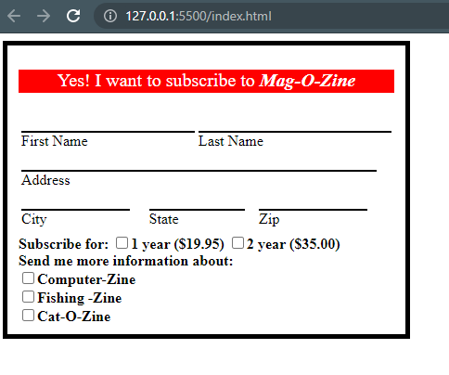

1. Use the table tag to design given image

.<!DOCTYPE html>

<html lang="en">

<head>

  <meta charset="UTF-8">

  <title>Table</title>

    <style>

        table,th,td {

            border: 1px solid black;

            border-collapse: collapse;

            padding: 15px;

            text-align: center;

        }

    </style>

</head>

<body>

  <table>

      <caption>Health Chart</caption>

      <tr>

      <td rowspan="2">State of Health</td>

      <td colspan="2">Fasting Value</td>

      <td>After Eating</td>

      </tr>

      <tr>

          <td>Minimum</td>

          <td>Maximum</td>

          <td>2 hours after eating</td>

      </tr>

      <tr>

          <td>Healthy</td>

          <td>70</td>

          <td>100</td>

          <td>Less than 140</td>

      </tr>

      <tr>

        <td>Pre-Diabetes</td>

        <td>101</td>

        <td>126</td>

        <td>140 to 200</td>

    </tr>

    <tr>

        <td>Diabetes</td>

        <td>More than 126</td>

        <td>N/A</td>

        <td>More than 200</td>

    </tr>

    </table>

</body>

</html>

**OUTPUT:**

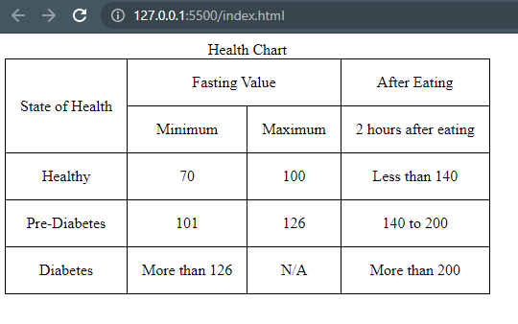

1. Write HTML input tags snippet to show default values for all Form elements.

<!DOCTYPE html>

<html lang="en">

<head>

    <meta charset="UTF-8">

    <meta http-equiv="X-UA-Compatible" content="IE=edge">

    <meta name="viewport" content="width=device-width, initial-scale=1.0">

    <title>Input Tags</title>

</head>

<body>

    <p>Button : <input type="button" value="Button 1"></p>

    <p>Check Box : <input type="checkbox" value="Checkbox"></p>

    <p>Color : <input type="color" value="#ff0000"></p>

    <p>Date : <input type="date" value="2021-08-01"></p>

    <p>Datetime : <input type="datetime" value="2021-08-01 10:00AM"></p>

    <p>Datetime-local : <input type="datetime-local" value="2021-08-01T10:00"></p>

    <p>Email : <input type="email" value="abc@gmail.com"></p>

    <p>File : <input type="file"></p>

    <p>Hidden : <input type="hidden" value="Enter hidden"></p>

    <p>Image : <input type="image" value="Image"></p>

    <p>Month : <input type="month" value="2021-08"></p>

    <p>Number : <input type="number" value="08"></p>

    <p>Password : <input type="password" value="Enter password"></p>

    <p>Radio : <input type="radio" value="Radio"></p>

    <p>Range : <input type="range" value="30"></p>

    <p>Reset : <input type="reset" value="Reset 1"></p>

    <p>Search : <input type="search" value="google"></p>

    <p>Submit : <input type="submit" value="Submit 1"></p>

    <p>Tel : <input type="tel" value="0422367890"></p>

    <p>Text : <input type="text" value="Enter text"></p>

    <p>Time : <input type="time" value="12:00"></p>

    <p>Url : <input type="url" value="www.google.com"></p>

    <p>Week : <input type="week" value="2021-W15"></p>

</body>

</html>

OUTPUT:

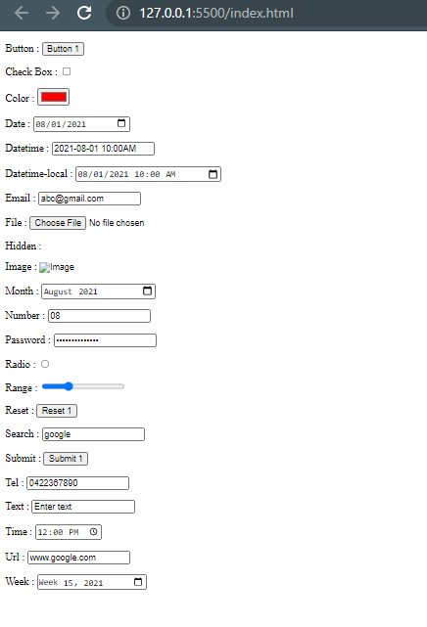

10. In your, HTML page add the below line and Highlight it without using any CSS.

<!DOCTYPE html>

<html lang="en">

<head>

    <meta charset="UTF-8">

    <meta http-equiv="X-UA-Compatible" content="IE=edge">

    <meta name="viewport" content="width=device-width, initial-scale=1.0">

    <title>Hightlight</title>

    <style>

        mark{

            background-color: yellow;

        }

    </style>

</head>

<body>

    <ul>

        <li><mark>"HTML & CSS is awesome"</mark></li>

    </ul>

</body>

</html>

**OUTPUT:**

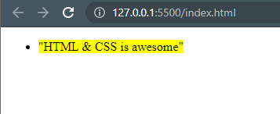

1. Create an HTML page, which should contain all types of input elements.

<!DOCTYPE html>

<html lang="en">

<head>

    <meta charset="UTF-8">

    <meta http-equiv="X-UA-Compatible" content="IE=edge">

    <meta name="viewport" content="width=device-width, initial-scale=1.0">

    <title>Input Tags</title>

</head>

<body>

    <p>Button : <input type="button"></p>

    <p>Check Box : <input type="checkbox"></p>

    <p>Color : <input type="color"></p>

    <p>Date : <input type="date"></p>

    <p>Datetime : <input type="datetime"></p>

    <p>Datetime-local : <input type="datetime-local"></p>

    <p>Email : <input type="email"></p>

    <p>File : <input type="file"></p>

    <p>Hidden : <input type="hidden"></p>

    <p>Image : <input type="image"></p>

    <p>Month : <input type="month"></p>

    <p>Number : <input type="number"></p>

    <p>Password : <input type="password"></p>

    <p>Radio : <input type="radio"></p>

    <p>Range : <input type="range"></p>

    <p>Reset : <input type="reset"></p>

    <p>Search : <input type="search"></p>

    <p>Submit : <input type="submit"></p>

    <p>Tel : <input type="tel"></p>

    <p>Text : <input type="text"></p>

    <p>Time : <input type="time"></p>

    <p>Url : <input type="url"></p>

    <p>Week : <input type="week"></p>

</body>

</html>

OUTPUT:

