BIPOLAR AND SLEEP APNEA DETECTION

Department of Computer Application PES University

Jagadish S

Department Of Computer Applications PES University, Bangalore [jagadishbob123@gmail.com](mailto:jagadishbob123@gmail.com)

# ABSTRACT

Mental issue is a main problem everywhere globally bipolar and sleep apnea are some foremost issues. Bipolar and sleep apnea kinds of disorders are separate hospital-based issues that could co-arise in many people and both of which could have a giant effect on human basic fitness and well-being. bipolar disease is grouped by the aid of high temper swings including a series of mania and melancholy whilst sleep apnea is a sleep problem this is indicated by way of recurrent episodes of interrupted respiratory

for the duration of sleep. Bipolar and sleep apnea detection helps a person to check whether the person has bipolar or sleep apnea disorder this gives results at earlier stages if the disorder is detected at an earlier stage it can be effectively diagnosed and treated.

The project aims to develop a tool for the detection of the phenomenon of bipolar and sleep apnea in individuals the tool will utilize a combination of diagnostic methods including physical exams medical history sleep studies and psychological evaluations the first step of the project will involve conducting a thorough literature review to gather information on current characteristic methods and best practices for the detection of the phenomenon of these two conditions this will be used to inform the design and to make a diagnostic

Dr .lekha Achuth

Department Of Computer Applications

PES University, Bangalore [lekha@pes.edu](mailto:lekha@pes.edu)

# INTRODUCTION

The process of making-decision is made more difficult by the fact that medical information frequently contains information that has been withheld discovering previously hidden trends in medical information and performing data analysis both need the use of computer vision data analysis is a popular practise in many different fields including the business world government the transportation industry the medical field and the marketing field 6 there are many methods for making this analysis more efficient and machine learning is one of them data mining is a subset of machine learning that works with massive volumes of they’ll-formatted data there are three primary uses for algorithms in the medical field illness prediction detection and diagnosis bipolar illness may be diagnosed and treated more effectively if it is diagnosed and treated at an earlier stage and these approaches are designed to do just that in past years medical research focused on a wide range of automatically generated characteristics gleaned from structural information.

# 1.2 PROBLEM STATEMENT

The problem statement of bipolar and sleep apnea could result in a complicated and punishing state of affairs for the affected person and the healthcare specialists the symptoms of both ailments might be severe and incapacitating impairing a person’s capability to feature in day-by-day existence including activity school and social activities bipolar sickness can exacerbate the symptoms of sleep apnea .

**1.3 PROPOSED SOLUTION**

The objective of this project is to determine the presence or absence of bipolar and sleep apnea in the subject additionally if a patient has type 1 or type 2 bipolar disorder assume that they are likely to enter a bipolar disorder phase based on the medical report

the user provided the required input information next the historical data set is loaded because most medical records contain missing information reliable estimation becomes difficult to fill up the gaps interpolation and data cleaning are necessary using an approach that combines data cleansing and computing they must turn unstructured data back into unstructured data when the calculation is complete this approach aims to identify individuals with sleep apnea as early as possible and provide them with appropriate treatment to alleviate symptoms and improve overall health and they’ll-being

# LITERATURE SURVEY

Domain study of bipolar and sleep apnea detection would involve a thorough literature review study design collection information analysis evaluation working and dissemination of results to gain information on the occurrence of the two conditions and its diagnostic tool and help in improving the treatment of these conditions.

• Literature review: doing a thorough study on the existing materials at the co-prevalence of bipolar disorder and sleep apnea such as analyzing the hazard symptomatic strategies and remedy selections for those problems

• Study design: Developing a research study that aims to investigate the diagnostic tool and its effectiveness in detecting the co-occurrence of these two conditions. The study design could be observational, cross-sectional, or case-control study.

• Data collection: Recruiting a diverse sample of participants and collecting data using the diagnostic tool, as well as other relevant data such as medical history, sleep studies, and psychological evaluations.

• Data analysis: Analyzing the data collected to determine the diagnostic tool’s sensitivity, specificity, and overall accuracy in detecting the co-occurrence of bipolar disorder and sleep apnea.

• Implementation and evaluation: It Implements the diagnostic tool in a clinical setting and evaluates its effectiveness in practice, such as the impact on patient outcomes, including improved quality of life and reduced symptoms of both conditions.

* 1. **Existing system:**

It is essential to be able to accurately diagnose the patient through physical tests and clinical judgment computer-aided decision support systems may be required for reliable choices healthcare outcomes are large volumes of data related to patient selection patient feedback treatments follow-up visits medications and other concerns you need to put in a lot of planning to achieve the goals due to increasing data legitimate technology is required to collect and process data it is essential to use the correct disease prediction from the ever-increasing medical data however processing a lot of data is also crucial.

* 1. **Drawbacks of Existing Systems:**

Drawbacks of existing systems are issues with diagnosis limited access to specialised care limited patient education limited knowledge on the prevalence of the illnesses and the difficulty of treatment are some of the difficulties of identifying the occurrence of bipolar disease and sleep apnea these shortcomings may lead to inconsistent and erroneous diagnoses which could have an adverse effect on the efficacy of the diagnosis and therapy

D

# METHODOLOGY

It comprises of two modules namely Doctor Module, Patient Module

1. **1.Doctor Module:**

A doctor can use this system for the detection and management of bipolar and sleep apnea disorder detection. A new doctor can register for the first time and after the registration is complete the doctor can log in to the system. the doctor can select the disorder either bipolar or sleep apnea. In bipolar tests, the doctor should take a clinical test for the patient and enter the required information. after which the prediction will happen. in sleep apnea, the doctor needs to upload the EEG data after the data has been uploaded the result will be generated. the doctor can even send the report to the patient directly through the mail. there is user-friendly interface so that a non technical person can understand the system and use it.

**2.Patient Module:**

A patient can take the primary test for bipolar disorder, the patient can view the report of bipolar. A new patient should register into the system after the registration is complete. the patient can log in to the system and there will be two options in the menu either to take the bipolar test or to view the report. report section will be empty for new patients. if the patient wishes to take the bipolar test he will be redirected to the bipolar test page where there are 5 questions that the patient needs to ansitr if he gets 3 out of 5 then the system prompts the user to consult the doctor at an earlier stage then there is report section he the patient can view the report generated by the doctor.

# ARCHITECTURE DIAGRAM

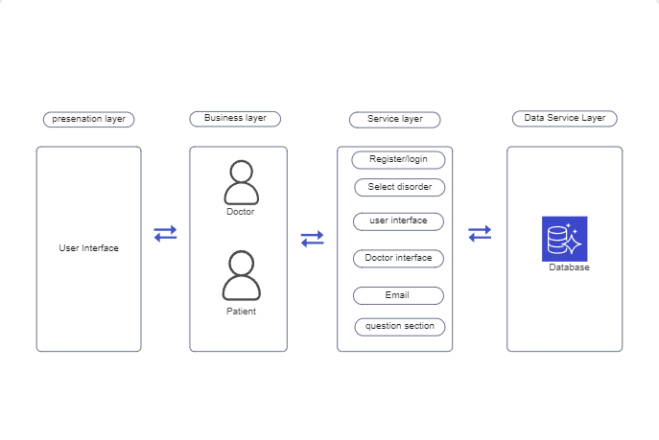

1. **CONCLUSION**

The main purpose of developing this application is to make people provide automatic results of disorders. This will help patients to easily see their reports online and know about their disorder stage. Secondly, doctors would be easier to know what their patients are suffering from disorders and which stage it is. It helps to take necessary action to cure the disorders.

# FUTURE ENHANCEMENT

This application may be expanded in the future to include the ability to anticipate additional illnesses, such as diabetes and lung cancer. In the future, they will be able to predict Bipolar disorder using supervised learning algorithms. Online therapy will eventually be included in this application. In the future, adding AI algorithms will assist to forecast illnesses more precisely and enhance the outcomes. In order for the findings to more reliably predict illnesses in the future, more diseases should be present, and the list of other biomarkers should also be enlarged. Even other chronic diseases like arthritis, cardiopathy, and cancer should be monitored for early detection phases. This is the main hope for screening against cardiopathy and cancer in the near future. Because of the natural environment and people’s eating habits, there are a great number of opportunities for people to be afflicted by a variety of diseases.

**7.Results**

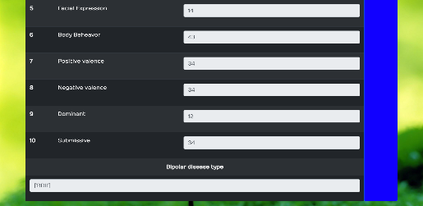

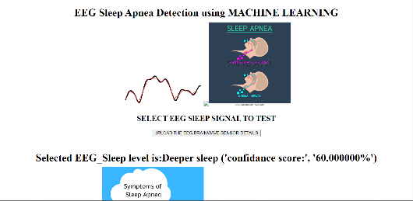

# 8.REFERENCES

1. M. Chen, Y. Hao, K. Hwang, L. Wang, and L. Wang, “Disease prediction by machine earning over big data from healthcare communities,” 2017
2. B. Qian, X. Wang, N. Cao, H. Li, and Y.-G. Jiang,“ A relative similarity based method for interactive patient risk prediction,” 2017.
3. Ajinkya Kunjir, Harshal Sawant, Nuzhat F.Shaikh, “Data Mining and Visualization for prediction of Multiple Diseases in Healthcare,” Oct 2017 pp.23-25

[4] V. Ankitha1 , P. Manimegalai2 , Dr. P. Subha Hency Jose3 , Raji.P4 LITERATURE REVIEW ON SLEEP APNEA ANALYSIS BY MACHINE LEARNING ALGORITHMS USING ECG SIGNALS Published: 2021