**MEASURING THE HEALTH STATUS OF LEAF**

**INTRODUCTION:**

Measuring the health status of leaf using Arduino UNO then storing the data in cloud and verifying the analysis report in Thing Speak server. Using RGB sensor, which senses the leaf colour and compare it with the inbuilt storage of Micro controller and sends the report to the server without the presenting of the server at crop location to measure.

**HARDWARE REQUIRED:**

1. Computer (LAPTOP).
2. Arduino UNO
3. RGB Sensor
4. WiFi Module
5. Connecting Wires
6. Leaf (I/P)

**WORKING PROCEDURE:**

Initially place the sensor over the leaf and get the readings from it later WiFi module will sent the data through cloud the server. Then the status of leaf will be displayed to the server under any instant of time.

**BLOCK DIAGRAM:**

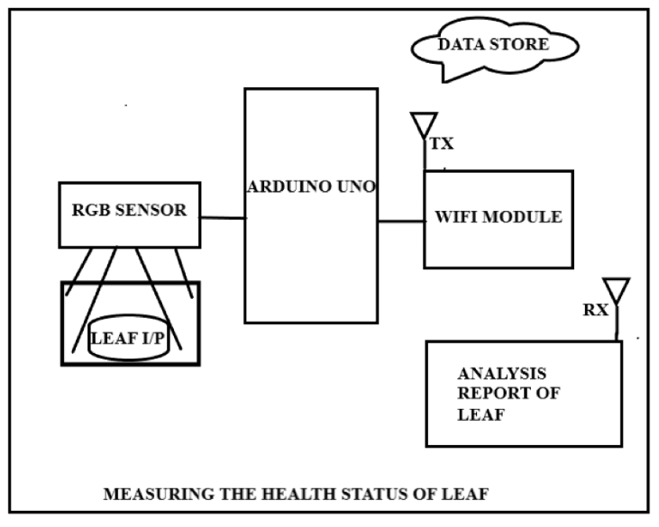

**CONCLUSION:**

This project mainly focuses on the health status of leaf at any instant of time.

**NEED OF PROJECT:**

In this present agricultural sector, many people are unaware of how much levels of potassium, calcium has been reduced in their fields. To know their values time to time before the complete destruction of complete crop. This project will help them to spray which kind of fertilizer to them in which time.

**APPLICATION:**

This project will store the complete data of leaf at each and every day, with that data we can easily recognise the health status of leaf under any circumstances.

**By:**

P. Yeshwanth Reddy ( 170040653 ) Mail Id: [170040653@kluniversity.in](mailto:170040653@kluniversity.in) Mobile 9177179256

P . Jagadish Kumar(170040690 ) Mail Id: [170040690@kluniversity.in](mailto:170040690@kluniversity.in) Mobile : 8187085521

P. Sai Charan Kumar (170040656 ) Mail Id: [170040656@kluniversity.in](mailto:170040656@kluniversity.in) Mobile : 9542342390