**A Dissertation Interim Report on**

**Online Multiplayer Chess Game**

**Name of student: Jagadish Parajuli**

**UN ID: 21422012**

**BSc Computing**

**Supervisor: Nischal Khadka**

**NAMI College**

**University of Northampton**

**Jorpati, Kathmandu, Nepal**

**CSY4010 COMPUTING DISSERTATION INTERIM REPORT**

**Online Multiplayer Chess Game**

**By Jagadish Parajuli Un id**

**Submitted in partial fulfilment of the requirements for the degree of**

**BSC COMPUTING (SOFTWARE ENGINEERING)**

**The University of Northampton**

**2023**

**Index of Contents**

**LIST OF FIGURES**

**LIST OF TABLES**

1. **INTRODUCTRION**
   1. **DISSERTATION BACKGROUND**
      1. **COMPARABLE SYSTEM**
         1. **Chess.com**
         2. **Lichess.org**
      2. **AREA OF IMPROVEMENTS**
   2. **AIMS AND OBJECTIVES**
   3. **DISSERTATION METHODOLOGY**
      1. **SOFTWARE REQUIREMENTS ENGINEERING AND SOLUTION SPECIFICATION**
      2. **SYSTEM ANALYSIS AND DESIGN**
      3. **SYSTEM IMPLEMENTATION**
      4. **DATABASE DEVELOPMENT**
      5. **SYSTEM TESTING**
      6. **SYSTEM EVALUATION**
2. **REQUIREMENTS ENGINEERING**
   1. **ELICITATION ACTIVITIES**
      1. **INTERVIEW PLANS**
      2. **INTERVIEW FINDINGS**
      3. **BACKGROUN RESEARCH**
   2. **REQUIREMENTS SPECIFICATION**
      1. **PROBLEM DOMAIN DESCRIPTION**
      2. **FUNCTIONAL REQUIREMENTS**
      3. **PERFORMANCE REQUIREMENTS**
3. **SYSTEM ANALYSIS AND DESIGN**
   * 1. **USE CASE DIAGRAM**
     2. **ACTIVITY DIAGRAM**
     3. **DATABASE DESIGN**
4. **SYSTEM INRTERFACE DESIGN**
   1. **DRAFT INTERFACE DESIGN**
      1. **WIREFRAMES**
      2. **SYSTEM SCREEN MOCK-UPS**
5. **SYSTEM BUILD AND TECHNICAL NOTES**
6. **TEST STRATEGY**
7. **ON PROGRESS**
8. **REFERENCES**

**APPENDIX 1 – PROJECT TIMESCALES**

1. **Introduction**
   1. **Dissertation Background**

Chess is one of the oldest games of strategy and intellect, played between two players on a square board commanding their alternating pieces. This game has been continued for centuries because of its intellectual challenges and endless possibility.

With evolving technology and the internet, the popularity of chess has tremendously increased over the past years. In the present days, two leading chess platforms, chess.com and lichess.org, have revolutionized the way chess used to be played by engaging the players beyond boundaries.

* + 1. **Areas for Improvements**

Fair match making is only possible with a fair rating system in every chess platform. But most of the chess platforms have the limitation of assigning true ratings after large sequences of matches.

Yamada, Kishi, Oguchi, Nakano (2023) developed a decision tree for estimation the rating of online player. They used the first few moves in determining their skill set where they used 100000 chess game for training the decision tree which was able to predict players skill with 80% accuracy. This study is considered highly applicable as implementation of such decision tree can create fairer match making, resulting in better gaming experience.

In current days, there is huge availability of traditional chess engines which works with algorithm like min max depth search, alpha beta pruning and Monte Carlo Tree Search (MCTS). Along with such algorithm use of machine learning is also applicable, alpha zero a chess engine developed upon principle of deep learning have changed thoughts on how chess should be played.

J. Madake, C. Deotale, G. Charde, S. Bhatlawande (2023) showed some chess algorithm developments. They explained how the algorithm min max goes up to certain depth in the recursive tree of valid moves and evaluates the position. Turn of player (maximizing or minimizing), the value of evaluation is returned.

While min max algorithm calculates nodes for all the children, alpha beta pruning is used for optimizing the search tree. If any nodes have only one possibility it stops evaluating a move considering that further moves will be worse than the previous move. So, it prunes away the branches which possible may not affect final evaluation.

The open availability of these engines has created a problem of cheating in online matches. Well established platforms used to have a strong cheating detection system but only persons cheating on with traditional approaches like using stockfish are detected. A machine learning algorithm convolutional neural network (CNN) and densely connected neural networks can be implemented for training the unanalyzed and analyzed data for detecting the player is cheating or playing on their own skills.

* 1. **Aims and Objectives**

The aim of this project is to deliver an online platform for chess players providing popular functionality for improving gaming experience and skills development environment. The features are listed below:

* Managed portfolio
* Multiplayer function with chat system
* Rating System and leaderboards
* Tournaments and friendly challenges
* Analysis tool
* Puzzles

Objectives:

* To maintain player’s portfolio using front end technology including HTML5, CSS3 and JS for UI, MySQL as database system and Laravel framework for backend management.
* To implement online matchmaking and chat system using WebSocket technology for Realtime connection.
* To implement a rating system for players showing their skills and ensure fair opponent in matches.
* To develop a game analysis tool using stockfish API for analyzing matches and improve their skills.
* To provide a tournament system for encouraging players to compete for excellence in all different modes of games.

Completion of these objectives delivers an online multiplayer chess platform for players for engaging in chess community with most appreciated features.

* 1. **Dissertation Methodology**

This part of the report is focused on the software life cycle, explaining all the techniques implemented for delivering the final product. Agile methodology is used for developing this project following its cycle of planning, design, development, testing and deployment.

Advantages:

* More flexible than traditional methodology as it requires feedback from customers after every sprint development.
* Reduces risk of complete failure of project as this methodology releases software in various parts giving developer early notice regarding problems in quickly resolvable quantity.
* Constant customer interaction helps to increase satisfaction as the customer is involved in development by giving feedback from time to time.

Disadvantages:

* Compared to typical methodology, agile requires less documentation resulting in difficulties to track project progress and maintenance.
* The methodology is only suitable for projects having changing requirements in a short timeline.
  + 1. **Software Requirements Engineering and Solution Specification**

The techniques used for software requirements engineering are client interview and background research.

* + 1. **System Analysis and Design**

Activity diagram, use case diagram, sequence diagram, algorithm workflow, wireframes and mockups system workflow are the techniques for system analysis and design.

* + 1. **System Implementation**

The system implementation requires user interface design, Realtime communication between players during matches and backend programming. Languages chosen to handle them are listed below:

* User Interface design: HTML5, CSS3 and JS
* Realtime Communication: WebSocket in Laravel framework
* Backend programming: PHP using Laravel framework.
  + 1. **Database Development**

An open-source database, MySQL, is used for storing the data in this project. It is reliable and cheap, supported by various programming languages. Use of relational database management system provides a strong data integrity for storing data in structured manner.

* + 1. **System Testing**

White box testing and black box testing are used for system testing. The advantages and disadvantages of using these techniques are listed below.

|  |  |  |
| --- | --- | --- |
| Techniques | Advantages | Disadvantages |
| White Box Testing | * It has a high coverage of testing as this method examines internal code and logic. * As it checks internal code, the errors are detected early. * Helps to analysis the performance. | * The tester requires knowledge of the system. * This technique can be more time consuming. * User perspectives are not properly focused. |
| Black Box Testing | * Testing is performed on real world scenarios. * No need to understand the internal flow of software. * User experience is in great focus. | * In many cases, this technique is unable to find complex defects. * Tester may not find proper solutions for issues or failures. |

* + 1. **System Evaluation**

The usability of the system by the chess players will be showing the system evaluation. This technique of evaluation is known as usability evaluation.

1. **Requirements Engineering**

This section has documentation of client interviews, and research of comparable systems to reduce the gap between product and expected features.

* 1. **Elicitation Activities**

Interview findings were conducted to understand if customers or players had some more issues in the current chess platform which they would suggest for system improvements.

Mr. Nished Karki was interviewed, an intermediate chess player with a rating of 1600, on chess.com and has also been using many other chess platforms for skill development.

* + 1. **Interview Plans**

Client: Mr. Nished Karki

Interview Date: Friday 22nd June 2023

Time: 01:00 to 03:00 PM

Location: Baneshwor, Kathmandu

|  |  |  |
| --- | --- | --- |
| Objective | Interview Question | Interview Answer |
| Motivation | How long have you been playing chess? For what specific reason you are continuing to play? | Playing chess is my hobby from childhood and with the exposer of internet and technology, playing chess online is main source of entertainment |
| Which platform are you engaged with for playing chess? Is there any specific reason for choosing this platform? | Currently, chess.com is the platform which I have been playing chess online. No not for any specific reason but the vast user base of this platform offers variety of matches which overall satisfies my playing strategies. |
| Is this platform enough for you? | This platform is just enough for playing multiplayer online modes which is very limited, but I would expect some more varieties in same platform as a free to play player. |
| Platform | Can you explain in detail about the most appreciated features of current platforms? | As a free to play player I mostly engage myself with online multiplayer mode, puzzles, game analysis and some community updates. |
|  | Do you have any kind of dissatisfaction with current platforms? | As I said before, chess.com is the platform where I used to enjoy chess. But the main problem with this platform is that it is a profit-oriented platform so advertisement and limitation for free players are often disturbing. Along with that limitation of puzzles and game analysis also becomes barrier for skill development. |
| System Limitations | Have you ever experienced any kind of errors or some serious issues? | My main dissatisfaction with the existing system is with the game engine, rating system and cheating detection.   * Traditional chess engines are unable to give proper analyses in some critical positions. * Often good players should play large number of games to reach the ratings they deserve. * Still the platform is just able to detect very traditional cheating patterns. |

* + 1. **Interview Findings**

The interview session shows that Mr. Nishedh Karki is a competitive chess player who expects chess platform more than just day-to-day multiplayer matches. Interview shows that he has huge experience of using chess.com as a free to play player. The business policy of such a platform often disturbs players and limits their possibility of growth. This project can greatly benefit such players.

Expected features of players found according to this interview is listed below:

* Variety of multiplayer modes
* Unlimited puzzles
* Strong game analysis tool
* Interactive chess community
* Proper initial rating of players
* Proper cheating detections

The interview shows that players will be more interested in engaging themselves in new platforms with some improvement in critical features.

* + 1. **Comparable System Analysis**

Exploring the offerings provided by well-established platforms, some appreciated features by chess enthusiasts are listed below.

**Table 1.1. – 1 Popular Features of chess.com and lichess.org**

|  |  |  |  |
| --- | --- | --- | --- |
| Features | Chess.com | Lichess.org | Player Feedback |
| Attractive UI/UX | Available | Available | Lichess.org has better board interface |
| Variety Gaming Modes | Available | Available |  |
| Online Multiplayer Gameplay | Available | Available |  |
| Fair Skill Level Match Making | Available | Available | Rated based on large number of past games on both sites |
| Tournaments | Available | Available |  |
| Training and Puzzles | Available | Available | Very Limited in both websites |
| Analysis Tool and Game Review | Available | Available |  |
| Active Community | Available | Available | Chess.com has more active community |
| Mobile Friendly | Available | Available |  |
| Learning Resources | Available | Available | Very Limited in both sites |
| Portfolio Management | Available | Available |  |
| Cheating Detection | Available | Available |  |

* + - 1. **Chess.com**

Chess.com is well established chess website started in 2005 when two friends – Jay and Erik decided the world needed a better chess website. This website hosts more than ten million chess games every day and employs more than four hundred individuals as programmers, content editors and member support.

Strengths:

* Huge number active players and community.
* Well guided learning resources.
* Frequent availability of tournaments and events.
* Offers many game variations and time controls.

Weaknesses:

* Advanced features like unlimited game analysis and unlimited puzzles are only available for paid membership.
* Interface complexity and unmanaged player portfolios.
  + - 1. **Lichess.org**

Lichess.org is an open-source chess server developed by donations and volunteers. Thibault Duplessis, founder of Lichess.org started as a hobby project making this site an open source for anyone to read the source code or make any contributions. Today, more than five million games are played every day in Lichess remaining 100% free.

Strengths:

* Open-source platform with no memberships or advertisements.
* Availability of strong analytical tools for unlimited game analysis and skill enhancements.
* Provides an attractive UI chess board with minimalist design.

Weaknesses:

* Less number of active players compared to other platforms.
* Very limited resources and tutorials.
  1. **Requirement Specification** 
     1. **Problem Domain Description**

After conducting interview and a study of comparable systems following problem domains are identified:

* **Attention Span:**

Key Challenges for developers are to hold the players with an attractive interface and variety of gaming modes. The problem can be solved by comparing the User Interface, appreciated by large number of people, and creating similar interface by adding more features.

* **Fair Play:**

One of the main problems in current platforms is errors in cheat detection. Traditional chess engines like stockfish and some other machine learning algorithms have flooded internet and players use them in wining against their opponent. These violets fair play of the game. Along with that, unfair matches between low rated players and high rated players can also create mismatching of games.

* **Multiplayer Experience:**

Often players get irritated by playing with their opponent online if the player plays with low speed and lagging internet. For such problems no solution can be provided. But in some cases, due to huge traffic in system game crashes which should be well handled.

* **Varieties of Game modes:**

Chess should have enough varieties for players as they should choose the mode of game they want for their entertainment or skill enhancements. The various modes may depend upon game associated time or puzzles.

* **Performance:**

Two issues should be mainly focused on performance management, weak devices, and badly created algorithms. The user should be well alert regarding the system and developers should optimize their algorithms.

* + 1. **Functional Requirements**
* **Portfolio Management:**

Players should be able to create new accounts with a proper login, logout system. After successfully logging inside the system. The player should be able to see all records of games and his information available in the system.

* **Online Multiplayer gameplay:**

Players should have features to play online variety of opponents matching their skill level. The multiplayer features should be well optimized so that any games should not be lagged in Realtime connection.

* **Chat System:**

This system is mainly targeted for players playing online at a specific time. The chat messages will not be stored in databases for further use. Player can chat with opponents in Realtime matches.

* Rating System:

Most important aspect of the system is rating system. The system should have fair rating system for effective match making and leaderboard view.

* **Tournaments:**

Players should have proper chances for enrolling in tournaments choosing the categories. The players should also have features for proposing tournaments and if accepted by admin they should be able to see other players competing in their tournament.

* **Leaderboards:**

Based on the rating system leaderboard should be visible in leaderboard section.

* **Game Analysis:**

A powerful tool for game analysis should be available for players for analyzing their matches. The analysis tool should also show the comparative moves for players according to their skill level.

* **Puzzles:**

The puzzles should be unlimited for players looking for skill enhancements. Often the player looks for puzzles for critical thinking and quick recognition of patterns in the game.

* + 1. **Performance Requirements**
* **Scalable:**

The system should be designed to handle huge growth in future. It should have the capacity to provide many matchmakings at a single time without any disruption.

* **Server Performance:**

Server should be able to hold large set of data of players information and games. The computation load of the server should not affect the gaming experience of the player.

* **Responsiveness:**

The device view of the platform has a significant role in the growth of the system. The platform should be responsive in all the device variations.

* **Cheat Detections:**

Effective algorithms should be developed for cheating detection as players playing fairly des not stand a chance against powerful chess engines which ultimately affects the growth of platform.

1. **System Analysis and Design**
   1. **Activity Diagram**

Activity diagram of chess working mechanism is shown in the figure below. In the figure GameController class is the main class which overall controls all the gaming functions.

Figure 3.1. – 1 Chess Working Mechanism Activity Diagram

* 1. **Use case Diagram**

Use case diagram is shown below for system access for admin users and players.

Figure 3.2. – 1 Admin and User Access diagram

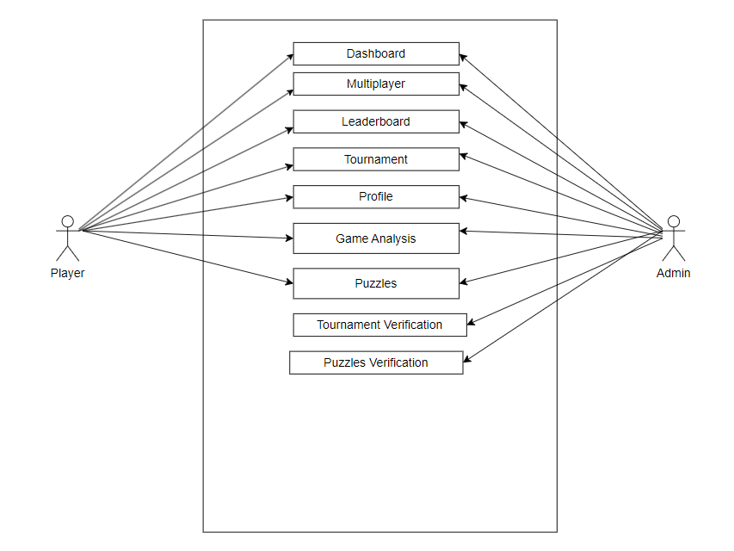

* 1. **Database Design**

In the current system available information related to players, matches, friends, and moves is mainly highlighted. The ERR diagram of the current system is shown below.

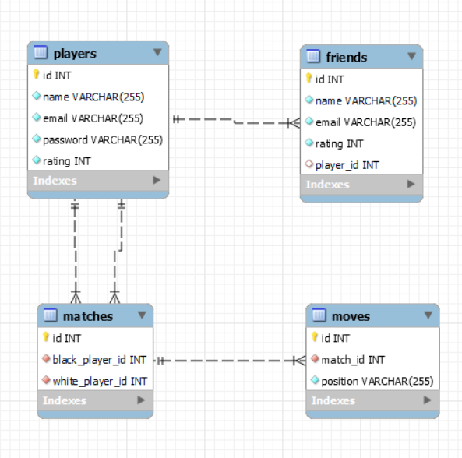

1. **System Interface Design**
   1. **Wireframes**

After analysis of system requirements, the following wireframes were created.

Figure: 4.1. – 1 Dashboard wireframe

Figure: 4.1. – 2 Multiplayer mode

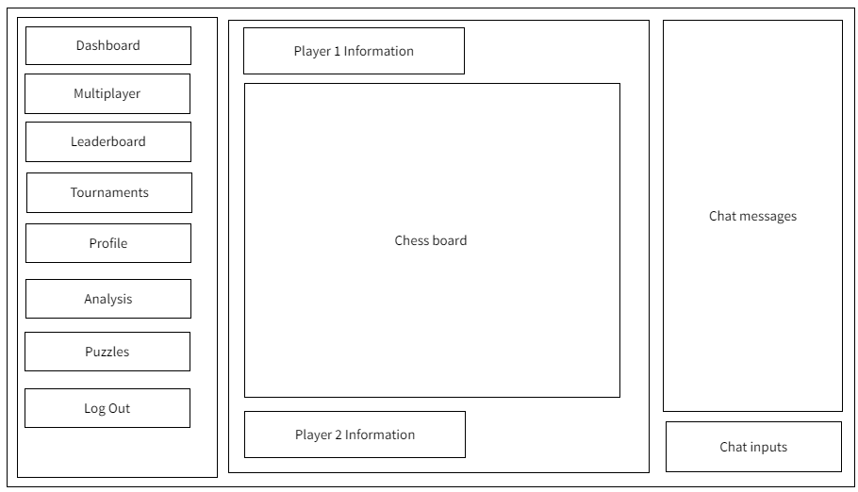

Figure 4.1. – 3 Leaderboard Wireframe

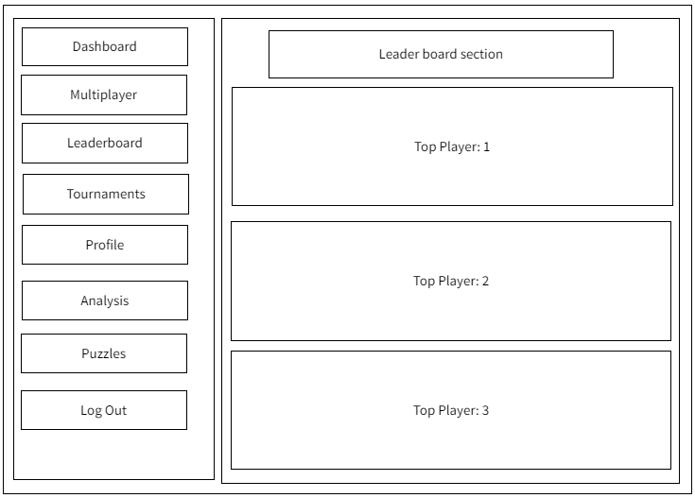

Figure 4.1. – 4 Tournament Mockups

Figure 4.2. – 5 Analysis Board Wireframe

Figure 4.2. – 5 Puzzle Board Interface

* 1. **System Screen Mock-ups**

Mock-ups are taken from chess platforms which will be implemented in the final project.

Figure 4.2. – 1 Dashboard mockups

Figure 4.2. – 2 Multiplayer mode mockups

Figure 4.2 – 3 Leaderboard Mockup

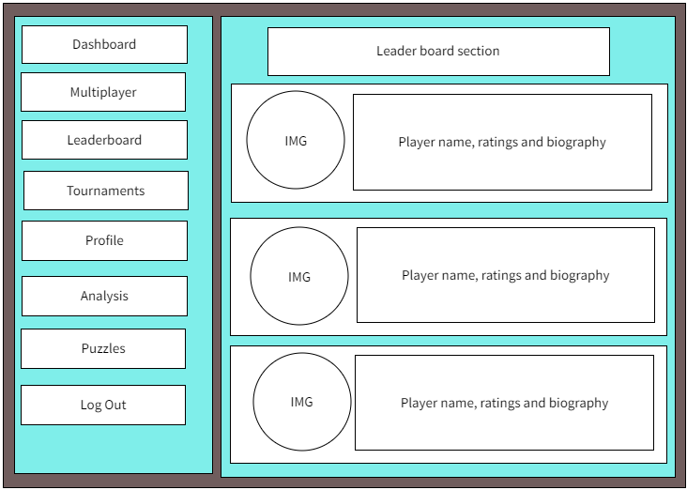

Figure 4.2 – 4 Tournament Mockups

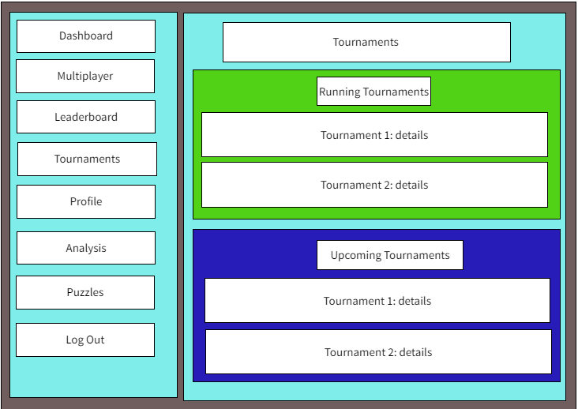

Figure 4.2. – 5 Analysis Board Mockups

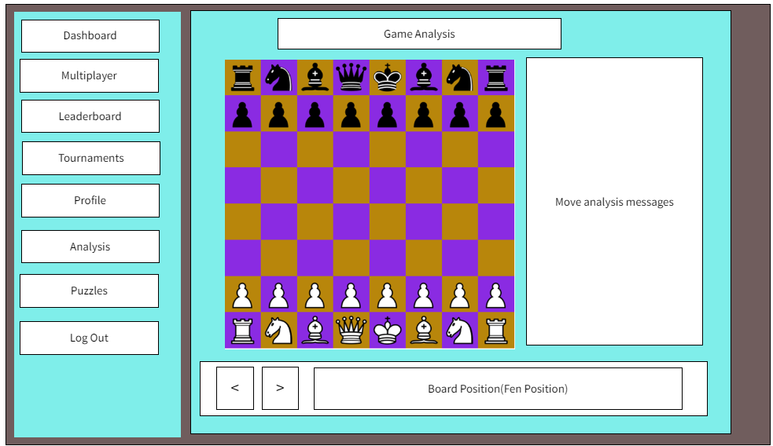

Figure 4.3. – 6 Puzzle Interface Mockups

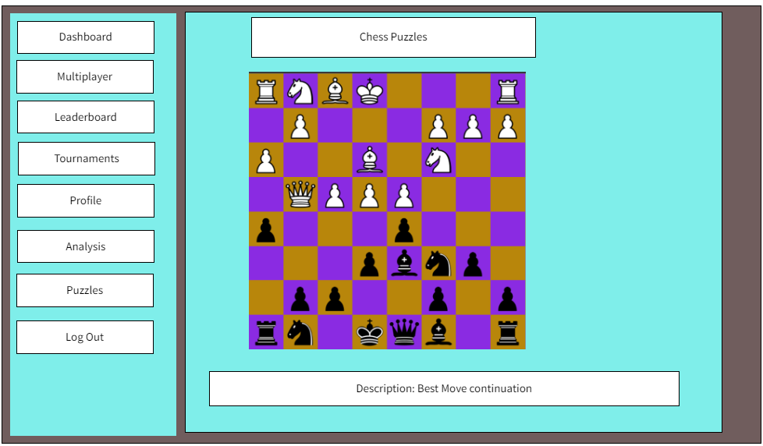

1. **System Build and Technical Notes**

Building this project, player information database should be a priority. In figure 5.1 – 1 code for connecting to MySQL database is shown in Laravel framework.

Figure 5.1 – 1

Now the software is connected to MySQL database and CRUD operations in user information can be performed for security concerns along with storing the moves played by players in online matches.

* 1. **Chess Board Representation**

A class EmptyChessBoard is created for creating board which is a div html elements which is firstly empty. Most important User Interface in chess platform should be of board representation. After the creation of 8x8 square chess board, it is passed to next class BoardWithPieces which places the chess pieces according to the FEN position which describes pieces position in each rank.

Figure 5.1. – 1.1

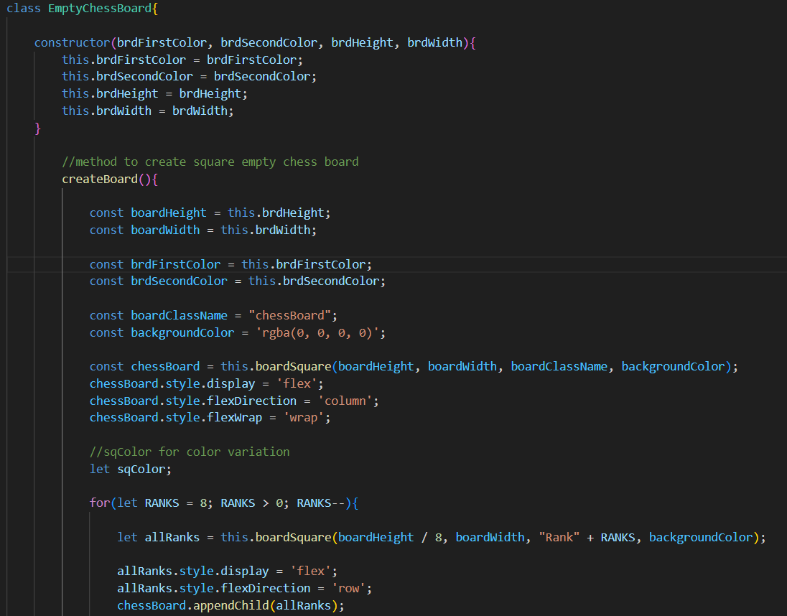

Figure 5.1. – 1.2

Figure 5.1. – 2.1

Figure 5.1. – 2.2

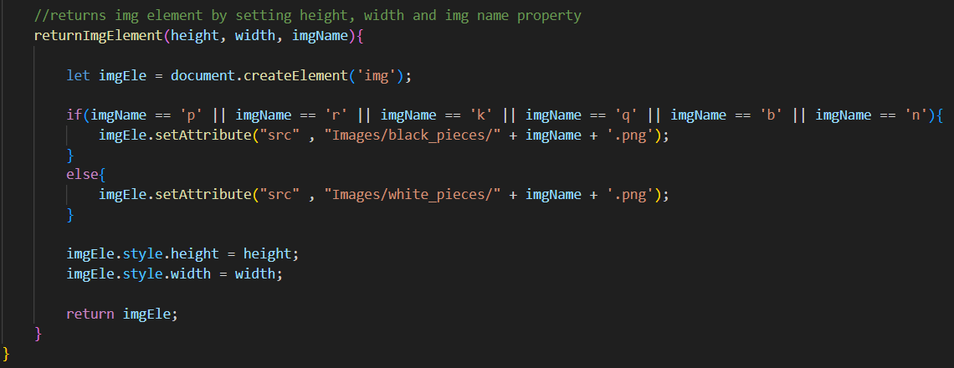

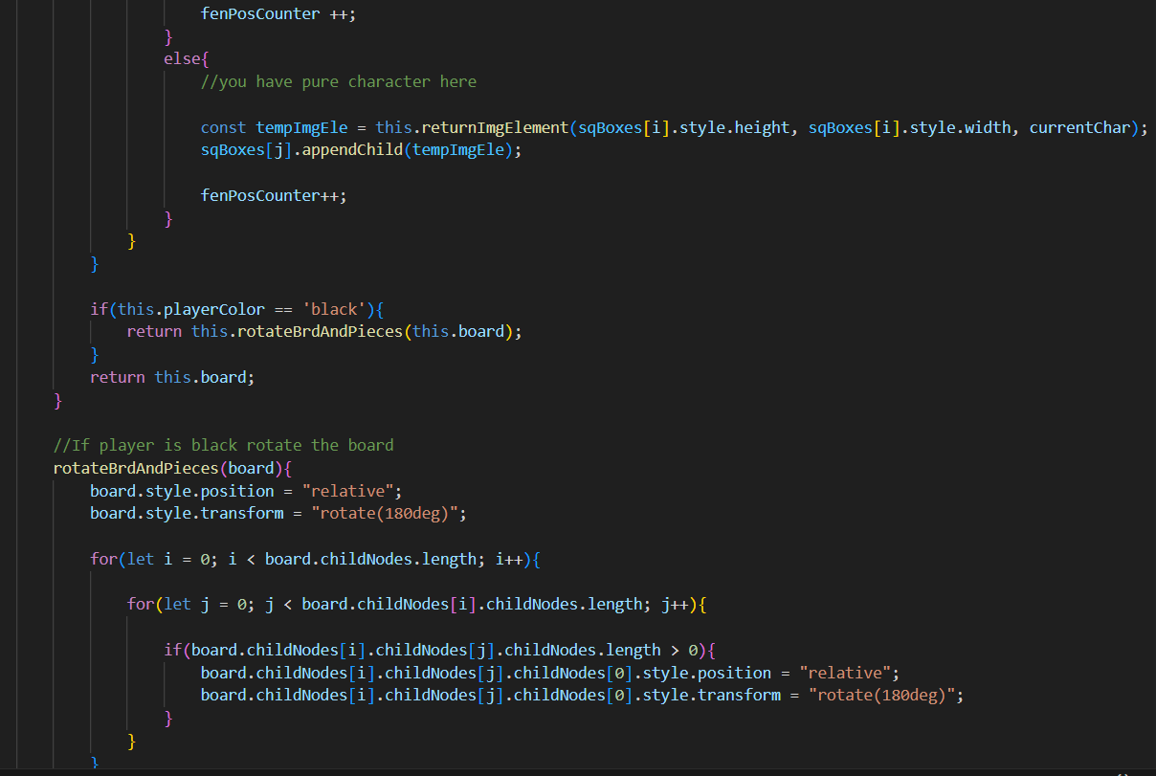

The final representation on browser is shown in Figure 5.1. – 3

Figure 5.1. - 3

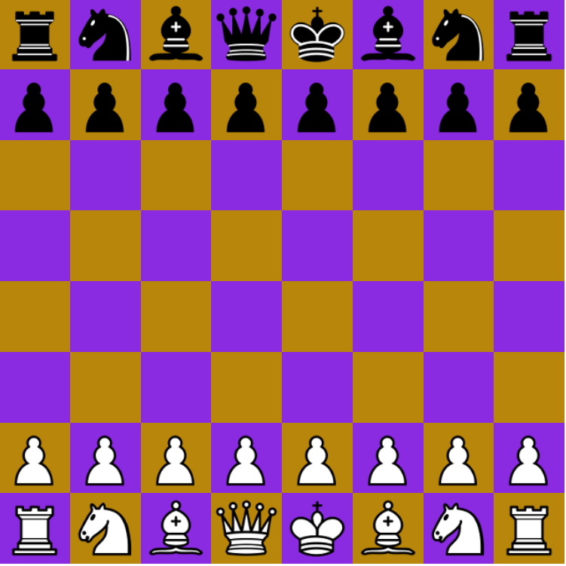

* 1. **Piece movements**
* **Pawn movement:**

Moves single square and two square for first time. Captures diagonally. The algorithm screenshot is shown below with final display.

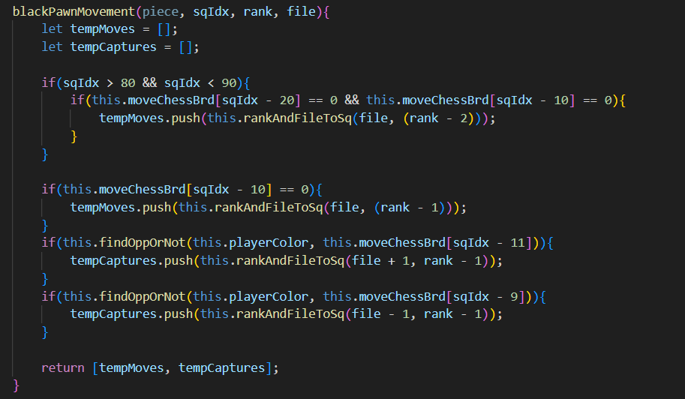

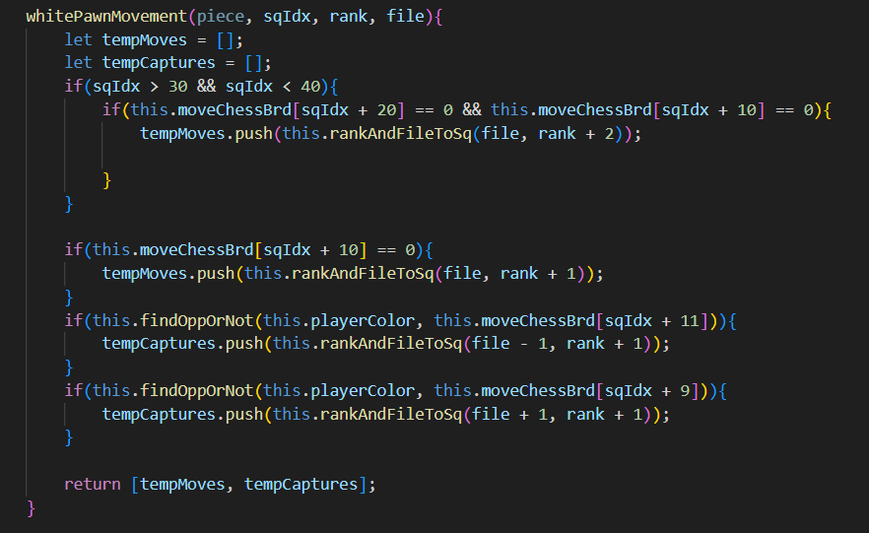

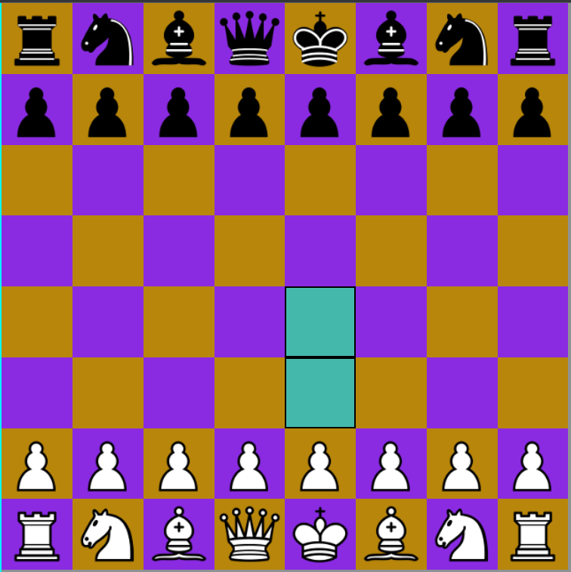 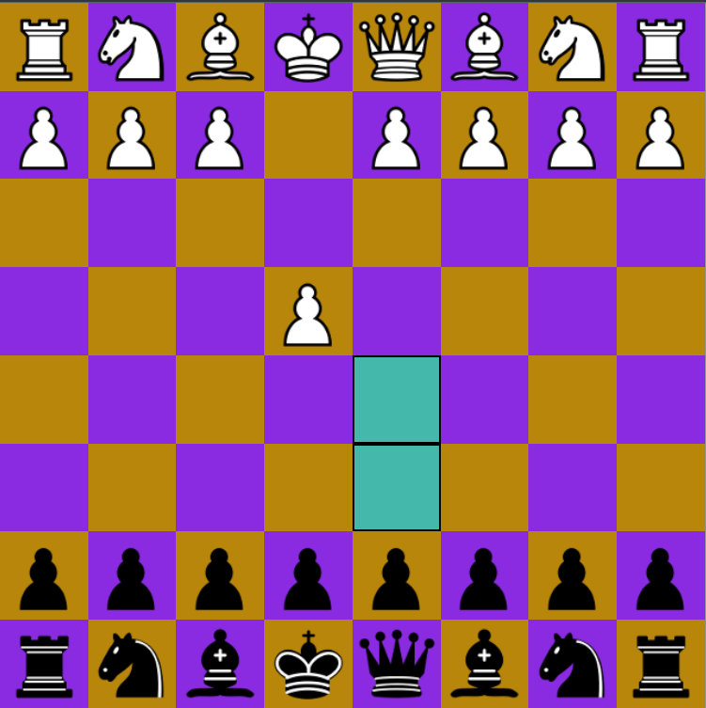

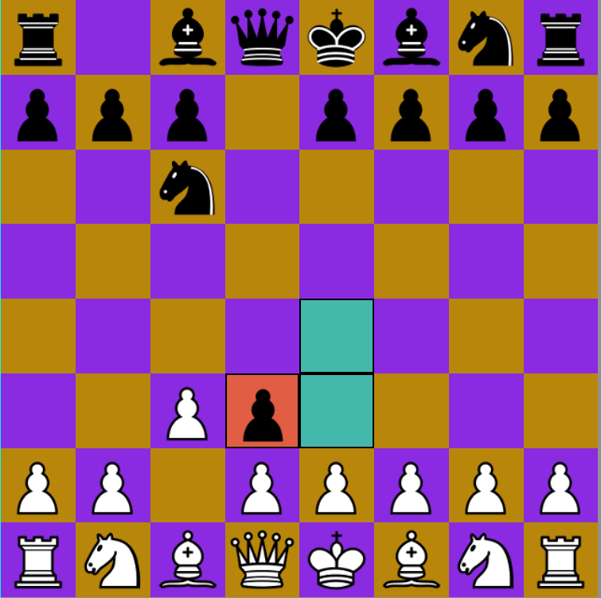 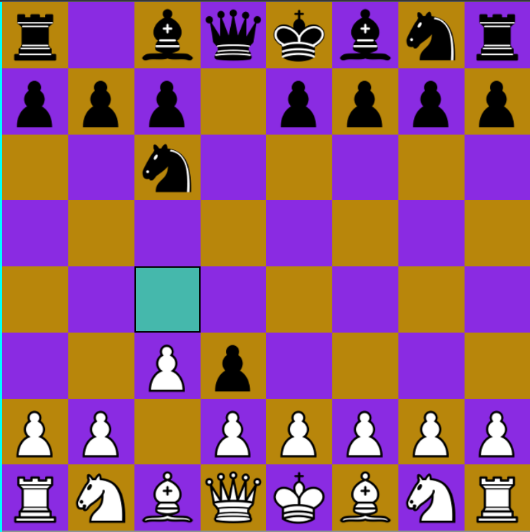

* Night movement:

Night moves in L-shape in all eight directions wherever the legal moves are available.

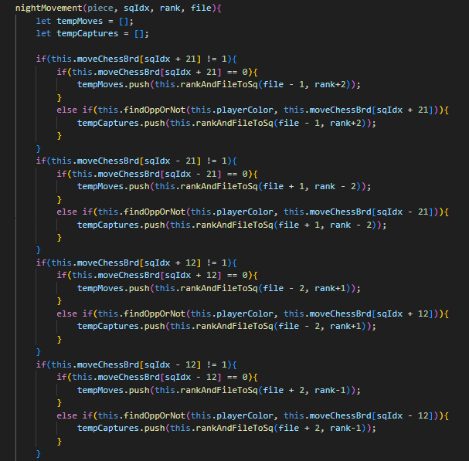

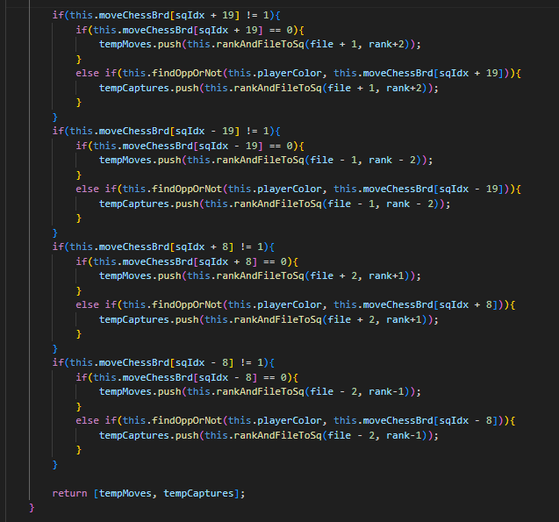

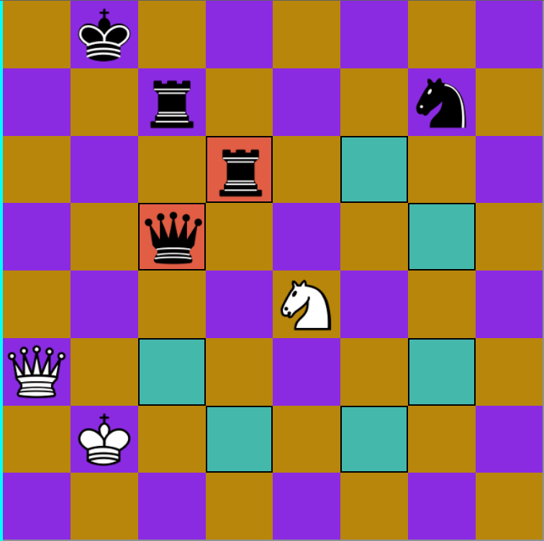

* King movement:

King moves in single square in all the direction in available square. The screenshot of king moving in all direction is shown below.

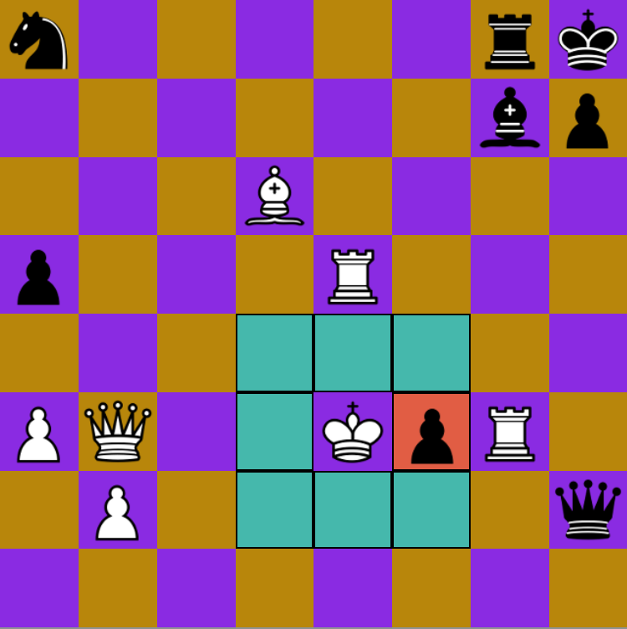

* Queen, rook, bishop movement:

The movement for queen, rook and bishop are very similar to each other. The screenshot of piece movement in chess board is shown below.

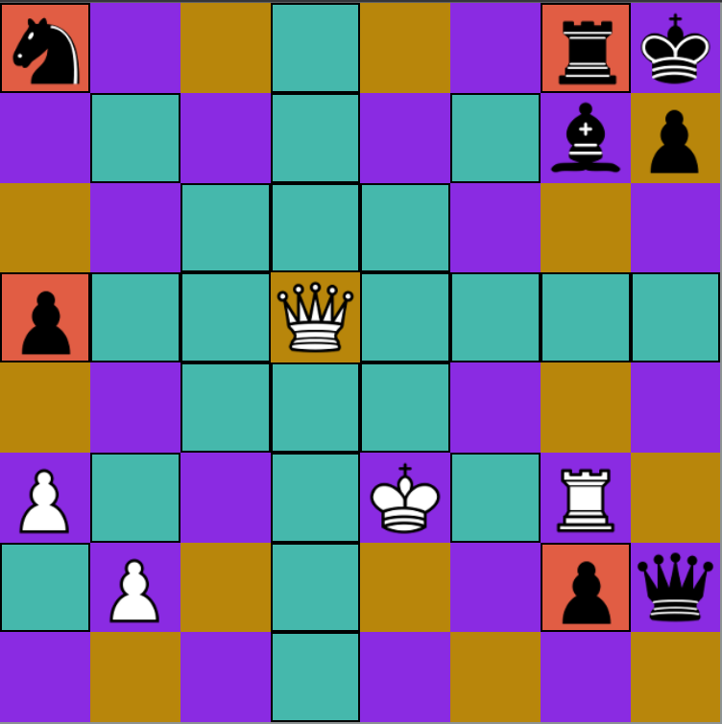 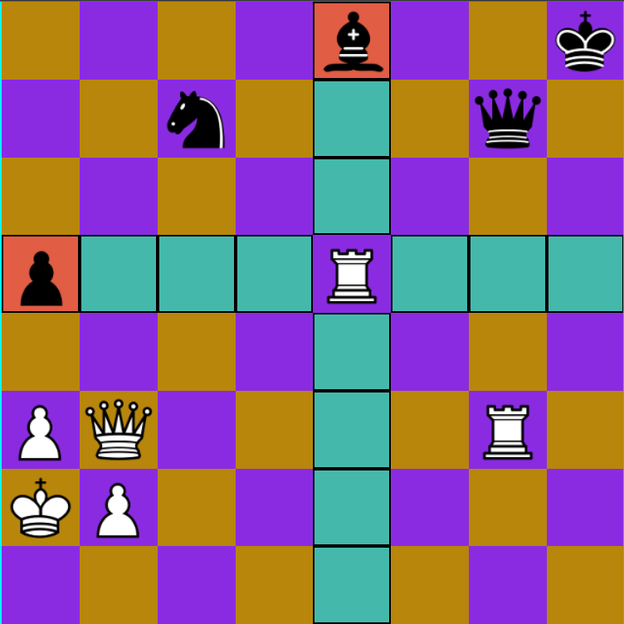

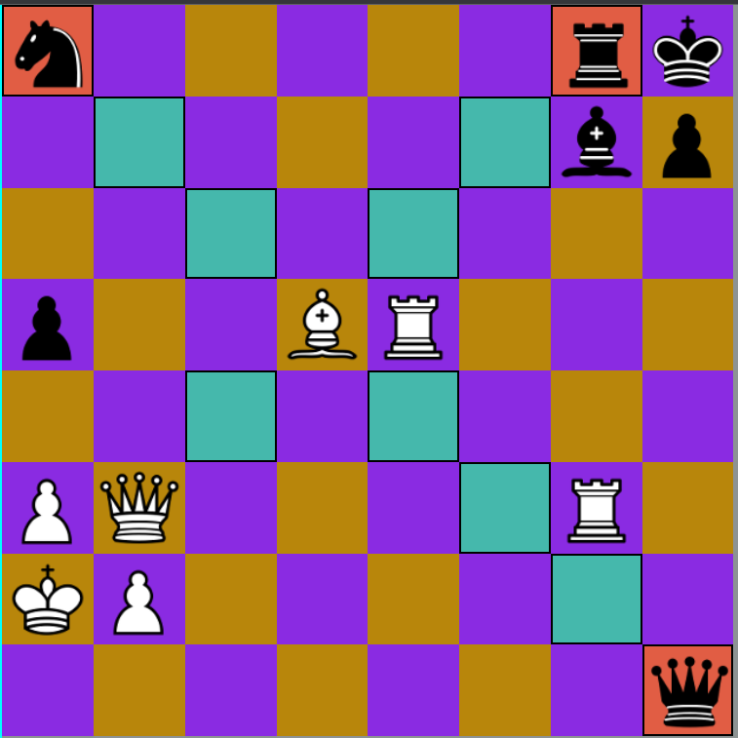

1. **Test Strategy**

To find all working function of system test case are developed. The current system only contains working mechanism for chess principles. The test cases provided in this section of report is designed for overall system testing.

|  |  |  |
| --- | --- | --- |
| S. N | Test Cases Description | Expected Results |
|  | New players should be able to successfully register the system. | With the fulfillment of all the required information, new players are successfully able to register in system. |
|  | Users should be able to successfully login into the system with correct credentials and unregistered users or users with incorrect credentials should be restricted | Users can successfully login into the system with proper credentials and users with incorrect credentials or unregistered users can see the error message. |
|  | Online multiplayer gaming with other players. | Player can choose the gaming mode they want to play and start the match, a player with similar rating is offered as opponent. |
|  | Moves validation in chess games | Player can only move their own pieces; each move can only move in legal squares defined by rules. |
|  | Attempt to make invalid moves | If player makes any attempt for making invalid moves, then error message is shown in game status message area. |
|  | Send and receive messages in Realtime matches | Message is shown in the text area in Realtime as player sends them. |
|  | Game Analysis function | Players can choose any games they have played before or play moves with the available engine and engine guides the player for analyzing the good, best, excellent, or extra ordinary moves. |
|  | Tournament enrollment of players | Players can view all the currently running tournaments and upcoming tournaments in the tournament section. Based on the player’s interest they can enroll in current or any upcoming tournaments. |
|  | Create new tournaments | Players can create new tournaments by submitting new tournament offers from tournament section and after admin approval players can enjoy the tournament they have proposed. |
|  | Leaderboard view | In leaderboard section of the system, players can view the top players with their ratings. |
|  | Logout from the system | By clicking in the logout button in the navigation menu player can logout. |

1. **On Progress**

Development of online multiplayer chess game system is being continued with focus on programming chess principles and Realtime communication between two players. The development process has achieved successful registration and login system, along with that player can play chess with all the chess rules integrated in the system.

Overall, the study and analysis of the system requirements have also shown some additional requirements for better user experience and security concerns. To address such requirements active research and development is taking place with constant effort.

1. **References**

**Appendix 1 – Project Timescales**

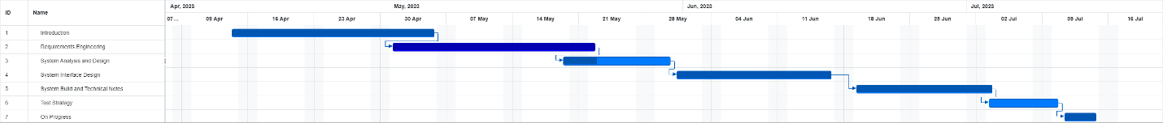

**Appendix 2 – Project Diary/Log**



