LINKIFIC INTERNSHIP
DAY 13 PROJECT DOCUMENTATION
Natural Language Processing: Text Preprocessing and TF-IDF
Internship Domain: Artificial Intelligence and Machine Learning
Prepared by: Jagadish Pothuraju
Roll Number: 23WU0102153

1. Introduction
Natural Language Processing (NLP) is a field of artificial intelligence that enables computers to process, analyze, and represent human language. Raw text often contains inconsistent capitalization, punctuation, and common words. Preprocessing prepares text for analysis, while TF-IDF converts text into numerical features that machine-learning algorithms can use.

2. Objectives
- Understand basic NLP concepts.
- Convert text to lowercase.
- Tokenize sentences into words.
- Remove selected stopwords.
- Apply TF-IDF vectorization to a small text dataset.
- Inspect and save preprocessing and TF-IDF outputs.
- Prepare the project for GitHub submission.

3. Tools and Technologies
Python, Pandas, Scikit-learn, Jupyter Notebook or Google Colab, and Matplotlib.

4. Dataset Description
The notebook uses a small, manually created practice dataset of 16 short product and service comments labelled positive, negative, or neutral. The labels are included for learning and inspection; this task does not train or validate a production sentiment classifier.

5. Text Preprocessing Techniques

5.1 Lowercasing
Lowercasing converts all alphabetic characters to lowercase. It helps reduce duplicate vocabulary entries caused only by capitalization, such as “Great” and “great”.

5.2 Tokenization
Tokenization divides text into smaller units called tokens. In this notebook, punctuation is replaced with spaces and the sentence is split on whitespace. More advanced tasks may use language-aware tokenizers.

5.3 Stopword Removal
Stopwords are frequent words such as “the”, “is”, and “and”. Removing them can reduce the number of features in some tasks. However, stopword removal is task-dependent: words such as “not” can change meaning, so preprocessing should be selected carefully.

6. TF-IDF Vectorization
TF-IDF stands for Term Frequency–Inverse Document Frequency. It represents each document as a numeric vector. Term frequency reflects how often a word occurs in a document, while inverse document frequency reduces the weight of terms that appear in many documents. The resulting matrix can be used as input to algorithms such as Logistic Regression or Naive Bayes.
The sample dataset produced a TF-IDF matrix with 16 documents and 48 vocabulary features when run with Scikit-learn TfidfVectorizer using English stopword removal.

7. Implementation Workflow
- Create and inspect the text dataset.
- Convert text to lowercase.
- Remove punctuation and tokenize text.
- Remove stopwords from the token list.
- Fit TfidfVectorizer and transform text into numeric features.
- Inspect important TF-IDF terms.
- Save the preprocessed dataset and TF-IDF matrix as CSV files.

8. Results and Output Files
The project contains a preprocessed dataset CSV, a TF-IDF matrix CSV, and a plot showing the terms with the highest average TF-IDF values in this sample. TF-IDF values are relative feature weights and do not, by themselves, predict sentiment.
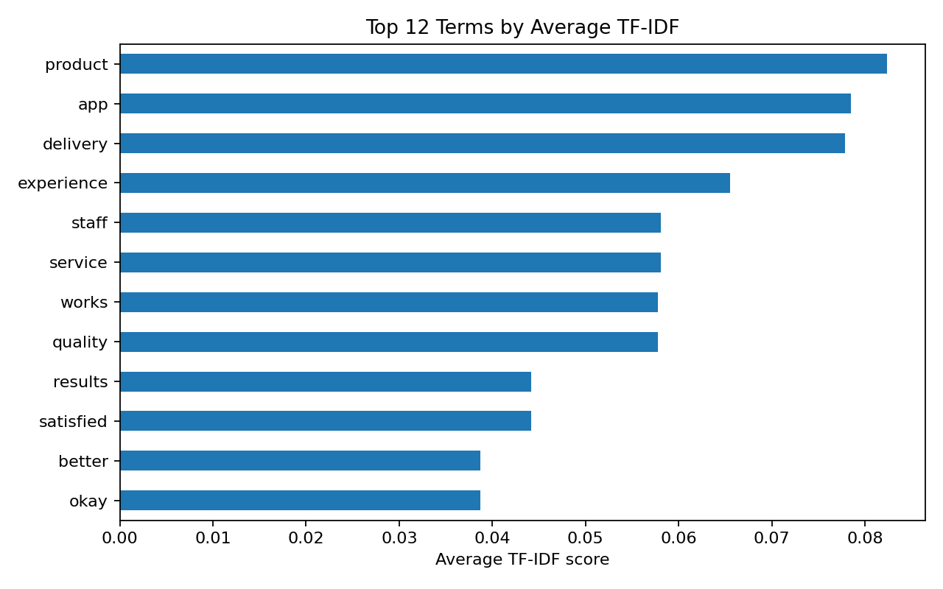
Figure 1. Top terms by average TF-IDF score in the practice dataset.

9. Key Learnings
- Learned how raw text can be standardized before analysis.
- Understood how tokenization creates word-level units.
- Learned that stopword removal is a task-dependent choice.
- Understood how TF-IDF turns text into numeric features.
- Learned to inspect and export transformed text data.

10. Challenges and Limitations
The dataset is small and manually created, so it is useful for demonstrating the workflow but not for drawing reliable conclusions about real-world sentiment. The simple tokenizer does not handle all language-specific cases. TF-IDF does not understand word order or meaning the way modern contextual language models do.

11. Conclusion
This task introduced a basic NLP pipeline: lowercasing, tokenization, stopword removal, and TF-IDF vectorization. The output shows how text can be transformed into numerical features for later machine-learning tasks. A future extension could train a sentiment classifier and evaluate it on a separate test set.

12. GitHub Submission
After reviewing the notebook and outputs, run the following commands from the project folder:
git add .
git commit -m "Day 13: NLP preprocessing and TF-IDF practice"
git push origin main

13. References
NLTK documentation: https://www.nltk.org/
Scikit-learn TfidfVectorizer documentation: https://scikit-learn.org/stable/modules/generated/sklearn.feature_extraction.text.TfidfVectorizer.html
Scikit-learn text feature extraction guide: https://scikit-learn.org/stable/modules/feature_extraction.html#text-feature-extraction

