1. Write a program to create an arraylist of double elements and add the elements, sort the elements in descending order and print it.

Solution

*package sba1;*

*import java.util.ArrayList;*

*import java.util.Collections;*

*import java.util.List;*

*public class Q1 {*

*public static void main(String[] args) {*

*List<Double> list2 = new ArrayList<Double>();*

*list2.add(35.55);*

*list2.add(21.55);*

*list2.add(53.55);*

*list2.add(43.55);*

*Collections.sort(list2, Collections.reverseOrder());*

*System.out.println("Array elements in descending order");*

*for (Double number : list2)*

*System.out.println(number);*

*}*

*}*

Output

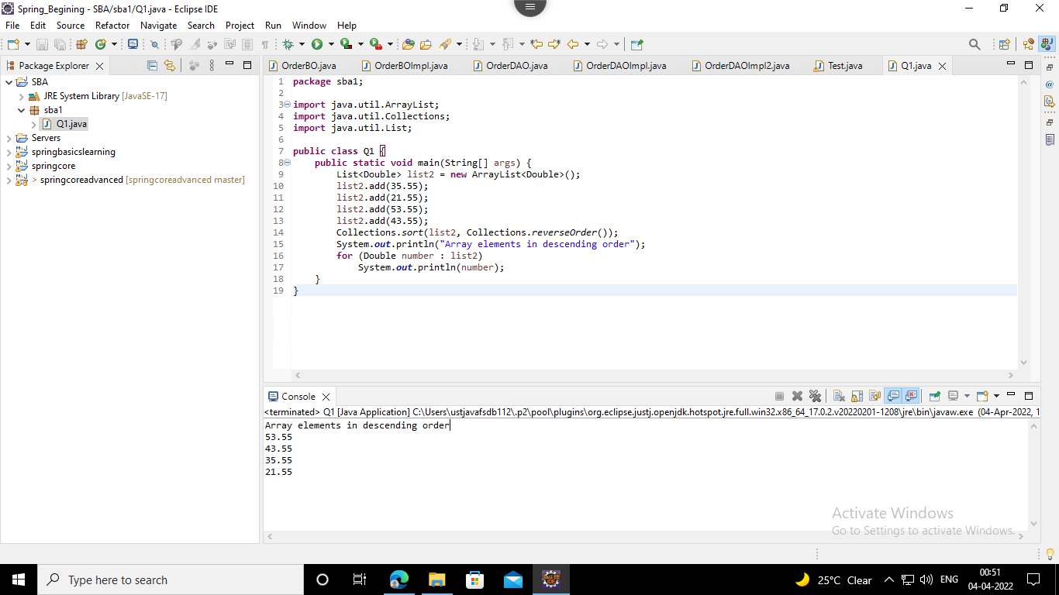

2. Create an arraylist of integers and find the sum and average of the entire list.

Solution

*package sba1;*

*import java.util.ArrayList;*

*import java.util.List;*

*public class Q2 {*

*public static void main(String[] args) {*

*List<Integer> list = new ArrayList<Integer>();*

*list.add(31);*

*list.add(11);*

*list.add(52);*

*list.add(25);*

*int sum = 0;*

*for (int i : list)*

*sum = sum + i;*

*System.out.println("Sum = " + sum);*

*int avg = sum / list.size();*

*System.out.println("Average = " + avg);*

*}*

*}*

Output

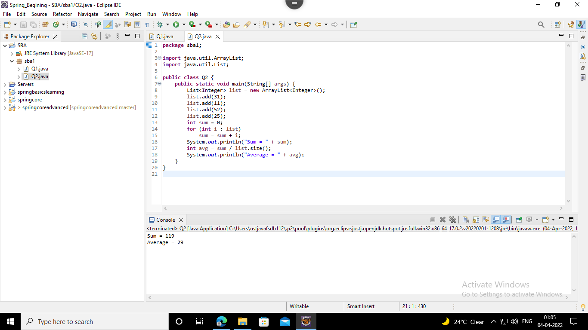

3. Create two arraylist of strings to take First_name and Last_name of the students, and print their whole name.

Solution

*package sba1;*

*import java.util.ArrayList;*

*import java.util.Scanner;*

*public class Q3 {*

*public static void main(String[] args) {*

*Scanner sc = new Scanner(System.in);*

*System.out.println("Enter no. of students");*

*int n = sc.nextInt();*

*ArrayList<String> first_name = new ArrayList<String>();*

*ArrayList<String> second_name = new ArrayList<String>();*

*for (int i = 1; i <= n; i++) {*

*System.out.println("Enter first name of student no." + i);*

*first_name.add(sc.next());*

*System.out.println("Enter last name of student no." + i);*

*second_name.add(sc.next());*

*}*

*for (int i = 0; i < n; i++) {*

*System.out.println(*

*"Full name of student no." + (i + 1) + "= " + first_name.get(i) + " " + second_name.get(i));*

*}*

*}*

*}*

Output

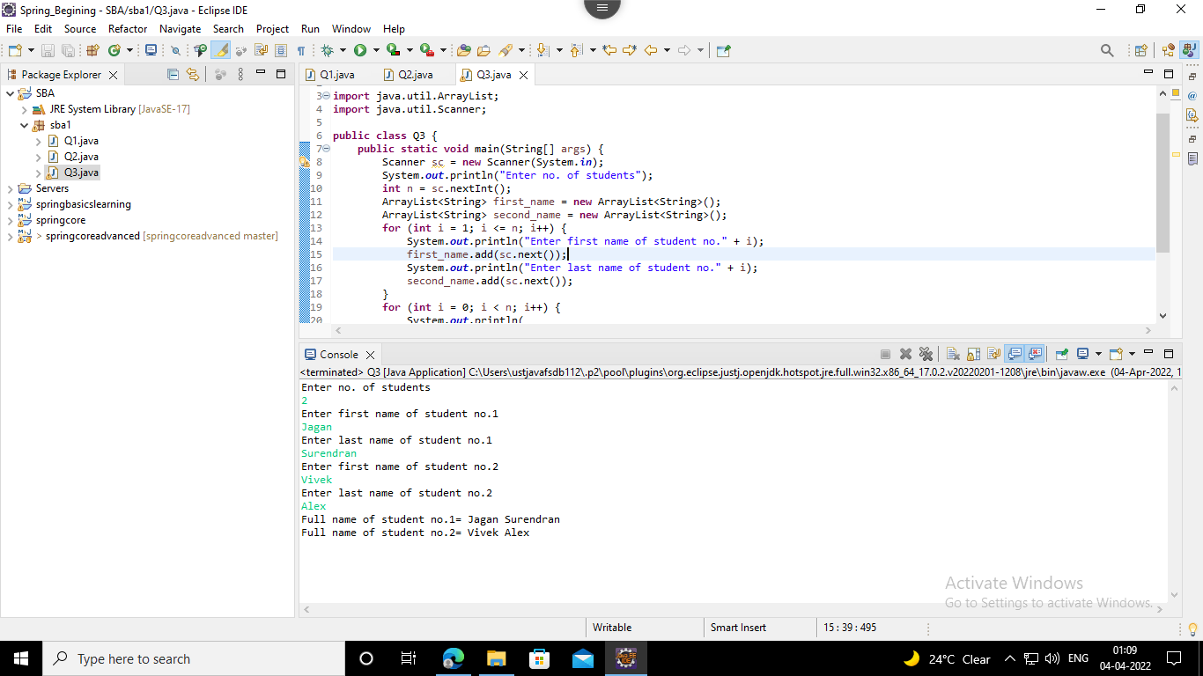

4. Write a program to check for the occurrence of a particular character in a string and display how many times it has occurred.

note: take the String and the character to be checked as a input from the user.

Solution

*package sba1;*

*import java.util.Scanner;*

*public class Q4 {*

*public static void main(String[] args) {*

*Scanner sc = new Scanner(System.in);*

*System.out.println("Enter a string");*

*String s1 = sc.nextLine();*

*System.out.println("Enter the character");*

*char ch = sc.next().charAt(0);*

*System.out.println("You have entered: " + ch);*

*int count = 0;*

*for (int i = 0; i < s1.length(); i++) {*

*if (s1.charAt(i) == ch)*

*count++;*

*}*

*if (count == 0)*

*System.out.println("Character is not found");*

*else*

*System.out.println("The number of times '" + ch + "' appeared = " + count);*

*}*

*}*

Output

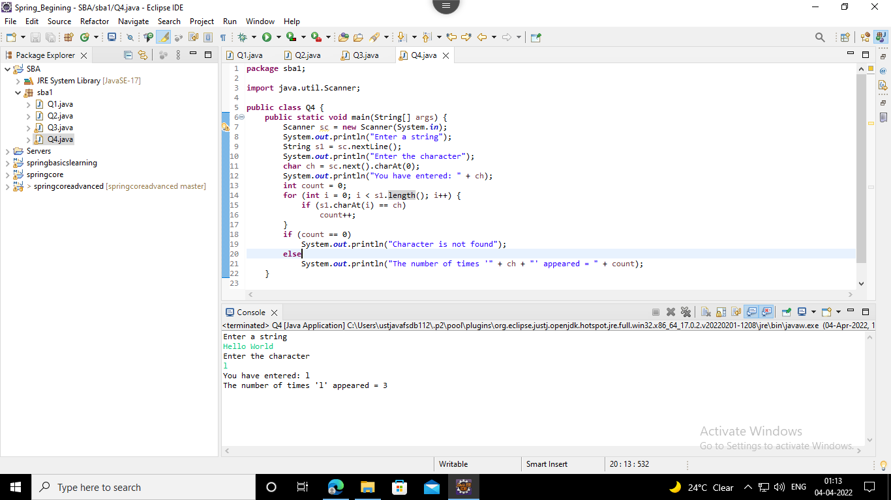

5. Write a program to take an input of a string with multiple words and convert it into a string array, and check if every element of that array is a Palindrome.

Note: Palindrome is a word which when reversed also is the same.

Solution

*package sba1;*

*import java.util.Scanner;*

*public class Q5 {*

*public static void main(String[] args) {*

*System.out.println("Enter a String");*

*Scanner sc = new Scanner(System.in);*

*String str = sc.nextLine();*

*String strArray[] = str.split(" ");*

*System.out.println("String : " + str);*

*System.out.print("String array : [ ");*

*for (int i = 0; i < strArray.length; i++) {*

*System.out.print(strArray[i] + ", ");*

*}*

*System.out.print("]" + "\n");*

*String word;*

*for (int i = 0; i < strArray.length; i++) {*

*word = strArray[i];*

*char[] str1 = new char[word.length()];*

*int count = 0;*

*for (int j = word.length() - 1; j >= 0; j--) {*

*str1[count] = word.charAt(j);*

*count++;*

*}*

*String word2 = new String(str1);*

*if (word.equals(word2)) {*

*System.out.println("Palindrome word : " + word);*

*}*

*}*

*}*

*}*

Output

